Conducting polypyrrole and polypyrrole/manganese dioxide composites prepared with a solid sacrificial oxidant of pyrrole

Irina Sapurina,^{ab} Constantin Bubulinca,ª Miroslava Trchová,^{c} Jan Prokeš,^{d} Jaroslav Stejskal^{e*}

ª Centre of Polymer Systems, Tomas Bata University in Zlin, 760 01 Zlin, Czech Republic
^{b} Institute of Macromolecular Compounds, Russian Academy of Sciences, St. Petersburg 199004, Russian Federation
^{c} University of Chemistry and Technology. Prague, 166 28 Prague 6, Czech Republic
^{d} Charles University, Faculty of Mathematics and Physics, 180 00 Prague 8, Czech Republic ^{e} Institute of Macromolecular Chemistry, Academy of Sciences of the Czech Republic, 162 06 Prague 6, Czech Republic

AUTHOR INFORMATION

Irina Sapurina – Centre of Polymer Systems, Tomas Bata University in Zlin, 760 01 Zlin, Czech Republic, and Institute of Macromolecular Compounds, Russian Academy of Sciences, St. Petersburg 199004, Russian Federation; sapurina@mail.ru; orcid.org/0000-0001-7579-7577
Constantin Bubulinca – Centre of Polymer Systems, Tomas Bata University in Zlin, 760 01 Zlin, Czech Republic; bubulinca@utb.cz
Miroslava Trchová – University of Chemistry and Technology Prague, 166 28 Prague 6, Czech Republic; Miroslava.Trchova@vscht.cz; orcid.org/0000-0001-6105-7578
Jan Prokeš – Charles University, Faculty of Mathematics and Physics, 180 00 Prague 8, Czech Republic; jprokes@semi.mff.cuni.cz; orcid.org/0000-0002-8635-7056
Jaroslav Stejskal (*Corresponding Author) – Institute of Macromolecular Chemistry, Academy of Sciences of the Czech Republic, 162 06 Prague 6, Czech Republic; stejskal@imc.cas.cz; orcid.org/0000-0001-9350-9647.

Abstract
Polypyrrole was prepared by the oxidation of pyrrole with solid manganese dioxide. The present study concerns the chemistry of this process rather than materials properties of the products. The oxidant alone is insoluble in aqueous medium but the reductive dissolution takes place in the presence of pyrrole. Polypyrrole is the exclusive product below the stoichiometric mole ratio [MnO₂]/[pyrrole] = 1.25, and polypyrrole/manganese dioxide composites result at higher ratios. Unlike with iron(III) chloride where protons are generated during the oxidation of pyrrole, with manganese dioxide they are consumed and water is a by-product. The sufficient acidity of the reaction medium is thus needed in order to obtain conducting materials. The presence of organic dyes in the preparation of polypyrrole improved the conductivity. One-dimensional morphology of polypyrrole was observed when methyl orange was introduced to the reaction mixture.

Keywords: Conducting polymer; Polypyrrole; Manganese dioxide; MnO₂; Organic dyes

Introduction
Polypyrrole is one of the most important conducting polymers due to its conductivity exceeding even 100 S cm⁻¹ [1–3] and to various morphologies that are produced: globules [4], nanofibers [5,6], nanosheets [7] and nanotubes [8]. Electroactivity, electrocatalysis, conductivity response to external stimuli, electronic polarizability, or electromagnetic radiation shielding represent applications based on additional electrical features. The applicability of polypyrrole extends to areas that are not associated with the conductivity [9]. This polymer serves as dye adsorbent in water-pollution treatment [3,10–12] or as a part of wound-dressing materials [13]. A good biocompatibility and low cytotoxicity should be mentioned with respect to biomedicine [14], when this polymer can be used both for the monitoring and electrical stimulation of biological objects. Environmental stability and the fact that polypyrrole nanotubes maintain most of its conductivity under physiological conditions [15,16] makes this polymer superior to another conducting polymer, polyaniline.
Polypyrrole has usually been used as the composites with various organic and inorganic components that provide added value and the produce a suitable material form. The former group is represented, e.g., by various cellulosic materials [17,18], the second, e.g., by inorganic oxides or sulfides [19–21]. The applications of polypyrrole/manganese dioxide composites proposed in the literature are aimed especially at energy conversion and storage, while less attention has been paid to the chemistry of the preparation. They have been tested as electrodes in batteries [22–24], supercapacitors [25–28], fuel cells [29] or electrochemical devices [30,31]. Another application field illustrated by electrocatalysis of hydrogen evolution [21] or oxygen reduction reactions [32], photocatalytic degradation of organic pollutants [33], and photoreduction of carbon dioxide [34].
From the synthesis point of view, polypyrrole/manganese dioxide composites are of interest for several reasons: (1) The composites have usually been produced by in-situ deposition of polypyrrole on manganese dioxide, which served as a reactive substrate. (2) Manganese dioxide is an oxidant which is strong enough to be used for the oxidation of pyrrole to polypyrrole instead of currently used iron(III) chloride. (3) Manganese dioxide differs from other oxidants by its insolubility in water, but it converts by reductive dissolution [35,36] to a soluble manganese(II) chloride in the course of pyrrole oxidation. These three roles of manganese dioxide in the preparation of polypyrrole have to be considered in concert and are an objective of the present study.
The presence of organic dyes during the synthesis of polypyrrole affects its morphology and conductivity [2,3,5,37,38]. Especially one-dimensional nanotubes with enhanced conductivity guided by methyl orange came to the forefront [8]. For that reason, the effect of organic dyes on the properties of polypyrrole prepared by the oxidation of pyrrole with solid manganese dioxide has also been included in the present study.

Experimental

Preparation
In all cases, 0.1 M pyrrole (0.7 mL/0.68 g per 100 mL, 98%, for synthesis, reagent grade, Sigma-Aldrich) was oxidized with 0.05–0.5 M of manganese dioxide (activated, ≈85%, particle size <10 μm, Sigma-Aldrich) in aqueous medium, i.e. both below and above the stoichiometric oxidant-to-monomer mole ratio 1.25. Three series of experiments were carried out. In the first (Series 1), 0.2 M hydrochloric acid was selected as the acidic reaction medium. In the second series (Series 2), 0.5 M hydrochloric acid was used. All syntheses have been carried out at ambient temperature, ≈20 °C, and the products were collected after 24 h. The solids were separated by filtration, rinsed with 0.2 M hydrochloric acid, followed by acetone, and left to dry in air for 5 days. The third series (Series 3) used 0.1 M pyrrole (0.68 g per 100 mL) and 0.125 M manganese dioxide (1.086 g per 100 mL) in 0.5 M hydrochloric acid), i.e. at the stoichiometric mole ratio between manganese dioxide and pyrrole, and investigated the effect of several organic dyes at 0.05 wt% concentration (50 mg per 100 mL). Methyl orange, safranin, neutral red, and acriflavine hydrochloride (all from Sigma-Aldrich) were selected as dye representatives.

Characterization
Morphology was observed with a scanning ultra-high-resolution electron microscope MAIA3 Tescan. The conductivity was determined by four-point van der Pauw method on pellets 13 mm in diameter and ca 1 mm thick prepared at 527 MPa in a hydraulic press when such a preparation was feasible. The set-up included a current source Keithley 220, a Keithley 2010 multimeter and a Keithley 705 scanner with a Keithley 7052 matrix card. Apparent density was calculated from the mass and geometry of pellets. FTIR spectra of the powders were recorded with a Nicolet 6700 spectrometer (Thermo-Nicolet, USA) equipped with an ATR extension GladiATR (PIKE Technologies, USA) with diamond crystal. Spectra were collected in the 4000–400 cm^{–1} wavenumber region with a DLaTGS (Deuterated L-alanine doped triglycine sulfate) detector at resolution 4 cm^{–1}, 64 scans, using Happ-Genzel apodization.

Results and discussion
Polypyrrole is routinely prepared by the oxidation of pyrrole with iron(III) chloride (Fig. 1a). Hydrogen atoms abstracted from the pyrrole molecules during their linkage to polypyrrole chain are released as protons, here as hydrochloric acid, and acidity of the medium increases. Along with the hydrolysis of iron(III) chloride this ensures the sufficient acidity that is required for the successful polymerization.
The situation is different for the manganese dioxide oxidant (Fig. 1b), which is insoluble in the reaction medium and its presence does not alter the acidity. The hydrogen atoms abstracted from pyrrole molecules participate in this case in the formation of water, i.e. they do not affect pH either. When 0.2 M hydrochloric acid was used as a medium (Series 1), the hydrochloric acid was consumed in the protonation of constitutional polypyrrole units (Fig. 1b) and the acid was also consumed in the reductive conversion of manganese dioxide to manganese(II) salt (Fig. 2). The final pH of reaction mixture increased from 1 when the concentration of oxidant was low to 4–5 at the highest manganese dioxide content, i.e. the acidity became too low for the polymerization to proceed and pyrrole oligomers were produced instead. The external acid was thus needed in sufficient concentration to provide acidic medium for the polymerization of pyrrole. This was achieved when 0.5 M hydrochloric acid constituted the reaction medium (Series 2), and pH ≈ 1 was maintained throughout the oxidation.

.

Fig. 1. The oxidation of pyrrole to polypyrrole with (a) iron(III) chloride (the stoichiometric mole ratio [FeCl₃]/[pyrrole] = 2.5) or (b) manganese dioxide (the stoichiometric mole ratio [MnO₂]/[pyrrole] = 1.25).

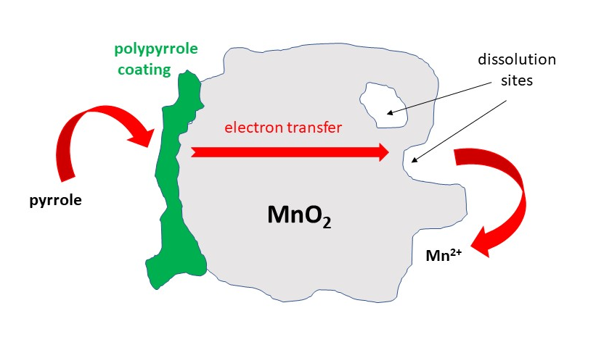
Fig. 2. Pyrrole is oxidized by manganese dioxide to polypyrrole. Electrons abstracted from pyrrole molecules are transferred through conducting polypyrrole to manganese dioxide, which is reduced to soluble manganese(II) ions, and dissolves. Dissolution may occur at any oxidant spot, at its surface or inside.

Yield
Below the stoichiometric composition of the reactants, [MnO₂]/[pyrrole] < 1.25, only a part of pyrrole is oxidized to polypyrrole and at the same time insoluble manganese dioxide converts to soluble manganese(II) chloride (Fig. 2). As the concentration of oxidant increases, the yield increases accordingly. In both Series, the products are polypyrroles slightly contaminated manganese compounds (Fig. 3a).
Above the stoichiometric composition of the reactants, [MnO₂]/[pyrrole] > 1.25, all pyrrole is converted to polypyrrole, and along with the residual manganese dioxide a composite is produced. The yield increases accordingly (Fig. 3a) and content of manganese dioxide in the composite as well (Fig. 3b).

Morphology
The size distribution of manganese dioxide particles is broad and particles of the order of 10 μm with irregular shape are accompanied by nanoparticles (Fig. 4a). Polypyrrole/manganese dioxide composites prepared at [MnO₂]/[pyrrole] = 2.5 ratio with low dioxide content display mainly the morphology of globular polypyrrole produced on inorganic substrate (Fig. 4b). At high dioxide content in the composites prepared at [MnO₂]/[pyrrole] = 5, the features of inorganic component dominate along with polypyrrole aggregates (Fig. 4c).
Fig. 3. (a) The yield of solids prepared by the oxidation of 0.1 M pyrrole with various molar concentration of manganese dioxide in 0.2 M (open squares) and 0.5 M HCl (full squares). (b) The content of manganese dioxide in the composites with polypyrrole determined as an ash. Synthesis in 0.5 M HCl. The stoichiometric composition [MnO₂]/[pyrrole] = 1.25 is marked with a vertical arrow.
.
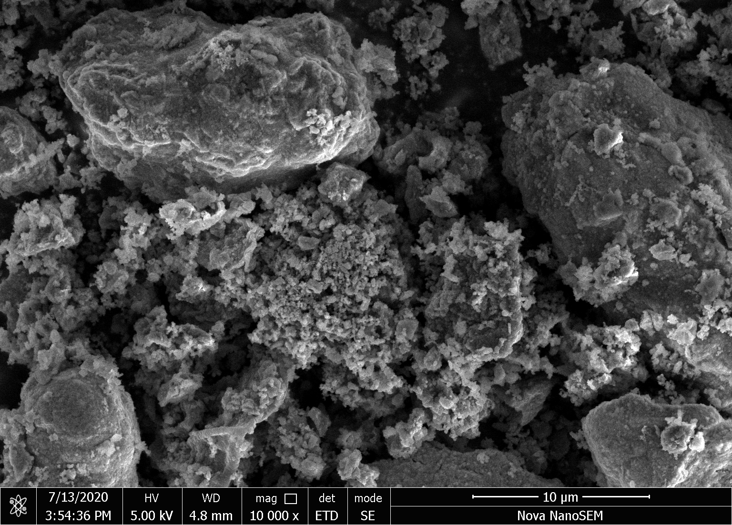
(a) MnO₂
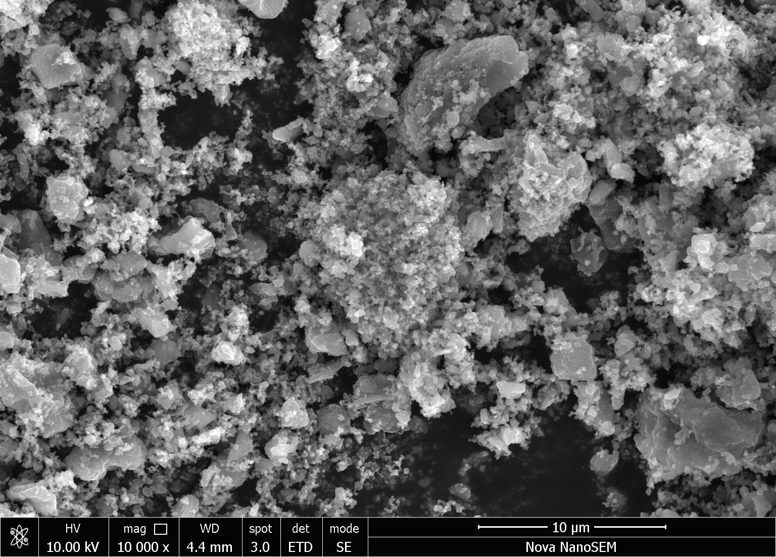
(b) [MnO₂]/[pyrrole] = 2.5
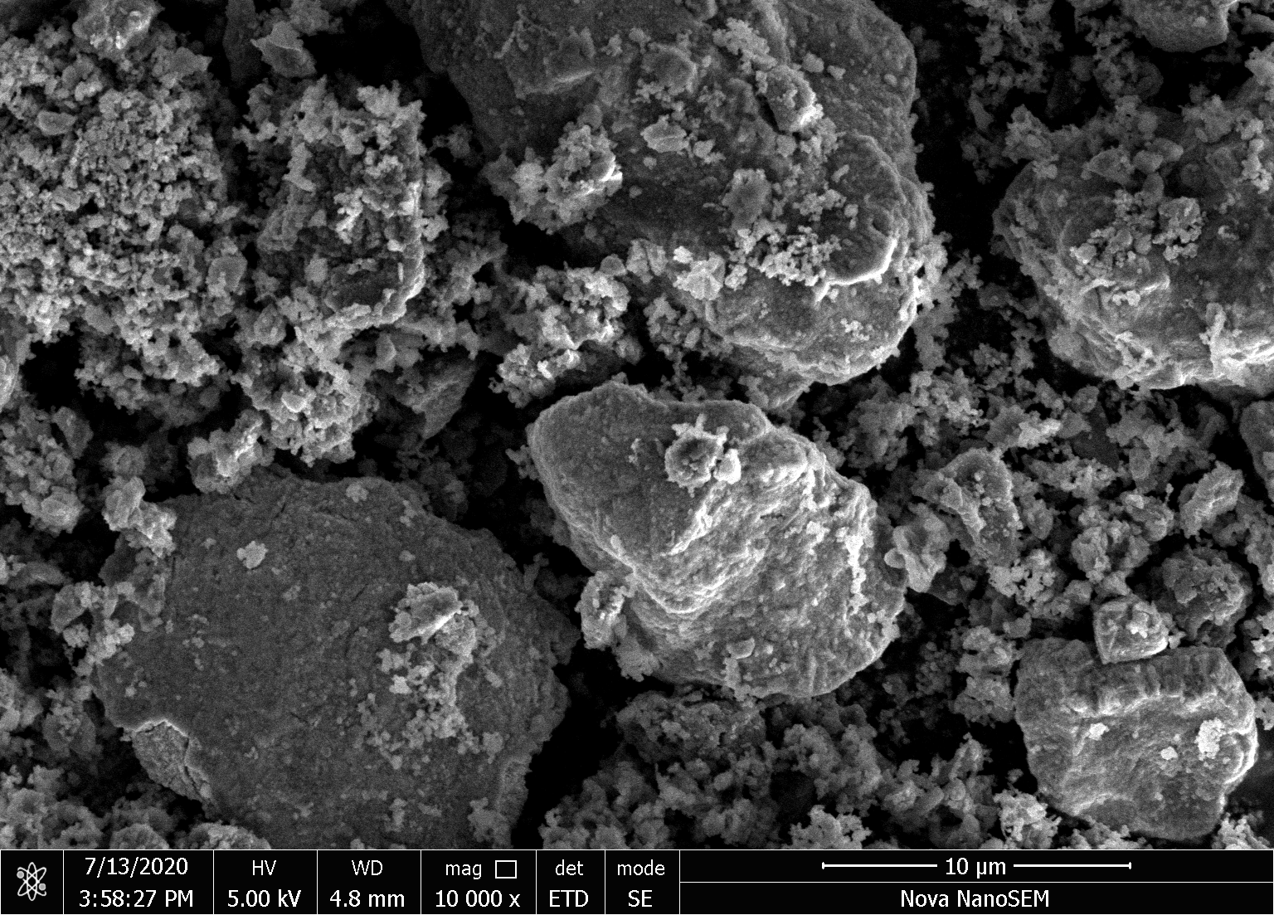
(c) [MnO₂]/pyrrole = 5
Fig. 4. Micrographs of (a) manganese dioxide and polypyrrole/manganese dioxide prepared at mole ratios [MnO₂]/[pyrrole] = (b) 2.5 and (c) 5 (scale bars 10 μm).

Conductivity
The oxidation of 1 mol of pyrrole with manganese dioxide requires 3 mol of hydrochloric acid (Fig. 1b). For the samples prepared by the oxidation of 0.1 M pyrrole in 0.2 M HCl, the acid became consumed and pH dropped from 1 to 4–5 above the stoichiometric content of oxidant. Under such conditions, the formation of non-conducting pyrrole oligomers may be anticipated, and the conductivity of product decreased (Fig. 5). The apparent densities indicated that the composites become rich in manganese oxide (Fig. 6), its content obviously exceeded the percolation limit and the conductivity started to be controlled by manganese oxide, and consequently increased. The conductivity of manganese dioxide powder used in the study was determined after compression to a pellet as 1.49 S cm⁻¹.
The oxidation of pyrrole carried out at 0.5 M HCl does not suffer from the acid depletion and the acidity was maintained at pH 1 for all samples. The fraction of manganese dioxide in the samples was lower compared with the previous case as confirmed again by reduced apparent densities (Fig. 6). The conductivity of composites was determined by the polymer matrix, in which polypyrrole was overoxidized or partly deprotonated and its conductivity was thus reduced.
Fig. 5. Conductivity of polypyrrole/manganese dioxide prepared by the oxidation of 0.1 M pyrrole with various [MnO₂]/[pyrrole] mole ratios in 0.2 M (open squares) and 0.5 M HCl (full squares). The stoichiometric composition is marked with an arrow.

Apparent density
Density of compact manganese dioxide is 5.03 g cm⁻³ but the apparent density determined from the mass and geometry of a pellet prepared by compression at 527 MPa is 2.65 g cm⁻³. As the concentration of manganese dioxide in the reaction mixture increased above stoichiometric composition, a residual manganese dioxide constitutes a part of the product. The yield (Fig. 3a) and the apparent density (Fig. 6) increased accordingly, i.e. the composites become rich in inorganic component (Fig. 3b).
Fig. 6. Apparent density of polypyrrole/manganese dioxide prepared by the oxidation of 0.1 M pyrrole at various [MnO₂]/[pyrrole] mole ratios of manganese dioxide in 0.2 M HCl (open symbols) and 0.5 M HCl (closed symbols).

FTIR spectra
ATR FTIR spectra of polypyrrole/manganese dioxide prepared at various mole ratios [MnO₂]/[pyrrole] in 0.2 M hydrochloric acid (Series 1) can be divided into three groups (Fig. 7a). The spectra of samples prepared at ratios 0.5 and 1 only slightly differ from the spectrum of standard polypyrrole (spectrum PPy in Fig. 7a). The absorption above 1600 cm^{–1} associated with a polaron band slightly decreased and the maximum observed at 1690 cm^{–1} which corresponds to the presence of carbonyl group formed by the nucleophilic attack of water during the preparation [39, 40] is well distinguished in the spectra of these samples. The bands situated at 1530 cm^{–1} (C–C stretching vibrations in the pyrrole ring) and at 1143 cm^{–1} (breathing vibrations of the pyrrole rings) shifted to the higher wavenumbers. Other bands of polypyrrole situated at 1432 cm^{–1} (C–N stretching vibrations in the ring), at 1287 cm^{–1} (C–H or C–N in-plane deformation modes), at 1040 cm^{–1} (C–H and N–H in-plane deformation vibrations) and the peaks at 1090 and 962 cm^{–1} remain at the place (interpretation of the peaks see the reference [8]). These changes correspond to the slight deprotonation of polypyrrole as it is demonstrated by comparison with the spectrum of standard polypyrrole deprotonated with 0.01M NaOH (see Fig. 7a). It is in correlation with the decrease of conductivity of these samples (Fig. 5). The spectra of samples prepared at 1.25, 2 and 2.5 ratios are very close to the spectrum of standard polypyrrole deprotonated with 0.1% ammonium hydroxide (see Fig. 7a) and it is also in agreement with decrease of conductivity of these samples (Fig. 5). When the ratio [MnO₂]/[pyrrole] increased to 3 and 5 M, the spectra are strongly influenced by the spectrum of MnO₂ (see Fig. 7a), which is present in the samples (Fig. 6). The conductivity of these samples increased (Fig. 5).
ATR FTIR spectra of polypyrrole/manganese dioxide prepared at various [MnO₂]/[pyrrole] ratios in 0.5 M hydrochloric acid (Series 2) can be divided in two groups (Fig. 7b). The spectra of samples prepared at 0.5, 1 and 1.25 ratios are close to the spectrum of standard polypyrrole (spectrum PPy in Fig. 7b) and the samples have also higher conductivity than those of the Series 1 (Fig. 5). The conductivity decreases for the samples prepared at 2–5 ratios. This is demonstrated by their spectra which are close to the spectrum of standard polypyrrole deprotonated with 0.1% ammonium hydroxide (Fig. 7b). The presence of manganese dioxide in the samples prepared in 0.5 M hydrochloric acid is not detected in the spectra which corresponds to the lower content of manganese dioxide compared to the synthesis in 0.2 M hydrochloric acid (Fig. 6).
Fig. 7. ATR FTIR spectra of polypyrrole/manganese dioxide prepared at various mole ratios [MnO₂]/[pyrrole] in (a) 0.2 M and (b) 0.5 M hydrochloric acid. The spectra of standard polypyrrole and of polypyrrole deprotonated with 0.01 M NaOH and 0.1% ammonium hydroxide [15] are shown for comparison.

Dyes in the polypyrrole preparation
Next experiments (Series 3) have been carried out at the stoichiometric mole ratio [MnO₂]/[pyrrole] = 1.25. It was demonstrated above that under such conditions manganese dioxide is practically consumed during the oxidation of pyrrole (Figs 1b,3b) and the product is thus polypyrrole and rather than the composite with manganese dioxide. For that reason, this section refers to polypyrrole only.
It has recently been reported that the presence of various organic dyes in the course of pyrrole oxidation may convert polypyrrole morphology from globular to one-dimensional nanofibers or nanotubes and, at the same time to improve polypyrrole conductivity [8,37]. Methyl orange azo dye, acriflavine of acridine type and two phenazine dyes, neutral red and safranin, have be found to support the formation of one-dimensional morphologies [37] and, for that reason they have been tested also in the present study.
Except for methyl orange (Fig. 8a), which supported the growth of one-dimensional morphologies, the typical globular morphology of polypyrrole is maintained when the preparation took place in the presence of other dyes (Fig. 8b–d). It has to be mentioned that the morphology generally differs from the samples prepared with iron(III) chloride reported in the literature [37]. This means that the morphology in the present state is affected mainly by the solid phase represented by manganese dioxide, even though it is later consumed in the reaction.
When it comes to the conductivity, except for acriflavine all dyes improved this parameter, in the case of methyl orange even 80-times (Table 1). This is still below the level usual for polypyrrole prepared with iron(III) chloride in the presence of methyl orange [1,4], methyl red [2], or safranin [3], when conductivity reached or even exceeded 100 S cm⁻¹.

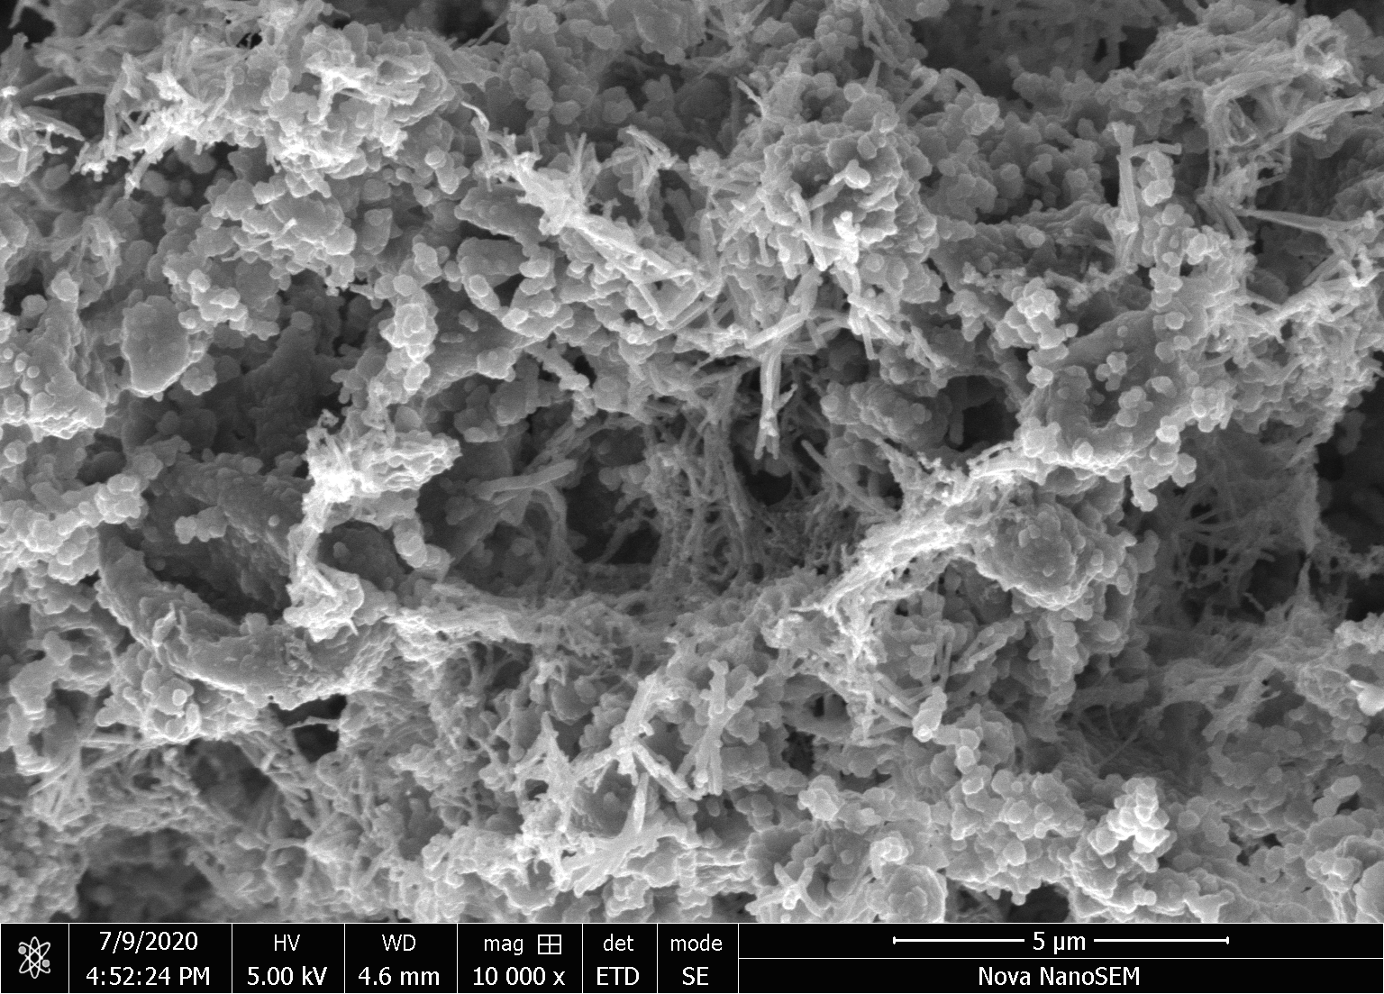 | 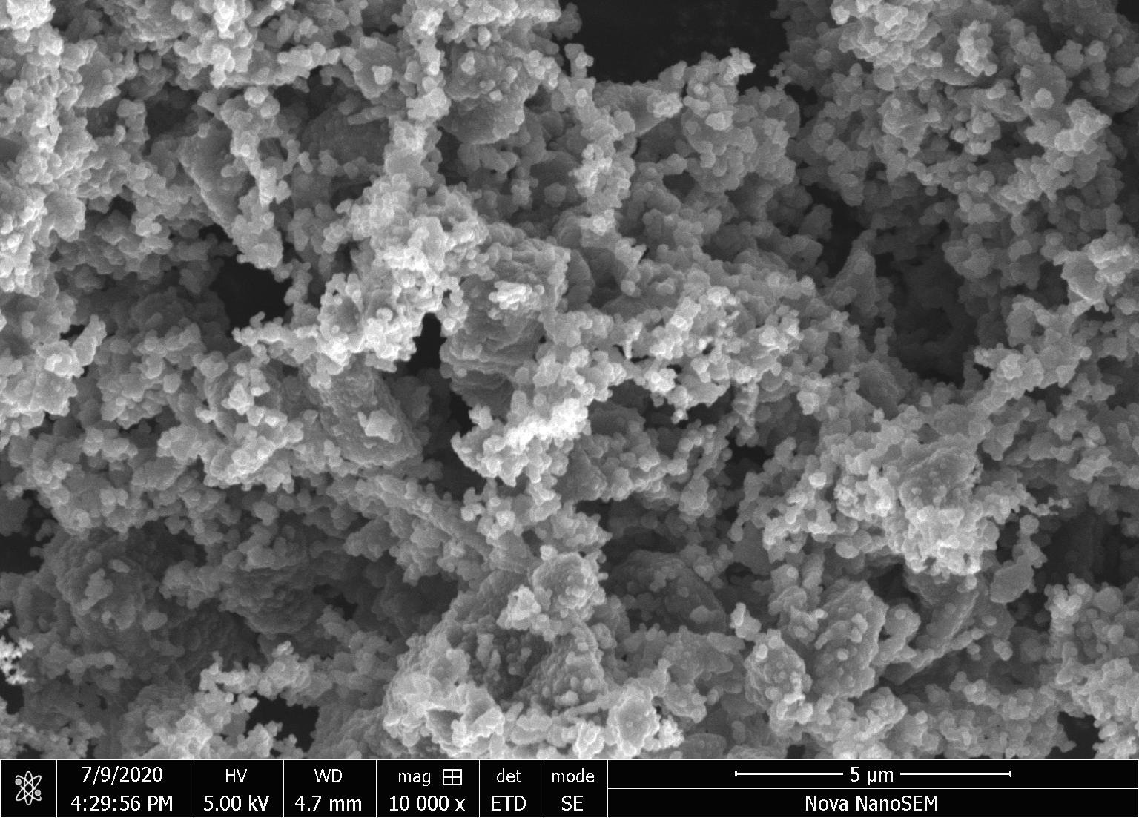
(a) Methyl orange | (b) Safranin
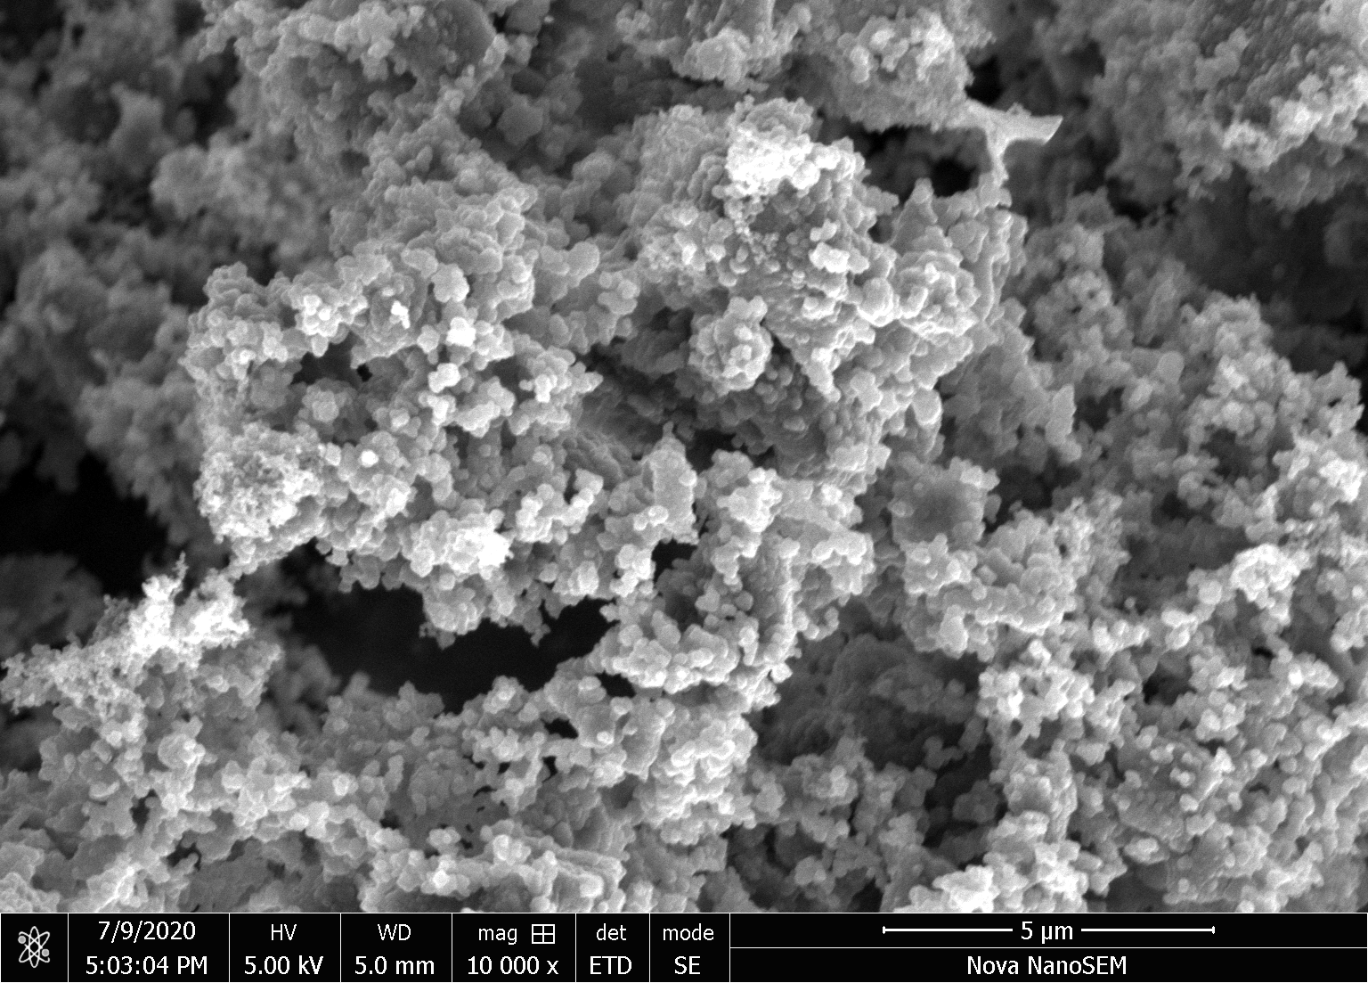 | 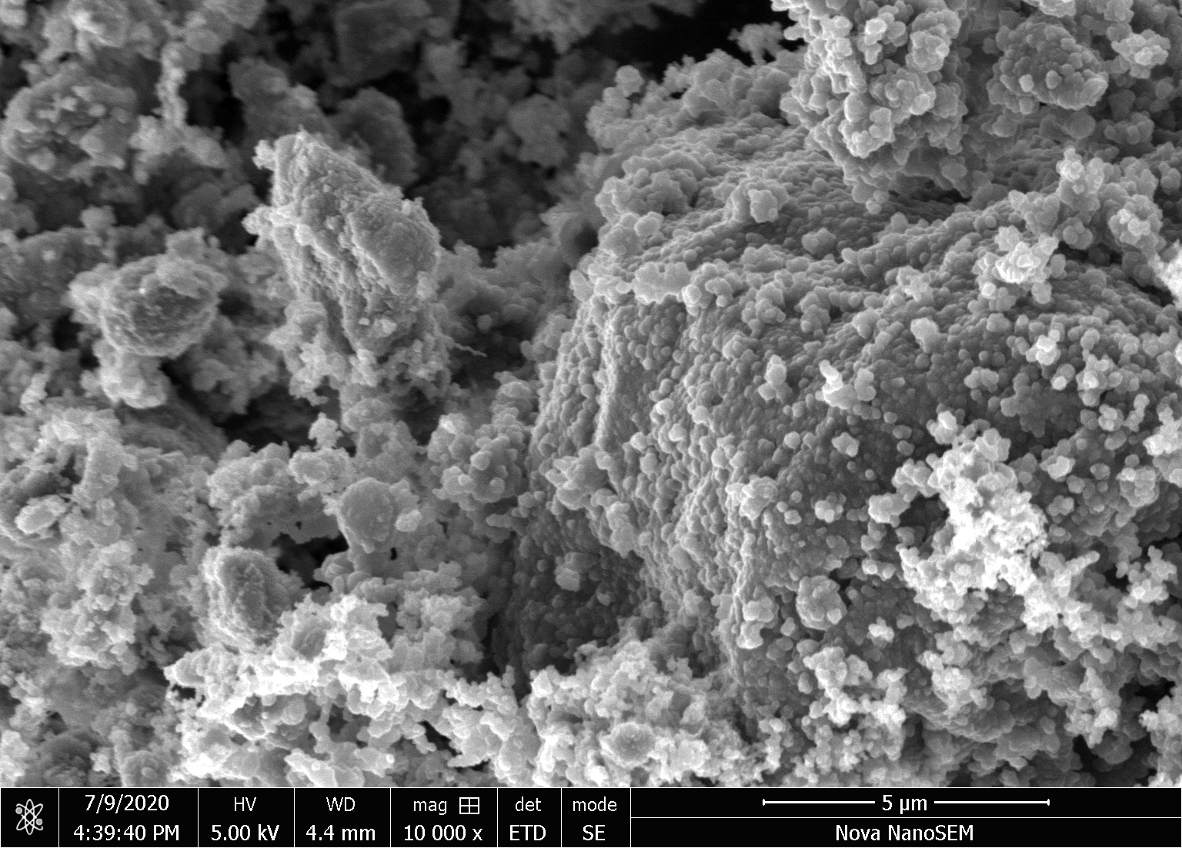
(c) Neutral red | (d) Acriflavine
Fig. 8. Morphology of polypyrrole prepared in the presence of organic dyes. Scale bars 5 μm.

Table 1. The yield per gram of pyrrole and the conductivity of polypyrroles prepared in the presence of organic dyes.
Dye | Yield, g g⁻¹ | Conductivity, S cm⁻¹
Methyl orange | 1.25 | 9.77
Neutral red | 0.83 | 3.47
Safranin | 0.91 | 2.20
Acriflavine hydrochloride | 0.67 | 0.0207
No dye | 0.81 | 0.122
ª Reaction conditions: 0.1 M pyrrole, 0.125 M manganese dioxide, 500 mg L⁻¹ dye; 20 °C.

ATR FTIR spectra of polypyrrole prepared in the presence of organic dyes correspond to conducting form of polypyrrole (Fig. 9) and they reflect well the values of conductivity (Table 1). The enhanced absorbance above 1600 cm^{–1} is highest for sample prepared in presence of methyl orange, then for neutral red and safranin. It is higher than in the spectrum of polypyrrole prepared without any dye with a lower conductivity. In the case of azo dye, acriflavine, the spectrum corresponds to the slightly deprotonated sample as it is shown in Fig. 7a. The presence of dyes does not manifest itself in the spectra using surface sensitive ATR technique. This is in agreement with the model of polymer chains growing on a dye template [41,42]
Fig. 9. FTIR spectra of polypyrrole/manganese dioxide prepared in the presence of organic dyes. Spectrum of polypyrrole with no dye (PPy) corresponds to the spectrum of sample prepared at [MnO₂]/[pyrrole] = 1.25. The spectra of dyes are shown for comparison: A – acriflavine hydrochloride, S – safranin, MO – methyl orange, and NR – neutral red.

Conclusions
Pyrrole was oxidized with solid manganese dioxide in aqueous medium. The originally insoluble dioxide undergoes reductive dissolution in the presence of organic reductant, pyrrole, and converts to a soluble manganese(II) salt. Below the stoichiometric mole ratio [MnO₂]/[pyrrole] < 1.25, polypyrrole is the only product of oxidation. The properties of polypyrrole does not differ from the analogous polymer prepared with a classic oxidant, iron(III) chloride. Above this ratio, polypyrrole/magnetite composites are obtained. The preparation is simple and proceeds smoothly with a high yield. The acid has to be added to the reaction mixture at sufficient concentration, in the contrast to common oxidations using iron(III) chloride. Polypyrroles have the conductivity of the order of 10⁻¹ S cm⁻¹, i.e. comparable with the common synthesis using iron(III) chloride. The conductivity of polypyrrole/manganese dioxide composites is lower but still above 10⁻⁴ S cm⁻¹. The conductivity increased to 10 S cm⁻¹ by the introduction of an organic dye, such as methyl orange, to the reaction mixture, similarly like in oxidations using iron(III) chloride. These conclusions allow for the better understanding of the preparation of composites for the application in energy storage devices.

Acknowledgments
The authors thank the Czech Science Foundation (19-04859S) and the Technology Agency of the Czech Republic (TH71020006) for financial support.

Conflicts of interest
The authors declare no conflicts of interest.

References
[1] Li Y, Bober P, Trchová M, Stejskal J. Polypyrrole prepared in the presence of methyl orange and ethyl orange: nanotubes versus globules in conductivity enhancement. J Mater Chem C 2017;5:4236–4245. doi: 10.1039/c7tc00206h
[2] Minisy IM, Bober P, Šeděnková I, Stejskal J. Methyl red dye in the tuning of polypyrrole conductivity. Polymer 2020;207:122854. doi: 10.1016/j.polymer.2020.122854.
[3] Minisy IM, Acharya U, Kobera L, Trchová M, Unterweger C, Breitenbach S, Brus J, Pfleger J, Stejskal J, Bober P. Highly conducting 1-D polypyrrole prepared in the presence of safranin. J Mater Chem C 2020;8:12140–12147. doi: 10.1039/d0tc02838j
[4] Sapurina I, Li Y, Alekseeva E, Bober P, Trchová M, Morávková Z, Stejskal J. Polypyrrole nanotubes: the tuning of morphology and conductivity. Polymer 2017;113: 247–258. doi: 10.1016/j.polymer.2017.02.064
[5] Bober P, Li Y, Acharya U, Panthi Y, Pfleger J, Humpolíček P, Trchová M, Stejskal J. Acid Blue dyes in polypyrrole synthesis: the control of polymer morphology at nanoscale in the promotion of high conductivity and the reduction of cytotoxicity. Synth Met 2018;237:40–49. doi: 10.1016/j.synthmet.2018.01.010
[6] Stejskal J, Kohl M, Trchová M, Kolská Z, Pekárek M, Křivka I, Prokeš. Conversion of conducting polypyrrole nanostructures to nitrogen-containing carbons and its impact on the adsorption of organic dye. Mater Adv 2021;2:706–717. doi: 10.1039/d0ma00730g
[7] Milakin KA, Acharya U, Trchová M, Zasońska BA, Stejskal J. Polypyrrole/gelatin cryogel as a precursor for macroporous conducting polymer. React Funct Polym 2020;157:104751. doi: 10.1016/j.reactfunctpolym.2020.104751
[8] Stejskal J, Trchová M. Conducting polypyrrole nanotubes: a review. Chem Pap 2018;72:1563–1595. doi: 10.1007/s11696-018-0394-x
[9] Stejskal J. Conducting polymers are not just conducting: a perspective for emerging technology. Polym Int 2020;69:662–664. doi: 10.1002/pi.5947
[10] Ayad MM, Amer WA, Zaghlol S, Minisy IM, Bober P, Stejskal J. Polypyrrole-coated cotton textile as adsorbent of methylene blue dye. Chem Pap 2018;72:1605–1618. doi: 10.1007/s11696-018-0442-6
[11] Stejskal J. Interaction of conducting polymers, polyaniline and polypyrrole, with organic dyes: polymer morphology control, dye adsorption and photocatalytic decomposition. Chem Pap 2020;74:1–54. doi: 10.1007/s11696-019-00982-9
[12] Sapurina IYu, Shishov MA, Ivanova VT. Sorbents for water purification based on conjugated polymers. Russ Chem Rev 2020;89:1115–1131. doi: 10.1070/RCR4955
[13] Korupalli C,Li H, Nguyen N, Mi FL, Chang Y, Lin YJ. Conductive materials for healing wounds: their incorporation in electroactive wound dressing, characterization, and perspectives. Adv Healthcare Mater, early access. doi: 10.1002/adhm.202001384
[14] Capáková Z, Radaskiewicz KA, Acharya U, Truong TH, Pacherník J, Bober P, Kašpárková V, Stejskal J, Pfleger J, Lehocký M, Humpolíček P. The biocompatibility of polyaniline and polypyrrole 2: doping with organic phosphonates. Mater Sci Eng C 2020;113:110986. doi: 10.1016/j.msec.2020.110986
[15] Stejskal J, Trchová M, Bober P, Morávková Z, Kopecký D, Vrňata M, Prokeš J, Varga M, Watzlová E. Polypyrrole salts and bases: superior conductivity of nanotubes and their stability towards the loss of conductivity by deprotonation. RSC Adv 2016;6:88382–88391. doi: 10.1039/c6ra19461c
[16] Prokeš J, Varga M, Vrňata M, Valtera S, Stejskal J, Kopecký D. Nanotubular polypyrrole: Reversibility of protonation/deprotonation cycles and long-term stability. Eur Polym J 2019;115:290–297. doi: 10.1016/j.eurpolymj.2019.03.037
[17] Tissera ND, Wijesena RN, Rathnayake S, de Silva RM. Heterogeneous in situ polymerization of polyaniline (PANI) nanofibers on cotton textiles: improved electrical conductivity, electrical switching, and tuning properties. Carbohydr Polym 2018;186:35–44. doi: 10.1016/j.carbpol.2018.01.027
[18] Wang F, Li QC, Park JO, Zheng SH, Choi E. Ultralow voltage high-performance bioartificial muscles based on ionically crosslinked polypyrrole-coated functional carboxylated bacterial cellulose for soft robots. Adv Funct Mater 2020;2007749. doi: 10.1002/adfm.202007749
[19] Acharya U, Bober P, Trchová M, Zhigunov A, Stejskal J, Pfleger J. Synergistic conductivity increase in polypyrrole/molybdenum disulfide composite. Polymer 2018;150:130–137. doi: 10.1016/j.polymer.2018.07.004
[20] Korshak YuV, Motyakin MV, Plyushchii IV, Kovarskii AL, Degryarev YeN, Petrushevska AG, Alekperov RA, Dyatlov VA, Tsatsakis AM, Luss AL, Mezhuev YO. Pyrrole oxidative polymerization by manganese oxide(IV) on silica gel surface. Polymer 2019;180:121717. doi: 10.1016/j.polymer.2019.121717
[21] Stejskal J, Acharya U, Bober P, Hajná M, Trchová M, Mičušík M, Omastová M, Pašti I, Gavrilov N. Surface modification of tungsten disulfide with polypyrrole for enhancement of the conductivity and its impact on hydrogen evolution reaction. Appl Surf Sci 2019;492:497–503. doi:10.1016/j.apsusc.2019.06.175
[22] Gemeay AH, Nishiyama H, Kuwabata S, Yoneyama H. Chemical preparation of manganese dioxide polypyrrole composites and their use as cathode active materials for rechargeable lithium batteries. J Electrochem Soc 1995;142: 4190–4195. doi: 10.1149/1.2048483
[23] Sui YM, Liu CF, Zou PC, Zhan HC, Cui YZ, Yang C, Cao GZ. Polypyrrole coated δ-MnO₂ nanosheet arrays as a highly stable lithium-ion-storage anode. Dalton Trans 2020;49:7903–7913. doi: 10.1039/d0dt01658f
[24] Zhang Y, Xu GB, Liu X, Wei X, Cao JX, Yang LW. Scalable in situ reactive assembly of polypyrrole-coated MnO₂ nanowire and carbon nanotube composite a freestanding cathodes for high performance aqueous Zn-ion batteries. ChemElectroChem 2020;13:2762–2770. doi: 10.1002/celc.202000253
[25] Zhang AQ, Xiao YH, LuLZ, Wang LZ, Li F. Polypyrrole/MnO₂ composites and their enhanced electrochemical capacitance. J Appl Polym Sci 2013;128:1327–1331. doi: 10.1002/app.38153
[26] Dong S, Wang ZY, Wang JL, Yao Y, Liu HF. Polypyrrole and polypyrrole@MnO₂ nanowires grown on graphene foam for asymmetric supercapacitor. Mater Express 2020;10:1308–1316. doi: 10.1166/mex.2020.1766
[27] Fu JL, Zhang Y, Zhao H, Jiang RJ, Zhang RJ. Core/sheath structured ultralong MnO_{x}/PPy nanowires feature improved conductivity and stability for supercapacitor. J Colloid Interface Sci 2020;559:39–44. doi: 10.1016/j.jcis.2019.10.006
[28] Sui ZY, Chang ZS, Xu XF, Li YL, Zhu XM, Zhao C, Chen Q. Direct growth of MnO₂ on highly porous nitrogen-doped carbon nanowires for asymmetric supercapacitors. Diamond Related Mater 2020;108:107988. doi: 10.1016/j.diamond.2020.107988
[29] Liu X, Yin WF, Liu X, Zhao XH. Enhanced Cr reduction and bioelectricity production in microbial fuel cells using polypyrrole-coated MnO₂ on carbon cloth. Environ Chem Lett 2020;18:517–525. doi: 10.1007/s10311-019-00958-x
[30] Diaz-Arriaga CB, Baas-Lopez JM, Pacheco-Catalan DE, Uribe-Calderon J. Symmetric electrochemical capacitor based on PPy obtained via MnO₂ reactive template synthesis. Synth Met 2020;269:116541. doi: 10.1016/j.synthmet.2020.116541
[31] Rakhrour W, Selloum D, Henni A, Cherrad N, Chikouche I, Benalia M, Mouffok S, Djedid M, Bouzar N, Tingry S. Electrochemical synthesis of an organometallic material based on polypyrrole/MnO₂ as high-performance cathode. J Inorg Organomet Polym Mater, early view. doi: 10.1007/s10904-020-01664-w
[32] Bocchetta P, Amati M, Gregoratti L, Kiskinova M, Sezen H, Taurino A, Bozzini B. Morphochemical evolution during ageing of pyrolysed Mn/polypyrrole nanocomposite oxygen reduction electrocatalysts: A study based on quasi-in situ photoelectron spectromicroscopy. J Electroanal Chem 2015;758:191–200. doi: 10.1016/j.jelechem.2015.07.015
[33] Parveen A, Surumbarkuzhali N. Strategies and insights towards the high performance visible light photoctalytic activity of MnO₂/PPy hybrid catalyst: challenges and perspectives. J Mater Sci: Mater Electron 2020;31:11955–11966. doi: 10.1007/s10854-020-03750-8
[34] Yang J, Wang ZY, Jiang JC, Chen WX, Liao F, Ge X, Zhou X, Chen M, Li RL, Xue ZG, Wang G, Duan XZ, Zhang GQ, Wang YG, Wu YE. In-situ polymerization induced atomically dispersed manganese sites as cocatalyst for CO₂ photoreduction into synthesis gas. Nano Energy 2020;76:105059. doi: 10.1016/j.nanoen.2020.105059
[35] Bafghi MS, Zakeri A, Ghasemi Z, Adeli M. Reductive dissolution of manganese ore in sulfuric acid in the presence of iron metal. Hydrometallurgy 2008;90:207–212. doi: 10.1016/j.hydromet.2007.07.003
[36] Xin BP, Li T, Li X, Dan ZG, Xu FY, Duan N, Zhang YT, Zhang HY. Reductive dissolution of manganese from manganese dioxide ore by autotrophic mixed culture under aerobic conditions. J Cleaner Prod 2015;92:54–64. doi:10.1016/j.jclepro.2014.12.060
[37] Stejskal J, Prokeš J. Conductivity and morphology of polyaniline or polypyrrole prepared in the presence of organic dyes. Synth Met 2020;264:116373. doi: 10.1016/j.synthmet.2020.116373
[38] Moučka R, Sedlačík M, Kasparyan H, Prokeš J, Trchová M, Hassouna F, Kopecký D. One-dimensional nanostructures of polypyrrole for shielding of electromagnetic interference in the microwave region. Int J Mol Sci 2021;21:8814. doi: 10.3390/ijms21228814
[39] Blinova NV, Stejskal J, Trchová M, Prokeš J, Omastová M. Polyaniline and polypyrrole: a comparative study of the preparation. Eur Polym J 2007;43:2331–2341. doi: 10.1016/j.eurpolymj.2007.03.045
[40] Omastová M, Trchová M, Kovářová J, Stejskal J. Synthesis and structural study of polypyrroles prepared in the presence of surfactants. Synth Met 2003;138:447–455. doi|: 10.1016/S0379-6779(02)00498-8
[41] Kopecká J, Kopecký D, Vrňata M, Fitl P, Stejskal J, Trchová M, Bober P, Morávková Z, Prokeš J, Sapurina I. Polypyrrole nanotubes: mechanism of formation. RSC Adv 2014;4:1551–1558. doi: 10.1039/c3ra45841e
[42] Trchová M, Stejskal J. Resonance Raman spectroscopy of conducting polypyrrole nanotubes: disordered surface versus ordered body. J Phys Chem A 2019;122:9298–9306. doi: 10.1021/acs.jpca.8b09794

Table of Content:

Conducting polypyrrole and polypyrrole/manganese dioxide composites prepared with a solid sacrificial oxidant of pyrrole

Irina Sapurina, Constantin Bubulinca, Miroslava Trchová, Jan Prokeš, Jaroslav Stejskal

Mangenese dioxide is an efficient oxidant of pyrrole in the preparation of polypyrrole/manganese dioxide composites.

