Mathematical Method as a Tool for the Identification of Assets within the Organization Providing Insurance against Cyber Risk)

  - Lukáš Pavlík
Tomas Bata University in Zlin, Faculty of Applied Informatics, Department of Security Engineering )

Abstract: This article is focused on the issue of cyber risk insurance. The author presents the use of the mathematical method for the identification and evaluation of assets of the organization. Utilization of this method is presented on the specific type of organization that is used for modeling the example. The results of the mathematical method is presented through grafical representation and tables. Finally, it is a discussion on the possible use of this issue in cyber security for the nearest future.

Keywords: cyber risk, information system, pareto analysis, asset

JEL classification: L 44

Grant affiliation: The paper is developed as a part of the IGA project called Design methodology for determination of prices also of the information system organization in terms of cyber risks, registred under IGA/FAI/2017/008..

Introduction
The issue of insurance information systems against the effects of cyber risk is currently relatively new trend, especially in the domestic market. When we calculating the price of information system organization, which is important for determining the amount of insurance coverage, it is necessary to analyze, identify and measure selected assets. Assets are now an integral part of the company structure. The simplest definition of the term asset is property that its owner brings revenue, or is expected for corporate, that he will bring in the future (Pal 2013).
Assets may thus have both financial and non-financial character. In the case of information systems can be eg. hardware, software, goodwil etc. But there can be assets that may not be directly related to the organization's information system. These assets are in the final price information system, however, directly involved. It can be eg. a production machine, reputation of company. In the case of the analysis and identification of assets, we can use several analytical tools. If we have a larger amount of assets is required of them to choose only those that have a certain weight and influence on the price information system. Pareto analysis can help to fast decision making, selection and importance of the assets of the organization (Sadhukhan 2007, Pandey 2014).
This article will introduce the possibility of using Pareto rules and for the selection of the most important assets of the organization in the context of providing insurance against cyber risk. These assets are compared with cyber risk scenarios. The issue will be applied to the generalized type of organization that will be used for process modeling solutions (Leigh 2014, Johnosn 2014).

Pareto Analysis
Pareto analysis (or ABC analysis too) is very simple and effective tool that enables organizations to focus precisely using mathematical procedures on what is important to them. This method can be used while e.g. products, customers or services. Under this rule is applied the principle of 80/20. This nonlinear dependence is manifested in almost all areas of human activity, especially in business. To view the Pareto rule is mainly used Lorenz curve inverted (Salter 2013, Lasak 2014).

Example of Use
Example: SCADA Ltd. company wants to insure keep its data in case of theft, loss or misuse. It is therefore necessary to carry out an overall analysis of the organization to determine what type of cyber risks the organization is most vulnerable and which assetes are the most valuable. Since the company owns a large amount of data and documents, it is necessary for the accurate calculation of the amount of coverage to perform categorization of data and documents that contain sensitive data and their price is therefore for the company in this area it’s highest.

Determination Assets of the Organization
Determination of assets within an organization involves determining the tangible and intangible resources that have significance for the organization in terms of its functioning. These assets may be due to the realization of cyber risks disturbed and thus may be compromised function of the organization as a whole. Among the valuable assets that can be included in this group follows:
- technological procedures, plans and know-how,
- suppliers,
- subscribers,
- information system unit,
- internal documents,
- computer and communications services,
- the organization's reputation, image,
- manufacturing machinery,
- hardware (computers, printers etc.),
- the communication device,
- software development tools,
- data,
- database.
The next step is to determine the significance of assets and assign them specific values, depending on their importance. For this, moreover, it is necessary to choose the appropriate method by which the results will be clear and understandable to interpret. Based on the character of the examined example, Pareto analysis is chosen method (Salter 2013, Lasak 2014).

Selecting the appropriate methods for the analysis of the importance of assets –applications Pareto analysis

If we are to properly decide which assets are important to the organization and that while the less, it is necessary to compile a table of the assets and their associated values. In the first step, the assets are valued, then determined the frequency and cumulative frequency and eventually the entire sample is expressed as a graph. These values are assigned in the range of 1 to 5 from which the number 1 indicates the highest importance and number 5 the lowest importance (Salter 2013).
Assets are chosen according to their impact on the company's information system in the event of cyber risks. All assets thus directly related to the information system of the organization by ensuring its functions. These assets was determined based on the research company KOVO Ltd.
Tab 1. Assets organizations and their values
Assets | Value
Technological procedures, plans and know-how | 1
Contractors | 2
Subscribers | 2
Information systems unit | 1
Internal documents | 3
Computer and communications services | 1
The organization's reputation, image | 1
Manufactoring machineri | 2
Hardware (computers, printers etc.) | 1
THe communication device | 4
Software development tools | 1
Data | 1
Database | 3

The next step will be based on the assigned values to calculate the cumulative frequency and according to this indicator construct the Lorenz curve.

Tab. 2 Cumulative rate assets
The value of assets | Frequency | Cumulative frequency | Calculation
1 | 7 | 7
2 | 3 | 10 | = 7 + 3
3 | 2 | 12 | = 7 + 3 + 2
4 | 1 | 13 | = 7 + 3 + 2 + 1
5 | 0 | 13 | = 7 + 3 + 2 + 1 + 0
Total | 13

Another table again reflects the results of the frequency and cumulative frequency percentage. On the basis of this last step can be assembled with the Lorenz curve chart, which is necessary for expression of the final result.
Tab. 3 Absolute and relative frequency assets
 | The frequency value according to the assigned values |  | Cumulative rate of assets according to the assigned values
The value of assets | Absolute | Relative | Absolute | Relative
1 | 7 | 53,85 % | 7 | 53,85 %
2 | 3 | 23,08 % | 10 | 76,92 %
3 | 2 | 15,38 % | 12 | 92,31 %
4 | 1 | 7,69 % | 13 | 100 %
5 | 0 | 0 % | 13 | 100 %

The next step is final and has expressed Pareto analysis in the form of a chart. According to this output, we can determine which assets to the organization within the insured of cyber risks are important and which are not.
Tab. 4 Freequency and cumulative frequency assets expression in perecentage
Asset | Frequency | Cummulative frequency
1 | 54 % | 53,9 %
2 | 23 % | 76,2 %
3 | 15 % | 92,3 %
4 | 8% | 100,0%
5 | 0% | 100,0%

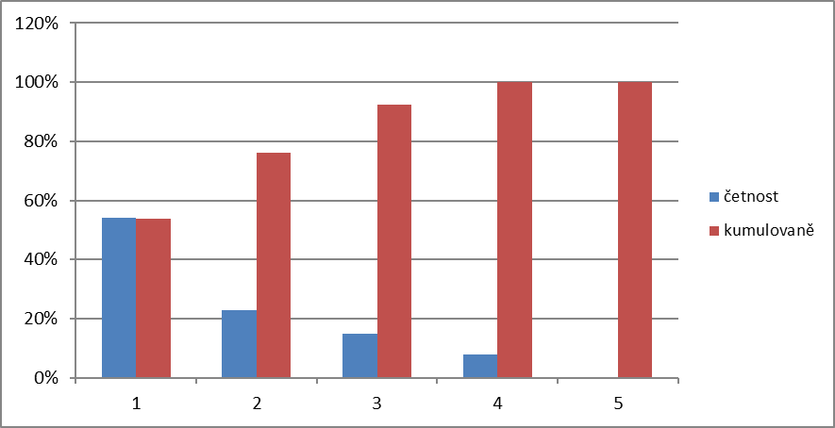
cumulative frequency
frequency
Fig. 1 Finally chart of Pareto analysis

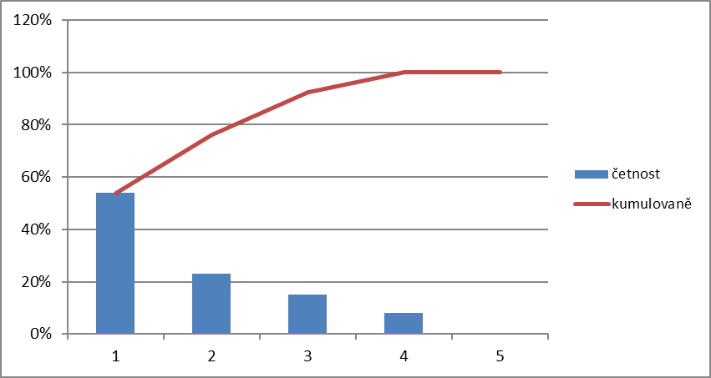
cumulative frequency
frequency
Fig. 2 Lorenz curve of Pareto analysis

Assessment of the importance of assetss by the chosen method
According to Pareto diagram can be concluded that the assets are crucial for the organization. According to the rule that 80% of the studied population is negligible and only 20% is important we conclude that the most important asset, according to the graphic expression, can include those which are rated values 1 and part value of the second (Carly 2014).
These assets include:
- technological procedures, plans and know-how (1),
- information systems unit (1),
- computer and communications services (1),
- the organization's reputation, image (1),
- hardware (computers, printers etc.) (1),
- software development tools (1),
- data (1),
- contractors (2),
- subscribers (2),
- manufactoring machineri (2).

Conclusion
In conclusion, the use of Pareto analysis is wide. For the area of information systems and security the usage of this method can be very helpful. If we are forced to make decisions quickly can the application of the Pareto analysis significantly helps. When identifying critical assets of the organization, it is necessary to use an appropriate analytical methods, which can be just Pareto analysis. Within the context of insurance, focusing on the area of cyber risks, it is advisable to use multiple methods and combine them with each other. For example, we can use fuzzy logic for futher modelling. Given that this area is not yet designed a uniform methodology for valuing information system is to use pareto analysis, one of the ways to keep their effective decisions backed by scientific method. Identification, analysis and valuation of the assets of the organization is a key activity of the entire methodical process of valuation, since the assets of the organization determine the total cost of the information system. The final amount is then used as a basis for establishing fair amount of coverage in case of realization of cyber risks in the organization (Carly 2014, Satava 2015).

Literature:
J. Carly, “10 key facts you need to know about cyber insurance, USA, 2014, Insurance cataloge, pp. 72-75.
J. Salter, “The Risk Management Society,”2013, [cit. 2017-01-04] Avilable from:https://www.rims.org/aboutRIMS/Newsroom/News/Pages/cybersurvey15.aspx.
J. Satava. “Implementation of the directive governing the physical security of the computer network in an environment of government,” Tomas Bata University in Zlín, 2015.
Johnson, B.; Laszka, A.; Grossklags, J., "The Complexity of Estimating Systematic Risk in Networks," Computer Security Foundations Symposium (CSF), 2014 IEEE 27th, vol., no., pp.325, 336, 19-22 July 2014
P. Lasak, “Pareto analysis,” 2014 [cit. 2017-02-03] Avilable from: http://office.lasakovi.com/excel/grafy/paretuv-diagram-graf/.
Pal, R.; Golubchik, L.; Psounis, K.; Pan Hui, "On a way to improve cyber-insurer profits when a security vendor becomes the cyber-insurer," IFIP Networking Conference, 2013, vol., no., pp.1,9, 22-24 May 2013
Pandey, P.; Snekkenes, E.A., "Applicability of Prediction Markets in Information Security Risk Management", 2014 25th International Workshop on Database and Expert Systems Applications (DEXA), vol., no., pp.296,300, 1-5 Sept. 2014
Sadhukhan, S.K., "Insuring Big Losses Due to Security Breaches through Insurance: A Business Model," System Sciences, 2007. 40th Annual Hawaii International Conference on System Sciences (HICSS'07), vol., no., pp.158a,158a, Jan. 2007
T. Leigh, and J. Finkle,. “Insurers struggle to get grip on burgeoning cyber risk market,” USA, Boston 2014.

Contact:
Ing. Lukáš Pavlík
Tomas Bata University in Zlin
Faculty of Apllied Informatics
Nad Stráněmi 4511, 760 05, Zlín
E-mail: lpavlik@fai.utb.cz

Brief information about the author:
Lukas Pavlík is a Ph.D. student at the Faculty of Applied Informatics, Tomas Bata University in Zlin. In his own research focuses on issues of pricing information system in the context of providing insurance against cyber risk.

