THE USE OF FINANCIAL controlling INSTRUMENTS IN A PARTICULAR COMPANY
Jana Zlámalová

Abstract
This contribution is focused on the application of selected tools for financial controlling of a specific company. Financial controlling is an integral part of the controlling system of business management. Controlling is used in companies as an efficient tool to manage individual processes in many fields. There is a special focus on the application tools of controlling in a specific company to eliminate shortages, which were discovered from the analysis of current company conditions. Another aim is to improve financial management of a company, by suitable tools of financial controlling that will develop effective management of a company.
Keywords: controlling, financial controlling, planning, analysis of deviations, reporting.
- Introduction
The level of a company relates to decision-making skills of managers. In today’s conditions, when there is huge competition in markets and dynamics of work environs puts work managers under increasing pressure. They are overloaded by tasks, have big responsibilities and demands are higher and higher. With regards to the current situation on the market, most companies are trying to secure competitive abilities. So it is necessary to be focused on rationalization of production, increasing productivity and quality of products and limitation of operations that give no value to the company. System of controlling is one of the most effective tools helping to achieve goals. Tools of controlling can, during effective implementation and correct use, eliminate weak spots and ensure effective production process. Ensuring required quality for affordable prices contributes to higher satisfaction of customers, which is base of competitiveness of every single product or provided service.
In practice controlling is often incorrectly understood as supervision. Controlling is not only supervision but it is also a system of management based on complex information and an organisation´s combination of managing and organisational and control process, where the goal is to improve and make more effective management as a unit. Controlling has that quality, that its tools are possible to be applied in every single company, when they are correctly chosen and correspond with the needs of a specific company. When correctly applied, they contribute to higher economic stability and ensuing development and better results. Another advantage of controlling is that interconnects knowledge and information of various business fields and thanks to that, it comes better orderliness, and top management has all necessary materials for correct decision making. Today controlling is already an essential part of modern management. There is a special focus on the application tools of controlling in a specific company. Aim is to improve financial management of a company, by suitable tools of financial controlling that will develop effective management of a company.
The theoretical part of the work proceeds from the analysis of today’s problematic conditions and from literary research dealing with controlling and financial controlling. Another part describes the methodology that focuses on used methods. On the basic of outline analysis and evaluation for assessment of current conditions, correct financial tools are selected. These include short term financial planning, monitoring of costs and sales, developmental trends and basic indicators of financial analysis. The piece focused on outcomes deals with the evaluation of current conditions, the application of controlling tools and an evaluation of a level of individual indicators. In the economic conclusion is the evaluation of main contributions by means of a compressive summary about financial and economic conditions of company and risks are assessed.

- Theoretical Outcomes
Nowadays as the marketing environment is constantly changing and competition is increasing, factors of company achievements are changing too. To compete, companies are using modern and flexible technologies that ensure high quality of products, flexible reaction in terms of customers’ demands communication with them and as the creation of good working conditions for their employees that will contribute to achievement of the business´s output goals or support competitiveness.
The term “controlling” is treated differently by every author different. There is no single general definition of controlling. Kerzner (2013, p. 225) sees controlling like a three-level process of measuring a progress in direction to the goal, evaluation of what is needed to be done and the taking of necessary corrective measures to achieve or exceed set goals. He sees the three following steps: are measuring, evaluating and removing mistakes.
Horváth (2003, p. 10-12) reported the system of controlling has four parts: philosophy of controlling, tools of controlling, organisation of controlling and process of controlling.
Eschenbach (2000, p. 93-94) reported the main aim of controlling is to secure the vitality of company. Secondary goals are ensuring ability of anticipation, adaptation and abilities of coordination. Eschenbach (2011, p. 40-41) in his second book adds to these secondary goals one more: ensuring the feasibility of plans.
Eschenbach (2000, p. 134, 203, 206) reported the effectiveness of controlling is higher when the controlling system is faultless, more formalized and stronger. From goals, indicators of system effectiveness are dedicated. The success of controlling is decided ty the controller that is doing the controlling and as well how the management is using it. The position of controlling is influenced also by the size of a company, the concept of controlling and the diversity of tasks and the overall system of departments. The independence of this department is always important. The controller must have the possibility to accomplish his tasks objectively and independently and must have access to company top management and be able to cooperate with them and he must have various mains of recourse. Situating controlling at highest levels in hierarchy is ideal.
Havlíček (2014, p. 77) reported financial controlling serve to continuous evaluation of financial plans and financial goals. Financial controlling is focused on aims determined in financial planning and we can differentiate it on financial strategical and financial operative controlling.
Financial controlling is understood by Chodas (2012, p. 29) as the controlling of cash flow and thus securing daily liquidity. According to her, financial controlling represents the controlling of constant and circulating assets and is divided into controlling of working capital, controlling of debts and reserves and controlling of liquidity.
A study by Rajnoha et al. (2015) concentrates on business performance management and measurement is a relatively complex and difficult process, which is currently undergoing significant changes in terms of both theory and practice. Previously used indicators, methods and models, largely based on financial indicators and methods of financial management, have been gradually modified and improved to provide owners and managers with a sufficient true and fair view of business performance. System in the company may favour the comprehensive and elaborate system of strategic planning, which further subsequently reflected in higher business performance.
Micheli & Mari (2014) is aimed at the secure long-term prosperity and company performance should be at least equal importance with which they dealt with the operational and financial problems. The need to establish links between planning, decision, action and results has generated substantial interest in the measurement of organizational performance as a performance is a notion that permeates contemporary societies, as it is used to assess the quality of individual and collective efforts.
The implementation of financial controlling is the topic of an article of Chmutova and Maskimova (2014). It speaks about the importance of the process of identification of qualitative constitution during the financial controlling, where candidates have these competences: personal (initiative, communication skills, creativity, purposefulness and responsibility); manager competences (ability to work in a team, conflict management, ability to lead people, strategic thinking, ability to plan team work and distribute rights and responsibilities and coordinate operations); specific manager skills (ability to decide in conditions of uncertainty and dynamics, analytics skills, ability to manage new trends and methods of work and use them, abilities and skills to create authorized delivery, special knowledge – theoretical solutions and recommendation of modern science with focus on implementation of controlling).
A study by Iseri-Say et al. (2008) is devoted to the issue how the adoption of management tools (the study considered the group of 25 tools) influences organizational performance. Their findings show a significant positive relationship between competitive positioning, organizational integrity, performance capabilities, customer equity, financial results and adoption of management tools and techniques.
A study by Afonina (2015) is devoted to a more balanced impression of organizational performance we used the combination of financial and non-financial outcomes. The need of non-financial measures has been mentioned in many studies. The study provides the evidence how strategic management tools and techniques can affect performance.
The research of Kruml and Duspiva (2015) between small and medium companies in the manufacturing industry in the Czech Republic show that less than two thirds of companies want to use controlling in any form. That means that here exists a space big enough for the expansion of this effective tool to small and medium companies. Secondary research that changed its analysis, evaluation and comparison of financial directions showed that companies with using controlling reach better results.
Kruml and Duspiva (2015) reported two thirds of 57 researched companies do not use financial controlling. That means that there is still enough space between small and medium companies for expansion of such an important tool for administration. Companies that use these tools reach better results in indicators like liquidity, ROE, total ration of debt to GDP and productivity of work. On the other hand, they were worse in dynamics of profit before taxation and ROA. It indicates that companies with financial controlling put emphasis on the effectiveness of management and use more leverage for higher debt; that might be related to the practical application of controlling in administration and direction and decisions of management.
Sedliaciková, Vacek and Sopková (2015) reported the level of knowledge in financial controlling as well as the execution of control in economical practice is, in general, low. From an empirical point of view, the article „How Slovak small and medium enterprises perceive financial controlling” shows that 41,9% from small and 55,2% from medium companies don’t find financial controlling and financial operating as identical fields. 11,6% small and 37,2% medium companies are engaged in financial analysis and prognosis. Methods of financial planning are executed by 9,7% of small companies and by 40% of medium companies. Inspecting operations that support economic activities with use of liquidity use 4,8% of small and 16% of medium companies. Financial regulation techniques focused on analysis and monitoring of roots of divergences in cash flow are engaged in 6,5% of small and 35,7% of medium companies.
A study by Skokan et all (2013) is aimed at the bigger companies pay more attention to strategic management and have more often prepared detailed strategy than smaller enterprises. Strategic planning is definitely reasonable activity of any company, since enterprises who did prepare detailed strategic document proved in 80 % of observed performance parameters better results than enterprises without written business plan. Enterprises who did prepare brief, partial, concise strategic document proved only in 40 % of observed performance parameters better results than enterprises without written business plan, so there is necessary to put impact on proper strategic planning in all significant business areas.
Parnell (2013), who confirms that retail SMEs with high strategic clarity will outperform those with moderate strategic clarity, but SMEs with low strategic clarity outperformed those with moderate strategic clarity.

- Methodology
Zlámalová (2016, p. 44) the tools of financial controlling have been implemented in a company that does not want to be named. This company specializes in manufacturing of specific and demanding plastic pressed parts by the squirting of thermoplastics. This company was established in year 1991 in the city of Zlin. Its legal form is Ltd. This company employs about 50 employees. The main business is repairing mechanical parts of machines for plastic manufacturing, manufacturing of plastic materials, buying goods for reselling, mediation business in fields of trade, manufacturing and services and meditation business in fields of engineering, plastic business and electro technics.
The chosen company is subjected to an analysis with the current application controlling tools both from a strategic and an operative point of view. These attributes will be evaluated: using tools for planning, comparison of plans and reality, evaluation of control process, analysis of deviations, the cause of deviations and then a proposal of measures and follow-up reporting. From the analysis of the current situation of application controlling tools of the company will emerge possibilities for improving.
Zlámalová (2016, p. 93) the purpose was to suggest the installation of chosen tools of financial controlling. The chosen financial tools for this company are indicators of financial analysis, monitoring sales growth and expenses, developmental trends, short term planning and analysis of deviations and reporting. Any increase of takings and expenses and financial analysis indicators and their development will be monitored quarterly; the development of selected indicators will be expressed graphically for better clarity. trends related to costs and profits are developmental, so we will monitor development of individual items quarterly and for easier orientation, will express it graphically with individual items compared to one another. The short term planning is composed of the sales plan, expenses and management results. These plans are created three months ahead; for first month a more detailed plan is formed. At the end the deviations are determined by discovering causations and measuring suggestions. The reporting contains discovered information from previous analysis and development.
Zlámalová (2016, p. 67) based on the economic analysis, it was found that the part of circulating property on whole actives is a little less than 80% and little less than 50% of whole assets are debts – and those primarily debts from business relations. Supplies are one fifth of the whole assets. Foreign sources create most of whole total liabilities whereas the highest parts on foreign sources have short term liabilities, or a little bit less than 40%. The share of sales from the sale of their own products and services are high, estimated at 80%. One half of total costs are created by the consumption of material and energies; the extent of this item is higher annually. Since 2012, the company has been profitable. The participation of clean working capital on circulating assets in last two years is about 50%. The debts of the company are much higher than recommended values: in year 2011, it was nearly 80% but during the years since, it has constantly decreased and now is a little bit higher than 60%. Long-term foreign sources of the total foreign sources took approximately one fifth; it shows that the company has a high percentage of short-term foreign capital. To focus on liquidity, the company achieves its recommended values only in the last monitored year. Indicators of profitability show that the company was in the year 2011 unprofitable, but for the rest of the monitored years profitable. The time of supply turnaround is between 25 to 33 days. The time of debt turnaround is more than two months and the time of liability turns around in two months. The Z-score indicator says that the company has a satisfying financial situation since year 2012. The curve of its Z- score is higher than the recommended level of 2,99. The indicator index IN reaches in the last two years values higher than the marginal value 1,6 and proves that company is creating values.

- Results
The chosen company was analysed in detail against the current application of controlling tools. In this company there is not a controlling department, nor is this company using any controlling tools for strategical or operative controlling. From a strategical point of view, the company has only formed a SWOT analysis: they know their strong and weak sides, opportunities and threats. From an operative viewpoint, the company uses tools for planning only marginally. The company is comparing data annually and as well plans of actuality only in some fields. The process of planning is not connected to the process of control, analysis of deviation, creation of their causation or follow up reporting. Data are compiled for purpose of the obligated final accounting needed for banks.
The company draws up only obligated final accounting as a balance of profit and loss report. Reports are oriented only on history and are not focused on the future of company and are drawn up quarterly. The company does not follow any indicator, like liquidity, activity, profitability, debts, etc.
The company plans on basis of arranged orders. After they receive an order, the company creates a buying plan of material, time when manufacturing begins and the process of distribution as well. Every year, the company creates a plan of sales, plan of manufacturing and a plan of supplies and that is on the basis on of arranged orders and basic data from the previous year. These plans do not serve as a basis for follow up control, but are only nominal. The company draws up reports of profits and losses quarterly and sends this document to the bank where they have their credit. Every year a plan is created and that is only with a focus on the comparison between the first plan and reality.
Another weakness is that company does not follow and does not evaluate any indicators: liquidity, rate of return, activity and debts, etc. These indicators evaluate development in time and show financial health of the company and would show weak points that need to be eliminated. The company then does not follow developmental trends of the most important items and they do not seem to care about the growth of takings and expenses in view of individual items. Another field is planning: the company creates only the most important plans, which are nominal and then do not work with them anymore: they do not analyse them, compare them, define deviations of plans and reality, look for problems or offer steps for their elimination. The most important problems following information obtained from analysis become the basis for installation of chosen tools of financial controlling.
From the analysis of the current situation of using controlling tools of company, there were identified the following critical spots of controlling in the analysis of company.
- Use of financial analysis indicators for more effective management.
- Sales and expenses growth evaluation
- Developmental trends evaluation
- Creation of Forex management proposals
- Creation of short term planning
- Analysis of deviations for better management
- Proposal and creation of regular plans and comparison with reality, analysis of deviations and proposals for improving
- Proposal of effective reporting
These deficiencies are possibility limiting the efficiency of improvement of the economic management of the company. Suitably chosen tools for this company are then stated. Stated proposals come from the actual needs of company. Into consideration is taken as well regard for the field of business, size of the company, financial situation and future development of the company. Because of the extent of the article, I focus here only on the most important ones.
The company does not look to sales and expense growth: that is the reason why I suggest treatment and evaluation of sales and expense growth development. I recommend the creation of quarterly evaluations and due to the fast rate of sales growth. Rate of sales and expense growth must be managed. During the growth of sales, assets are circulating assets and that increases pressure on financing. At the same time, fixed expenses are increasing and investment expenses as well. Unmanaged enormous growth of sales leads to the overheating of a company, which is why I suggest evaluating profit, expenses, material demands, wage demands and service demands. All these items play important parts in results of management and are connected to sales. I recommend comparing mutual connection, profitability and expense of sales and then mutual connections with material wage and service demands. I propose comparing an actual quarter with its previous quarter as well as with the same quarters of the last year – and then to create a prediction for following quarters. Predictions are based on current levels and future development. To determine the company level on basis of these indicators, I suggest reporting for easier orientation with individual indicators shown by graphs.
The company regularly checks sales and compares them year-on-year. Every year, a plan is created which is then compared to reality, but only in such a way that evaluates if all goals were achieved or not. Its purpose is only indicative. The same situation applies in the case of costs and the resulting economic activities. Results of economic activities proceed from reports of profit and loss and are checked quarterly. For this reason, I suggest creating a plan of sales, plan of costs and plan of economic activities.
Planning of sales, costs and economical activities is the basis for whole system of planning process. I suggest to create these plans three months ahead, and for the first month of the period, a detailed sales plan. The detailed plan is divided into individual products, individual items, materials, services, etc. This plan will be modified monthly. The plan of sales comes first from arranged obligations and demands of customers regarding the last period and then will be modified on the basis of future expected development of company, then competition, economic development, etc. A one-year plan of sales is divided in these items: year plan, plan of cumulative, plan for individual months and percentage of year performance for quarters. A detailed monthly plan contains the year plan, cumulative plan, month plan, and percentage for year performance of the month.
To determinate deviation, we must compare plans and reality. I suggest to compare exactly that. By this comparison, it will be shown the amount of deviation. The resulting analysis of deviation will indicate reasons of deviation and suggest actions to eliminate deviation sources. This leads to accuracy improvement in the planning process. When the toleration limit is exceeded, the deviation analysis will be executed. I suggest observing deviations from plans on the basis of determined plans. These deviations will be expressed absolutely and relatively. Form comes from monthly sales planning and is composed of the monthly plan, reality and absolute deviation as well as in relevant amounts. With the help of a plan, comparison with reality will determine the amount of absolute deviation and perceptually will be expressed the amount of relative deviation. If the deviation article exceeds the tolerance limit, the deviation analysis will be executed, when will then indicate the reason of formation, after which an action will be suggested. In following table (Tab.1), the proposal of form for analysis of plan fulfilment that comes from monthly planning of economic activities is shown. The form is divided from plans, reality, absolute and relative deviation and from tolerance deviations in relevant amounts.
Table 1 Plan fulfilment analysis (Self processing)
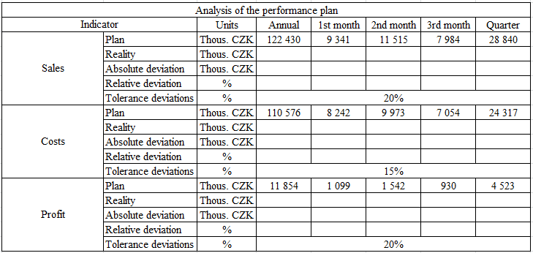
Deviation analysis will pass all items and indicators that exceeded the fixed plans. The goal of deviation analysis of real and planned values is to get information, why there was deviation and where the roots of this deviation lie. Reasons of deviation formation have various origins. Mostly, it is a change in external conditions in the market, by the competition. Another reason of deviation is wrong planning of the leading worker, who did not see all factors, possibilities and company status during the planning or else determined an unattainable goal Deviation connected with expenses and profits is created because of changes in input or selling costs or the quantity of change of sold items and products. This analysis is created quarterly. The following (Tab.2) shows determination of deviations in sales plan.
Table 2 Determination of deviations by sales plan
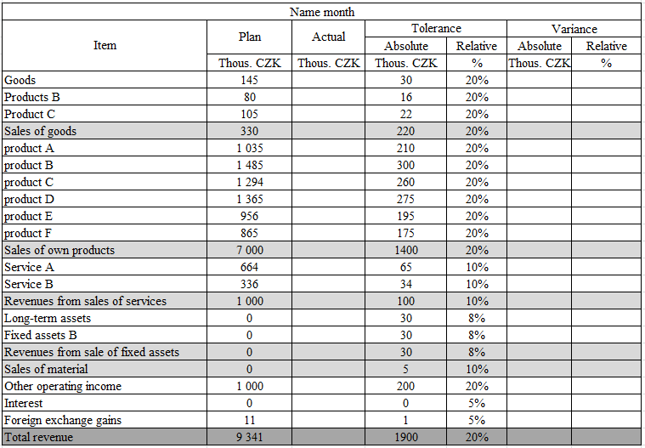

The biggest shortcoming of this company is that no one cares about watching individual indicators and their development. That is the reason why I recommend focusing on watching individual indicators: liquidity, debt, activity etc. Then I recommend focusing on sales and expense growth development in relation to individual items. The comparison of these items gives the company an overview about how the company is developing and what to focus on. Then I recommend to be focused on developmental trends of individual indicators in time, like for example sales, profit, expenses, material expenses, personal expenses, etc.
For better clarity, faster orientation and easier imagination I suggest covering into reporting as well graphical statement of selected indicators. Then there is a possibility to include into the analysis a comparison of several years, quarters or months. Mentioned reports can be customized to the various and actual needs of company in dependence on priority. A necessary part of the reports should be as well the comparison with plan and comparison with values for a comparable period in the previous year. Individual reports are of course filled with proper comments that point out on the biggest changes and unwanted developments. This comment has added information that is impossible to read from the tables or a graph. The conclusion should be a summary and emphasis on indicators and quantity, and on achieved goals and those that did not achieve required aims. And then to describe correctional rules leading to situation improvement.
Annual reporting focused on a year evaluation of development in individual indicators and items allows a compact overview for company development. Evaluated are year plan fulfilments of sales, expenses, economic activities, deviations determination and reasons of their origins, and corrective actions are made.
Quarterly reporting is created from individual items and indicators development. Evaluations of financial analysis indicators, sales and expenses growth and development trends come from their quarter development. At the same time, the current quarter is compared with previous quarters and as well with the same quarter of the previous year. Plans for fulfilment of sales, expenses, economic activities results come from monthly fulfilment. Absolute and relevant deviations are determinate and compared with tolerance deviation. When this deviation is exceeded, an analysis is made to find the root causes and corrective actions. After discovery of the new reality, plans are changed. This leads to better management and higher company effectivity.
Zlámalová (2016, p. 72- 85) in next table (Tab. 3), a development overview for indicators of financial analysis in individual years is demonstrated. Statistics that are between recommended values are highlighted by green and statistics that are out of this bound are highlighted by red.
Table 3 Financial analysis indicators development (Self processing)
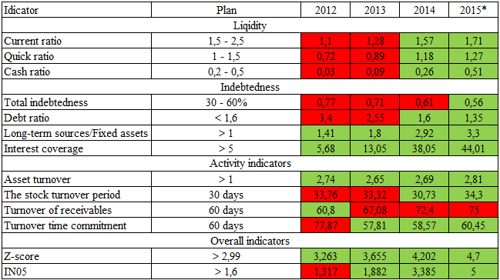

- Discussion and conclusion
The purpose of this article was to submit suggestions for improvement in the management of the company with help of selected indicators of financial controlling and to get a complex overview about company development as a unit and to create better conditions for decision making of top management.
The main benefit of this work is in the provision of whole overview about financial and economical company management, and as well as creating materials for following better decision making about the company’s future. Financial controlling tools application leads to gaining and widening of the information skills of existing information, thanks to correct analysis of the current company level and development evaluation, and thanks to correct development prediction for future external and internal environments. On that basis, a plan should be created for the following period to prevent possible additional expense and risk inception. By regular calculations of basic economic indicators and following their comparison with a plan and with time, management has a better possibility to react immediately. By following control where evaluation and comparison is made, we can isolate mistakes and eliminate shortages that are repeating themselves, and a company can get advantage against the competition. This company with help of these tools will get a lot of fully-fledged and useful information that leads to effective management, and will prove important materials for management. In the upshot, it will correct implementation of financial controlling tools expenses saving and increasing profit.
Everything has risks. These risks present themselves in every phase. It is impossible to prevent all the risks and find them in time. Some risks are impossible to easily eliminate and must be counted for future as possible risks. I find the main risk in personal field and technical and financial field. The main risk I see is the personal unwillingness to change old methods and to accept new. Possible aversion and resistance can have negative influence on the whole implementation and application of these tools. There can be an unwillingness of employees to cooperate or to help. It is important to inform all employees with new tasks about their defined duties that relate to this project and to highlight efficient benefits of them. It is needed to persuade them about the importance and meaning to their company and to themselves individually. If the company will do everything honestly, it will eliminate the risks – or it might also eliminate all risks.
It is important to understand everything, as it is a benefit for the company as a unit and as well as for top management, in that it brings valuable information for planning and decision making about company future. All the changes should be purposefully enforced and used. Risks should be prevented and eliminated so their impact is as small as possible.

References
Afonina A. (2015). Strategic Management Tools and Techniques and Organizational Performance: Findings from the Czech Republic. Journal of Competitiveness, 7 (3), 19-36 http://doi.org/10.7441/joc.2015.03.02.
Eschenbach, R., Güldenberg, S., Hoffmann, W. (2000). Controlling (1st ed.) Praha, ASPI Publishing. ISBN 80-85963-86-8.
Eschenbach, R., Siller, H. (2011). Controlling professionell: Konzeption und Werkzeuge (2nd ed.). Stuttgart, Schäffer-Poeschel.
Havlíček, K. (2014). Small business: management & controlling. Kíjv, Universitet Ukraine. ISBN 978-966-388-494-3.
Horváth, Péter (2003). Das Controllingkonzept: der Weg zu einem wirkungsvollen Controllin-gsystem. (5th ed.). München: Deutscher Taschenbuch Verlag.
Chmutova I., Maksimov M., Maryna, V. (2014). Formation of the Project Team on Introduction of Financial Controlling into Banking Activity. Business Inform. 279-285. ISSN:2222-4459.
Chodasová, Z. (2012). Corporate Controlling: management tool (1st ed.). Bratislava, Statis. ISBN 978-80-85659-70-2.
Iseri-Say, A., Toker, A., & Kantur, D. (2008). Do popular management techniques improve performance? Journal of Management Development, 27 (7), 660-677. DOI: http://dx.doi.org/10.1108/02621710810883580.
Kerzner, H. (2013). Project management: a systems approach to planning, scheduling, and controlling. (11th ed.). Hoboken, New Jersey: John Wiley & Sons.
Kruml, L., Duspiva, P. (2015) Effect of Controlling on the Economic Performance of Smes in the Czech Republic. Scientific Papers of the University of Pardubice, Series D: Faculty of Economics and Administration. 22(34), 63-74. ISSN:1211-555X.
Micheli, P., & Mari, L. (2014). The theory and practice of performance measurement. Management Accounting Research, 25, (2), 147–156. doi: 10.1016/j.mar.2013.07.005.
Parnell, J. A. (2013). Uncertainty, Generic Strategy, Strategic Clarity, and Performance of Retail SMEs in Peru, Argentina, and the United States. Journal of Small Business Management, 51(2), 215-234. http://dx.doi.org/10.1111/jsbm.12010.
Rajnoha R., Lorincová S.(2015). Strategic Management of Business Performance Based on Innovations and Information Support in Specific Conditions of Slovakia. Journal of Competitiveness, 7 (1), 3-21 http://doi.org/10.7441/joc.2015.01.01.
Sedliacikova, M., Vacek, V., Sopkova, E. (2015) How Slovak Small and Medium Enterprises Perceive Financial Controlling. Procedia Economics and Finance. 26. 82-85. doi: 10.1016/S2212-5671(15)00842-4.
Skokan K., Pawliczek A., Piszczur R. (2013). Strategic Planning and Business Performance of Micro, Small and Medium-Sized Enterprises. Journal of Competitiveness, 5 (4), 57-72 http://doi.org/10.7441/joc.2013.04.04
Zlámalová, J. (2016) The project of implementation selection of financial instruments in a particular company. Zlín. Master thesis. Tomas Bata University in Zlín, Faculty of Management and Economics, Department of Business Economics. Supervisor of Master thesis Petr Novák.

Contact Information
Ing. Jana Zlámalová, MBA
Tomas Bata University in Zlin
Faculty of Management and Economics
Mostni 5139, Zlin, 760 01
E-mail: jzlamalova@fame.utb.cz

