Electromagnetic, magnetorheological and stability properties of polysiloxane elastomers based on silane–modified carbonyl iron particles with enhanced wettability
Martin Cvek^{1,2}, Robert Moucka¹, Michal Sedlacik^{1*}, Vladimir Pavlinek¹
¹Centre of Polymer Systems, University Institute, Tomas Bata University in Zlin, Trida T. Bati 5678, 760 01 Zlin, Czech Republic
²Polymer Centre, Faculty of Technology, Tomas Bata University in Zlin, Vavreckova 275, 760 01 Zlin, Czech Republic
*corresponding author: msedlacik@utb.cz

Abstract
Soft carbonyl iron (CI) particles were successfully modified with a thin layer of tetraethoxysilane (TEOS) to enhance the wettability of their surface in hydrophobic media. The contact angle investigations and tensiometric analysis revealed and helped quantify the significantly enhanced wettability and, thus, the better interfacial adhesion of the TEOS–coated CI particles (CI–TEOS) with the non–polar siloxane–based materials. Therefore, stable magnetorheological elastomers (MREs) based on CI–TEOS particles and polydimethyl siloxane matrix were fabricated. The prepared composites had different particle loadings and microstructural characteristics: isotropic and anisotropic. These structural differences were confirmed by scanning electron microscopy and were found to considerably affect dielectric properties of the MREs due to various charge transport mechanisms within the particle clusters. Furthermore, the magnetorheological (MR) performances of isotropic MRE variants were analysed before and after exposure to acidic environment. After the corrosion test, the MRE based on bare CI particles exhibited dramatically decreased relative MR effect and mechanical properties when compared with its analogue containing CI–TEOS.

Keywords
magnetorheological elastomers, smart materials, particle coating, anisotropy, chemical stability

- Introduction
Magnetorheological elastomers (MREs) have recently drawn much attention due to their desirable properties and versatile fields of application [1-3]. Similar to their predecessors, i.e., magnetorheological (MR) fluids [4], they also exhibit the MR effect, but their benefits stem from their stability against particle sedimentation. Moreover, MREs possess certain mechanical properties even in the absence of an external magnetic field. These characteristics make them attractive for use in applications, such as vibration absorbers, sandwich beams, artificial muscles, or even electromagnetic shielding materials [3, 5-7].
An overwhelming majority of MREs are based on carbonyl iron (CI) particles [7-10] due to their suitable size and magnetic properties. However, there have been reported problems with respect to the oxidation of the iron particles [11]. The fillers incorporated in the matrix are not directly exposed to air, but moisture and oxygen can penetrate into the matrix. The process is accelerated at higher temperatures. These hygrothermal effects reduce the strength between the particles and the elastomeric matrix [8], which leads to lower performance of the MREs. In the development of MREs, attention is primarily paid to study different particle concentrations, particle sizes, or different matrices [9, 10, 12]. However, the basic presumption of particle wettability with the matrix is frequently overlooked, and the number of articles devoted to this phenomenon is limited. Nevertheless, the particle wettability and, thus, their adhesion to a matrix play a key role in efficient interfacial damping in MREs. The incompatibility of the inorganic particles and the matrix may lead to poor particle wettability, adhesion, dispersibility and ultimately to low energy absorption during loading [13, 14]. To eliminate this drawback, Li et al. [15] encapsulated the CI particles with poly(methyl methacrylate) via an emulsion polymerization. The use of their particles enhanced the bond strength between the particles and the silicone rubber matrix eventually resulting in a larger storage modulus of the MREs. Recently, Pickering et al. [14] used bis-(3-triethoxysilylpropyl) tetrasulphane (TESPT) to modify the surface of the iron sand particles. Having assessed the optimum amount of the TESPT for use in the MREs, they concluded that TESPT–treated particles also exhibited improved interfacial adhesion with natural rubber matrix.
However, in the MRE fabrication, the suitability of the particles has not yet been qualitatively described. Therefore, there is a need to implement a technique that will enable the determination of particle wettability with the corresponding matrix and, thus, the quality of the adhesion. A similar topic was successfully solved by Sedlacik et al. [16] in the development of MR suspensions in which particle compatibility with a carrier liquid was reflected in the suspension stability. They evaluated the surface free energy of the particles using capillary rise experiments based on the Washburn method and further computed the particles’ dispersive and polar components revealing the particle compatibility with silicone oil.
Here, we have adopted a similar approach, and together with the preparation of stable CI particles coated with tetraethoxysilane (TEOS), we qualitatively described the particle wettability with the siloxane–based matrix using tensiometric measurements. The CI–TEOS particles were incorporated into the polydimethyl siloxane (PDMS) matrix, and two variants of the MREs were prepared: with homogenously dispersed particles (isotropic, I–MRE) and with particles aligned into columnar structures (anisotropic, A–MRE). Due to different microstructures, the MREs were assumed to have different transport properties, which were analysed using dielectric relaxation spectroscopy (DRS). The transport properties are crucial for various practical applications of the MREs such as electromagnetic shielding applications [7]. In addition, the influence of acidic environment on the MR performance of the I–MRE variants was investigated and properly discussed.

- Experimental
2.1. Materials
All materials were used as received. The CI particles (SL grade) purchased from BASF (Germany) were used as a magnetic filler. The elastomer matrix was based on a commercially available two–component PDMS Sylgard 184 elastomer kit, which was obtained from Dow Corning (USA). Both components were mixed at a weight ratio of 20 (base); 1 (curing agent) to achieve a suitable matrix for the composites. PDMS was deliberately chosen as an appropriate matrix due to its good elasticity and high heat resistance. The modification agent tetraethoxysilane (TEOS, 98%) was purchased from Sigma–Aldrich (USA). Testing liquids for the surface free energy evaluation, namely ethylene glycol (C₂H₄(OH)₂, anhydrous, 99.8%), chloroform (CHCl₃, anhydrous, ≥99%), and n–hexane (C₆H₁₄, ≥99%) were also supplied by Sigma–Aldrich (USA). Hydrochloric acid (HCl, ACS reagent, 37%), toluene (p.a.), acetone (p.a.), and ethanol (p.a.) were purchased from Penta Chemicals (Czech Republic).

2.2. Modification of the CI particles
The CI particles (100 g) were treated with 0.5 M HCl (250 mL) for 10 minutes, which is similar to methods presented elsewhere [17]. Then, the particles were thoroughly washed with distilled water (5 times, 300 mL each), ethanol (3 times, 150 mL each), and acetone (3 times, 100 mL each) and were separated using a decantation method with a permanent magnet to accelerate particle sedimentation. Cleaning and washing procedures were adopted from [18]. Subsequently, the particles were dried (5 hours, 60 °C, 50 mbar) and then (90 g) dispersed in toluene (300 mL). The mixture was refluxed at 110 °C for 6 hours in the presence of an appropriate amount of TEOS. Finally, the modified particles were washed using toluene (3 times, 100 mL each), ethanol (3 times, 150 mL each), and acetone (3 times, 100 mL each) and were then dried (5 hours, 60 °C, 50 mbar).

2.3. Particle characterization
Scanning electron microscopy (SEM) was used to thoroughly examine the particle distribution, the particle microstructure, and the particle/matrix adhesion in the fabricated MREs using a desktop SEM (Phenom Pro, Phenom–World, Netherlands). The presented micrographs were taken at a 5 kV accelerating voltage using a secondary electron detector. To prove the presence of the TEOS layer on the CI substrate, Fourier transform infrared spectroscopy (FTIR) was performed using a Nicolet 6700 (Thermo Scientific, USA) in the attenuated total reflectance (ATR) mode. The absorbance, A, dependence on the wavenumber, ν, was taken in a typical range of 3600–700 cm^{–1} using a Ge crystal. For each measurement, 64 scans per spectrum were accumulated with a spectral resolution of 2 cm^{–1}. The densities of bare CI particles and their TEOS–coated analogues were obtained with a help of a gas pycnometer using nitrogen as a medium (UltraFoam 1200e, Quantachrome Instruments, Germany). Magnetization, M, responses of bare CI and the CI–TEOS particles to an external magnetic field in the range of ±10 kOe (±780 kA·m^{–1}) was investigated at an ambient temperature using vibrating–sample magnetometry (VSM, Model 7404, Lake Shore, USA). The vibration frequency was set to 82 Hz, whereas the amplitude of the vibration was 1.5 mm.

2.4. Contact angle investigation and surface free energy determination
Bare CI as well as CI–TEOS powders were compressed into pellets (diameter of 13 mm, thickness of ~1 mm) using a laboratory hydraulic press (Trystom Olomouc, H-62, Czech Republic) with a force of 50 kN. The contact angle (CA) determination was performed using the static sessile drop method carried out on a Surface Energy Evaluation system equipped with a CCD camera (Advex Instruments, Czech Republic) under laboratory conditions (temperature of 23 ± 1 °C, relative humidity of 62 ± 1 %). A droplet (5 μL) of silicone elastomer (uncured) was carefully dripped onto the surface of the pellet and the CA value was recorded. The presented CA results are the average values with standard deviations calculated from 10 independent measurements.
Further, the total surface free energy, γ, which is a factor describing the ability of a material to be wetted was analysed. This quantity can be expressed as the sum of two components: a dispersive term (superscript D), which also includes van der Waals interactions, and a polar term (superscript P) including the dispersive forces, such as the Debye or hydrogen–bond interactions [16]. The surface energy of a solid, γ_{S}, can further be determined from the contact angle data (obtained from γ evaluation) using the Owens–Wendt–Rabel–Kaeble (OWRK) theory. A comprehensive description of the OWRK theoretical aspects can be found elsewhere [16, 19].
The γ was determined using capillary rise experiments through the wetting rate of the powder investigated by the testing liquid (of surface energy γ_{L}). Three testing liquids with known physical properties were used (Table 1). The wettability was evaluated using Washburn’s method due to its suitability (e.g., reliability) for powder materials [20, 21]. The examined powders (3 g) were loaded into a glass cylindrical cell (inner diameter of 8 mm), which was attached to the electronic balance of a tensiometer (Krüss K100 MK2/SF/C, Hamburg, Germany). The speed of the packed cell into the given testing liquid was set to be 7 mm·min^{–1}. The testing liquid wetted the powder bed through a capillarity mechanism once the bottom of the cell with the loaded sample touched the surface of the liquid. For the calculations, it was assumed that n–hexane is a perfect wetting fluid with a contact angle of 0°.
To obtain reproducible data, the uniformity of the powder packing was considered. Non–uniform packing can lead to a variation in the effective pore size and can affect the geometric factor of the packed powder [20]. Therefore, considerable effort was spent to load the samples into the cell as identically as possible. To ensure the reliability of the data, the measurements were performed three times with each testing liquid. A constant temperature of 25 °C was maintained during the experiments with a heating/cooling circulator.

Table 1. The basic physical properties of the liquids (at 25 °C) used in the capillary rise experiments ª
Liquid | Viscosity (mPa·s) | Density  (g·cm^{–3}) | $$γ_{L}^{P}$$  (mN·m^{–1}) | $$γ_{L}^{D}$$  (mN·m^{–1})
Water | 1.002 | 0.998 | 52.2 | 19.9
Ethylene glycol | 20.810 | 1.109 | 16.8 | 30.9
Chloroform | 0.568 | 1.483 | 1.6 | 25.9
n–Hexane | 0.326 | 0.661 | 0.0 | 18.4
ª values were adopted from the tensiometer Krüss K100 software LabDesk 3.2.2.

2.5. Preparation of MREs
The representative samples containing 30 and 60 wt.% of the corresponding particles (~5.1 and ~15.7 vol.% of bare CI, and ~5.3 and ~16.3 vol.% of CI–TEOS, respectively) were prepared by mixing (10 minutes) appropriate amounts with the Sylgard base and the curing agent. Subsequently, the homogeneous mixture was outgassed at 10 mbar for 15 minutes at 20 °C. Then, the suspension was casted into a circular PTFE mould with a diameter of 30 mm and a thickness of 1.2 mm. The different spatial distribution of the particles was achieved by curing the systems in the presence of magnetic field (A–MRE) or without an external magnetic field (I–MRE). One specimen of each MRE variant (differing either in microstructure or particle loading) was prepared for the testing. During preparation of the A–MREs, the mould was situated in an electromagnet, and the whole assembly was placed into an oven pre-heated at 60 °C. The optimal curing time was determined as described in the Electronic Supporting Information (please see Figure S1). The true magnetic field (parallel to the sample thickness) in the mould was determined with a teslameter (Magnet-Physik, FH 51, Dr. Steingroever GmbH, Germany) and was found to be 250 mT. The I–MREs were cured under the same conditions without using the electromagnet. Finally, as–prepared samples were sealed into vessels and left to cool in a desiccator. The discoid samples with a 20-mm diameters used in the electromagnetic as well as the rheological measurements were cut out from prepared sheets using a manual press.

2.6. Electromagnetic properties
The dielectric properties of prepared MREs were obtained using DRS by means of an Alpha A high–performance frequency analyser (Novocontrol Technologies, Germany) in a frequency range from 0.1 Hz to 10 MHz. The prepared discoid samples of 20 mm in diameter and 1.2 mm in thickness were placed into a parallel plate capacitor with two gold–plated electrodes. The frequency, f, scans of the relative permittivity, $ε'$, and the dielectric loss factor, $ε"$, were investigated over a wide temperature range from –150 °C to 100 °C in 10 °C steps. The temperature was controlled with liquid nitrogen using a Quatro Cryosystem.

2.7. Magnetorheological activity
A rotational rheometer (Physica MCR 502, Anton Paar GmbH, Austria) connected to a magneto-cell (MRD 170/1T) was utilized for the MR measurements. The MCR 502 was equipped with a parallel–plate geometry (PP 20/MRD/TI) having a 20-mm diameter, and the prepared composites were accurately placed between the plates. The oscillatory measurements were performed within a magnetic field strength, H, in a range from 0 to 860 kA·m^{–1} at a constant temperature of 25 °C maintained using a Julabo (FS-18, Germany) temperature–controller. The dynamic properties of the prepared MRE samples were studied in the linear viscoelastic region (LVR) defined for the MR measurements. To ensure that all of the data fall into the LVR, the measurements were carried out using the strain amplitude of 0.2 % at a fixed frequency of 5 Hz. The assessment of the MR performance of the MREs is a complex phenomenon, and currently there are several techniques that can be considered. (i) A direct determination of the viscoelastic moduli is the simplest and the most common method [9, 22-24], which includes only one sweep measurement of the MR properties. (ii) The second approach involves the measurement of one sample various times because the time pre–configuration of the MRE to a magnetic field ultimately affects its performance [25]. (iii) The most recent method takes measurements in ascending/descending magnetic fields, as the MREs exhibit hysteresis behaviour. It is known, that using this method, the dynamic modulus saturates after several cycles of shear loading, and hence the stable dynamic properties can be obtained [26]. The last–mentioned technique was used in this study, and the dependences of G' and G" on the applied H were investigated. After each measurement, a demagnetization cycle to measure the geometry was performed. To avoid slipping between the MRE sample and the PP20 geometry, an initial normal force of 1 N (perpendicular to sample) was applied.

2.8. Stability properties
Besides enhancing the particle/matrix wettability, the TEOS coating was chosen in order to enhance the resistance of the particles against an acidic environment. To accelerate the corrosion process, the discoid samples of the MREs were exposed to 10 mL of aqueous solution of HCl acid (5M) for 3 days at laboratory conditions. After the tests, the samples were thoroughly rinsed with ethanol (50 mL) and dried at mild conditions (35 °C, 24 hours). Finally, the MR activity of as–treated MREs was investigated as described in paragraph 2.7., and compared with the initial MR performance before the chemical treatment.

- Results and discussion
  - TEOS coating characterization
The FTIR spectra of the particles under investigation were compared to prove the presence of the TEOS coating. As seen in Figure 1a, the spectrum of bare CI showed no distinct absorption bands due to its chemical composition. However, the spectrum of the CI–TEOS particles exhibited patterns typical for siloxane materials (Figure 1b). The peak at 1254 and the intensified band occurring at 813 cm^{–1} were assigned to Si–C bonds typical for organosilicon compounds. A broad peak at 1110 cm^{–1} was attributed to the antisymmetric stretching of the Si–O–Si groups while the increased absorption levels at 1007 cm^{–1} was matching with the Si–O bonds. The results are in a good agreement with those presented by Sedlacik et al. [7] successfully demonstrating the coating process.
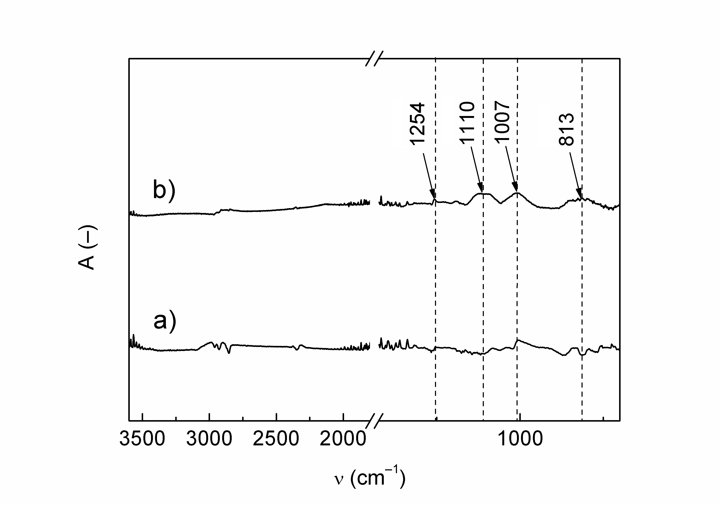
Figure 1. FTIR–ATR spectra of the bare CI particles (a) and their TEOS–coated analogues (b).

  - Magnetic properties and particle density
The application of the polymer coating on the CI particle surface can enhance both thermo–oxidative and chemical stabilities [18]. However, it is necessary to preserve sufficient magnetization, M, of the CI because the coating materials are mostly non–magnetizable. Therefore, the magnetic hysteresis loops of the CI before and after the coating procedure were investigated, as shown in Figure 2. As expected, M decreased due to TEOS coating. Although the silanization method through the self–assembly of the TEOS does not allow for the direct control of its thickness, and the decrease in the magnetization was negligible, which implies the thickness of the overlayer was of a nanometre scale, which also corresponds to particle densities that decreased only slightly from 7.79±0.10 g·cm^{–3} to 7.46±0.09 g·cm^{–3} due to TEOS modification. Therefore, it can be asserted that the molar ratios of the reactants and the reaction conditions were chosen appropriately. Both materials also exhibited almost hysteresis–free character, indicating a fast and complete demagnetization process.

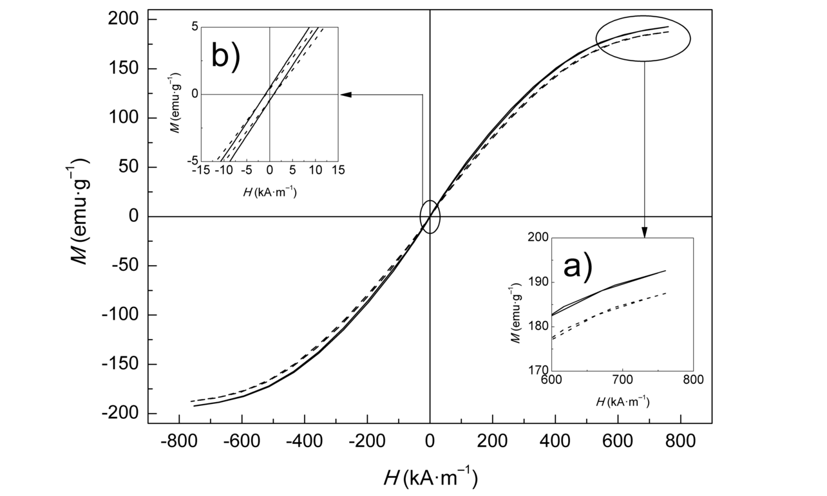
Figure 2. VSM results of the bare CI (solid lines) and their TEOS–coated analogues (dashed lines). The inset (a) illustrates the particle magnetizations at high fields (600–780 kA·m^{–1}), whereas the inset (b) shows a detail of the hysteresis of studied samples.

  - Wettability of the particles with the matrix
The CA as an indicator of the particle wettability was investigated using the static sessile drop method. Figure 3 displays the side-views of Sylgard base droplets on the pellets consisted from the investigated materials. The average CA value of (85.1±5.7)° was obtained for bare CI particles, while their TEOS–modified analogues exhibited CA value of (59.7±6.2)°. The results clearly showed the enhanced wettability of modified particles in hydrophobic media. Therefore, improved compatibility of the MRE based on CI–TEOS is expected.
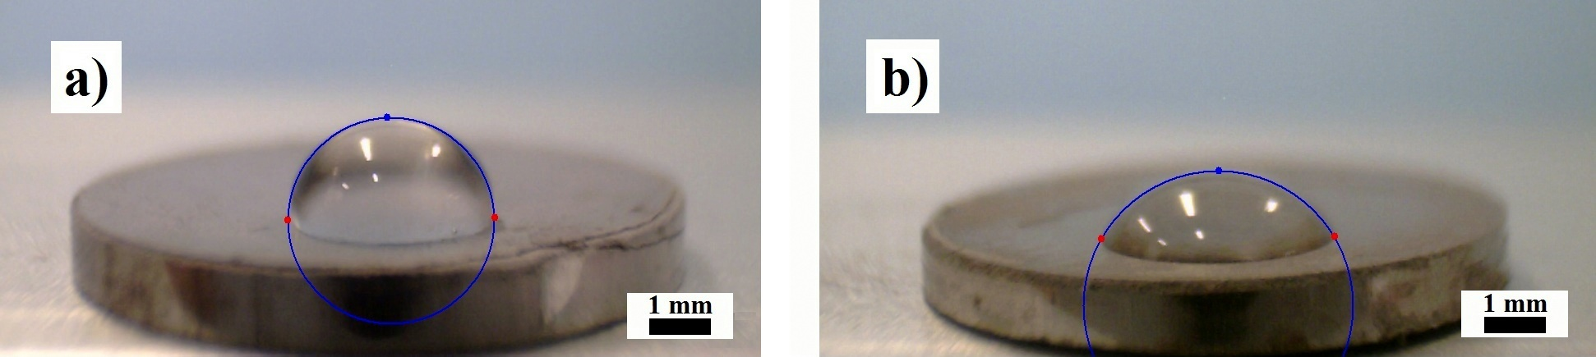

Figure 3. Sessile droplets of dimethyl siloxane on the compressed pellet of bare CI (a) and CI–TEOS (b) with denoted shape lines.

The surface free energies of the bare CI particles and their TEOS–coated analogues were determined using capillary rise experiments and the Washburn method. The overall results for both tested powders are summarized in Table 2. The coated particles exhibited a greater contact angle in water indicating their enhanced hydrophobicity. Moreover, due to the presence of the TEOS layer, γ decreased whereas its dispersive component significantly increased. Recently, it has been shown on similar material systems [16] that the dispersive part of γ predominantly influences the particle wetting in non–polar materials. Therefore, these results suggest enhanced dispersibility and better wetting of the CI–TEOS particles with the uncured PDMS matrix material during the preparation of the MREs ultimately resulting in their improved particle/matrix interface properties.

Table 2. Contact angle values, total surface free energies, and their individual components for bare CI and their TEOS–coated analogues.
Sample code | Contact angle (°) |  |  | $γ$  (mN·m^{–1}) | $γ_{S}^{P}$  (mN·m^{–1}) | $γ_{S}^{D}$  (mN·m^{–1})
Sample code | H₂O | C₂H₄(OH)₂ | CHCl₃ | $γ$  (mN·m^{–1}) | $γ_{S}^{P}$  (mN·m^{–1}) | $γ_{S}^{D}$  (mN·m^{–1})
bare CI | 66.5 | 63.1 | 55.4 | 34.4 | 27.2 | 7.2
CI–TEOS | 90.0 | 65.1 | 61.0 | 20.9 | 8.4 | 12.5

  - Microstructure evaluation of the MREs
The microstructural characteristics of the prepared MREs were studied on the I–MRE samples based on 60 wt.% of the magnetic filler. As shown (Figure 4a, 4b), bare CI particles exhibited poor dispersibility in PDMS matrix with a tendency to form aggregates due to attraction forces as a result of their incompatibility with the matrix, when compared with the MRE based on the TEOS–coated particles.
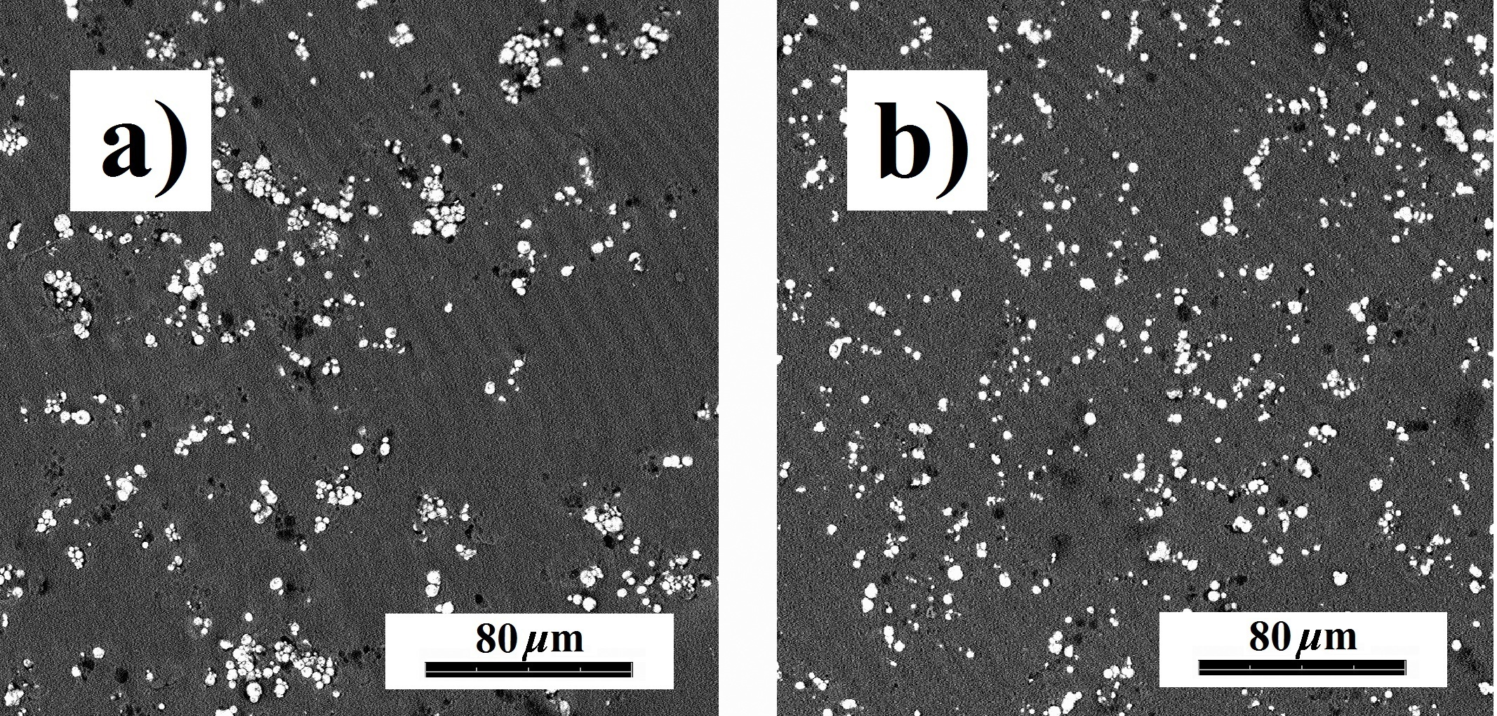
Figure 4. SEM images of the I–MREs based on 60 wt.% of bare CI particles (a) and CI–TEOS particles (b).
Figure 5 shows the SEM of the freeze–fractured surface images of the MREs based on 60 wt.% CI–TEOS particles. From picture, the different fabrication conditions are observed to result in different microstructures. A random distribution of particles can be observed in Figure 5a proving the isotropic character of the I–MRE sample. Conversely, the columnar structures of the aligned particle segments parallel to the magnetic field direction are noticeable in the A–MRE as expected (Figure 5b). The effect of different microstructure on dielectric properties was investigated as presented further in text (Section 3.5).
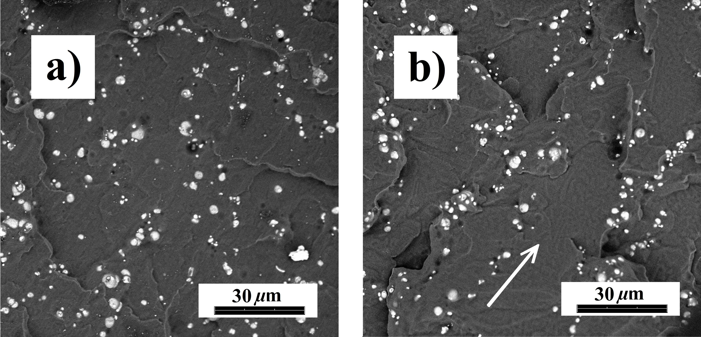
Figure 5. SEM images of the I–MRE (a) and the A–MRE (b) based on 60 wt.% CI–TEOS particles. The arrow shows the magnetic field direction during the curing process.

  - Dielectric relaxation spectroscopy
Dielectric relaxation spectroscopy was used to study different microstructures of the fabricated MREs for the first time in the area of these smart systems. The results are presented in the electric modulus formalism for the sake of comprehensibility as the MREs based on 60 wt.% CI–TEOS particles exhibited considerable dielectric losses due to substantial contribution of direct current (DC) conductivity. The complex electric modulus,$M^{*}$, is defined as the inverse of the complex permittivity, $ε^{*}$, and is the preferred quantity when describing systems with DC conductivity to suppress dielectric losses.
The measured data were displayed as a set of frequency dependencies of M" with a separate curve for each measured temperature (Figure 6). Thus, each observed relaxation process is manifested a as a peak shifting with temperature to higher frequencies. Prior to the description of the relaxation mechanisms inherent to the investigated systems, let us note that all of the samples showed artefact in the form of electrode polarization at high temperatures and low frequencies, which was not taken into consideration.
All investigated MREs exhibited a relaxation related to the glass transition the PDMS matrix used [27] represented by a very broad peak (apparent in Figure 6a, 6b) in the temperature region from –120 to –90 °C, and the temperature dependence is well described by the Vogel–Fulcher–Tammann equation [28].

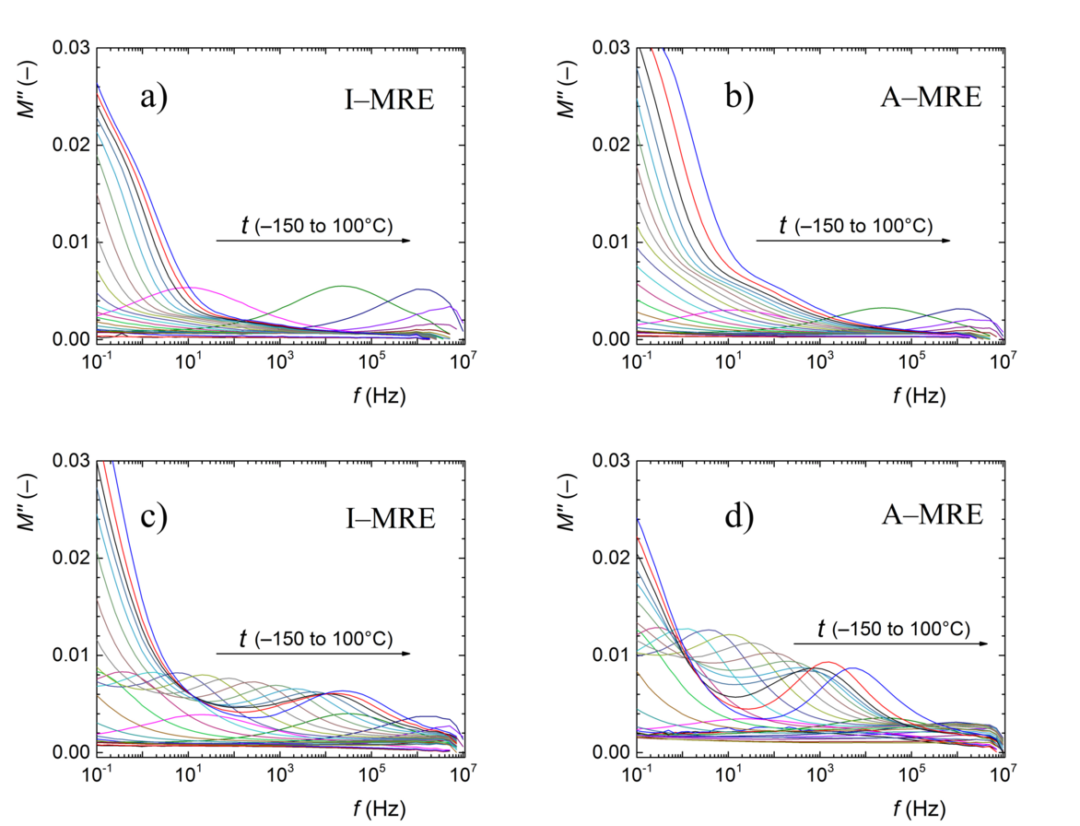
Figure 6. Electric loss modulus,$M''$, versus frequency, f, for the MREs with different microstructures based on 30 wt.% (a, b) and 60 wt.% (c, d) CI–TEOS particles.

Due to the presence of the embedded CI–TEOS particles in the MRE, an additional relaxation processes appeared, which can be linked to the interfacial polarization at the particle/elastomer matrix interface. Another relaxation occurring in the studied systems was a process related to the charge transport among the filler particles, which is most often achieved by a mechanism of variable–range hopping (VRH), which is typical in materials with electrically conductive fillers [29-31]. This phenomenon was presented because filler particles are, at low volume fractions generally separated, and thus, the conditions for ohmic contact are not fulfilled. The above mentioned process is manifested by additional peak registered in a region of low frequencies and high temperatures, which is present only for the MREs based on sufficient CI–TEOS loading, i.e., 60 wt.% (Figure 6c, 6d). The relaxation process in A–MRE slightly but distinctly differed from its isotropic counterpart as can be clearly seen in the relaxation map plot (Figure 7). Both recorded processes followed the Arrhenius law:
 | $$f=f_{0} exp\left(-\frac{E_{a}}{kT}\right)$$ | (1)
where f is the frequency, f₀ is a pre–exponential factor, E_{a} represents an activation energy, T is the absolute temperature and k is the Boltzmann constant.
This indicates a β–relaxation process appearing during the charge hopping among the individually separated CI–TEOS particles. However, the different microstructure of the MREs based on 60 wt.% of the CI–TEOS particles resulted in a different extracted process E_{a}. The E_{a} of the A–MRE was only ~0.79 eV compared with ~0.93 eV for the I–MRE. This finding indicates that the observed relaxation process in the MREs indeed corresponded to the charge transport particularly the VRH with the E_{a} representing the average barrier height that a charge has to overcome during its transport. In the case of A–MRE, the average distance among the particles was lower because the particles were preferentially organized into columnar structures due to the applied magnetic field (Figure 5), which resulted in a reduction in E_{a} by approximately 15%.
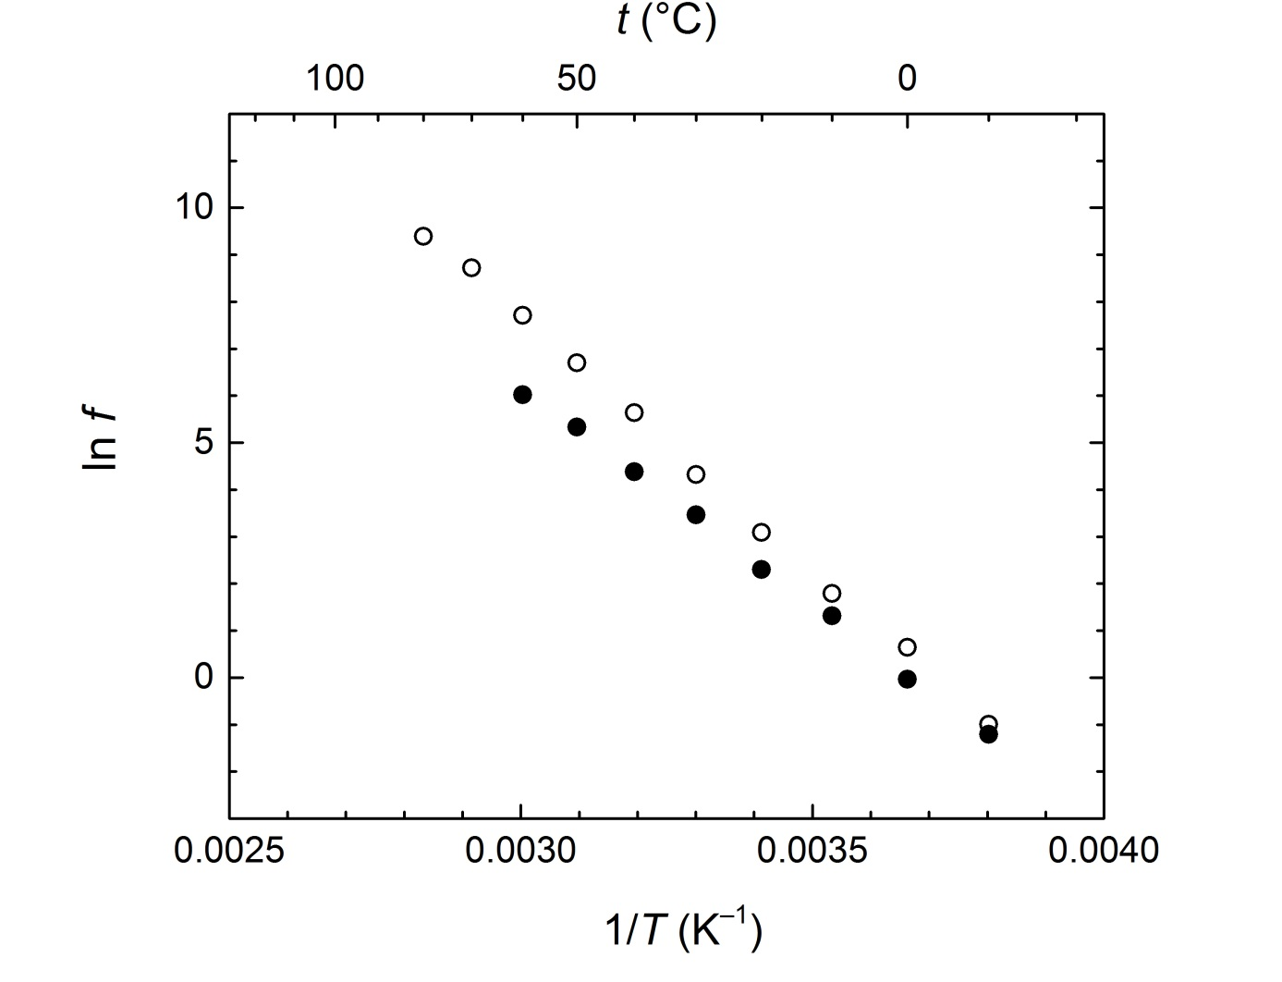
Figure 7. Relaxation map (Arrhenius plot) for the I–MRE (open circles) and the A–MRE (solid circles) both based on 60 wt.% CI–TEOS particles.

This interpretation also explains the dielectric spectra of the MREs based on 30 wt.% CI–TEOS particles in which the distance among the filler particles is overly large for the charge transport based on the VRH mechanism. Therefore, the DRS spectra of these samples yielded no distinct corresponding relaxations (Figure 6a, 6b). The results also imply a suitable particle dispersibility and no local particle cluster formation as the β–relaxation process was indistinguishable in these systems.
Successful use of DRS for determining not only particle loading but also changes in the microstructure of the MREs turns this technique into a powerful tool for studying the transport properties in these materials, which are crucial for the electromagnetic applications of the MREs, such as radio–absorbing materials [7].

  - Magnetorheology
The performance of the MREs in magnetic fields is strongly dependent on the content of the embedded magnetic particles [6]. Therefore, from a practical point of view, the MREs based on 60 wt.% CI–TEOS particles appear to be advantageous [8] and, thus, were subjected to MR characterization. The samples based on this concentration were analysed in magneto–sweep tests with ascending/descending magnetic fields (denoted by the arrows) to obtain stable dynamic MR properties. As seen in Figure 8a, the G' of the neat matrix was independent of the applied magnetic field strength, H. This can be explained as a consequence of the absence of the magnetic filler. Further, the G' of the neat matrix was significantly less than that of the MREs comprising magnetic particles, which indicates that the particles exhibited strong adhesion to the matrix, and thus, they possessed a reasonable reinforcing effect [32]. Generally, both MREs demonstrated an increasing G' when increasing H, however, the MRE based on bare CI exhibited the higher G' values since the hydroxyl groups on the CI surface most likely reacted with silane groups of the curing agent, which led to covalent particle/matrix bonding as was explained recently [23, 33]. The TEOS coating restricted the covalent bonding between the particles and the matrix, and despite the enhanced wettability the MRE based on CI–TEOS particles exhibited lower G' values when compared with that based on bare CI. The performances of both I–MRE variants are summarized in Table 3 together with their relative MR effect, e, defined as:
 | $$e=\frac{G_{H}^{'}-G_{0}^{'}}{G_{0}^{'}}×100 \%$$ | (2)
where $G_{0}^{'}$ is the off–state storage modulus , and $G_{H}^{'}$ denotes the maximum on–state storage modulus (obtained at H = 860 kA·m^{–1}). The MRE based on CI–TEOS particles with enhanced wettability was characterized by slightly higher MR effect since the absence of covalent particle/matrix bonding increased the movement of magnetic particles due to lower composite stiffness [34].
However, the undisputable advantage of the TEOS coating stems from its ability to preserve sufficient MR effect even after exposure to concentrated acidic environment. The both samples exhibited decreases in their mechanical properties and also relative MR effects after the chemical treatment. However, as seen in Table 3, the MRE based on CI–TEOS particles was characterized by only slightly decreased G' and still sufficiently high MR effect. On the contrary, the MRE based on bare CI exhibited drastically decreased G', as well as substantial loss of the relative MR effect become apparent. These phenomena occurred due to the degradation of the magnetic particles as a result of the exposure to acidic environment, which led to decreased particle/matrix adhesion and a loss of magnetic properties [16, 35]. Interestingly, the G' of the MRE based on bare CI was lower when compared to G’ of neat matrix, thus the corroded particles lacked the reinforcing effect and acted rather like the microcavities reducing the mechanical properties [33].
Figure 8b shows the dependence of the loss modulus, G", on the applied H. This quantity in both MREs followed the trends of G' dependences as it increased with H, which can be explained as a consequence of the field–induced magnetic filler network formation [26]. The enhanced G" represented the energy dissipation caused by the interfacial slipping between the magnetic particles and the matrix [25]. Sorokin et al. [26] further presumed that possible rupture of the polymer segments may result in a huge increase in G". However, this phenomenon was not observable in the neat matrix behaviour due to the absence of the particles. The MRE based on bare CI exhibited higher G" when compared with the one based on CI–TEOS, as the bare CI particles were covalently bonded to matrix which was reflected in higher stress transfer [32]. After the corrosion test, the situation was completely different and the MRE based on CI–TEOS particles was characterized by sufficiently preserved G" because these particles were better protected against acid due to TEOS coating.
Chemical stability of the MREs is the essential prerequisite for their practical applications, and the TEOS coating appears to be suitable for enhancing the particle wettability with PDMS matrix and at the same time protecting the CI particles against acidic environment leading to the MREs with higher MR effect, stability and durability.

Table 3. The off–state, $G_{0}^{'}$, and on–state, $G_{H}^{'}$, moduli of the fabricated I–MREs and their relative MR effects, e, before and after the corrosion test.
Initial properties
filler for the MRE | $G_{0}^{'}$ (kPa) | $G_{H}^{'}$ (kPa) | e (%)
bare CI | ~274 | ~392 | ~42.8
CI–TEOS | ~180 | ~281 | ~56.2
Properties after corrosion tests
bare CI | ~65 | ~84 | ~29.6
CI–TEOS | ~133 | ~194 | ~45.6
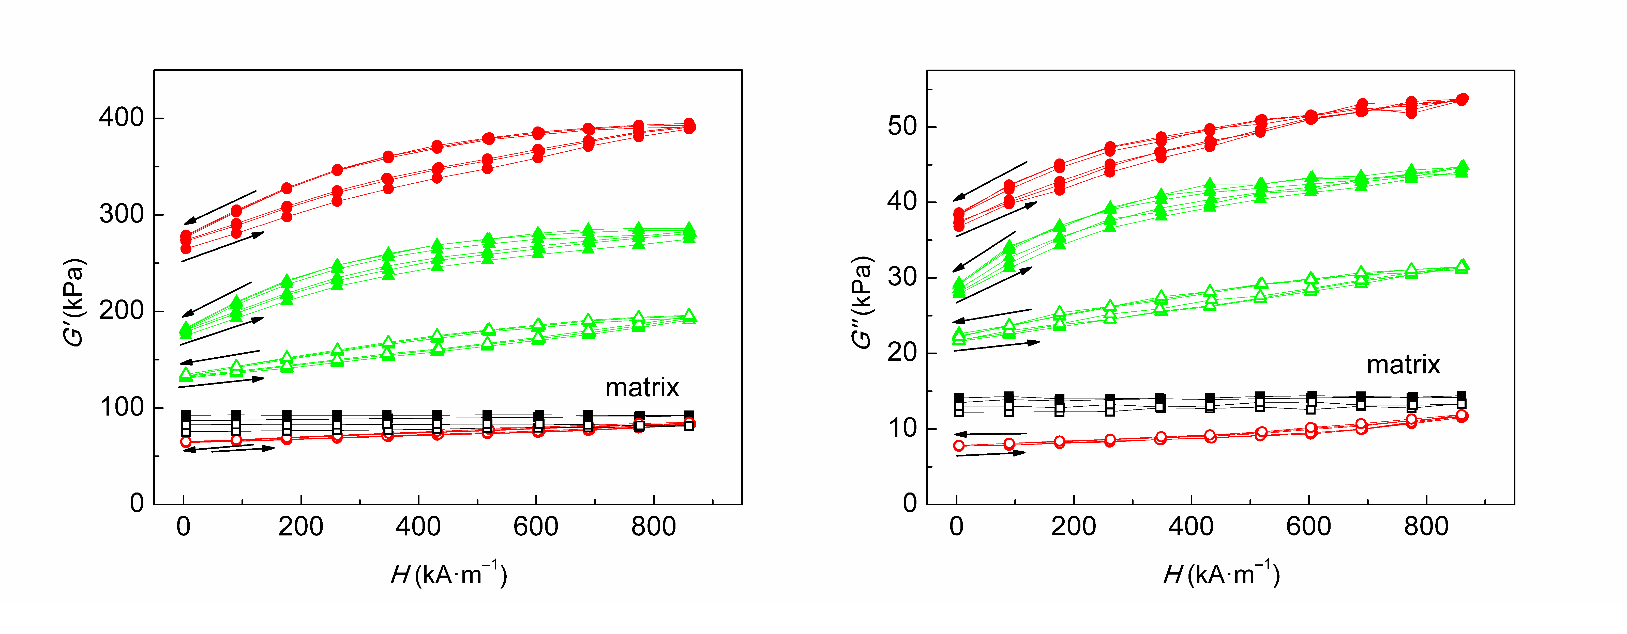
Figure 8. The storage, G', and the loss, G", moduli of the neat matrix (squares) and the I–MREs based on bare CI (circles) and their CI–TEOS analogues (triangles) as a function of the applied magnetic field strength, H, before (solid symbols) and after (open symbols) the corrosion test.

- Conclusions
The surface of the CI particles was modified using a TEOS layer to form stable CI–TEOS particles with enhanced compatibility to the PDMS matrix. The FTIR technique provided the evidence that a thin layer of TEOS was successfully formed onto the surface of the CI particles. Further, the VSM analysis revealed negligibly decreased magnetization due to TEOS coating. Capillary rise experiments using the Washburn method proved that particle modification decreased γ from 34.4 mN·m^{–1} to 20.9 mN·m^{–1} while significantly increasing the dispersive component from 7.2 mN·m^{–1} to 12.5 mN·m^{–1}, which resulted in enhanced dispersibility and better wetting of the CI–TEOS particles with the PDMS matrix as proved by SEM and contact angle investigation, respectively. The I–MREs and A–MREs based on the CI–TEOS particles and the PDMS matrix were fabricated. Different MRE microstructures have been, for the first time, studied using DRS, which revealed the charge transport (VRH) relaxation processes in the MREs based on 60 wt.% particles. The organized structure of the A–MRE resulted in the activation energy of the process decreasing by approximately 15 % compared with the isotropic sample, which was ascribed to the lower average barrier height charge that must be overcome during transport. This represents a crucial phenomenon for MREs in electromagnetic applications. The MR performances of the MREs based on 60 wt.% particles before and after the exposure to acidic environment were evaluated. It was shown that the MRE based on bare CI have a greater G' due to particle/matrix covalent bonding and a lower relative MR effect (~42.8 %) when compared to the MRE based on CI–TEOS, which exhibited slightly higher relative MR effect (~56.2 %). After the chemical treatment, the dramatic decrease of mechanical properties as well as MR effect (~29.6 %) of the MRE based on bare CI particles occurred, while the MRE based on CI–TEOS demonstrated still sufficient mechanical properties and MR effect (~45.6 %). The obtained results may lead to a better understanding of MRE durability operating under demanding conditions such as acidic environment and, thus, help tailor these smart materials towards a specific application.

Acknowledgements
Author M. C. gratefully appreciates the Internal Grant Agency of Tomas Bata University in Zlin [project no. IGA/CPS/2016/008] for the financial support. Author M. S. wishes to thank the Grant Agency of the Czech Republic [14-32114P] for financial support. This work was also supported by the Ministry of Education, Youth and Sports of the Czech Republic – Program NPU I [LO1504].

References

[1] Filipcsei G, Csetneki I, Szilagyi A and Zrinyi M, 2007 Magnetic field-responsive smart polymer composites Adv. Polym. Sci. 206 137–89.
[2] Kela L and Vahaoja P 2009 Recent Studies of Adaptive Tuned Vibration Absorbers/Neutralizers Appl. Mech. Rev. 62 060801.
[3] Nguyen V Q, Ahmed A S and Ramanujan R V 2012 Morphing Soft Magnetic Composites Adv. Mater. 24 4041–54.
[4] de Vicente J, Klingenberg D J and Hidalgo-Alvarez R 2011 Magnetorheological fluids: a review Soft Matter 7 3701–10.
[5] Dyniewicz B, Bajkowski J M and Bajer C I 2015 Semi-active control of a sandwich beam partially filled with magnetorheological elastomer Mech. Syst. Signal Process. 60–61 695–705.
[6] Li Y C, Li J C, Li W H and Du H P 2014 A state-of-the-art review on magnetorheological elastomer devices Smart Mater. Struct. 23 123001.
[7] Sedlacik M, Mrlik M, Babayan V and Pavlinek V 2016 Magnetorheological elastomers with efficient electromagnetic shielding Compos. Struct. 135 199–204.
[8] Behrooz M, Sutrisno J, Zhang L Y, Fuchs A and Gordaninejad F 2015 Behavior of magnetorheological elastomers with coated particles Smart Mater. Struct. 24 035026.
[9] Fan Y C, Gong X L, Xuan S H, Zhang W, Zheng J A and Jiang W Q 2011 Interfacial friction damping properties in magnetorheological elastomers Smart Mater. Struct. 20 035007.
[10] Fuchs A, Sutrisno J, Gordaninejad F, Caglar M B and Liu Y M 2010 Surface Polymerization of Iron Particles for Magnetorheological Elastomers J. Appl. Polym. Sci. 117 934–42.
[11] Lokander M, Reitberger T and Stenberg B 2004 Oxidation of natural rubber-based magnetorheological elastomers Polym. Degrad. Stab. 86 467–71.
[12] Jung H S, Kwon S H, Choi H J, Jung J H and Kim Y G 2016 Magnetic carbonyl iron/natural rubber composite elastomer and its magnetorheology Compos. Struct. 136 106–12.
[13] Park J O, Rhee K Y and Park S J 2010 Silane treatment of Fe3O4 and its effect on the magnetic and wear properties of Fe3O4/epoxy nanocomposites Appl. Surf. Sci. 256 6945–50.
[14] Pickering K L, Khimi S R and Ilanko S 2015 The effect of silane coupling agent on iron sand for use in magnetorheological elastomers Part 1: Surface chemical modification and characterization Compos. Part A Appl. Sci. Manuf. 68 377–86.
[15] Li J F, Gong X L, Zhu H and Jiang W Q 2009 Influence of particle coating on dynamic mechanical behaviors of magnetorheological elastomers Polym. Test. 28 331–7.
[16] Sedlacik M and Pavlinek V 2014 A tensiometric study of magnetorheological suspensions' stability RSC Adv. 4 58377–85.
[17] Belyavskii S G, Mingalyov P G, Giulieri F, Combarrieau R and Lisichkin G V 2006 Chemical modification of the surface of a carbonyl iron powder Prot. Met. 42 244–52.
[18] Cvek M, Mrlik M, Ilcikova M, Plachy T, Sedlacik M, Mosnacek J and Pavlinek V 2015 A facile controllable coating of carbonyl iron particles with poly(glycidyl methacrylate): a tool for adjusting MR response and stability properties J. Mater. Chem. C 3 4646–56.
[19] Owens D K and Wendt R C 1969 Estimation of the Surface Free Energy of Polymers J. Appl. Polym. Sci. 13 1741–7.
[20] Alghunaim A, Kirdponpattara S and Newby B M Z 2016 Techniques for determining contact angle and wettability of powders Powder Technol. 287 201–15.
[21] Galet L, Patry S and Dodds J 2010 Determination of the wettability of powders by the Washburn capillary rise method with bed preparation by a centrifugal packing technique J. Colloid Interface Sci. 346 470–5.
[22] Khimi S R and Pickering K L 2015 Comparison of dynamic properties of magnetorheological elastomers with existing antivibration rubbers Compos. Part B Eng. 83 175–83.
[23] Rabindranath R and Bose H 2013 On the mobility of iron particles embedded in elastomeric silicone matrix Int. Conf. Electrorheol. Fluids Magnetorheol. Suspensions 13th 412.
[24] Tian T F, Li W H, Alici G, Du H and Deng Y M 2011 Microstructure and magnetorheology of graphite-based MR elastomers Rheol. Acta 50, 825–36.
[25] Xu Y G, Gong X L, Xuan S H, Zhang W and Fan Y C 2011 A high-performance magnetorheological material: preparation, characterization and magnetic-mechanic coupling properties Soft Matter 7 5246–54.
[26] Sorokin V V, Stepanov G V, Shamonin M, Monkman G J, Khokhlov A R and Kramarenko E Y 2015 Hysteresis of the viscoelastic properties and the normal force in magnetically and mechanically soft magnetoactive elastomers: Effects of filler composition, strain amplitude and magnetic field Polymer 76 191–202.
[27] Johansson C and Robertsson M 2007 Broadband dielectric characterization of a silicone elastomer J. Electron. Mater. 36 1206–10.
[28] Stickel F, Fischer E W and Richert R 1996 Dynamics of glass-forming liquids .2. Detailed comparison of dielectric relaxation, dc-conductivity, and viscosity data J. Chem. Phys. 104 2043–55.
[29] Aguilar-Hernandez J and Potje-Kamloth K 2001 Evaluation of the electrical conductivity of polypyrrole polymer composites J. Phys. D: Appl. Phys. 34 1700–11.
[30] Psarras G C 2006 Hopping conductivity in polymer matrix-metal particles composites Compos. Part A Appl. Sci. Manuf. 37 1545–53.
[31] Ramanujam B T S, Mahale R Y and Radhakrishnan S 2010 Polyethersulfone-expanded graphite nanocomposites: Charge transport and impedance characteristics Compos. Sci. Technol. 70 2111–6.
[32] Fu S Y, Feng X Q, Lauke B and Mai Y W 2008 Effects of particle size, particle/matrix interface adhesion and particle loading on mechanical properties of particulate-polymer composites Compos. Part B Eng. 39 933–61.
[33] Cvek M, Mrlik M, Ilcikova M, Mosnacek J, Munster L, Pavlinek V 2017 Synthesis of silicone elastomers containing silyl-based polymer grafted carbonyl iron particles: An efficient way to improve magnetorheological, damping and sensing performances Macromolecules 50 2189–200.
[34] Fan Y C, Gong X L, Xuan S H, Qin L J, Li X F 2013 Effect of cross-link density of the matrix on the damping properties of magnetorheological elastomers Ind. Eng. Chem. Res. 52 771–8.
[35] Cvek M, Mrlik M, Ilcikova M, Mosnacek J, Babayan V, Kucekova Z, et al. 2015 The chemical stability and cytotoxicity of carbonyl iron particles grafted with poly(glycidyl methacrylate) and the magnetorheological activity of their suspensions RSC Adv. 5 72816–24.

