Enhancement of radio-absorbing properties and thermal conductivity of polysiloxane-based magnetorheological elastomers by the alignment of filler particles
Martin Cvek^{1,2}, Robert Moucka¹, Michal Sedlacik^{1*}, Vladimir Babayan¹, Vladimir Pavlinek¹
¹Centre of Polymer Systems, University Institute, Tomas Bata University in Zlin, Trida T. Bati 5678, 760 01 Zlin, Czech Republic
²Polymer Centre, Faculty of Technology, Tomas Bata University in Zlin, Vavreckova 275, 760 01 Zlin, Czech Republic
*corresponding author: msedlacik@cps.utb.cz

ABSTRACT
A design for the fabrication of more effective, thin, light-weight radio-absorbers (RAs) based on magnetorheological elastomers (MREs) is demonstrated. Carbonyl iron (CI) particles were incorporated into polydimethylsiloxane matrix either homogeneously (isotropic) or with preferential orientation into chain-like structures (anisotropic). The reflection coefficient (R) of MRE-based single-layer metal-backed RAs was calculated on the basis of transmission line theory. The results show that the orientation of CI particles strongly enhances the permittivity of the systems, while preserving their permeability, which ultimately manifests itself in enhanced absorption of electromagnetic energy and reduced thickness of RAs. Thus, RAs based on anisotropic MREs are characterized by superior electromagnetic shielding capability in the microwave frequency range compared to their isotropic analogues, which offers great practical as well as economic advantages. Moreover, the thermal conductivity of both types of RAs was investigated, since efficient energy dissipation is important to prevent heat build-up under a radio-absorbing shield and thus to extend the service life of the protected device.

Keywords
Multifunctional composite; Magnetorheological elastomer; Electromagnetic shielding; Shielding effectiveness; Thermal properties; Anisotropy

- Introduction.
Magnetorheological elastomers (MREs) represent a group of smart composite materials comprising micron-sized magnetically permeable particles embedded in an elastic polymer matrix. The main feature of these materials is their controllable magnetic field-responsive elasticity; thus, MREs were originally designed for damping applications, including vibration dampers or mechanical shock attenuators [1-4]. In the last years, novel opportunities for the application of MREs have appeared. A successful preparation of MRE-based artificial muscle [5], a magnetoresistive sensor based on an MRE-hybrid [6], and a design of an MRE-based flexible microchannel for biological fluid transport [7] are examples of expanding application of these materials. An application of exceptional practical importance has recently been demonstrated in a study by Sedlacik et al. [4], in which MREs were successfully used to absorb electromagnetic (EM) energy through various loss mechanisms related to the magnetization and electric polarization processes.
Due to the development of electronic information technology and a massive increase in the number of electronic devices, the problems of EM interference, EM pollution and EM signal leakage of targets have become serious issues. These undesirable phenomena may lead to malfunctioning of sensitive electronic components or may have a harmful effect on living organisms [8, 9]; therefore, radio-absorbing materials and radio-absorbers (RAs) have gained huge importance.
With respect to the physical principles of operation, absorbers of interference and absorptive type are distinguished. The former type dissipates EM wave energy due to the interference of waves, while the latter type converts energy into Joule heat through various mechanisms involving weak scattered currents, magnetic hysteresis and high-frequency dielectric losses. However, often these two principles are combined.
The standard goal of the design of RAs is to obtain an absorber of minimal thickness with lowest possible reflectance within the widest possible operating bandwidth. The extension of the operating frequency range can be achieved through the use of frequency-selective surfaces [10] or by incorporating multi-component fillers such as spinel ferrites (NiZn, MnZn) and graphite [11]. Materials containing core-shell structures of magnetic core and electrically conductive polymeric shell also prove to be effective for this purpose [12, 13]. However, this work is primarily devoted to the investigation of the possibility of designing new RAs that have EM characteristics guaranteeing efficient absorption of EM radiation in the microwave frequency range and, at the same time, are thinner, lighter and cheaper/more economical.
According to their inner structure, MREs can be classified into two categories: isotropic (I-MREs), based on homogeneously distributed particles, and anisotropic (A-MREs), with particles aligned into chain-like structures. To fabricate the latter, an external magnetic field must be applied to an uncured liquid-state mixture of particles and polymer matrix [14-16]. The radio absorbing properties of isotropic MREs were studied in our previous work [4]; however, the effect of particle distribution on the EM shielding effectiveness is still unclear. Therefore, the main aim of the presented study is to examine the shielding ability of MRE-based RAs using the concept of composite anisotropy.
Thermal conductivity λ is also an important property for the development of functional RAs, because the devices under protection can generate a large amount of heat. Due to low λ of polymer-based RAs, the heat generated by a device under protection is accumulated, leading to local overheating. This may shorten the service life of the device or even lead to its failure. To date, the number of papers devoted to this phenomenon is limited. Therefore, we believe that the concept of composite anisotropy can help design novel RAs with more efficient energy dissipation and thus reduce heat build-up under the RAs.
The paper is organized as follows. First, we present the methods and materials involved in the fabrication of MRE-based magneto-dielectric type RAs. Then we characterize the fabricated composites, assess their thermal conductivity, and thoroughly analyze their shielding performance.

- Materials and Methods
2.1. Materials and preparation of composites
The soft carbonyl iron (CI) particles (SL grade, Fe content of ≥ 99.5 %) employed in the present investigation were obtained from BASF (Germany) and were used as a suitable magnetic filler. Polydimethylsiloxane (PDMS) elastomer (Sylgard® 184) purchased from Dow Corning® (USA) served as a matrix. Sylgard® 184 is supplied as a two-part liquid (base material and curing agent) kit; these components were mixed in a typical weight ratio of 10 : 1. This material was chosen due to its good elasticity in highly filled systems, flexibility, chemical inertness, and high heat resistance [17]. The materials were used as received.
I-MREs and A-MREs were prepared with various contents (60, 70, 80 wt.%) of CI particles. The density of CI particles was determined by an UltraFoam 1200e gas pycnometer (Quantachrome Instruments, Germany) with nitrogen as a gaseous medium. The value of density was averaged over ten independent measurements. Taking the densities of PDMS and of the compact CI SL powder to be 1.03 g·cm^{–3} (material data sheet) and 7.79 g·cm^{–3}, respectively, we obtained particle volume fractions of ~15.7, ~22.5, and ~33.2 vol.%. The fabrication process included the following steps. An appropriate amount of CI particles was mixed with the base component (10 parts) using an Ultra Turrax T 10 standard dispersing instrument (IKA® Werke GmbH, Germany). Then, the curing agent (1 part) was added, and the mixture was thoroughly stirred for 10 minutes. The homogeneous mixture was subsequently degassed under 10 mbar for 15 minutes at 20 °C in order to remove trapped air bubbles, and then the mixture was transferred into a mold. Molds of different dimensions were used to prepare samples for the measurements of radiation absorption and thermal properties (specified in the following sections). The crosslinking process of MREs was conducted at 60 °C for 200 minutes. To prepare A-MRE, a mold containing the uncured composite was placed between the poles of an electromagnet, and a static magnetic field was applied while the entire assembly was pre-heated at the desired temperature. The magnetic field strength in the mold was monitored with a Teslameter (Magnet-Physik, FH 51, Dr. Steingroever GmbH, Germany) and was set to ~185 kA·m^{–1}. Finally, the samples were left to cool down in a desiccator.

2.2. Scanning electron microscopy
Microstructural observations were performed on freeze-fractured surfaces of MREs with the help of a scanning electron microscope (SEM). The images were taken using a SEM instrument (Phenom Pro, Phenom–World, Netherlands) operating under an accelerating voltage of 5 kV.

2.3. Radio-absorbing properties of the RAs
The complex permeability, μ*, and complex permittivity, ε*, of MREs were measured using an Agilent E4991A impedance analyser (Agilent Technologies, USA) in a frequency range of 0.5–3 GHz at ambient temperature. Toroidal samples with outer diameter of 8 mm and inner diameter of 3.1 mm were used for the investigation of μ*, while dielectric properties were studied on cylindrical samples with a diameter of 15 mm. The specimens were cut out from an MRE sheet with a thickness of 1.2 mm.
The EM shielding performance of MRE-based RAs was evaluated based on the model of a single-layer metal-backed absorber [4, 18]. For the normal incidence of an EM wave (parallel to the induced particle structures in the case of an A-MRE-based RA), the reflection coefficient, R, is given by:
$R=20 log\left|\frac{Z-Z_{0}}{Z+Z_{0}}\right|$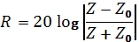, (1)
where Z and Z₀ are the wave impedances of the material and free space, respectively. The latter impedance is equal to one (Z₀ = 1), while Z is given by the equation
$Z=i\sqrt{\frac{μ^{*}}{ε^{*}}}tan\left(\frac{2πf}{c}\sqrt{μ^{*}ε^{*}}d\right)$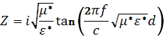, (2)
where c is the velocity of light and f is the frequency of the EM wave.
The frequency spectra of μ* and ε* of a given material are fixed; thus, one can vary the Z of the material at a given frequency (range) only by changing its thickness, d. Considering that the maximum absorption occurs when Z equals 1 (i.e., at the minimum of R) for a given frequency, we calculated the optimal thickness, the so-called matching thickness, d_{m}. For a fixed thickness, one can analogously define the matching frequency, f_{m}, as a frequency at which a given absorber of certain thickness has the maximum absorption.
Expressing d (from Equation 2), we obtain a complex matching thickness:
$d_{m}^{*}=\frac{c}{2πf\sqrt{μ^{*}ε^{*}}}\tan^{-1}\left(-\sqrt{\frac{ε^{*}}{μ^{*}}}\right)$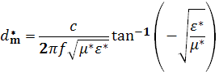. (3)
For obvious reasons, the matching thickness is approximated by the real part of d_{m}* with negligible imaginary component ($\left|\frac{d_{m}^{''}}{d_{m}^{'}}\right|<0.01$) at the absorption attains its maximum.

2.4. Thermal properties of the RAs
The thermal conductivity of MREs was characterized by a TCi™ Thermal Conductivity Analyzer (C–Therm Technologies Ltd., USA), which employs the modified transient plane source (MTPS) technique. The principle of the MTPS is based on one-dimensional heat transfer into a sample. Basically, a sample is placed on the central heater/sensor element in the shape of a spiral surrounded by a guard ring. A known current applied into the spiral produces a small amount of heat. As a result, the temperature at the sensor–sample interface increases, which induces a change in the voltage of the sensor element. The thermal properties of the sample are determined from the variation rate of the sensor voltage [19]. In the experiment, the surface of the sensor was cleaned and dried. The distilled water (0.1 mL) as a contact agent was dripped onto the sensor surface and covered by an MRE sample (with diameter of 25 mm and height of 3 mm). A force of 3 N was applied to the MRE sample to ensure sufficient contact between the sample and the sensor surface, while preventing the sample deformation and possible distortion of the measurement results. The temperature stability was verified in real time using the TCi´s software monitoring function (temperature of 22±1 °C). In order to achieve repeatability and accuracy of the measurements, the thermal parameters were measured three times on each side of the sample.

- Results and discussion
3.1. Microstructural characteristics
The microstructure of the fabricated MRE-based RAs was investigated via SEM. Despite the well-known tendency of CI particles to aggregate in hydrophobic media [20], in the I-MRE-based RAs, the CI particles were sufficiently dispersed within the PDMS matrix (Figure 1a). On the other hand, in the A-MRE-based RAs, the CI particles were readily assembled into chain-like structures (Figure 1b) due to exposure of the uncured particle-matrix system to an external magnetic field. The mechanism of formation of chain-like particle structures is now clearly understood. In the presence of an external magnetic field, magnetically permeable particles generate dipole moments, and two magnetic forces become significant. The first is an attractive particle-to-particle force, which aligns particles into chain-like structures, while the second force is a repulsive one, which separates the formed chains [17]. The mean column diameter and the number of chains per unit area are functions of applied magnetic field strength [21]. As seen in Figure 1, an applied magnetic field strength of ~185 kA·m^{–1} was sufficient to alter RA microstructure and to develop oriented particle structures.

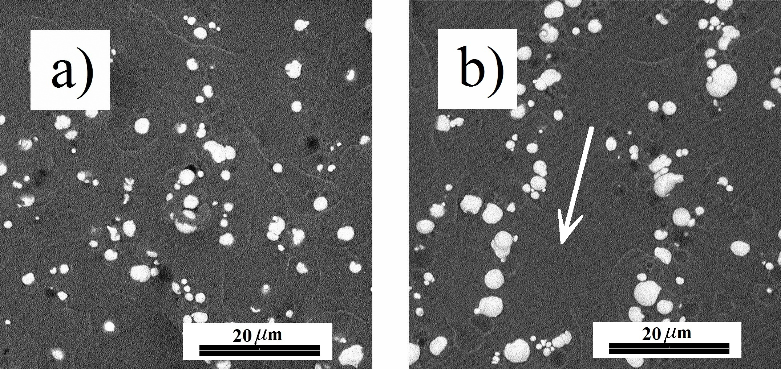
Figure 1. Microstructure of I-MRE-based (a) and A-MRE-based (b) RAs containing 70 wt.% of CI particles. The arrow indicates the direction of the magnetic field applied during the fabrication process.

3.2. Shielding performance
The EM shielding performance of the fabricated MRE-based RAs was calculated in the frequency range from 0.5 to 3 GHz utilizing a single-layer metal-backed absorber model (Equation 1). As shown in Figure 2, all tested composites exhibit a minimum of R (R₀, maximum absorption) at a frequency of 1.5 GHz. It was found that both the CI particle concentration and the RA microstructure considerably affect the intensity of the minimum. Taking an R value of –10 dB as an absorption threshold [4, 18], one can conclude that all RAs except for the I-MRE-based one with 60 wt.% of CI particles have a certain frequency band (f_{min}, f_{max}) in which more than 90 % of incident radiation is attenuated.
As can be seen from Figure 2 and Table 1, for a given concentration of magnetic filler, A-MRE-based RAs are characterized by enhanced absorption of electromagnetic energy (deeper reflection minima) as compared with RAs based on I-MREs. Moreover, while having virtually the same operating bandwidth, expressed as f_{max}/f_{min}, the thickness of A-MRE-based RAs can be reduced by 28%, 19% and 18% compared with their isotropic analogues for filler mass loading of 60 wt.%, 70 wt.%, and 80 wt.%, respectively.

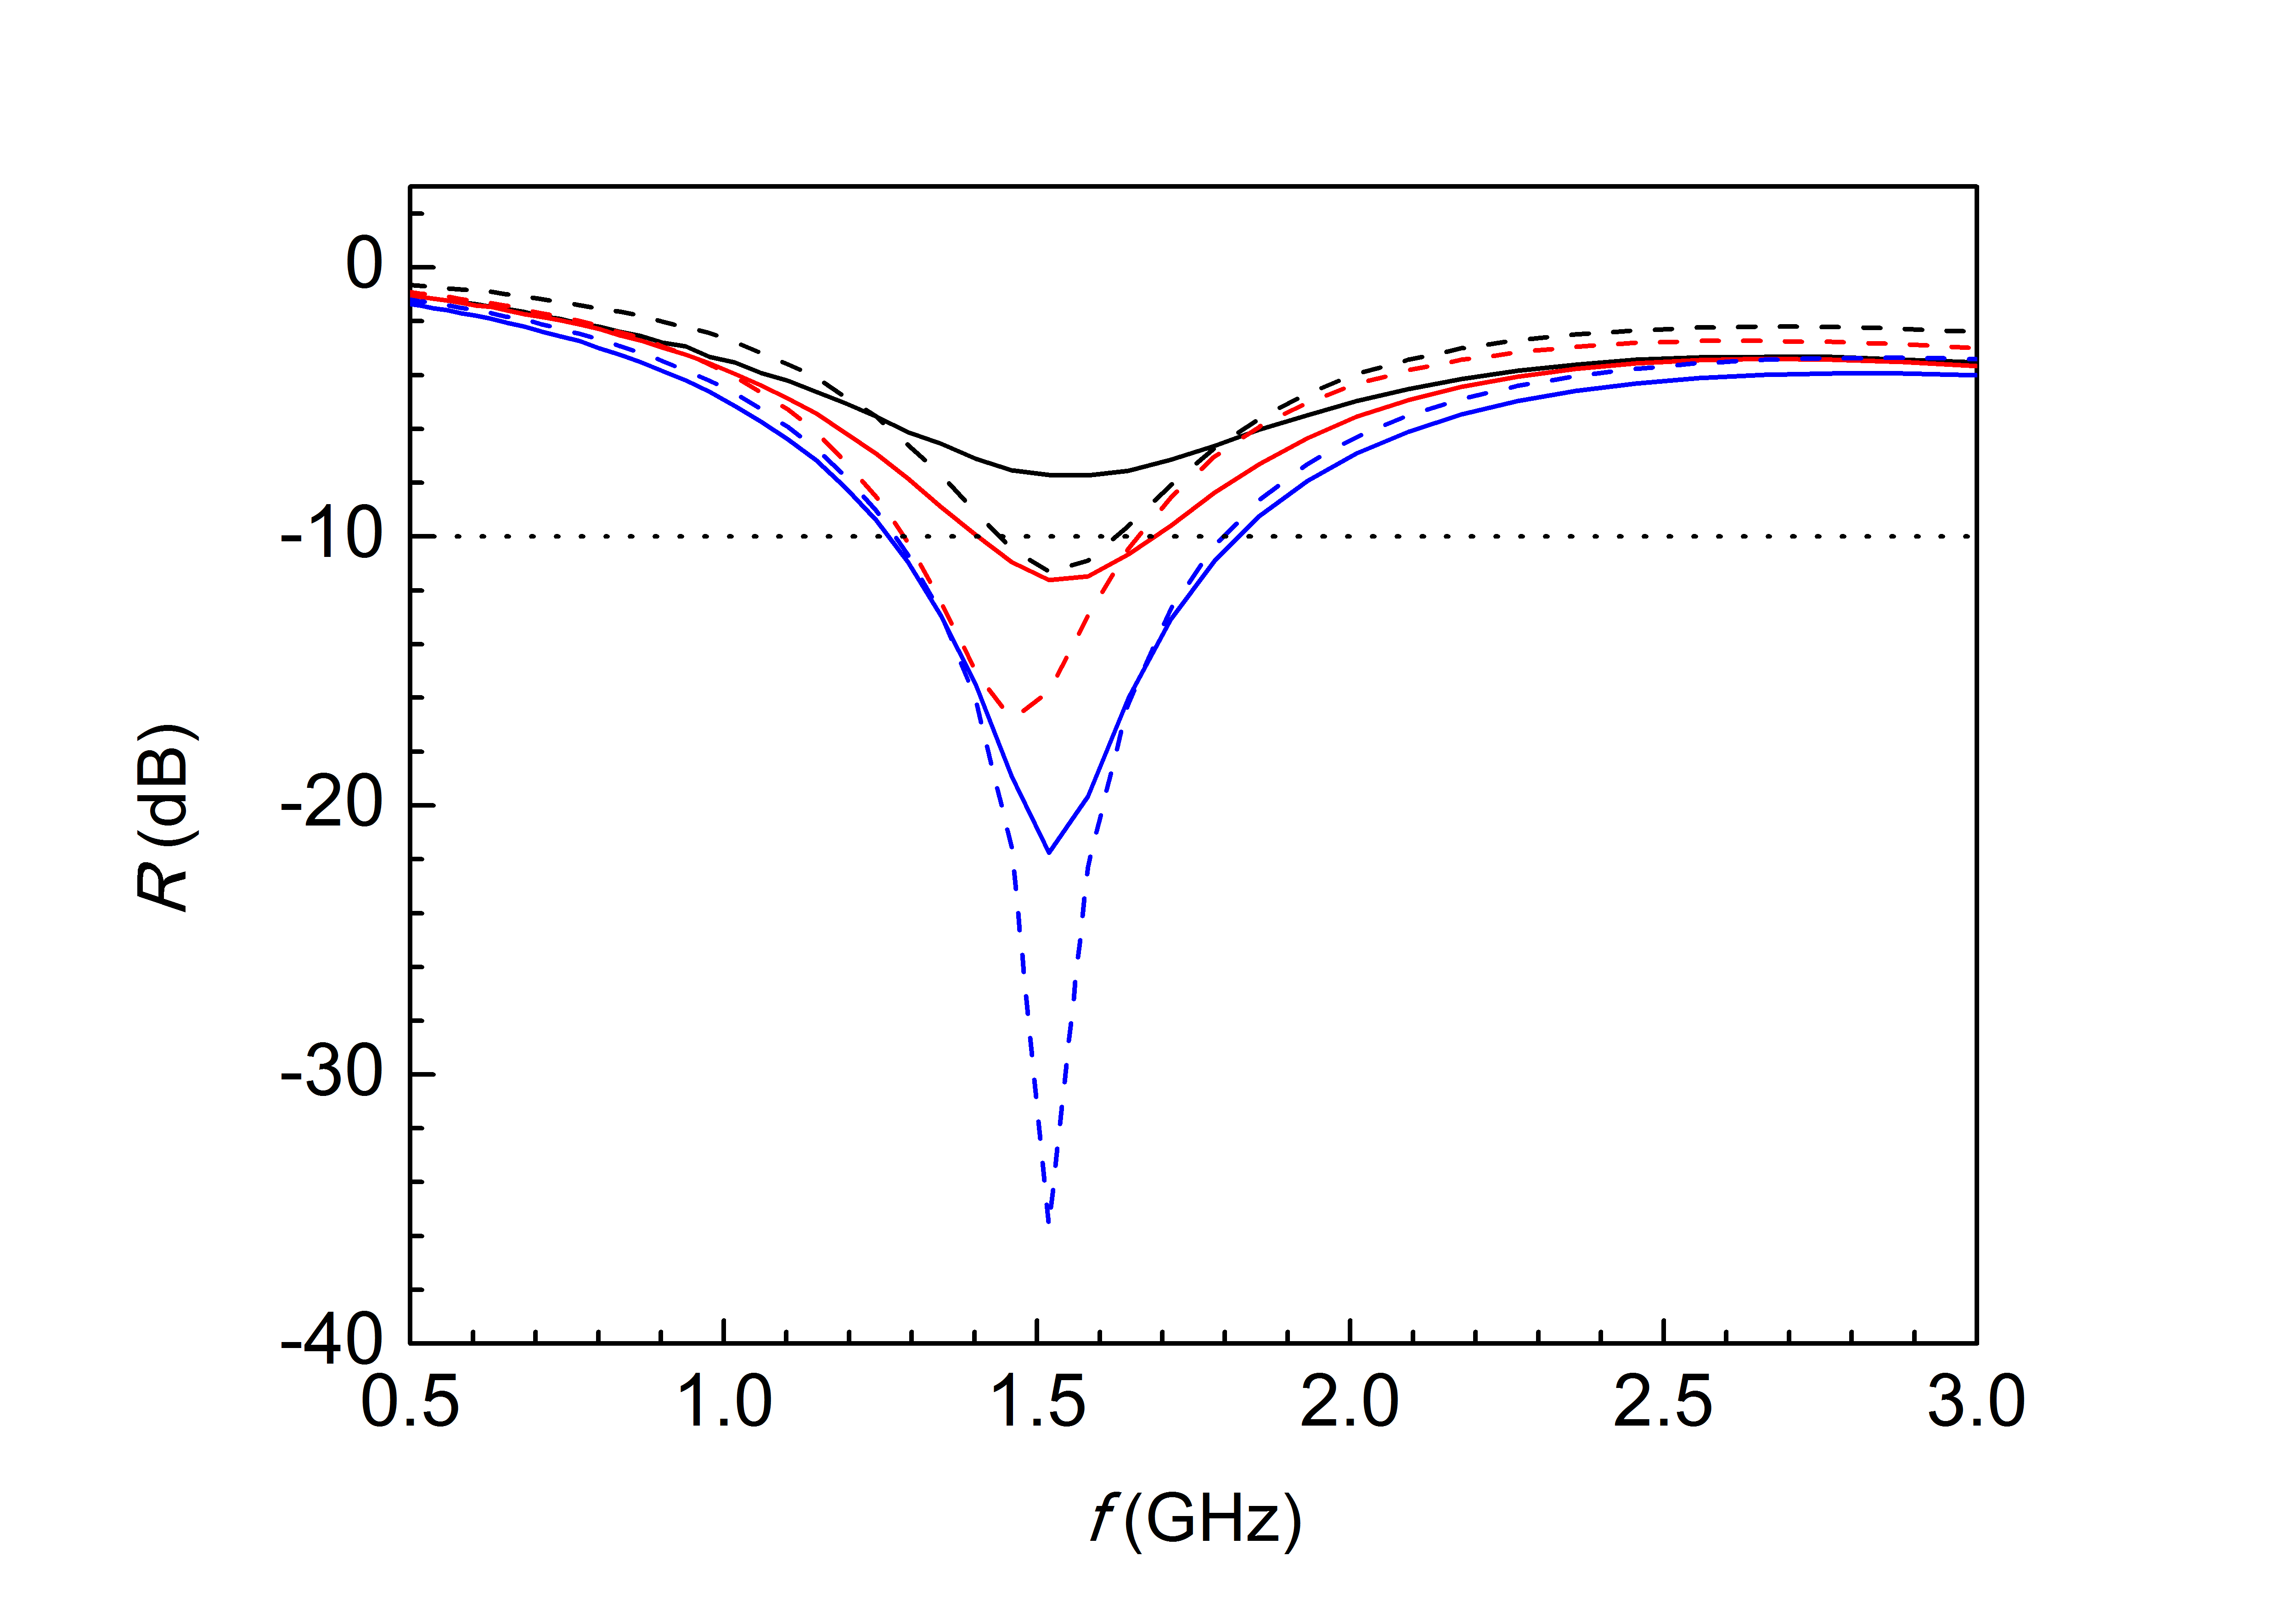
Figure 2. Frequency, f, dependence of the reflection coefficient, R, for I-MRE-based (solid lines) and A-MRE-based (dashed lines) RAs containing 60 wt.% (black), 70 wt.% (red), and 80 wt.% (blue) of CI particles computed for an absorber thickness equal to the matching thickness, d₀.

The physical principle behind the RA microstructure influence on the shielding effectiveness can be attributed to the differences in the dielectric spectra of I-MREs and A-MREs. The μ* and ε* represent core quantities for the R calculation (Equation 1, 2), thus it is reasonable to investigate their frequency dependences separately. Figure 3 shows μ* and ε* as functions of frequency for the MRE-based RAs based on different particle loadings. Both real and imaginary parts of the μ* and ε* were found to increase with increasing particle loading. Conversely, different RA microstructure had a negligible impact on μ’ and μ’’ but strongly influenced only ε’ and ε’’. Similar phenomenon was also observed by Kashi et al.[22] on poly lactide/graphene nanoplatelet nanocomposites after embedding graphene nanoplatelet. Permittivity generally describes the ability of a material to get polarised in a response to an applied electric field. It is apparent that the ε’ increased remarkably (~2.1 fold, ~1.6 fold, ~1.4 fold) as well as ε’’ due to particle clustering for the RAs based on 60, 70 and 80 wt.%, respectively. This phenomenon stems from the fact that a development of more conductive paths by orienting the CI particles into chain-like structures will considerably improve the low permittivity of the I-MRE-based RA. A greater polarization of the oriented particle structures ultimately contributed to the considerably enhanced overall polarization of the MRE-based RAs, therefore the ε* is inherently dependent on the particle distribution.
To conclude, the presence of particle chain-like structures significantly increases both components of ε* while preserving μ*, which, in turn, leads to enhanced absorption characteristics and reduced thickness of RAs. The above-mentioned features of the investigated MRE-based RAs clearly indicate that the spatial orientation of the filler within the matrix demonstrated in the current study can be successfully applied to significantly enhance the overall EM shielding efficiency, as well as to reduce the thickness/mass and eventually the cost of as-prepared RAs.
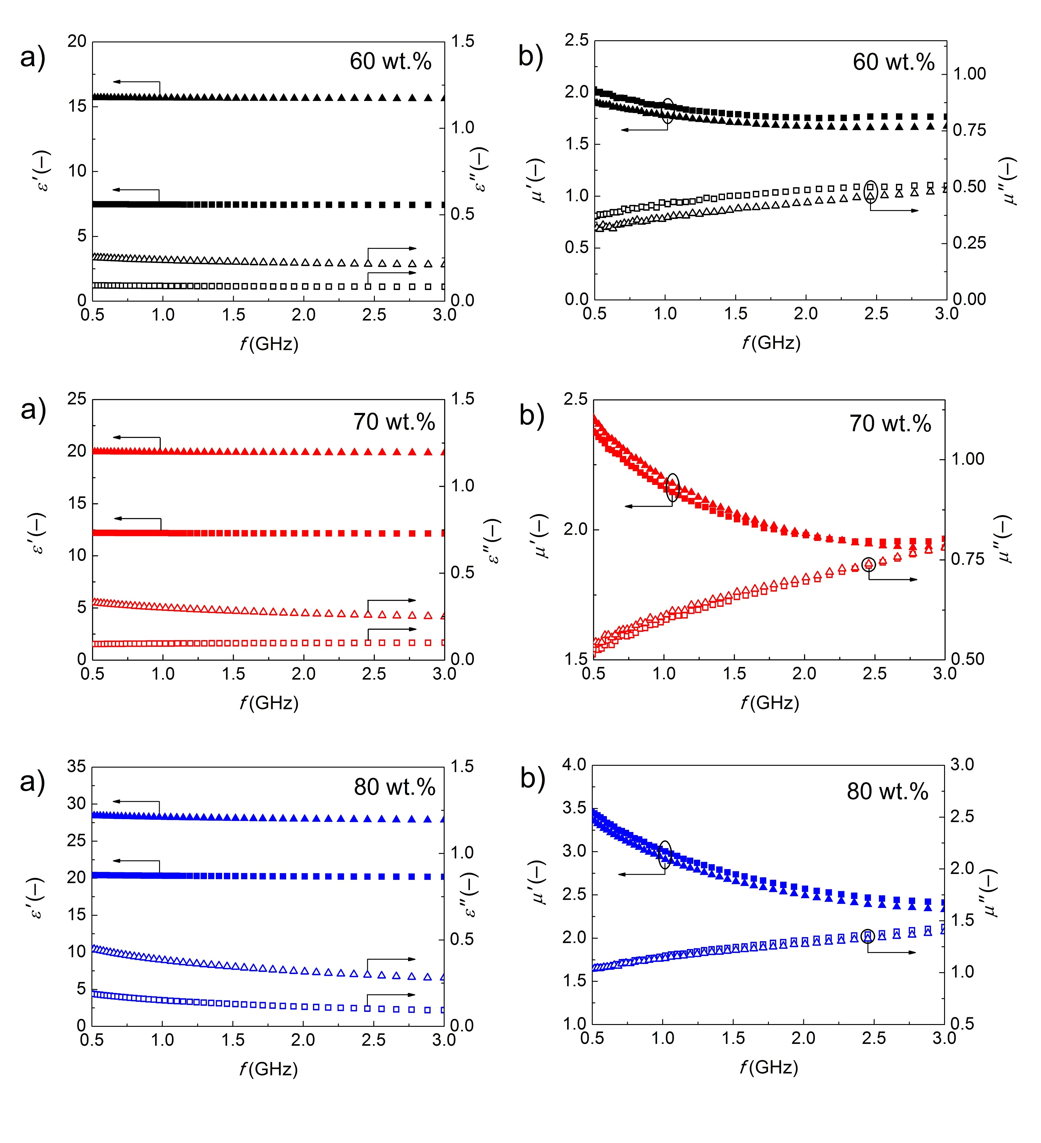Figure 3. Frequency, f, dependence of the real part (solid symbols) and the imaginary part (open symbols) of the complex permittivity, ε*, (a), and the f dependence of the real part (solid symbols) and the imaginary part (open symbols) of the complex permeability, μ*, (b) for I-MRE-based (squares) and A-MRE-based (triangles) RAs containing 60 wt.% (black), 70 wt.% (red), and 80 wt.% (blue) of CI particles.

Table 1. Absorption performance and characteristics of the fabricated MRE-based RAs.
Material for RA fabrication (CI content; wt.%) | f_{min}  (GHz) | f₀  (GHz) | f_{max}  (GHz) | R₀  (dB) | d₀  (mm) | f_{max}/f_{min}  (–)
I-MRE (60) | – | 1.55 | – | –8 | 13.0 | –
A-MRE (60) | 1.44 | 1.54 | 1.63 | –11 | 9.4 | 1.13
I-MRE (70) | 1.40 | 1.54 | 1.69 | –12 | 9.5 | 1.21
A-MRE (70) | 1.29 | 1.46 | 1.66 | –17 | 7.7 | 1.29
I-MRE (80) | 1.26 | 1.52 | 1.82 | –22 | 6.2 | 1.44
A-MRE (80) | 1.27 | 1.52 | 1.80 | –36 | 5.3 | 1.42

3.3. Thermal transport properties
We also investigated the effect of particle concentration and particle distribution on the λ of MRE-based RAs. In the case of A-MRE-based RAs, the thermal properties were measured in a direction parallel to that of induced chain-like structures. As depicted in Figure 4, the presence of CI considerably influences the λ when compared to the results for the neat matrix. Higher CI particle concentrations considerably increase the λ of A-MRE-based RAs as well as of their isotropic analogues.
Further, the alignment of CI particles along a preferred direction contribute to the further enhancement of λ and thus to more efficient heat dissipation. This phenomenon can be explained by the presence of magnetically-induced CI particle chain-like structures (Figure 1) in A-MRE-based RAs, in which particle chains represent preferential “easy” phonon flow paths [17].
For particle concentrations of 60, 70, and 80 wt.%, the λ of the fabricated A-MRE-based RAs increase by factors of 1.72, 1.47 and 1.33 as compared with their isotropic analogues. The decreasing trend of this factor can be attributed to the higher viscosity of the suspensions during preparation of highly concentrated RAs. In other words, the employed magnetic field strength applied during preparation of A-MRE-based RAs is insufficient to fully develop particle structures due to the high viscosity of such highly filled systems. A similar phenomenon was shown in [23], where the authors concluded that the arrangement of particles at high concentrations does not strongly influence the thermal behavior of MREs and that the level to which particles are aligned is lower.
In addition, the λ of two-phase composites can be predicted by several theoretical models [17, 23-25]. However, the theoretical predictions do not always provide good agreement with the experimental data. In our case, the data obtained for I-MRE-based RAs are in a sufficiently good agreement with the numerical predictions obtained from the equation (Equation 4) proposed by Lichtenecker [24]:
$λ=λ_{p}^{(1-ϕ)}λ_{m}^{ϕ}$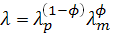, (4)
where λ, λ_{p} and λ_{m} are the thermal conductivities of the composite, the dispersed particles, and the polymer matrix, respectively. The symbol 𝜙 represents the particle volume fraction. To calculate λ, we took thermal conductivity values of 0.15 and 74 W/m·K for the neat PDMS and CI powder, respectively [26]. On the other hand, the thermal conductivities of A-MRE-based RAs were noticeably higher than those provided by the above-mentioned model. In such systems, heat transfer is facilitated by the presence of highly conductive particle chains.

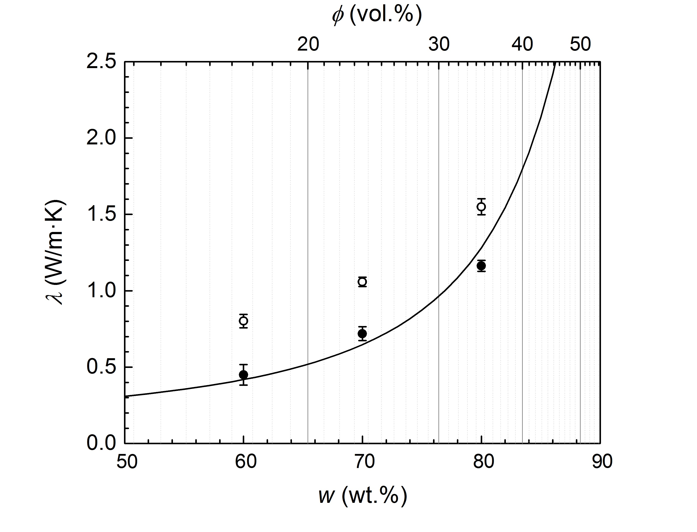
Figure 4. Thermal conductivity λ as a function of particle concentration (wt.%, bottom X axis; vol.%, top X axis) in I-MRE-based (solid circles) and A-MRE-based (open circles) RAs. The solid line is the result obtained by the Lichtenecker model.

- Conclusions
We have presented a novel approach to the design of more efficient RAs that is based on the alignment of filler particles. We have fabricated two variants of MRE-based RAs – isotropic and anisotropic – with different CI particle contents. A superior value of R was obtained for A-MRE-based RAs at frequencies about 1.5 GHz. We have demonstrated that A-MRE-based RAs exhibit significantly reduced d₀, which yields lighter RA elements. The results have shown that the enhancement of the EM shielding capability appears to be a consequence of preserved μ* and increased ε* due to enhanced composite polarization as a result of the particle alignment. Furthermore, A-MRE-based RAs are more effective in heat transfer in the direction of chain-like structures as compared to their isotropic analogues, which is a promising result for the ongoing practical applications. Thus, the alignment of filler particles appears to be an excellent strategy to improve the microwave absorption as well as the heat transport properties of as-designed RAs.

Acknowledgements
Author M. C. gratefully appreciates the Internal Grant Agency of Tomas Bata University in Zlin [project no. IGA/CPS/2016/008] for the financial support. Author M. S. wishes to thank the Grant Agency of the Czech Republic [14-32114P] for the financial support. This work was also supported by the Ministry of Education, Youth and Sports of the Czech Republic – Program NPU I [LO1504]. The thermal transport properties were obtained with the support of Operational Program Research and Development for Innovations co-funded by the European Regional Development Fund (ERDF) and national budget of the Czech Republic, within the framework of the project CPS - strengthening research capacity [reg. number: CZ.1.05/2.1.00/19.0409].

References
[1] Bica I 2009 Compressibility modulus and principal deformations in magneto-rheological elastomer: The effect of the magnetic field J. Ind. Eng. Chem. 15 773–6.
[2] Cvek M, Mrlik M, Ilcikova M, Mosnacek J, Munster L and Pavlinek V 2017 Synthesis of Silicone Elastomers Containing Silyl-Based Polymer Grafted Carbonyl Iron Particles: An Efficient Way To Improve Magnetorheological, Damping, and Sensing Performances Macromolecules. 50 2189–200.
[3] Park BJ, Fang FF and Choi HJ 2010 Magnetorheology: materials and application Soft Matter 6 5246–53.
[4] Sedlacik M, Mrlik M, Babayan V and Pavlinek V 2016 Magnetorheological elastomers with efficient electromagnetic shielding Compos. Struct. 135 199–204.
[5] Zrinyi M and Szabo D 2001 Muscular contraction mimiced by magnetic gels Int. J. Mod. Phys. B. 15 557–63.
[6] Bica I, Anitas EM, Bunoiu M, Vatzulik B and Juganaru I 2014 Hybrid magnetorheological elastomer: Influence of magnetic field and compression pressure on its electrical conductivity. J. Ind. Eng. Chem. 20 3994–9.
[7] Behrooz M and Gordaninejad F 2016 A flexible micro fluid transport system featuring magnetorheological elastomer Smart Mater. Struct. 25 025011.
[8] Cao XG, Ren H and Zhang HY 2015 Preparation and microwave shielding property of silver-coated carbonyl iron powder J. Alloys Compd. 631 133–7.
[9] Wang W, Guo JX, Long C, Li W and Guan JG 2015 Flaky carbonyl iron particles with both small grain size and low internal strain for broadband microwave absorption J. Alloys Compd. 637 106–11.
[10] Babayan VA, Kazantsev YN, Lopatin AV, Mal'tsev VP and Kazantseva NE 2011 Extension of the Operating Frequency Range of a Dielectric Radio Absorber with the Help of Frequency-Selective Surfaces J. Commun. Technol. Electron. 56 1357–62.
[11] Koledintseva M, Ravva PC, Drewniak J, Kitaitsev AA and Shinkov AA Engineering of ferrite-graphite composite media for microwave shields. IEEE Int. Symp. Electromagn. Compat.; New York, 2006.
[12] Babayan V, Kazantseva NE, Sapurina I, Moucka R, Stejskal J and Saha P 2013 Increasing the high-frequency magnetic permeability of MnZn ferrite in polyaniline composites by incorporating silver J. Magn. Magn. Mater. 333 30–8.
[13] Kim YY, Yun J, Kim HI and Lee YS 2012 Effect of oxyfluorination on electromagnetic interference shielding of polypyrrole-coated multi-walled carbon nanotubes J. Ind. Eng. Chem. 18 392–8.
[14] Boczkowska A, Awietjan SF and Wroblewski R 2007 Microstructure-property relationships of urethane magnetorheological elastomers Smart Mater. Struct. 16 1924–30.
[15] Khimi SR and Pickering KL 2016 The effect of silane coupling agent on the dynamic mechanical properties of iron sand/ natural rubber magnetorheological elastomers Composites, Part B 90 115–25.
[16] Xu YG, Gong XL, Xuan SH, Zhang W and Fan YC 2011 A high-performance magnetorheological material: preparation, characterization and magnetic-mechanic coupling properties Soft Matter 7 5246–54.
[17] Su JW, Liu X, Charmchi M and Sun HW 2016 Experimental and numerical study of anisotropic thermal conductivity of magnetically aligned PDMS/Ni particle composites Int. J. Heat Mass Transfer 97 645–52.
[18] Lopatin AV, Kazantseva NE, Kazantsev YN, D'Yakonova OA, Vilcakova J and Saha P 2008 The efficiency of application of magnetic polymer composites as radio-absorbing materials J. Commun. Technol. Electron. 53 487–96.
[19] Harris A, Kazachenko S, Bateman R, Nickerson J and Emanuel M 2014 Measuring the thermal conductivity of heat transfer fluids via the modified transient plane source (MTPS) J. Therm. Anal. Calorim. 116 1309–14.
[20] Zhang WL and Choi HJ 2012 Graphene oxide added carbonyl iron microsphere system and its magnetorheology under applied magnetic fields J. Appl. Phys. 111 07E724.
[21] Borbath T, Gunther S, Borin DY, Gundermann T and Odenbach S 2012 XuCT analysis of magnetic field-induced phase transitions in magnetorheological elastomers Smart Mater. Struct. 21 105018.
[22] Kashi S, Gupta RK, Baum T, Kao N and Bhattacharya SN 2016 Morphology, electromagnetic properties and electromagnetic interference shielding performance of poly lactide/graphene nanoplatelet nanocomposites Mater. Des. 95 119–26.
[23] Diaz-Bleis D, Vales-Pinzon C, Freile-Pelegrin Y and Alvarado-Gil JJ 2014 Thermal characterization of magnetically aligned carbonyl iron/agar composites Carbohydr. Polym. 99 84–90.
[24] Mamunya YP, Davydenko VV, Pissis P and Lebedev E 2002 Electrical and thermal conductivity of polymers filled with metal powders Eur. Polym. J. 38 1887–97.
[25] Pal R 2008 On the Lewis-Nielsen model for thermal/electrical conductivity of composites. Composites, Part A 39 718–26.
[26] Medina-Esquivel R, Yanez-Limon JM and Alvarado-Gil JJ 2008 Photothermal measurement of thermal diffusivity in carbonyl iron powder suspensions Eur. Phys. J.: Spec. Top. 153 75–7.

