Photochemically crosslinked poly(ε-caprolactone) with accelerated hydrolytic degradation

Csaba Kósa,ª Michal Sedlačík,^{b} Agnesa Fiedlerová,ª Štefan Chmela,ª Katarína Borská,ª Jaroslav Mosnáček^{a,*}

ª Polymer Institute, Slovak Academy of Sciences, Dúbravská cesta 9, 842 36 Bratislava, Slovak Republic
^{b} Centre of Polymer Systems, University Institute, Tomas Bata University in Zlin, Nad Ovcirnou 3685, 760 01 Zlin, Czech Republic
* Corresponding author: jaroslav.mosnacek@savba.sk; phone: 00421 2 3229 4353

Abstract
Irradiation of benzophenone (BP)-doped poly(ε-caprolactone) (PCL) films at λ>350 nm led to changes in molecular characteristics, viscoelastic properties and hydrolytic degradation rate of PCL. The influence of BP concentration on the changes in the PCL during irradiation of the BP-doped PCL film were investigated using gel permeation chromatography, analysis of gel content, DSC and rheological measurements. Changes in rate of basic hydrolysis of irradiated BP-doped PCL films were investigated as well. Irradiation of PCL film doped with at least 0.5 wt% of BP led to crosslinking of PCL and gel formation even though a simultaneous degradation was observed as well. Presence of polar groups formed during irradiation of BP-doped PCL films enhanced the rate of the subsequent hydrolysis of the crosslinked PCL films in comparison with hydrolysis of pure untreated PCL film.

Keywords: biodegradable polymer, photochemical crosslinking, viscoelastic properties, benzophenone

Introduction
Recently possible medical application and increasing request for environmentally more friendly polymeric materials evoked growing interest in research of biodegradable polymers. Polycaprolactone (PCL) is a degradable aliphatic polyester, which can be biodegraded by living organism (bacteria, fungi) enzymatically and non-enzymatically in the body [1-5]. The interesting properties of PCL, such us good solubility, low melting point and exceptional blend-compatibility, are the reason thatit is for long time the object of intensive research in biomedical applications [1]. PCL and its copolymers during the 1970s and 1980s were used in several drug-delivery systems especially for long-term encapsulated molecules [5,6]. For drug delivery systems the research is focused on the application of PCL biodegradable microparticles and nanospheres with high permeability to small drug molecules and negligible tendency to generate an acidic environment [1]. Some studies were also performed to utilize PCL in preparation of biodegradable implants. However, PCL does not possess the mechanical properties for high load bearing applications [1]. Nowadays PCL is the most intensively exploited in the tissue engineering due to the biodegradability, biocompatibility, easy processing and good rheological and viscoelastic properties in comparison with other resorbable polymers [7]. Main drawback of PCL in some applications could be its slow degradation both in vivo and in vitro due to its high crystallinity and high hydrophobicity [8,9]. To eliminate this disadvantage, recently various copolymers of PCL with other lactones or glycolides\lactides were used [9,10]. Such copolymers usually have impaired mechanical properties in comparison with PCL homopolymers.
Photochemical treatment of biodegradable polymers can lead to materials with modified properties and different degradation rate. Photochemical processes in PCL films were studied upon applying various radiation sources. Gamma irradiation of PCL led to both chain scission and crosslinking of the polymer in dependence on the irradiation dose level [11]. It was found, that the critical dose for observe measurable gel formation (crosslinking) was about 26 Mrad under both air atmosphere and vacuum [11]. To decrease the dose level the polyfunctional monomers can be used as crosslinking accelerators [12].
Contrary to the gamma radiation, upon irradiation of PCL with UV light (full spectrum of medium pressure mercury arc) only photodegradation via Norrish II cleavage mechanism was found [13,14]. Rate of photodecomposition of PCL was similar, regardless if inert or air atmosphere was used [13]. UV initiated crosslinking was obtained only upon modification of PCL ends with acrylic monomers and using phosphinic [15] or ketonic photoiniciators [16-18]. Among ketonic photoiniciators the derivatives of benzophenone (BP) were widely used [17]. BP and its derivatives are well known to be effective photoinitiators in radical polymerization and in the UV induced surface graft polymerizations especially in the presence of free or linked amines as coinitiators [19-22]. However, they were also investigated as an effective promoters in photocrosslinking of polymers, such as polyethylene (PE), polystyrene (PS) or poly(methyl methacrylate) (PMMA) upon irradiation with UV in the region of 300 – 400 nm [23-25]. Surprisingly no changes were observed by Bei et al. during irradiation of PCL in xenotest on air in the presence of low concentration (0.3 wt%) of BP [26]. On the other hand, the detailed study of the photoreaction of BP in the PCL matrix was not realized yet.
Recently we showed that photochemical transformation of benzil, i.e. (1,2-diphenylethan-1,2-dione), doped in the PCL films led to significant changes in molecular characteristics and rate of hydrolytic degradation of PCL [27]. Therefore, in this paper, we decided to do detail study of the influence of photochemical transformation of BP doped in the PCL film on changes in molecular characteristics and properties of PCL. It is shown here that the irradiation of PCL in the presence of at least 0.5 wt% of BP lead to changes in molecular characteristics of PCL accompanied by crosslinking of the PCL matrix. Despite of the PCL crosslinking, the hydrolytic degradation of the photochemically treated PCL was faster than for the original one.

Experimental part
Materials
Poly(ε-caprolactone) (CAPA® 6800, SOLVAY Caprolactones, GB) with M_{w} = 80,000 g·mol⁻¹, ρ =1.1 g·L⁻¹, crystalinity of 46.8 %, T_{m} = 58 – 60 °C; benzophenone (Schuchardt, Munchen, Germany) and chloroform p.a. (Penta, Chrudim, Czech Republic) were used as received. Tetrahydrofuran p.a. (THF) (POCH s.a. Gliwice, Poland) was stored over KOH overnight and then distilled from CaH₂.

Preparation of polymer films
PCL films were prepared by casting of 1 mL of chloroform solution containing 50 mg of PCL and various concentrations of BP (0.25 – 4 mg) on 10 cm² a glass plate. To ensure a slow evaporation of the solvent and obtain transparent film the glass plates were covered with Petri dishes. The self-supporting PCL films were separated from the glass plate by dipping into distilled water and dried at room temperature under vacuum. PCL films were placed in the frames made of aluminum foil and the uncovered middle part of about 6 – 7 cm² was irradiated and used for all studies. The amount of BP in this middle part of the prepared PCL film was confirmed by UV-VIS spectroscopy.
For rheological experiments PCL films were prepared by casting of 8 mL of chloroform solution containing 50 mg·ml^{–1} of PCL and various concentrations of BP in Petri dish with 6 cm diameter. After slow evaporation of the solvent the films were dried at high vacuum and melt pressed at 75 °C (1 min heating without pressure followed by pressing for 30 s at 20 kN and 30 s at 45KN).

Irradiation and measurements
Irradiation of polymer films with UV-VIS light at λ > 350 nm was carried out by medium pressure mercury lamp in Spectramat apparatus (Ivoclar AG, Schaan, Liechtenstein). For irradiation, the samples were inserted into the glass finger cooled with water to prevent the heating of the sample during the irradiation. The distance of each sample from the arc was about 10 cm. The power of light measured at the place of the sample was about 20 mW cm⁻².
Photochemical reaction of BP in PCL film was followed by FT-IR recorded on IMPACT 400 (Nicolet, Germany) Fourier transform infrared spectrophotometer in the range of 600 – 4000 cm⁻¹ (64 scans for each measurement). Concentration of BP in the middle part of the PCL films was determined by UV-VIS spectroscopy using Schimadzu UV – 1650 PC spectrophotometer (Shimadzu, Japan).
The molar mass and dispersity of PCL films were estimated by a Schimadzu GPC (Shimadzu, Japan) equipped with refractive index detector, 3 x PSS SDV 5 μm columns (d = 8 mm; l = 300 mm; 100 Å + 500 Å +10⁵ Å) using THF as an eluent and polystyrene standards for calibration.
For gel content determination the irradiated parts of the samples were cut from the aluminum frames, weighted and stirred in THF at ambient temperature for 18 h. Soluble part was used for GPC. Insoluble part of the film was refluxed in chloroform for 24 h, dried and weighted. Gel content was calculated as a ratio of dried gel to initial weight of the irradiated part of the film.
Hydrolysis was performed in 1M sodium hydroxide solution at 25 °C for predetermined periods of time. After hydrolysis, the films were washed intensively with distilled water at room temperature for 3 times, followed by drying under vacuum. The content of extractable product was determined from change of the weight of polymer films before (M₀) and after hydrolysis (M) (%_{extractable}. _{products} = 100 × (M₀ – M/M₀). After washing out the extractable products, the residual un-hydrolyzed part of the films was used for gel content determination.
The differential scanning calorimeter Mettler-Toledo DSC821e was used for the determination of melting temperature as well as crystallinity. The samples were heated (10 °C·min⁻¹) in the temperature range from 0 to 90 °C under nitrogen atmosphere. The crystallinity was determined from heat of fusion using reference value ΔH°m = 157 J·g⁻¹ for 100% crystalline PCL [28]. Indium was used for temperature and heat fusion calibration.

Rheological characterization
Real-time curing rheological experiments were performed with an Anton Paar – Modular Compact Rheometer MCR 502 (Austria) interconnected with UV-VIS curing mercury lamp system OmniCure Series 1000 (Lumen Dynamics, Canada). Light emitting diodes within the fixture emitted UV-VIS radiation in the wavelength range of 320–500 nm through a clear acrylic, UV transparent window. Radiation intensity was fixed throughout each experiment on 256 mW cm⁻². The temperature was controlled using an Anton Paar – TC 30 Temperature Control Unit with heating chamber CTD600 – Convection Temperature Device equipped with UV-VIS light Accessory for CTD 600. A parallel-plate measuring system with a diameter of 25 mm (PP25) and gap of 0.5 mm was used. All the measurements were performed at 70 °C to provide sufficient melting of the sample while the thermal decomposition did not occur.
Oscillatory shear tests were carried out as an effective way to study the dynamic characteristics of microstructures occurring during the UV-VIS irradiation. Firstly, the strain sweep was performed in the applied strain, γ, range of 0.1–10 % at a fixed frequency of 10 Hz with the aim of determining the position of the linear viscoelastic region (LVR). Then, the strain value within the LVR (1.58 % in all experiments) was used for frequency sweep measurement, i.e. the frequency, f, was changing from 0.1 to 10 Hz in a log scale with 10 pts/decade. Furthermore, the sample was exposed to irradiation for 1 hour at f = 3.16 Hz and γ = 1.58 % for real-time monitoring of viscoelastic moduli development. After this experiment, the frequency sweep described above was performed once again to give additional evidence of sample curing. The same testing and set up times have been kept for all the samples to guarantee equal conditions.

Results and discussions
Changes in FT-IR spectra during irradiation of PCL/BP films
A consumption of various concentrations of BP doped in PCL matrices during irradiation was followed by FT-IR spectroscopy. Usually, an ideal absorption band for following the BP consumption is the carbonyl stretching band. As is seen in Fig.1, irradiation of PCL film containing of approximately 7 wt % of BP led to decrease the characteristic stretching band of the carbonyl groups in the 1650 – 1670 cm⁻¹ region. On the other hand, at BP concentrations below 2 wt% the intensity of absorbance of carbonyl group was too low to follow the photochemical process. The BP consumption during irradiation of BP-doped PCL films can be followed also by decrease of the absorption band at 640 cm⁻¹, which belongs to absorption of BP phenyl ring (Fig.1). In this region PCL does not absorb and changes in absorption could be used for PCL films with all studied BP concentrations. . The BP consumption was accompanied by small increase of absorption in 640 – 660 cm⁻¹, from benzpinacol, which, together with benzhydrol, is usually formed from BP after hydrogen abstraction from hydrogen donors [29]. In addition, small broad peak was formed in 3360 – 3560 cm⁻¹ region corresponding to oxidation of PCL chains [30] and/or formation of benzhydrol and benzpinacol. Changes in the carbonyl absorption region (1690 – 1750 cm⁻¹) cannot be seen due to too high absorption of the PCL in this region. No changes in FT-IR spectra were observed after irradiation of pure PCL for 1.5 hour.

Fig. 1 FT-IR absorption spectra of 7 wt% BP in PCL matrix irradiated for various time at λ> 350 nm. Changes of carbonyl absorption of BP at 1660 cm⁻¹ and region of –CH absorption of BP phenyl ring at 640 cm⁻¹ are showed. The spectrum of benzpinacol, as a one of the product of BP photochemical transformation, in PCL is shown as well.

Effect of irradiation on the molecular characteristics of PCL matrix
The main photochemical reaction of BP in the presence of hydrogen donors is the hydrogen abstraction reaction by BP in its excited triplet state leading to the formation of ketyl radical [31,32]. Depending on the structure, the polymer matrices can serve as the hydrogen donors as well [33].The formed macroradical can react with another macroradical to form crosslinked polymer, or can react with oxygen to form peroxide, which finally lead to PCL chain scission (Scheme 1). These two competitive processes can proceed simultaneously.

Scheme 1 Formation of macroradical after abstraction of hydrogen from PCL chain by benzophenone in its excited state; and subsequent reactions of macroradical leading to crosslinking and/or oxidation accompanied with degradation of PCL chains

Since crosslinking and/or degradation of PCL could be expected during photochemical transformation of BP doped in PCL film, the changes in molecular characteristics of irradiated PCL/BP films were investigated by gel permeation chromatography (GPC) and determination of gel content. While in the case of pure PCL no changes in molecular characteristics were observed in GPC after irradiation for 1.5 hour, significant changes were observed in the presence of various concentration of BP. Typical changes in GPC traces after various time of irradiation are shown in Fig. 2 for PCL doped with 1 wt% of BP. Shift of the GPC traces to both higher and lower molar masses due to two competitive reactions, namely recombination of macroradicals and degradation, respectively, could be observed. Extension of the GPC traces to higher molar masses (formation of the shoulder) already after 10 min of irradiation indicated that the recombination process was preferable, while with prolonged irradiation time to more than 20 min the GPC traces started to shift to the lower molar masses. The evolution of molar masses during irradiation for all tested samples are shown in Figure 3. As can be seen, for all samples the molar mass first increased due to recombination reactions and with prolonged irradiation the molar masses decreased. It should be mentioned here, that in all cases the gel formation was observed after 10 or 20 min of irradiation and the GPC traces showed only the soluble part of PCL.
More detailed investigation of gel formation during irradiation of PCL/BP samples showed increasing the gel content with prolonging the irradiation time from 10 till 90 minutes reaching the maximum of gel content in the range of 77 – 85 %, depending on the BP concentration (Figure 3b). It should be mentioned, that prolonged irradiation to 120 min led to slight decrease of the gel content.

Fig. 2 GPC traces of PCL/BP (1 wt% BP) irradiated for various time at λ >350 nm.

Fig. 3 Evolution of a) molar mass (M_{n}) of soluble part of PCL and b) formed gel content with irradiation time for PCL films containing various concentration of BP.

Real-time rheological measurements
In order to follow the changes in the PCL structure and their direct impact to properties of the material a real-time rheological properties during irradiation of the PCL and PCL/BP films were studied. First amplitude sweep measurements were performed to determine region, in which the viscoelastic moduli of the material are independent on the applied strain (at constant frequency). Figure 4 presents the storage modulus, G’, representing elastic behaviour in the system and loss modulus, G”, representing viscous behaviour in the system, versus strain for PCL films containing various concentration of photoactive additive BP in the absence of UV irradiation to obtain the linear viscoelastic region (LVR). Evidently, G’ dominated over G” for all the samples reflecting their rather elastic character in the observed strain range. As can be also seen in Fig. 4, the LVR slightly decreased with increasing concentration of photoactive additive BP. The viscoelastic moduli started to be dependent on applied strain at higher strains. From LVR the strain value of 1.58 % was chosen and used in all subsequent rheology measurements.
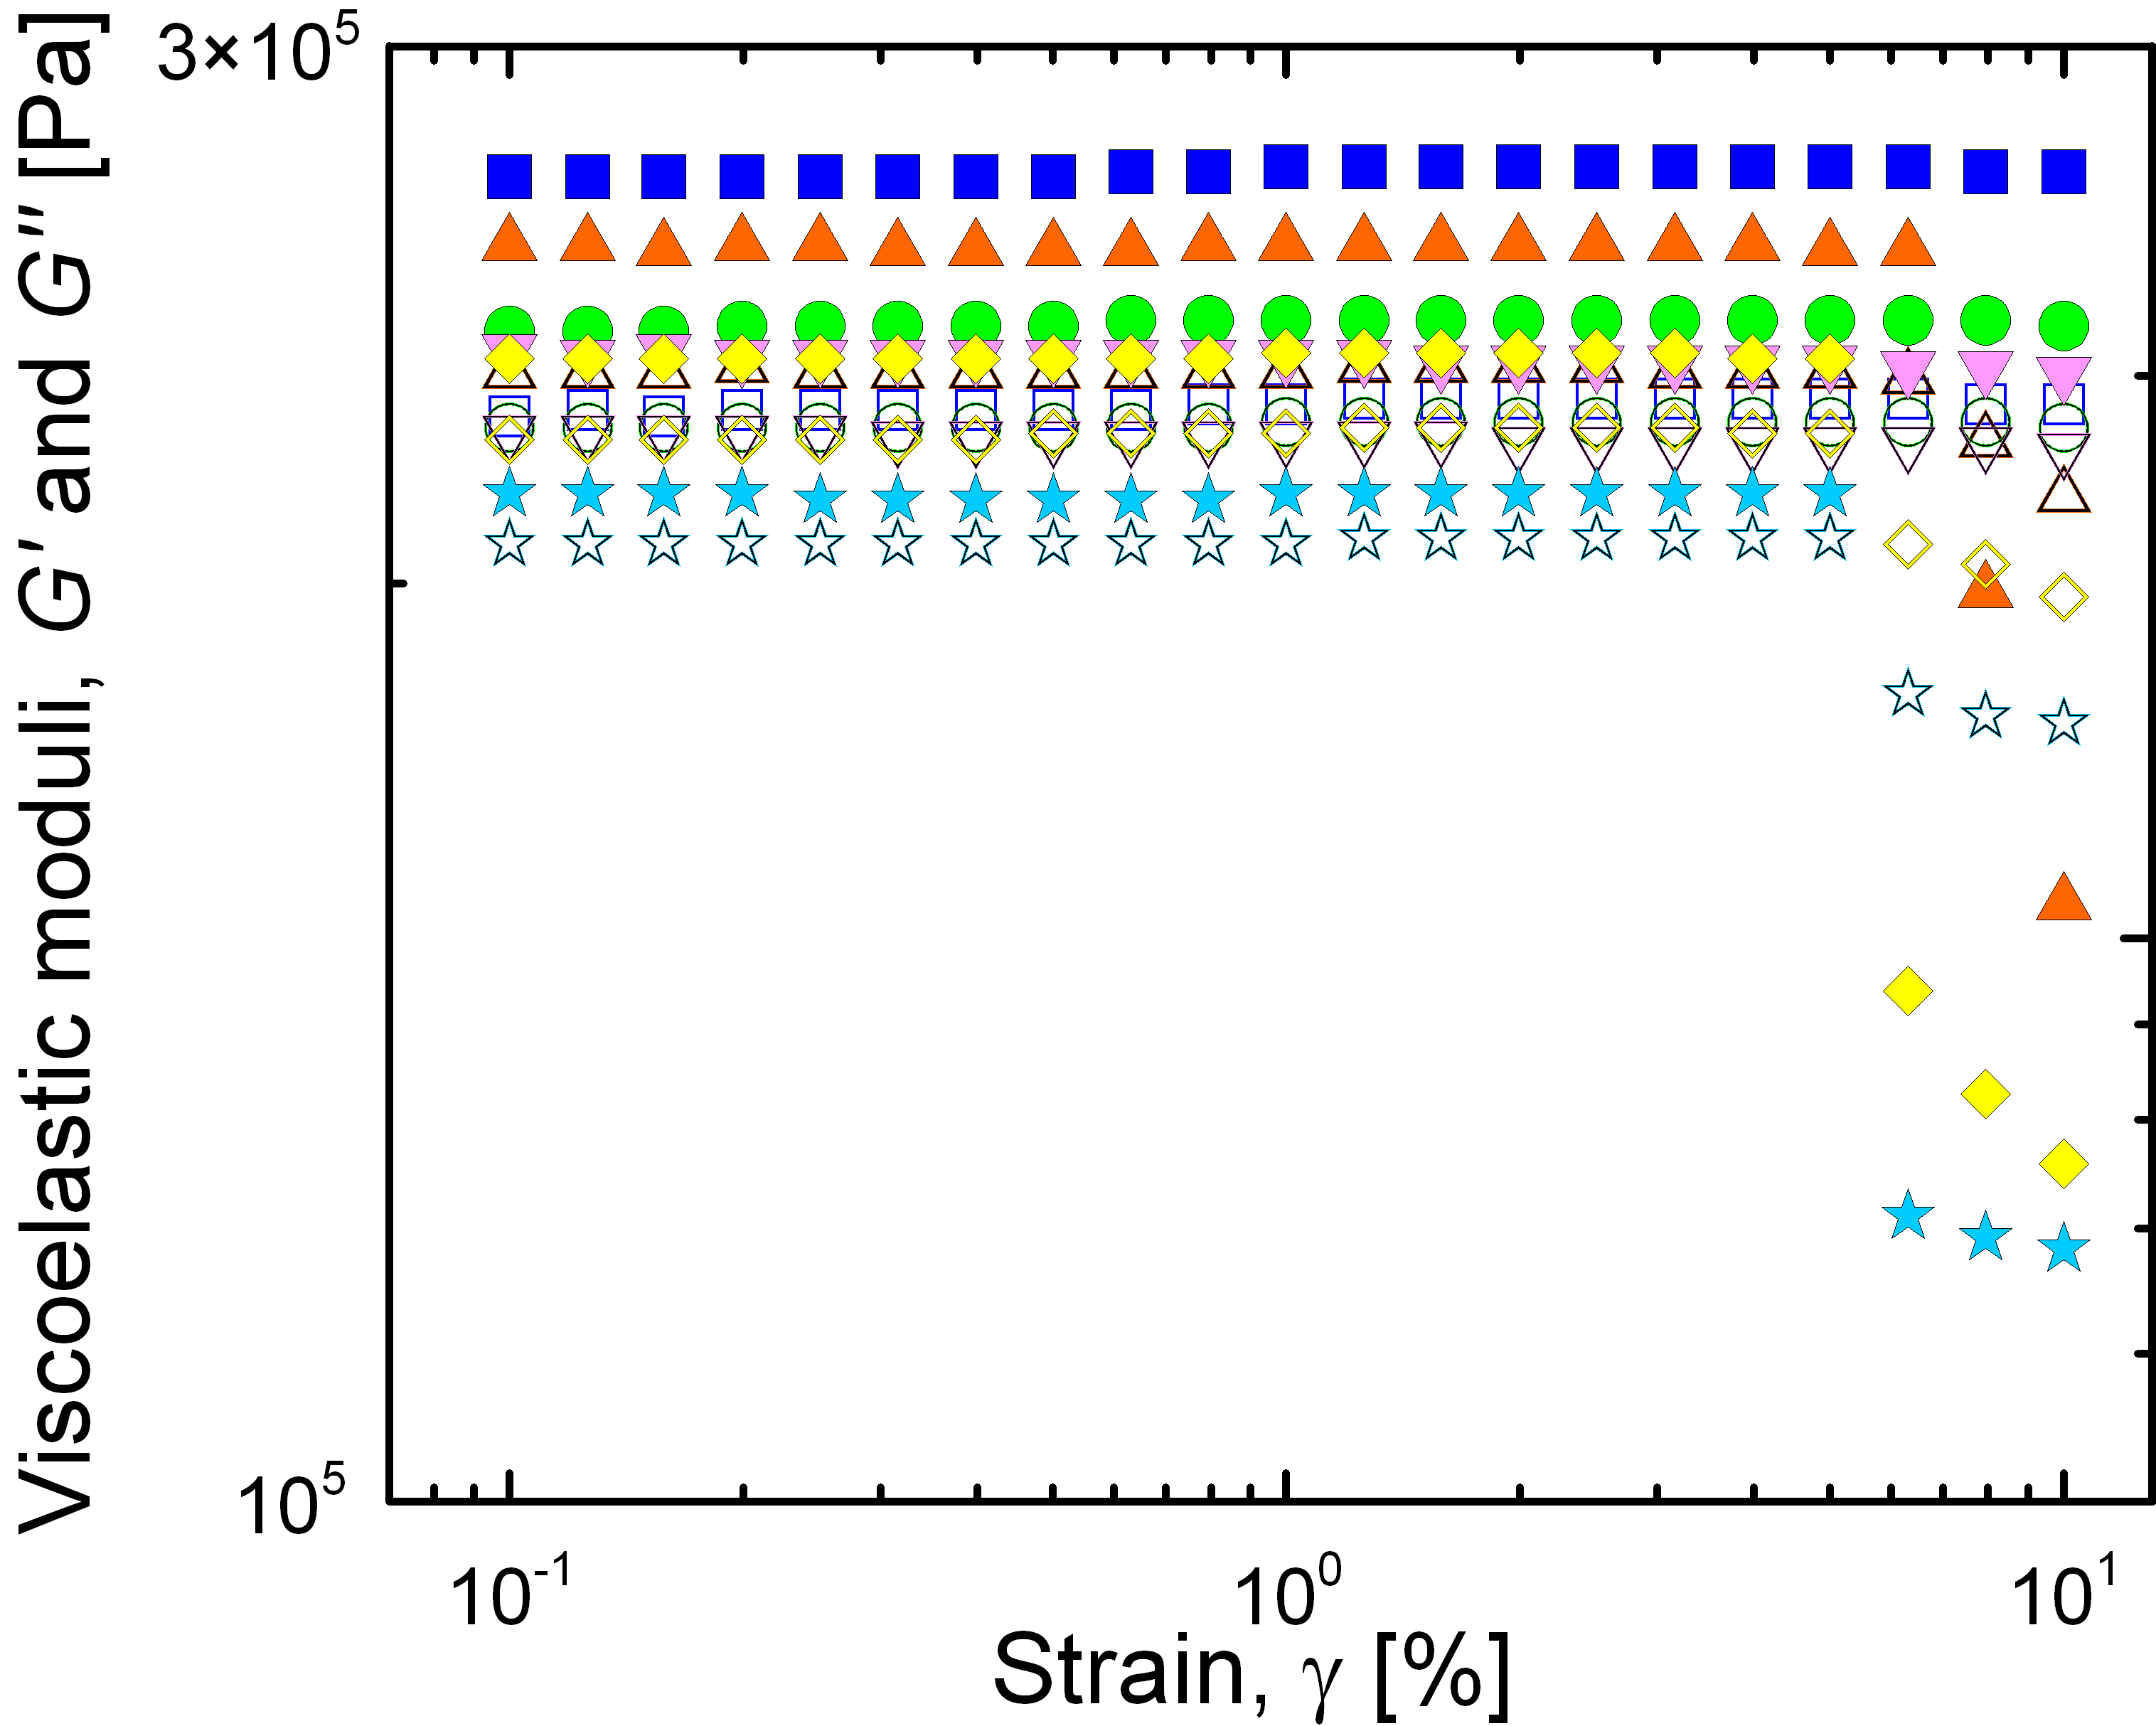
Fig. 4 Storage, G’, (solid symbols) and loss, G”, (open symbols) moduli versus strain, γ, at frequency of 10 Hz for pure PCL film and PCL/BP films containing various concentrations of BP. The symbols for BP concentration (wt.%): 0 (,), 0.5 % (,), 1 % (,), 2 % (,), 4 % (,), and 8 % (,).

For practical applications it is important to know the values of G’ and G” in LVR and their strain frequency dependence since viscoelastic moduli measured at low frequencies correspond to slow processes while viscoelastic moduli measured at high frequencies correspond to fast processes. Figure 5a shows frequency sweep in the range of frequencies 2.5 – 10 Hz (only the narrow range of frequencies where for irradiated PCL film the G’ overcomes G’’ is presented) for sample BP 0 %, i.e. pure PCL, before and after 1 hour of irradiation. In the non-irradiated sample, G” was slightly larger than G’ at low applied frequencies indicating more liquid-like character of the sample. However, the viscous response of the sample could not adapt to higher frequencies, i.e. G’ started to dominate over G”, resulting in rather solid-like character of the non-irradiated sample. Frequency sweep is an effective tool for the monitoring of curing reaction because less flexible macromolecular chains hinder the movement in molecular range and hence the domination of G’ moves to lower frequencies as the degree of curing increases. Although some changes occurred in the sample BP 0 % as the cross point of G’ and G”, i.e. the domination of elastic behavior over viscous one, slightly moved to lower frequencies after 1 hour of irradiation due to the increase in G’, it is not possible to fully assign this change to the cross-linking process.

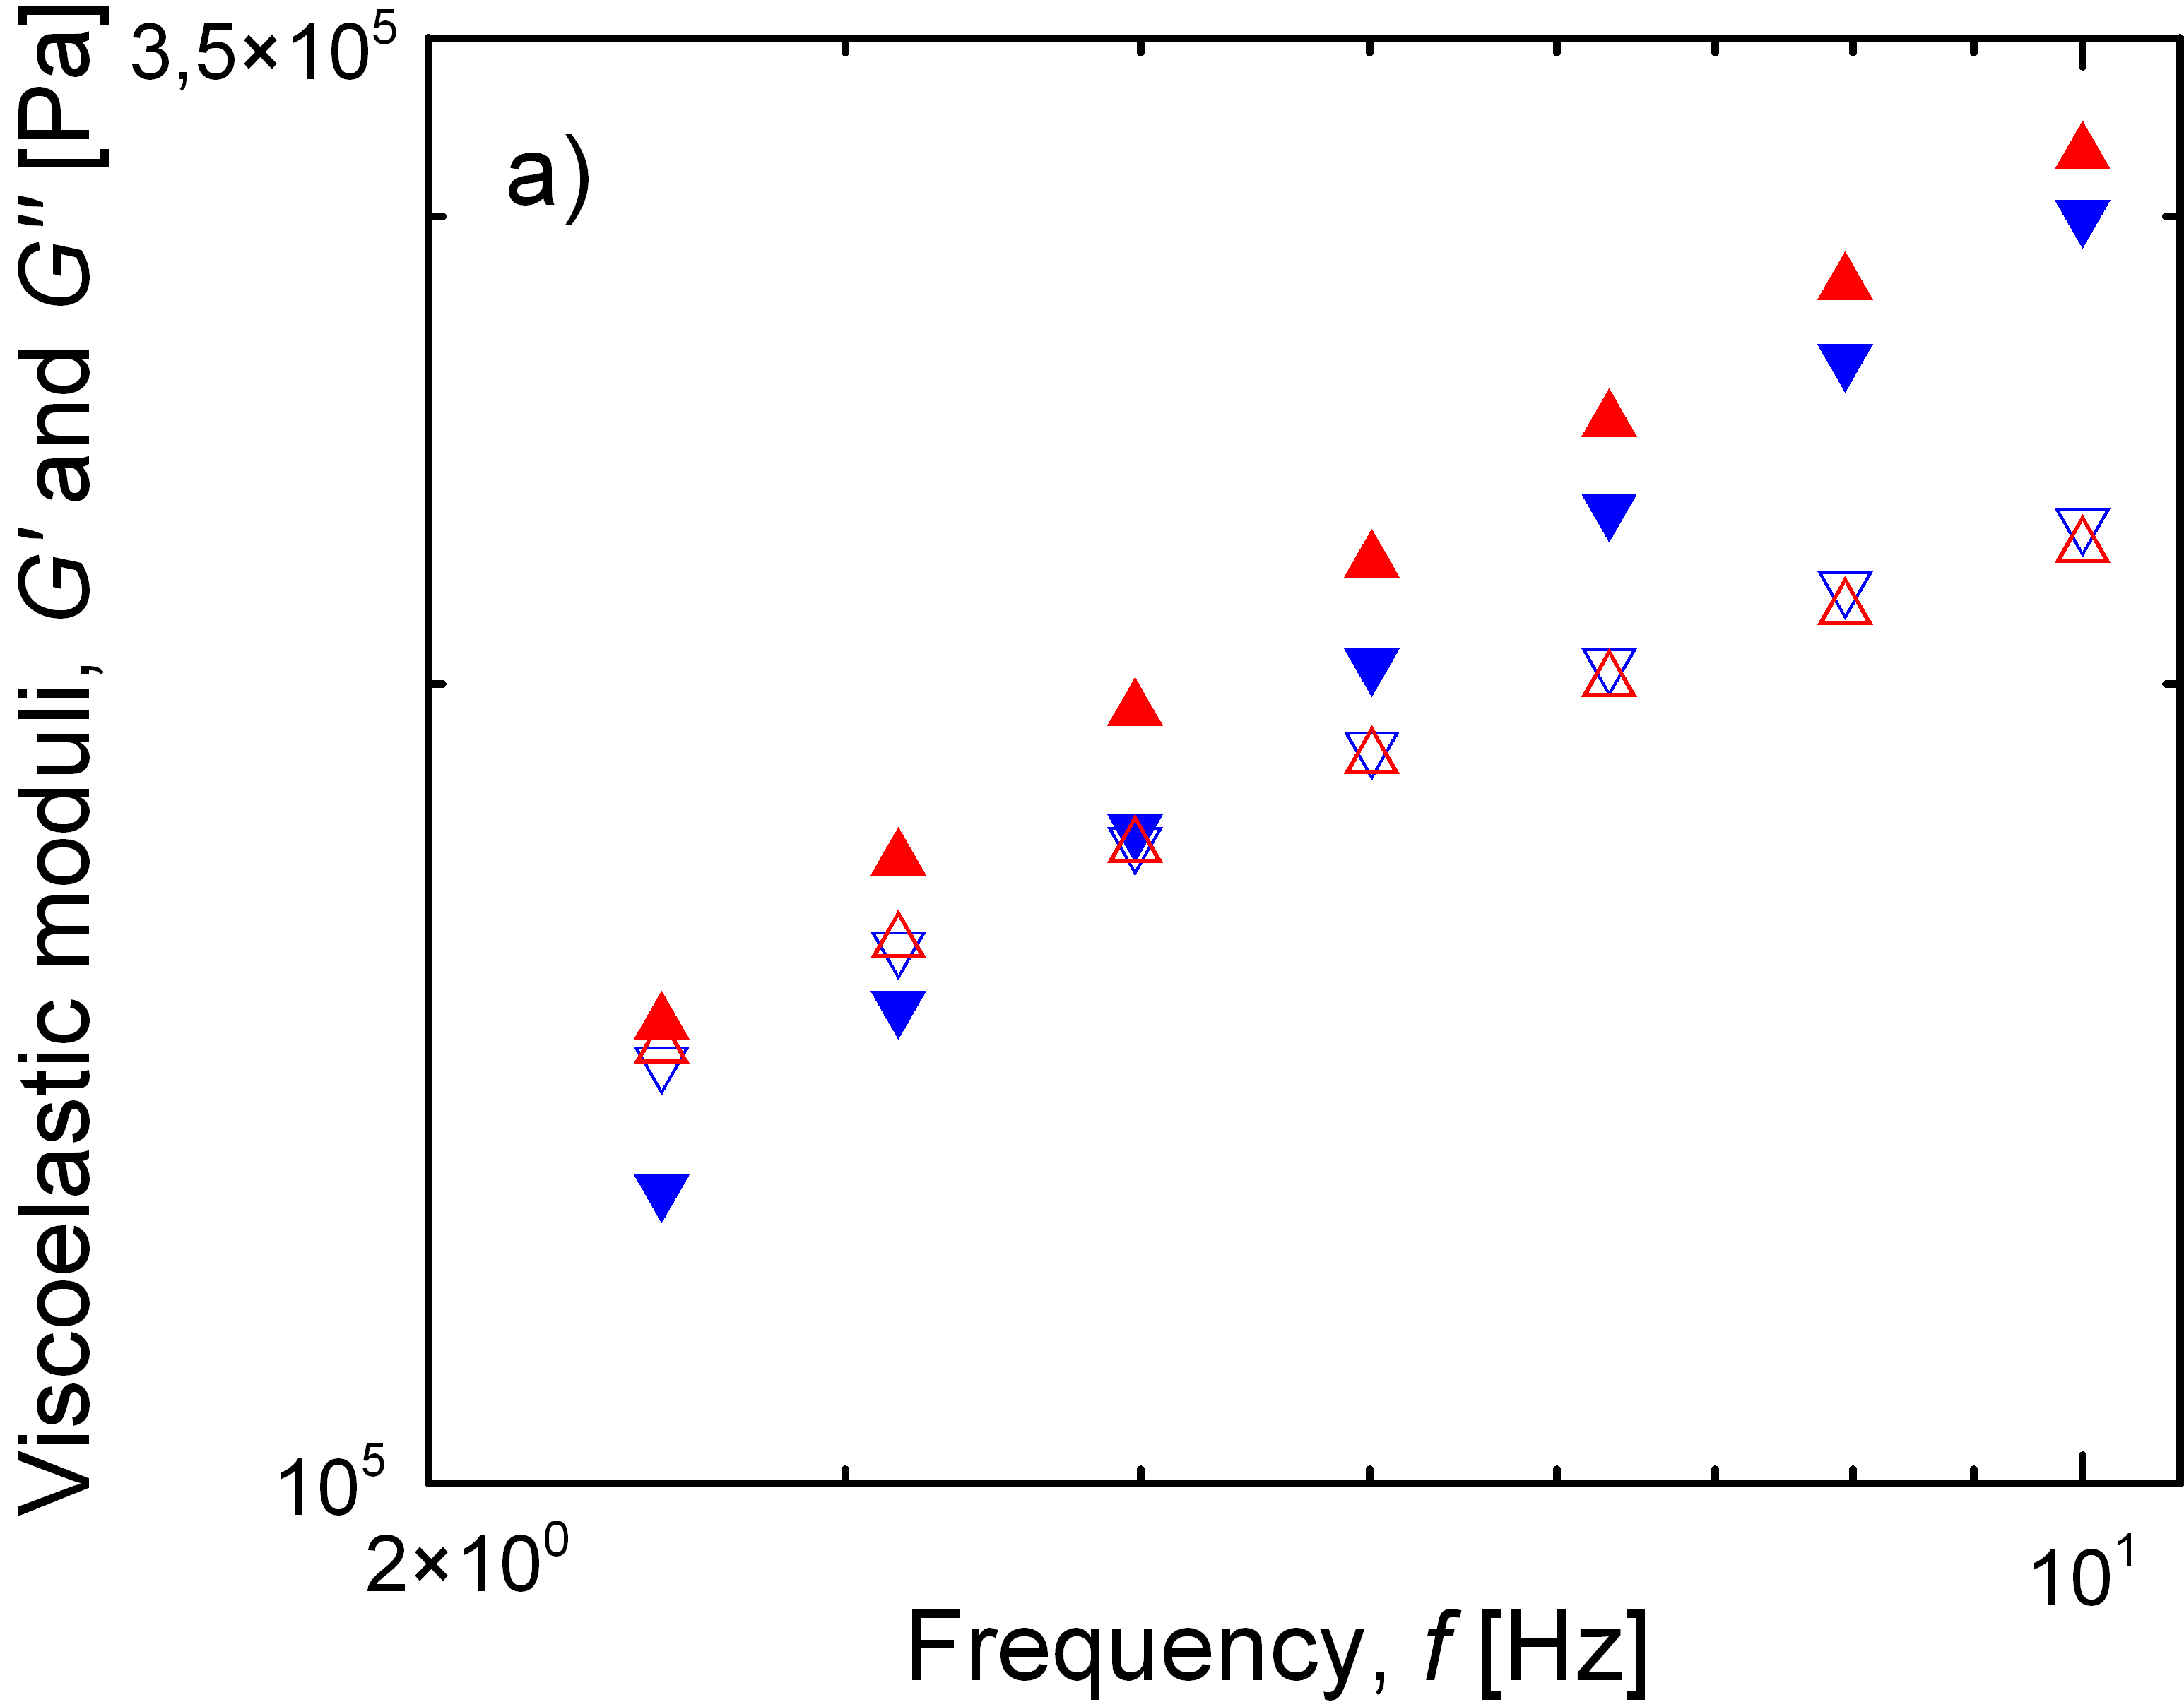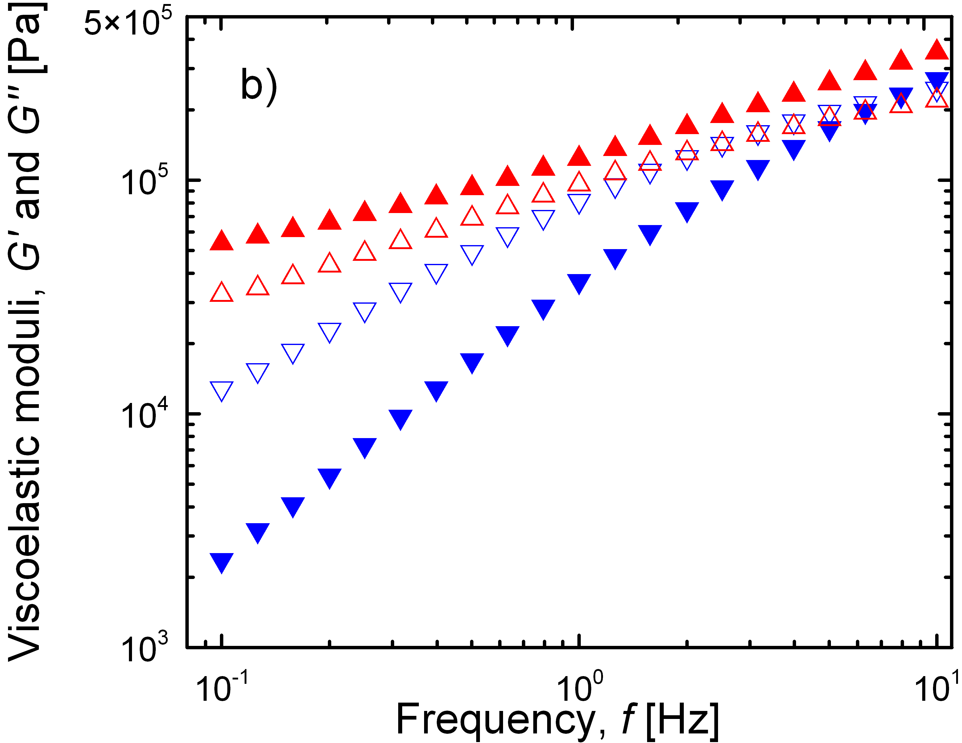
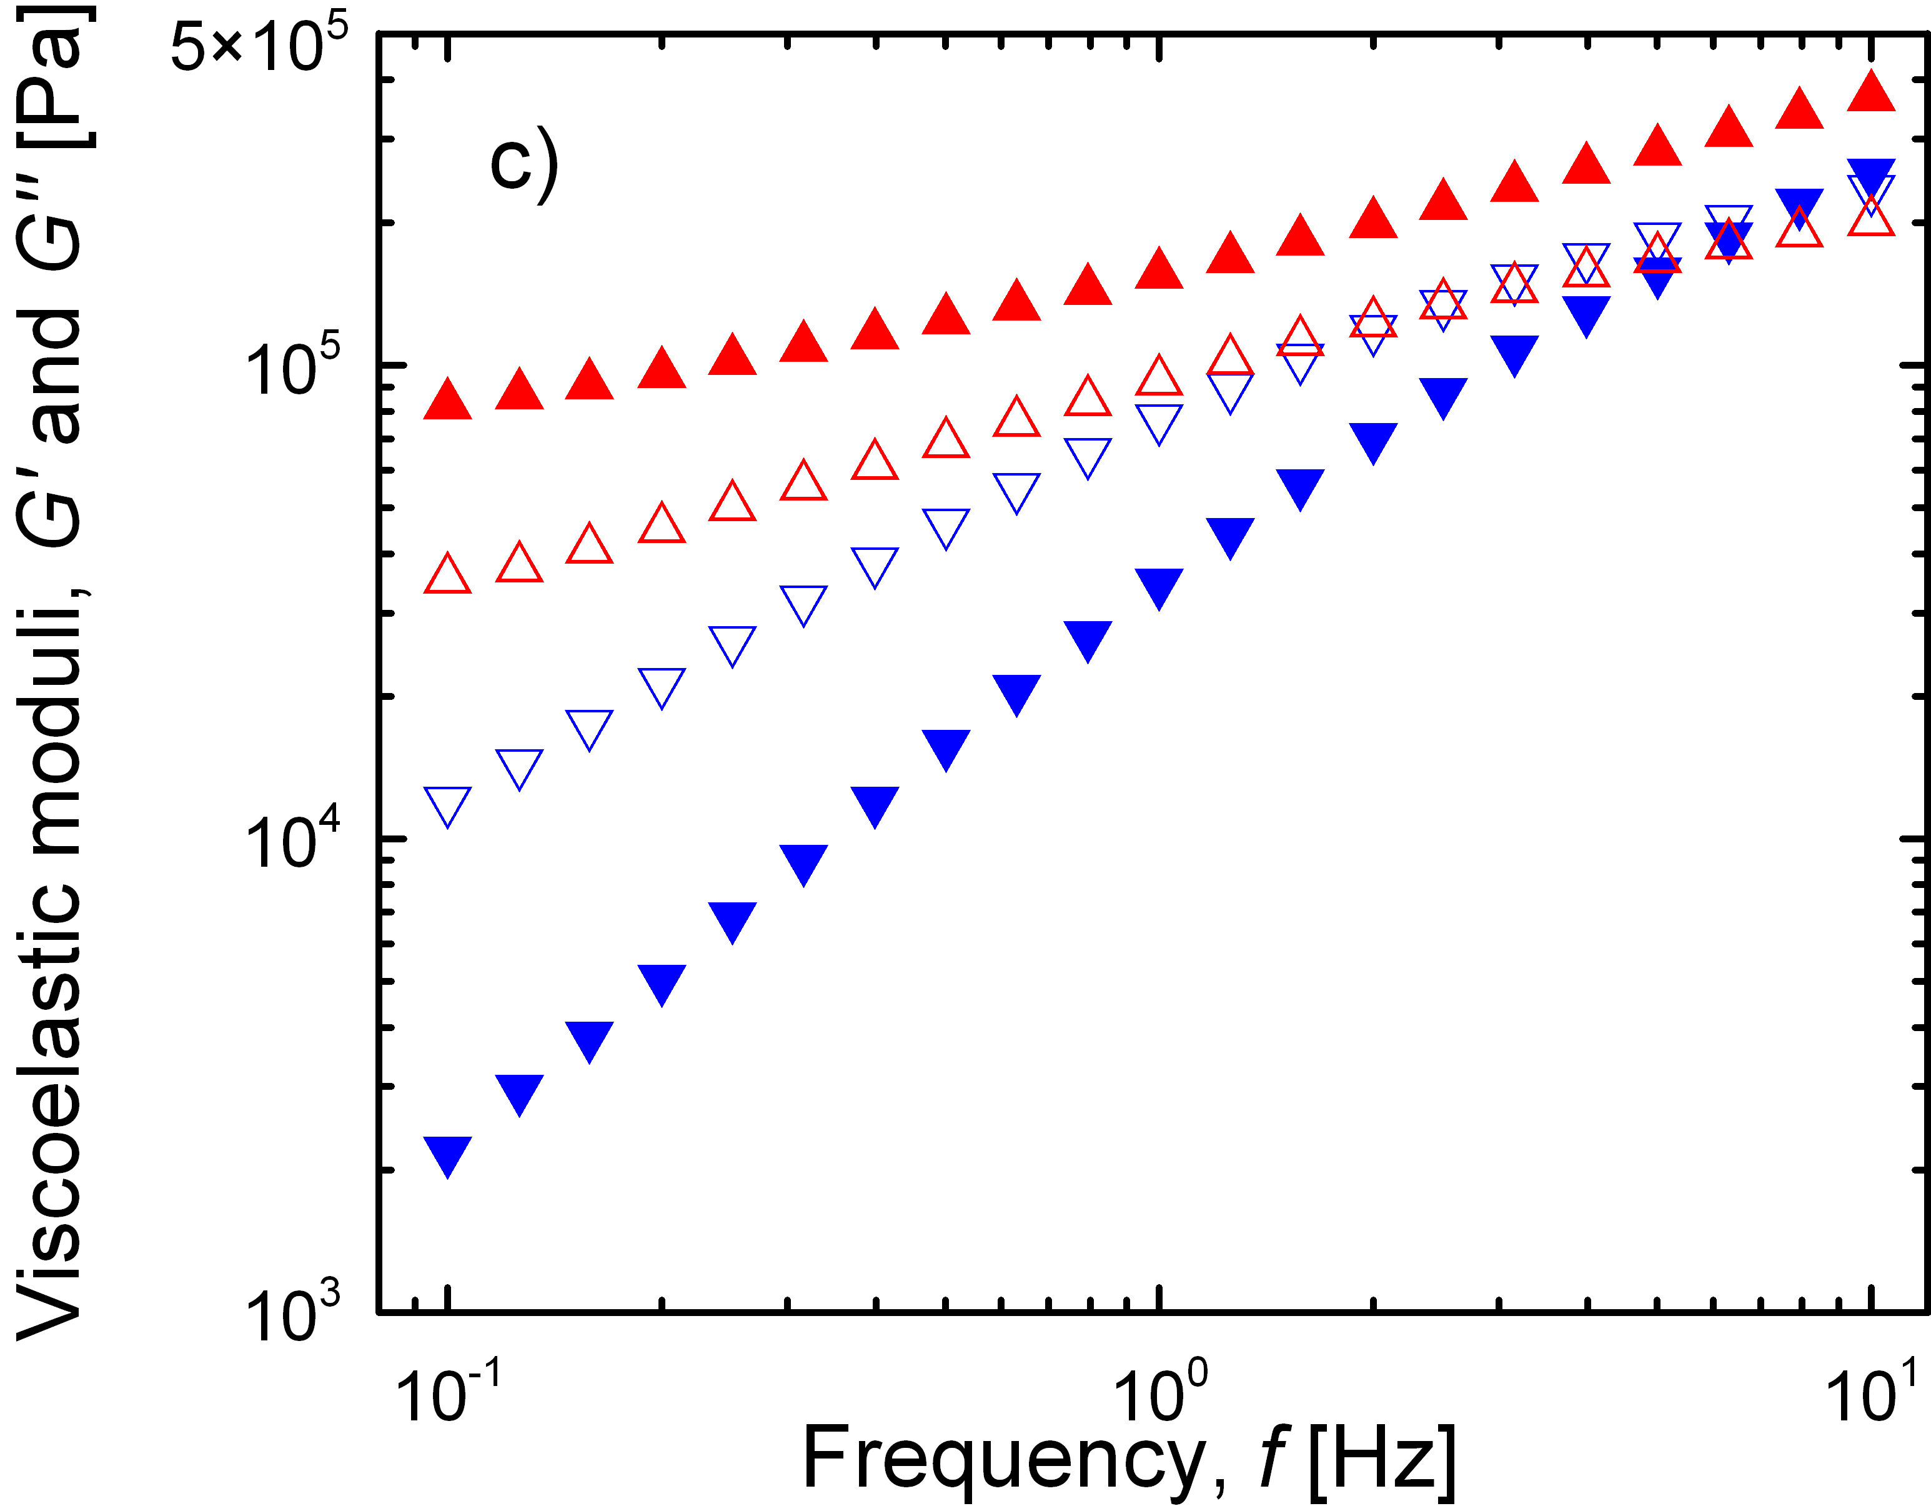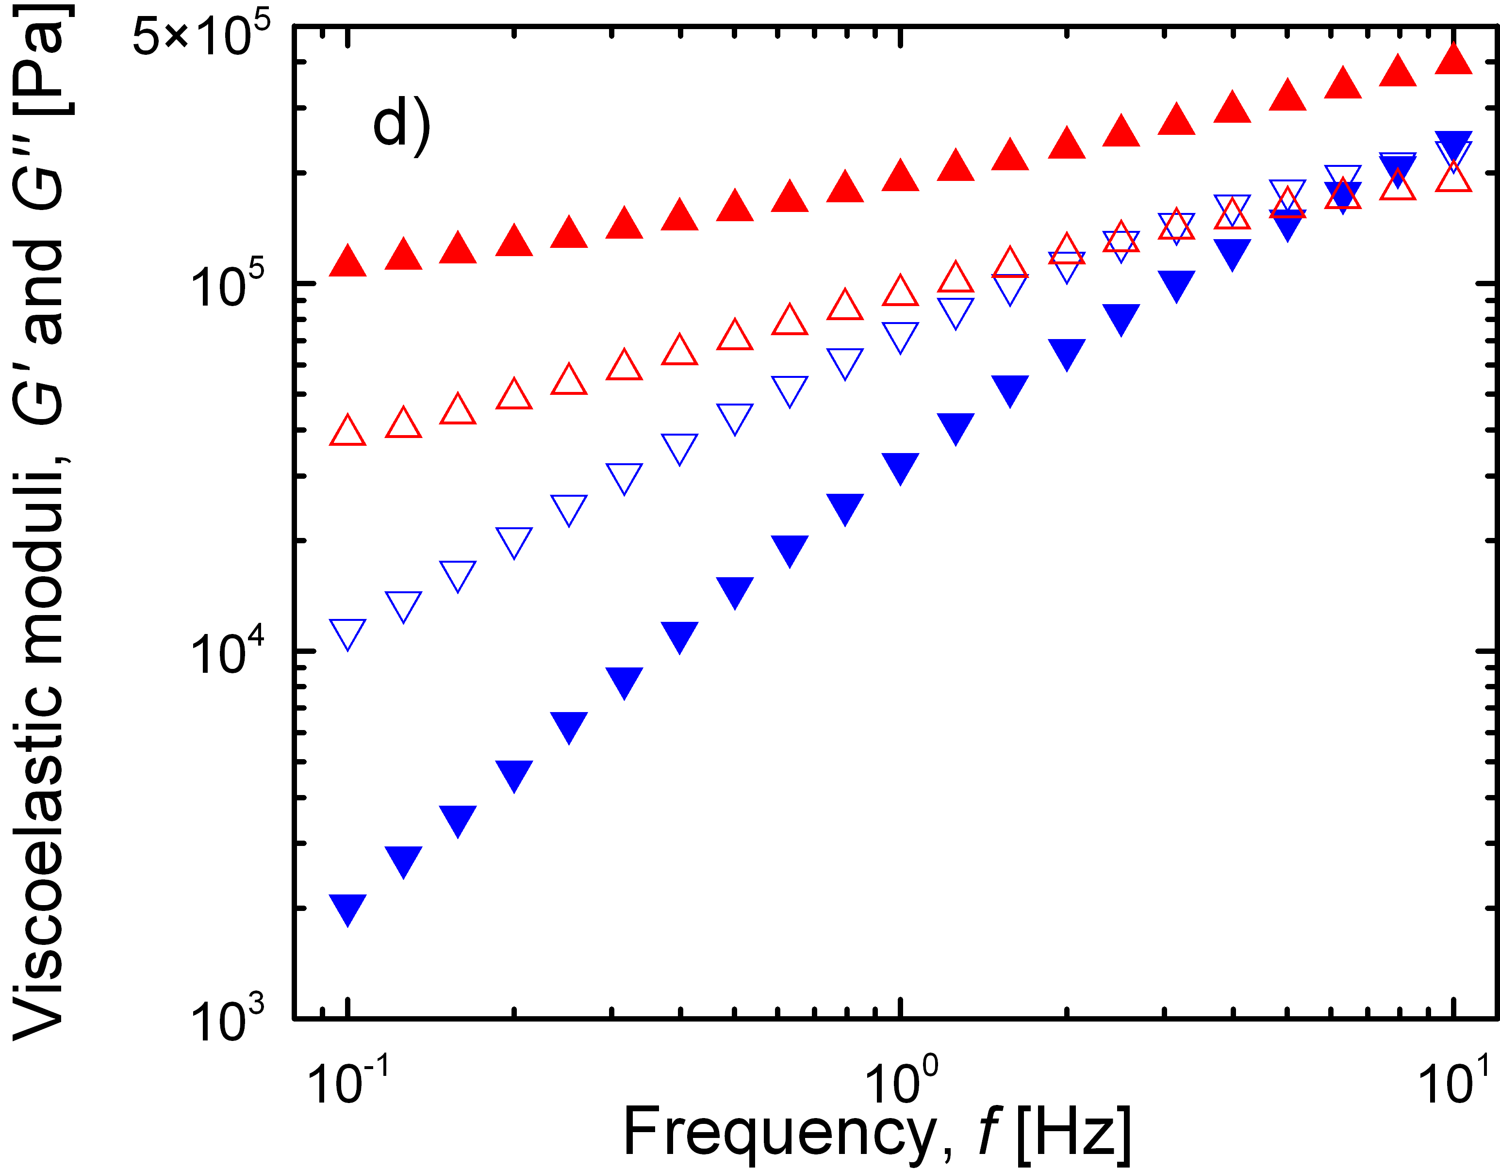
Fig. 5 Storage, G’, (solid symbols) and loss, G”, (open symbols) moduli versus frequency, f, for PCL containing a) 0 wt % BP; b) 0.5 wt% BP; c) 1 wt% BP; and d) 2 wt% BP before (,) and after 1 hour (,) of irradiation.

The cross-linking process undoubtedly occurred for all the samples containing photoactive additive BP (Fig. 5b–d). The original samples possessed the cross point of G’ and G” in the frequency range investigated, i.e. 0.1 – 10 Hz. Nevertheless, after 1 hour of irradiation the G’ became strongly dominating over G” in the whole investigated frequency range, i.e. all the samples evinced significantly higher elastic portion due to the cross-linking process. It is further evident that the ascendancy of G’ over G” increased with increasing concentration of BP up to 2 wt%. In addition, in the investigated frequency range, the slope of G’ decreased with increase of BP concentrations indicating formation of 3D internal network. For PCL films containing 4 and 8 wt% of BP the moduli after 1 hour of irradiation were similar to that ones in PCL films containing 2 wt % of BP.
Figure 6 shows real-time monitoring of photochemical processes effect on properties of PCL containing various concentrations of BP. From the development of G’ with irradiation time it is evident that the degree of curing was dependent on the concentration of BP, while the G’ retained almost unchanged during irradiation of the pure PCL. Furthermore, at studied frequency of 3.16 Hz, the cross point of G’ and G” caused by the curing occurred after around 800 s of irradiation. The time of the cross point of G’ and G” apparently decreased with the BP concentration. Only slight increase or even decrease of G’ was observed after increasing of BP concentration from 2 wt% up to 4 or 8 wt%, respectively. At low BP concentrations, the ketyl radicals, formed from BP after abstraction of one hydrogen from polymer matrix, can further abstract second hydrogen from polymer matrix to form benzhydrol. At higher concentrations, however, the concentration of the formed ketyl radicals is also higher thus increasing probability of their recombination to form benzpinacol without abstraction of the second hydrogen from the polymer matrix. Thus increase of the BP concentration over 4 wt% does not need to lead to increased crosslinking, due to higher extend of benzpinacol formation. The formation of benzpinacol was observable also in FT IR spectra in the 640 – 660 cm⁻¹ region (Fig. 1).
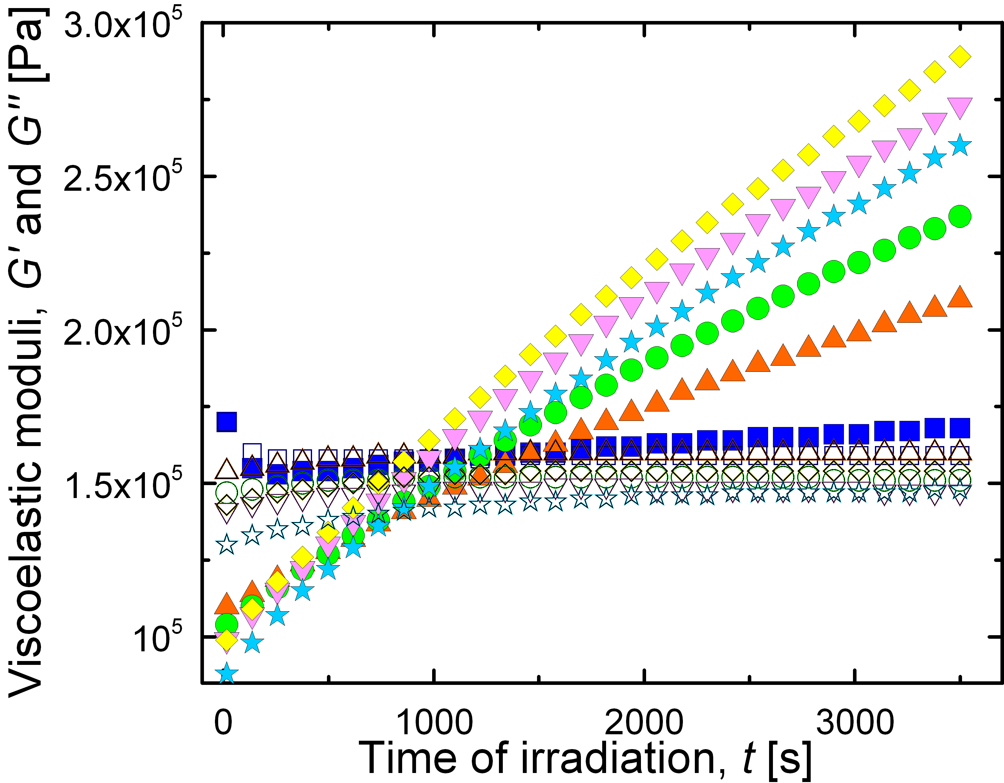
Fig. 6 Storage, G’, (solid symbols) and loss, G”, (open symbols) moduli versus time of irradiation, t, at strain 1.58 % and frequency of 3.16 Hz for PCL films with various concentration of BP. The symbols for BP concentration (wt.%): 0 (,), 0.5 % (,), 1 % (,), 2 % (,), 4 % (,), and 8 % (,).

Effect of irradiation on the crystallinity of PCL and PCL/BP films
The addition of BP to PCL films slightly decreased the crystallinity of PCL. Moreover, the changes in crystallinity of the PCL during irradiation were significantly depended on the concentration of BP in PCL matrix (Table 1). In the case of pure PCL either crystallinity or melting temperature did not show any remarkable changes during irradiation. Contrary that irradiation of PCL containing 2 or 4 wt% of BP led to the significant decrease in the PCL crystallinity. The crystallinity of PCL decreased with increasing both the irradiation time and BP concentration. That is, increasing the crosslink density due to higher concentration of BP reduced the degree of crystallinity of the PCL. Formation of crosslink junctions could disturb the reorganization and chain folding during the crystallization process resulting in formation of imperfect crystallites with smaller size. The same behavior was reported in [29,34] for crosslinking of PE and PCL by peroxides.

Table 1 Changes of melting temperature and crystallinity of PCL films with time of irradiation and BP concentration.
Irradiation time  (min) | Melting temperature (°C) / Crystallinity ^{a)} (%)
Irradiation time  (min) | pure PCL | 2 wt% BP | 4 wt% BP
0 | 57.6 / 53.3 | 56.2 / 49.4 | 53.4 / 50.3
30 | 57.5 / 51.6 | 55.3 / 45.9 | 55.7 / 41.1
60 | - | 54.8 / 43.3 | 56.0 / 38.5
90  120 | 57.5 / 52.5  57.8 / 52.3 | -  54.1 / 39.9 | 57.7 / 34.5  57.2 / 34.5
^{a)} 100 % crystallinity represents 157 J/g

Hydrolysis of the irradiated PCL/BP films
Both the changes in molecular characteristics and increase in polar groups in FTIR spectra observed for PCL/BP films after irradiation could also affect the rate of hydrolytic degradation of the irradiated PCL/BP films. Therefore a basic hydrolysis of the PCL films irradiated for 1.5 hour in the presence of 0.5, 1, 2 and 4 wt% of BP as an additive at λ > 350 nm was investigated. The hydrolysis results were compared to hydrolysis of unirradiated pure PCL film. Hydrolysis was followed by determination of the extractable products and changes in the gel content. Amount of extractable products was determined from the difference of the weight of the polymer film obtained before and after hydrolysis. Figure 7a shows that surprisingly, the rate of the weight loss of the irradiated PCL/BP films increased with increasing BP concentration. Moreover, despite the crosslinking of the PCL/BP films after irradiation, the weight loss during their hydrolysis was faster than for pure PCL film. These results could be explained by faster penetration of water to the PCL film due to present polar groups formed during irradiation of PCL/BP films.
Figure 7b shows that the gel content in the irradiated PCL/BP films decreased with time of hydrolysis. Moreover, faster decrease was observed in the case of PCL containing originally higher amount of the BP, probably due to higher oxidation of PCL chains during photochemical transformation of BP. This is in good agreement with faster weight loss during hydrolysis of irradiated PCL/BP films containing originally higher BP concentrations.

Fig. 7 Changes in amount of extractable products (a) and the gel content (b) during the hydrolysis of pure not irradiated PCL film and irradiated PCL films containing various concentration of BP. The PCL/BP films were irradiated for 90 min at λ > 350 nm and the hydrolysis was performed in 1M NaOH solution at 25 °C.

Conclusions
The effect of the irradiation (λ > 350 nm) of PCL film doped with various concentration of BP on the molecular characteristics of the PCL matrix was studied. GPC spectra showed significant changes in molecular characteristics of PCL doped with BP, including both chains scissions and macroradical recombinations, after a short irradiation time. The recombination reactions in PCL doped with BP prevailed over PCL chain scission reactions leading to gel formation. The real-time monitoring of the photochemically induced processes using rheological investigations under oscillatory shear measurements proved formation of the 3D internal network in the PCL films doped with BP. The results of increasing crosslinking with increasing BP concentration observed in frequency sweep were confirmed in real-time experiments since the elastic portion increased proportionally. Contrary that almost no changes occurred in pure polymer sample during irradiation. The crystallinity of the PCL films doped with BP progressively decreased with irradiation time. Despite the crosslinking, the rate of hydrolytic degradation of the photochemically treated PCL doped with BP was higher than for pure not irradiated PCL. Thus doping of PCL with only 0.5 wt% of BP and subsequent irradiation at λ > 350 nm can give a crosslinked material with good viscoelastic properties even at high temperatures and with retained good hydrolytic degradability for wide range of new biomedical and/or ecofriendly applications.

Acknowledgement
The authors thank for the financial support to the Slovak Research and Development Agency for financial support through the grant APVV-0109-10, the Grant Agency VEGA through Grant 2/0112/13 as well as the Centre of Excellence SAS for Functionalized Multiphase Materials (FUN-MAT). This research was also carried out with support of the Operational Program Research and Development for Innovations co-funded by the European Regional Development Fund (ERDF) and national budget of the Czech Republic, within the framework of the Centre of Polymer Systems project (CZ.1.05/2.1.00/03.0111).

References
[1] Woodruff MA, Hutmacher DW. The return of a forgotten polymer—Polycaprolactone in the 21st century. Prog Polym Sci, 2010;35:1217-1256.
[2] Tsuji H, Mizuno A, Ikada Y. Blends of aliphatic polyesters. III. Biodegradation of solution-cast blends from poly(L-lactide) and poly(ε-caprolactone). J Appl Polym Sci. 1998;70:2259-2268.
[3] Fields RD, Rodriguez F, Finn RK. Microbial degradation of polyesters: Polycaprolactone degraded by P. pullulans. J Appl Polym Sci. 1974;18:3571-3579.
[4] Tsuji H, Ikada Y. Blends of aliphatic polyesters. II. Hydrolysis of solution-cast blends from poly(L-lactide) and poly(ε-caprolactone) in phosphate-buffered solution. J Appl Polym Sci. 1998;67:405-415.
[5] Pitt CG, Chasalow FI, Hibionada YM, Klimas DM, Schindler A. Aliphatic polyesters. I. The degradation of poly(ε-caprolactone) in vivo. J Appl Polym Sci. 1981;26:3779-3787.
[6] Bei J, He W, Hu X, Wang S. Photodegradation behavior and mechanism of block copoly(caprolactone-ethylene glycol). Polym Degrad Stab. 2000;67:375-380.
[7] Filipczak K, Wozniak M, Ulanski P, Olah L, Przybytniak G, Olkowski RM, et al. Poly(ε-caprolactone) Biomaterial Sterilized by E-Beam Irradiation. Macromol Biosci. 2006;6:261-273.
[8] Middleton JC, Tipton AJ. Synthetic biodegradable polymers as orthopedic devices. Biomaterials. 2000;21:2335-2346.
[9] Nair LS, Laurencin CT. Biodegradable polymers as biomaterials. Prog Polym Sci.32:762-798.
[10] Leinonen S, Suokas E, Veiranto M, Törmälä P, Waris T, Ashammakhi N. Holding Power of Bioabsorbable Ciprofloxacin-Containing Self-reinforced Poly-L/DL-lactide 70/30 Bioactive Glass 13 Miniscrews in Human Cadaver Bone. J Craniofac Surg. 2002;13:212-218.
[11] Narkis M, Sibony-Chaouat S, Siegmann A, Shkolnik S, Bell JP. Irradiation effects on polycaprolactone. Polymer. 1985;26:50-54.
[12] Abdel-Rehim HA, Yoshii F, Kume T. Modification of polycaprolactone in the presence of polyfunctional monomers by irradiation and its biodegradability. Polym Degrad Stab. 2004;85:689-695.
[13] Ikada E. Photo- and Bio-degradable Polyesters. Photodegradation Behaviors of Aliphatic Polyesters. J. Photopolym Sci. Technol. 1997;10:265-270.
[14] Ikada E. Relatioship between Photodegradability and Biodegradability of Some Aliphatic Polyesters. J. Photopolym Sci. Technol. 1999;12:251-256.
[15] Wang SF, Yaszeski MJ, Gruetzmacher JA, Lu LC. Photocrtosslinked poly(ε-caprolactone fumarate networks: Roles of crystallinity and crosslinking density in determining mechanical properties. Polymer. 2008;49:5692-5699.
[16] Elomaa L, Teixeira S, Hakala R, Korhonen H, Grijpma DW, Seppälä JV. Preparation of poly(ε-caprolactone)-based tissue engineering scaffolds by stereolytography. Acta Biomater. 2011;7:3850-3856.
[17] Kweon HY, Yoo MK, Park IK, Kim TH, Lee HC, Lee H-S, Oh J-S, Akaike T, Cho C-S. A novel degradable polycaprolactone networks for tissue engineering. Biomatrerials. 2003;24:801-808.
[18] Ferreira P, Coelho JFJ, Gil MH. Development of a new photocrosslinkable biodegradable bioadhesive. Int. J. Pharm. 2008;352:172-181.
[19] Deng J, Wang L, Liu L, Yang W. Developments and new applications of UV-induced surface graft polymerizations. Prog. Polym Sci. 2009;34:156-193.
[20] Allen NS, Catalina F, Green PN, Green WA. Photochemistry of carbonyl photoinitiators. Photopolymerisation, flash photolysis and spectroscopic study. Eur Polym J. 1986;22:49-56.
[21] Temel G, Enginol B, Aydin M, Balta DK, Arsu N. Photopolymerization and photophysical properties of amine linked benzophenone photoinitiator for free radical polymerization. J Photochem Photobiol A-Chem. 2011;219:26-31.
[22] Wang Y, Jiang X, Yin J. Novel polymeric photoinitiators comprising of side-chain benzophenone and coinitiator amine: Photochemical and photopolymerization behaviors. Eur Polym J. 2009;45:437-447.
[23] Chen YL, Rånby B. Photocrosslinking of polyethylene. I. Photoinitiators, crosslinking agent, and reaction kinetics. J Polym Sci A-Polym Chem Ed. 1989;27:4051-4075.
[24] Qu B, Xu Y, Shi W, Raanby B. Photoinitiated crosslinking of low-density polyethylene. 7. Initial radical reactions with model compounds studied by spin-trapping ESR spectroscopy. Macromolecules. 1992;25:5220-5224.
[25] Qu B, Xu Y, Ding L, Rånby B. A new mechanism of benzophenone photoreduction in photoinitiated crosslinking of polyethylene and its model compounds. J Polym Sci A-Polym Chem Ed. 2000;38:999-1005.
[26] Bei JZ, Hu XZ, Ma ZM, Wang SG. Photodegradation Behavior of Polycaprolactone-Poly(ethylene glycol) Block Copolymer. Chin Chem Lett. 1999;10:327-330.
[27] Mosnáček J, Borská K, Danko M. Photochemically promoted degradation of poly( 3-caprolactone) film. Mater Chem Phys. 2013;140:191-199.
[28] Homminga D, Goderis B, Dolbnya I, Groeninckx G. Crystallization behavior of polymer/montmorillonite nanocomposites. Part II. Intercalated poly(3-caprolactone)/montmorillonite nanocomposites. Polymer. 2006;47:.1620-1629.
[29] Khonakdar HA, Morshedian J, Mehrabzadeh M and Jafari SH. An investigation of chemical crosslinking effect on properties of high-density polyethylene. Polymer. 2003;44:4301-4309.
[30] Sabino MA. Oxidation of polycaprolactone to induce compatibility with other degradable polyesters. Polym Degrad Stab. 2007;92:986-996.
[31] Scully AD, Horsham MA, Aguas P, Murphy JKG. Transient products in the photoreduction of benzophenone derivatives in poly(ethylene-vinyl alcohol) film. J Photochem Photobiol A-Chem. 2008;197:132-140.
[32] Viltres Costa C, Grela MA, Churio MS. On the yield of intermediates formed in the photoreduction of benzophenone. J Photochem Photobiol A-Chem. 1996;99 51-56.
[33] Salmassi A, Schnabel W. Photochemistry in solid matrices: Laser flash photolysis of benzophenone in polymethyl-methacrylate and polystyrene matrices. Polym Photochem. 1984;5:215-230.
[34] Han C, Ran X, Su X, Zhang K, Liu N and Dong L. Effect of peroxide crosslinking
on thermal and mechanical properties of poly(ε-caprolactone). Polym Int. 2007;56:593-600.

FIGURE CAPTIONS
Fig. 1 FT-IR absorption spectra of 7 wt% BP in PCL matrix irradiated for various time at λ> 350 nm. Changes of carbonyl absorption of BP at 1660 cm⁻¹ and region of –CH absorption of BP phenyl ring at 640 cm⁻¹ are showed. The spectrum of benzpinacol, as a one of the product of BP photochemical transformation, in PCL is shown as well.
Fig. 2 GPC traces of PCL/BP (1 wt% BP) irradiated for various time at λ >350 nm.
Fig. 3 Evolution of a) molar mass (M_{n}) of soluble part of PCL and b) formed gel content with irradiation time for PCL films containing various concentration of BP.
Fig. 4 Storage, G’, (solid symbols) and loss, G”, (open symbols) moduli versus strain, γ, at frequency of 10 Hz for pure PCL film and PCL/BP films containing various concentrations of BP. The symbols for BP concentration (wt.%): 0 (,), 0.5 % (,), 1 % (,), 2 % (,), 4 % (,), and 8 % (,).
Fig. 5 Storage, G’, (solid symbols) and loss, G”, (open symbols) moduli versus frequency, f, for PCL containing a) 0 wt % BP; b) 0.5 wt% BP; c) 1 wt% BP; and d) 2 wt% BP before (,) and after 1 hour (,) of irradiation.
Fig. 6 Storage, G’, (solid symbols) and loss, G”, (open symbols) moduli versus time of irradiation, t, at strain 1.58 % and frequency of 3.16 Hz for PCL films with various concentration of BP. The symbols for BP concentration (wt.%): 0 (,), 0.5 % (,), 1 % (,), 2 % (,), 4 % (,), and 8 % (,).
Fig. 7 Changes in amount of extractable products (a) and the gel content (b) during the hydrolysis of pure not irradiated PCL film and irradiated PCL films containing various concentration of BP. The PCL/BP films were irradiated for 90 min at λ > 350 nm and the hydrolysis was performed in 1M NaOH solution at 25 °C.

