Carbonization of aniline oligomers to electrically polarizable particles and their use in electrorheology
T. Plachy ^{a,b}, M. Sedlacik ª, V. Pavlinek ª, M. Trchová ^{c} , Z. Morávková ^{c}, J. Stejskal ^{c}
ªCentre of Polymer Systems, University Institute, Tomas Bata University in Zlin, Nad Ovcirnou 3685, 760 01 Zlin, Czech Republic
^{b}Polymer Centre, Faculty of Technology, Tomas Bata University in Zlin, T. G. Masaryk Sq. 275, 762 72 Zlin, Czech Republic
^{c}Institute of Macromolecular Chemistry, Academy of Sciences of the Czech Republic, Heyrovsky Sq. 2, 162 06 Prague 6, Czech Republic
ABSTRACT
Aniline oligomers prepared via the oxidation of aniline under alkaline conditions at various concentrations of ammonia were carbonized at 650 °C in inert atmosphere. Subsequently, the prepared particles were mixed with silicone oil and the suspensions were used as electrorheological fluids. After the carbonization, when the higher amount of ammonia was present during the synthesis, the transition of morphology of the particles from microspheres to two-dimensional plates was observed. This transition led to a significant increase of viscosity of silicone-oil suspensions in the presence of external electric field, while their field-off viscosity remained nearly unchanged. Thus, the carbonization had the desired effect on the treated particles leading to extremely high electrorheological efficiency of the suspensions based on such particles. The highest electrorheological efficiency was achieved for the suspension based on carbonized particles prepared in 0.2 M ammonia. The dielectric spectroscopy was used as an evaluative tool of electrorheological performance of suspensions, and data correspond well with the obtained results from electrorheological experiments.
KEYWORDS: Aniline; Aniline oligomers; Carbonization; Electrorheology; Dielectric spectroscopy; Vibration spectroscopy
- Introduction
Electrorheological (ER) fluids are known as liquids altering their rheological parameters by application of an external electric field. Mostly, ER fluids are suspensions consisting of solid electrically polarizable particles dispersed in insulating liquid. In the absence of an external electric field, particles are randomly distributed within the suspension. However, when an electric field is applied, particles start to create highly organized structures due to the interaction of induced dipoles. This formation of chains and column-like structures spanning the gap between electrodes is accompanied by an abrupt increase in viscoelastic moduli and viscosity, and suspensions start to act as Bingham fluids because electrostatic forces start to dominate over hydrodynamic ones. These changes are completely reversible and fast (within milliseconds). In the presence of an external electric field, particles are oriented along the electric field direction thanks to dipole–dipole interaction. This phenomenon is called the ER effect. It is assumed that interfacial polarization and conductivity of the particles are dominant factors on the ER performance of ER suspensions [1]. Thanks to their unique properties, ER suspensions have been proposed for many applications, mainly in hydraulics and robotics, e.g., as dampers, clutches, torque transducers, in haptic masters for minimally invasive surgery systems [2] or haptic displays [3]. Both inorganic [4] and organic [5] materials have been used as a dispersed phase in ER suspensions. Also the composites consisting of combination of inorganic and organic materials were introduced [6, 7]. The group of organic materials is particularly represented by conducting polymers. Among them polyaniline (PANI) [8, 9] and polypyrrole [10] are of special interest. Polyaniline, as a material for electrorheology, has been reported in many scientific papers due to its easy and inexpensive synthesis [5, 8, 11-18]. Moreover, aniline-like oligomers with tuneable conductivities prepared by different reaction conditions or reaction substances have been introduced [19-21].
Conducting polymers, such as PANI, are unique among polymers in their ability to produce a variety of nanostructures [22, 23]. Conducting PANI is produced by the oxidation of aniline with ammonium peroxydisulfate under acidic conditions. When oxidation of aniline is started under alkaline conditions, non-conducting aniline oligomers are produced as microspheres of several micrometres in diameter [24]. Their molecular structure is open to discussion but it is assumed that they are represented by condensed aniline molecules including oxygen atoms resulting from hydrolytic processes (Fig. 1). These are the objects of present study.
N
H
2
N
O
N
H
N
H
N
H
2
oxidation
Fig. 1 – A possible structure of aniline oligomers.
In recent studies, conducting polymers have been exposed to elevated temperature in inert atmosphere in order to obtain carbonaceous nitrogen-enriched structures [25-30]. In some cases, this treatment has positively influenced the ER performance of suspensions based on these materials.
Morávková et al. [31] have prepared carbonized aniline oligomers obtained by the oxidation of aniline under alkaline conditions. After the carbonization, the transition of morphology from microspheres into two-dimensional plates was observed. This phenomenon has been explained as a consequence of a transition, when the liquid content of the microspheres is rejected outside the microspheres above 200 °C and self-assembles into plates. In electrorheology, closely related aniline-like oligomers have been studied by Mrlik et al. [20]; however, there is no mention about their carbonized analogues.
Yin et al. [32] have introduced an ER suspension based on graphene-supported carbonaceous sheets, which has shown significantly higher increase in viscosity in the presence of the external electric field in comparison with carbonized PANI particles, which possess globular shape. However, there is a lack of studies which would describe ER behaviour of two-dimensional carbonaceous enriched plates. Therefore, this study deals with aniline oligomers prepared under alkaline conditions and their subsequent carbonization at 650 °C, which lead in some cases to creation of two-dimensional plates.
- Experimental
  - Synthesis of aniline oligomers
Aniline (0.2 M; Sigma Aldrich) was oxidized with ammonium peroxydisulfate (0.2 M; Lach:Ner, Czech Republic) in the aqueous solutions of 0.1, 0.2, 0.5, 1 and 2 M ammonium hydroxide (NH₄OH; Lach:Ner, Czech Republic) or in water at room temperature. Solutions of the monomer and the oxidant in water were mixed at room temperature to start the oxidation. So-prepared particles are labelled as 0.1, 0.2, 0.5, 1, or 2 M regarding the amount NH₄OH presented during their synthesis. After the end of polymerization, the solids were collected on a filter after 2 h, rinsed with water, dried in air and then over the silica gel in a desiccator. A part of products deposited on silicon windows or in solid state was converted to bases by overnight immersion in 1 M NH₄OH, followed by separation and drying.
  - Carbonization
The carbonization of PANI base exposed up to 800 °C in air and in nitrogen atmosphere has been studied [33, 34]. According to the Raman spectra it was found that G and D bands characteristic for carbon-like structure (representing the graphitic and disordered modes of carbon) are well developed after PANI exposition at 650 °C in inert atmosphere. Therefore, the second set of the samples was prepared by an exposure of the particles to the temperature 650 °C in nitrogen. When the temperature was reached, the oven was switched off and the particles were left to cool to room temperature. These samples are further labelled as carbonized particles prepared in 0.1 M, 0.2 M, 0.5 M, 1 M or 2 M NH₄OH solution.
  - Characterization
The course of oxidation was monitored by acidity changes recorded with a pH-meter. The morphology and dimensions of the particles were investigated using scanning electron microscopy (SEM; VEGA II LMU, Tescan, Czech Republic). UV–Vis spectra of the oxidation products dissolved in N-methylpyrrolidone (Sigma Aldrich) were collected with a Lambda 20 spectrometer (Perkin Elmer, UK). Infrared spectra in the range of 400–4000 cm^{–1} were recorded at 64 scans per spectrum at 2 cm^{–1} resolution using a Thermo Nicolet NEXUS 870 FTIR Spectrometer with a DTGS TEC detector. Samples were dispersed in potassium bromide and compressed into pellets. Raman spectra excited in the visible range with a HeNe 633 nm laser were collected on a Renishaw inVia Reflex Raman microspectrometer. The scattered light was analyzed by the spectrograph with a holographic grating (1800 lines mm^{–1}). A Peltier-cooled CCD detector (578×385 pixels) registered the dispersed light. The conductivity of the original samples was measured by van der Pauw method using Electrometer Keithley 6517B (USA). The particles were pressed into the pellets of 13 mm diameter at pressure 15 MPa. Carbonized samples could not be pressed into pellets, thus their conductivity was not determined.
  - Preparation of suspensions
Experiments were performed with a fraction of samples grounded using a ball mill Lab Wizz 320 (Laarmann, The Netherlands), and sieved on a sieve with mesh diameter of 45 μm. Powders were mixed with silicone oil (Lukosiol M200, Chemical Works Kolin, Czech Republic, viscosity η_{c} = 194 mPa s, conductivity σ_{c} ≈ 10⁻¹¹ S cm⁻¹) in a ratio 1:9 (w/w). Before each experiment, the suspension was manually stirred for ca 5 min and then sonicated with a UZ Sonoplus HD 2070 kit (BANDELIN Electronic, Germany) for 1 min to assure homogeneous distribution of particles within the suspension.
  - Electrorheological experiments
Rheological behaviour of prepared suspensions in the absence and in the presence of electric field was investigated using a rotational rheometer Bohlin Gemini (Malvern Instruments, UK) with parallel plate geometry (a diameter 40 mm with a gap of 0.5 mm between plates) at 25 °C. Electric fields of strength within 0.5–3 kV mm^{–1} were generated by a DC high-voltage source TREK 668B (TREK, USA).The rheological measurements have been carried out in steady shear and oscillatory shear modes. Steady shear tests were performed at shear rate range 0.1–300 s^{–1}. In the case of oscillatory tests, firstly, an amplitude (dynamic strain) sweep test was performed to determine the linear viscoelastic region (LVR). Subsequently, frequency sweep tests with fixed strain from LVR within 0.1–1 Hz were carried out. Before each measurement, the suspensions were sheared for 60 s at a shear rate of 20 s^{–1} to destroy any residual internal structures. Prior to shearing the ER fluid in applied field, there was a 60 s delay to provide the time to build up the internal structures.
  - Dielectric measurements
An impedance analyzer Agilent 4524 (Agilent, Japan) together with a liquid test fixture Agilent 16452A were used for the investigation of dielectric properties. The data was collected in the frequency range 50–30×10⁶ Hz and fitted with Havriliak-Negami empirical model [35]:
where ε* stands for complex permittivity. The difference of static relative permittivity, ε′₀, and theoretical relative permittivity at infinite frequency, ε′∞, is called dielectric relaxation strength, ∆ε′. Parameter, ω, represents angular frequency, t_{rel}, is the relaxation time, and, a, and, b, are shape-dependent parameters. The last two parameters enable to fit asymmetric relaxation peaks. The parameter, a, determines the width of the relaxation peak and the parameter, b, its asymmetry [35].
- Results and discussion
  - Formation of oligoaniline microspheres in alkaline media
When the oxidation of aniline starts in an alkaline medium, the reaction is fast and exothermic and, consequently, the temperature increases during the reaction. Two hydrogen atoms are abstracted from each aniline molecule during their oxidative coupling, and they are released as protons; thus, the pH of the reaction mixture decreases (Fig. 2) [24].
The oxidation of 0.2 M aniline with 0.2 M ammonium peroxydisulfate gradually generates 0.2 M sulfuric acid. The acid is partly neutralized by aniline or reaction intermediates containing primary amino groups, and especially with NH₄OH which is the strongest base in the system. At its 0.1 M concentration, NH₄OH becomes completely neutralized, and the pH drops to acidic values (Fig. 2). The formation of polyaniline thus becomes possible in the advanced stages of oxidation. The 0.5 and 1 M NH₄OH was sufficient to maintain the reaction alkaline throughout the oxidation.
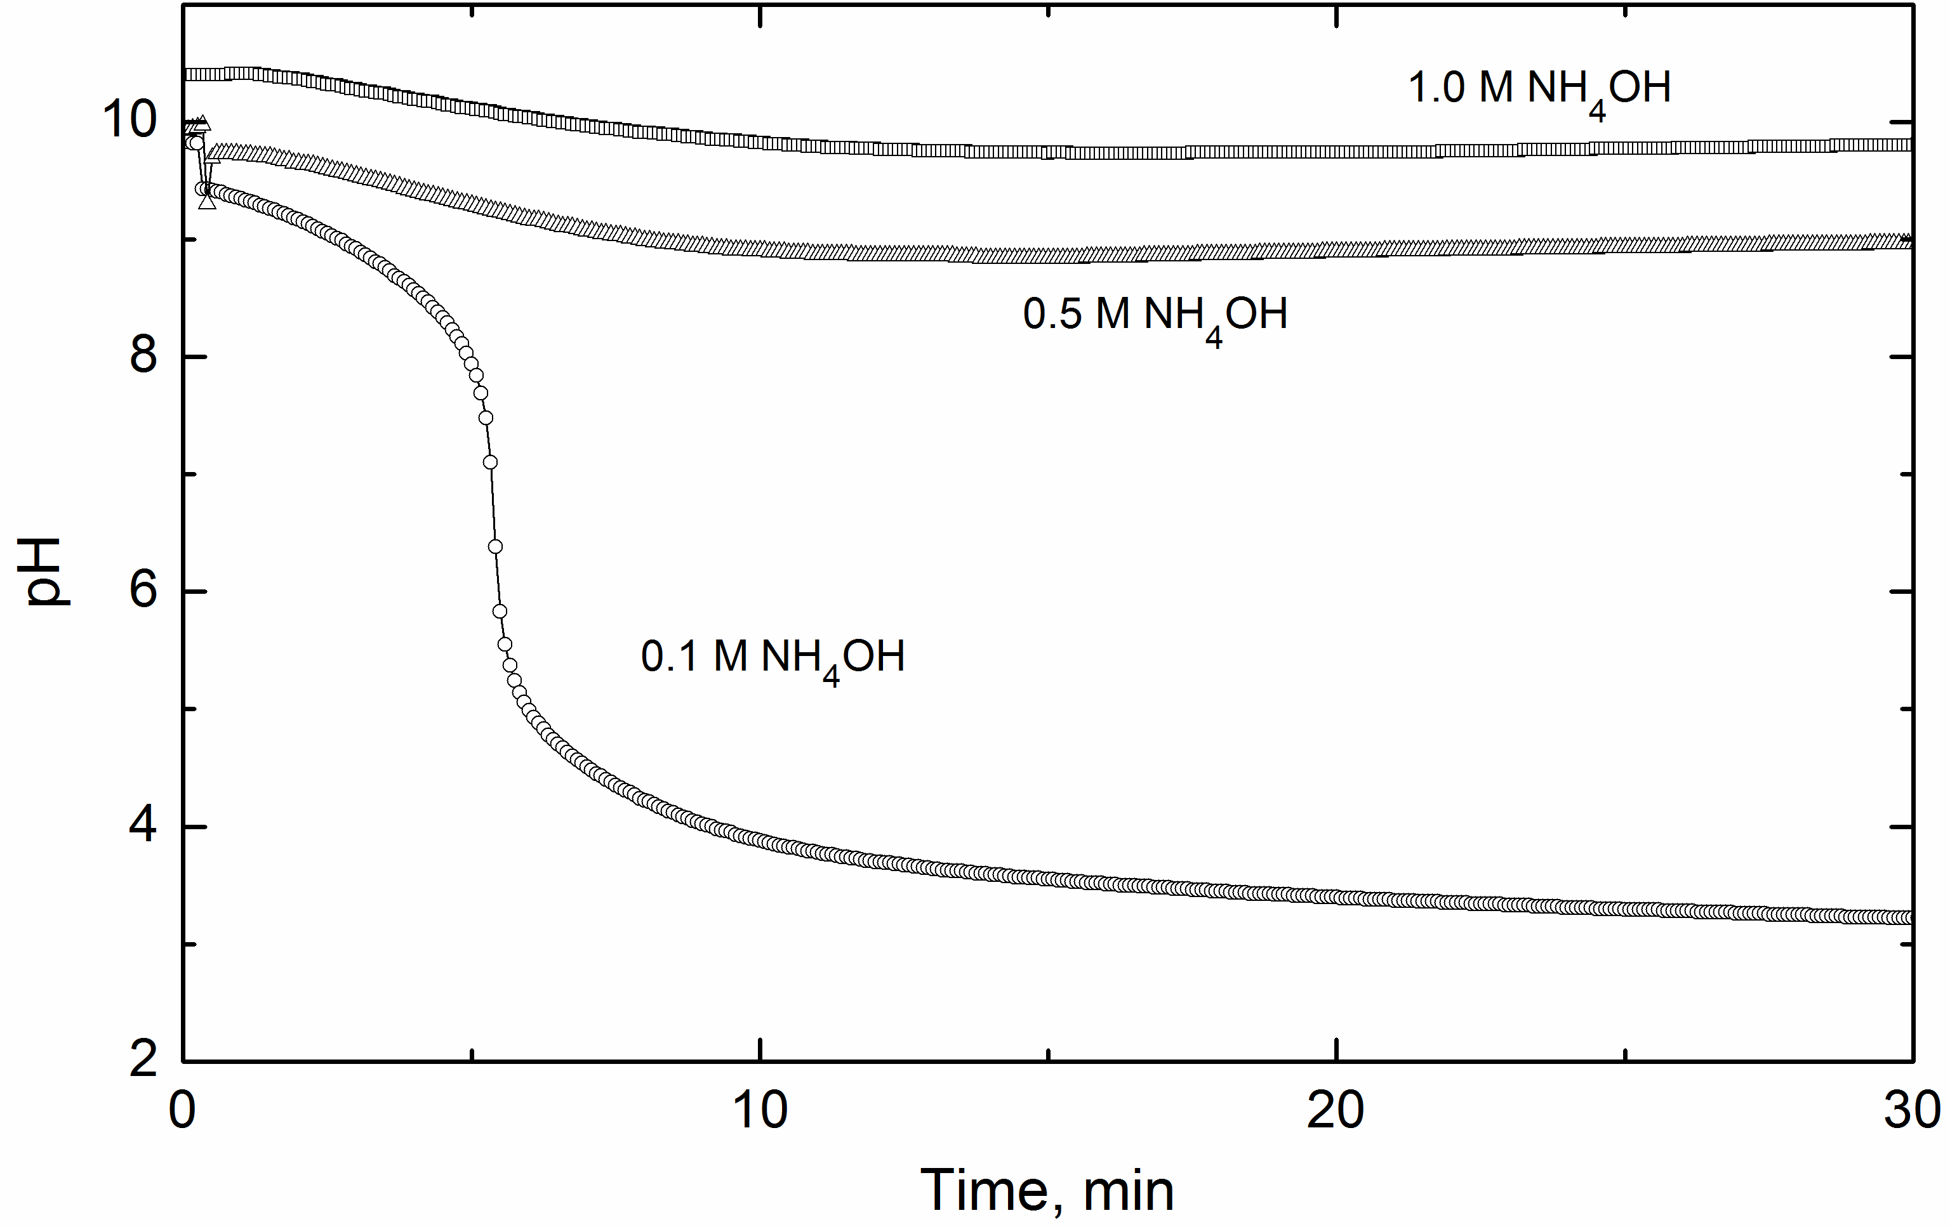
Fig. 2 – pH profiles during the oxidation of 0.2 M aniline with 0.2 M ammonium peroxydisulfate in 0.1, 0.5, and 1.0 M NH₄OH.
  - UV-visible spectra
UV–Vis spectra of aniline oligomers prepared in 0.5 and 1 M NH₄OH display a local maximum at 348 nm and a characteristic long tail extending to longer wavelengths (Fig. 3). The absorption band of PANI (emeraldine) base having the maximum above 600 nm is absent in aniline oligomers. This result confirms that the products prepared at low NH₄OH concentration, i.e. 0.1 and 0.2 M, contain a fraction of PANI in addition to aniline oligomers. The absorption maximum appears in the case of oxidation in 0.2 M NH₄OH and in water, when the pH drops to acidic values and the formation of polyaniline (emeraldine) becomes possible (Fig. 3).
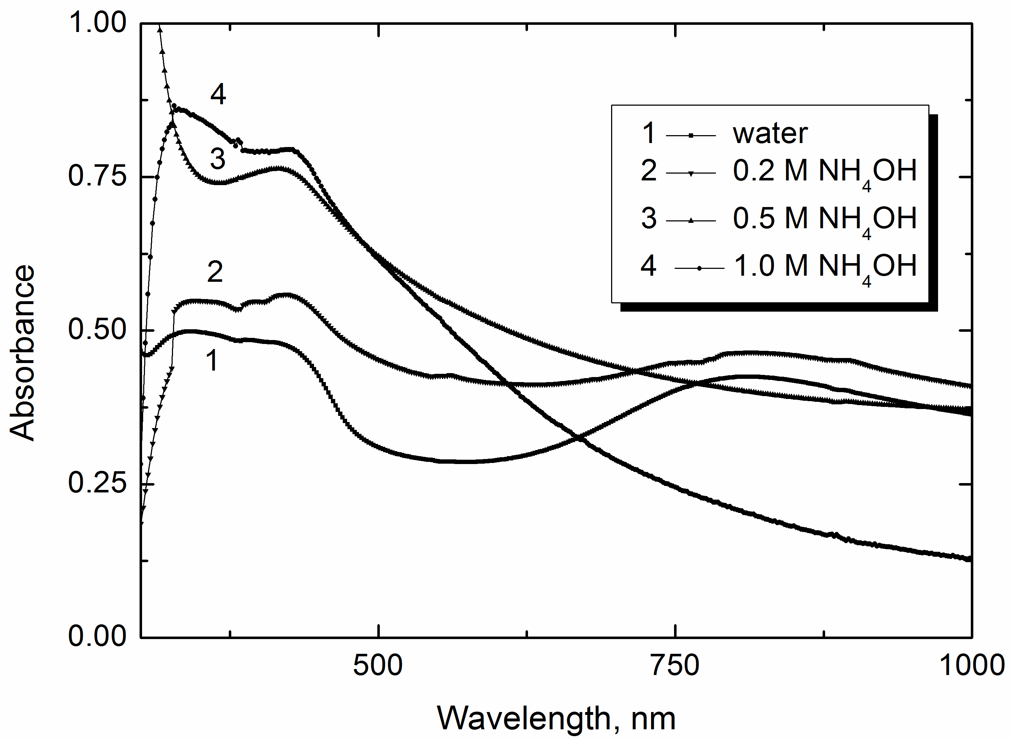
Fig. 3 – UV-Vis spectra of the powders obtained by the oxidation of aniline in water and in 0.2, 0.5, and 1.0 M NH₄OH, and dissolved in N-methylpyrrolidone.
  - FTIR spectra
In the infrared spectra of samples prepared in 0.2, 0.5, and 1.0 M NH₄OH (Fig. 4), the bands due to quinonoid and benzenoid ring-stretching vibrations are situated at 1581 and 1503 cm⁻¹. A shoulder observed at about 1630 cm⁻¹ corresponds most probably to N–H scissoring vibrations of aromatic amines or to the presence of phenazine units. The contribution of benzoquinones is possible. The sharp band at 1445 cm⁻¹ is attributed to the skeletal C–C stretching vibration of the substituted aromatic ring [36]. The broad band in the 1300–1230 cm⁻¹ region indicates the presence of the C–N stretching vibration of a primary aromatic amine, which confirms the oligomeric nature of the oxidation products. The band at about 1035 cm⁻¹ is assigned to the symmetric stretching vibrations in sulfonic groups linked by covalent bonds to the benzene ring. A prominent band at 824 cm⁻¹ in the substitution region 900–650 cm⁻¹ in the spectrum of the PANI base is due to the C–H out-of-plane bending vibrations of dominating para-coupled constitutional units. The bands at 746 and 691 cm⁻¹ correspond to the C–H out-of-plane bending and out-of-plane ring deformations of a mono-substituted phenylene ring, respectively [24, 36]. The spectrum of the oligomers displays bands at 3440 and 3324 cm⁻¹ of asymmetric and symmetric free N–H stretching vibrations, supporting the contribution of the N–H scissoring vibration. The peaks at 3266 and 3195 cm⁻¹ corresponding to the hydrogen-bonded N–H vibrations are detected in the spectrum of aniline oligomers. They are connected with hydrogen bonding of N–H groups with sulfonic or carbonyl groups [24]. The infrared spectra of samples prepared in 0.1 M NH₄OH and in water display a broad absorption band at wavenumbers higher than 2000 cm^{–1}, an increased absorption of the bands at 1300 and 1238 cm^{–1}, and a broad band centred at 1144 cm^{–1}, which are characteristic of the conducting protonated form of polyaniline [36].
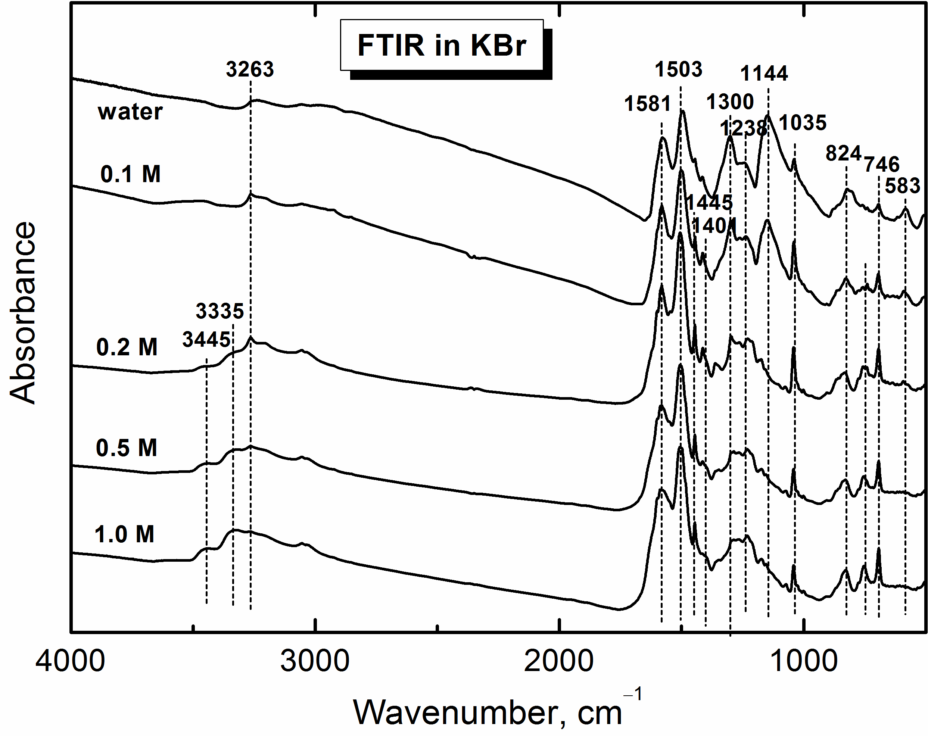
Fig. 4 – Infrared spectra of the powders obtained by the oxidation of 0.2 M aniline with 0.2 M ammonium peroxydisulfate in 0.1, 0.2, 0.5, and 1 M NH₄OH and in water.
  - Morphology
Fig. 5 shows images of prepared particles obtained by the scanning electron microscopy. It can be seen that, regardless of the concentration of NH₄OH during the synthesis of aniline oligomers, the original particles are all spherical or rather irregular. Their dimensions slightly increase with the increasing concentration of NH₄OH present during the synthesis. After the carbonization at 650 °C, the particles produced in the presence of the lowest amount of NH₄OH (0.1 M) became slightly smaller and possessing much rougher surface than their original analogues (Fig. 1a, d). It may be connected with the presence of a thin PANI layer on its surface. However, increasing concentration of NH₄OH led to a considerable increase of dimensions of carbonized particles and creation of two-dimensional plates (Fig. 1d–f). It has been described by the group of Stejskal [31] that probably those particles arose from larger plates which were sintered together and that broke down during the cooling from the melt to ambient temperature. Also on their surface higher aniline oligomers are produced during synthesis instead of PANI layer.
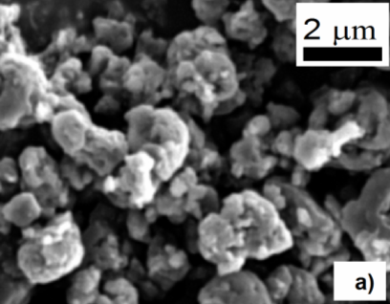 |  | 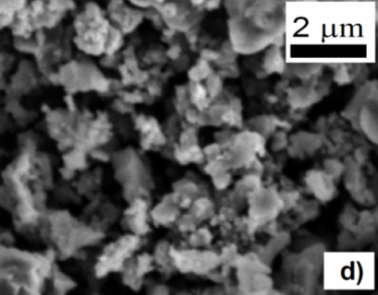
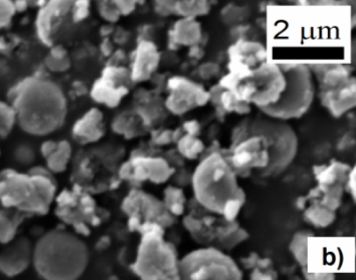 |  | 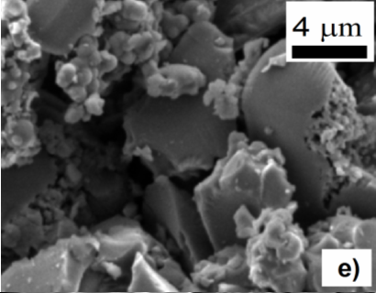
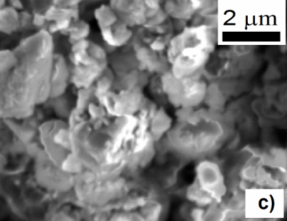 |  | 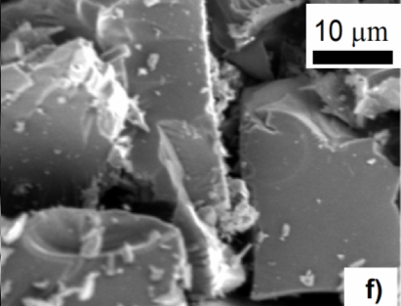
Fig. 5 – SEM images of original samples prepared in (a) 0.1 M, (b) 0.2 M, and (c) 2.0 M NH₄OH and (d–f) their carbonized analogues after treatment at 650 °C.
  - Spectroscopic evidence of carbonization
Raman spectroscopy is a useful tool in the structural characterization of graphitic materials [37]. The Raman spectra of the samples prepared in 0.2 M and 1.0 M NH₄OH obtained with 633 nm excitation line exhibit a strong fluorescence on which one can distinguish the dominant peak of C=C stretching vibration in quinonoid units situated at about 1600 cm^{–1} with a shoulder at about 1626 cm^{–1}, and the peaks at 1543, 1368, 1340, 1150 and 616 cm^{–1} in the spectrum of sample prepared in 0.2 M NH₄OH (Fig. 6a). They are slightly shifted to 1529, 1350, 1155, and 614 cm^{–1} in the spectrum of the sample prepared in 1.0 M NH₄OH (Fig. 6b) with respect to former sample, which contains a thin overlayer of PANI on particle surface. The spectra have recently been interpreted in [31, 38].
After heating to 650 °C in inert atmosphere Raman spectra confirm the conversion of the aniline-like oligomers to graphite-like carbon displaying two typical peaks located at about 1600 and 1340 cm⁻¹ that are assigned to graphitic (G) and disordered (D) modes, respectively [25, 37].
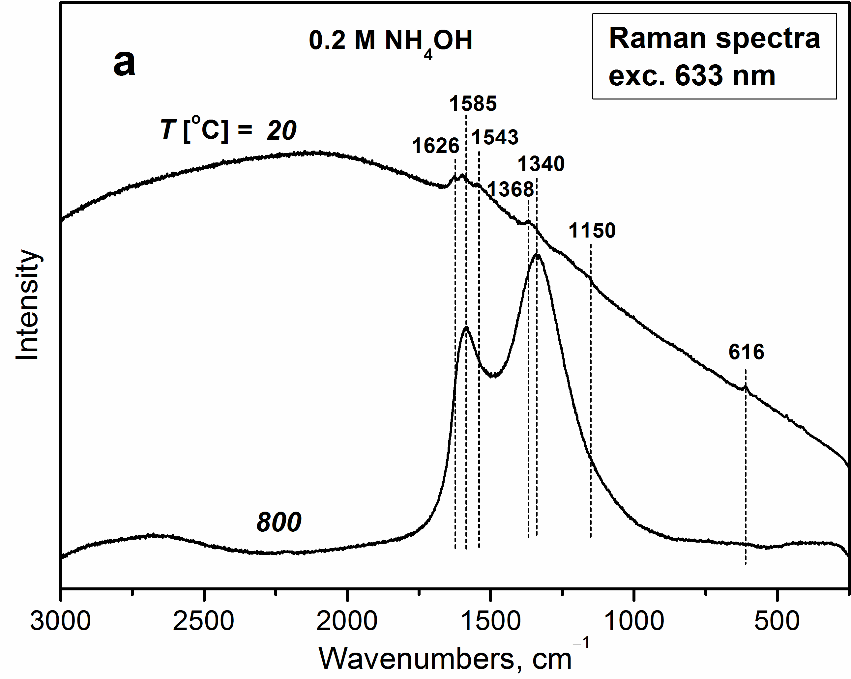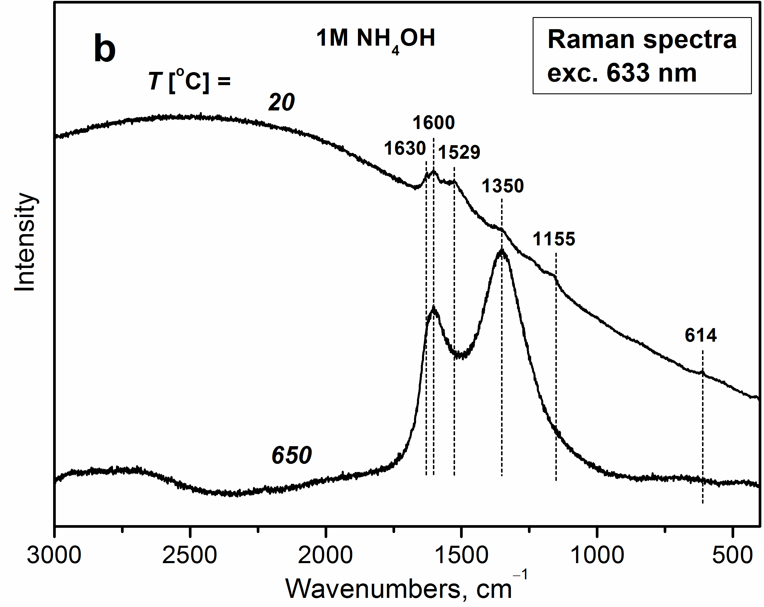
Fig. 6 – Raman spectra of the powders obtained by the oxidation of 0.2 M aniline with 0.2 M ammonium peroxydisulfate in (a) 0.2 M and (b) 1 M NH₄OH and their carbonized analogues.
  - Electrorheological behaviour
As it has been shown in previous studies [26, 27], suspensions based on carbonized materials usually possess a higher viscosity in the absence of electric field than the suspensions based on the original samples. This was a result of smaller particles size or higher porosity of carbonized particles leading to much higher specific surface area. Therefore, in this study, a field-off viscosity was also investigated, since low field-off viscosity is one of the crucial parameters for ER suspensions from the application point of view.
Fig. 7 shows the dependence of field-off viscosity on the shear rate for silicone oil suspensions based on (a) original and (b) carbonized particles. As it was mentioned above, with increase of NH₄OH presented during the synthesis the dimensions of particles undergoing the transformation into two-dimensional plates increased after carbonization; and thus as a consequence, except the carbonized sample prepared in 0.1 M NH₄OH solution, the field-off viscosity of suspensions based on carbonized particles was not significantly increased in comparison with field-off viscosity of suspensions based on original samples. The thin PANI layer on their surface transformed into cross-linked two-dimensional molecular structures [33, 39]. Only in the case of the suspension based on carbonized sample prepared in 0.1 M NH₄OH solution, the particles became smaller after the carbonization. As a result, the suspension based on these particles possesses higher field-off viscosity than its original analogue.
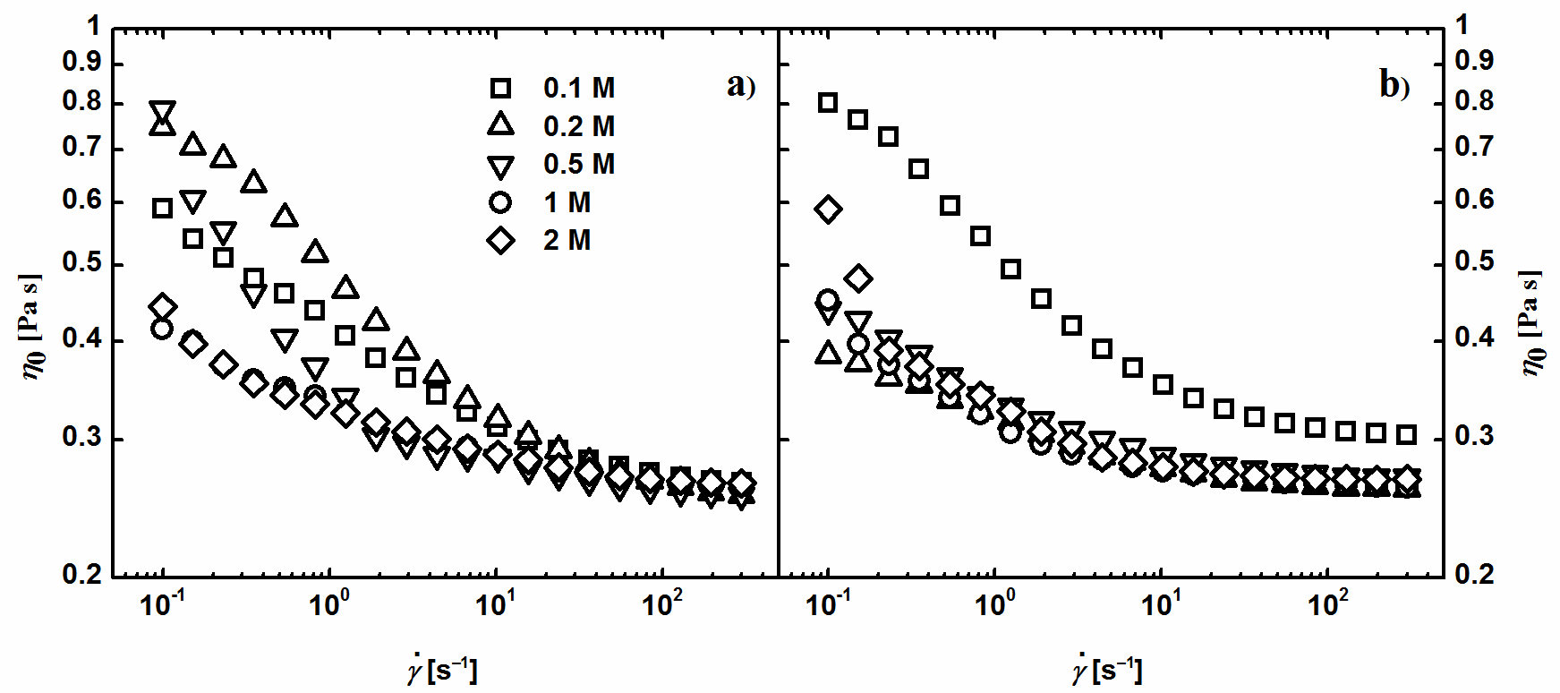
Fig. 7 – The dependence of shear viscosity, η₀, on the shear rate,, in the absence of the electric field for suspensions based on (a) original and (b) carbonized aniline oligomers prepared at various concentrations of NH₄OH.
The carbonization process significantly increased ER effect of suspensions based on such particles as illustrated on the rheological behaviour of the suspensions in steady shear flow upon the application of electric field (Fig. 8). In the case of the suspension based on original particles prepared in 0.1 M NH₄OH solution the results are not included in the plot, owing to high conductivity (Table 1) of this suspension which caused short-circuit of the measuring apparatus. This is connected with the presence of conducting PANI layer on the particle surfaces. As can be seen, the carbonization process and the transformation of particles into two-dimensional plates considerably increased ER performance of the suspensions. Suspensions based on carbonized particles prepared in 0.1 M and 0.2 M NH₄OH solution exhibit the highest ER effect. The yield stresses of these suspensions are around 200 Pa, which is comparable with some of the magnetorheological suspensions [40].
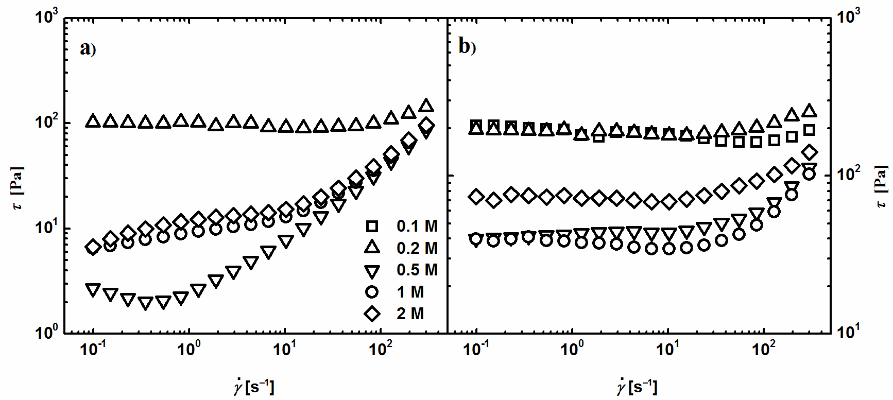
Fig. 8 – The dependence of shear stress, τ, on the shear rate, , for suspensions based on (a) original and (b) carbonized aniline oligomers prepared in various concentrations of NH₄OH at electric field strength 3 kV mm^{–1}.
The aniline oligomers were completely de-doped in the presence of 0.5 M and higher concentration of NH₄OH solution, which can elucidate the very close conductivity of particles prepared in 0.5 M, 1 M and 2 M NH₄OH solution (Table 1). The increased ER effect of suspension based on particles prepared in 2 M NH₄OH solution in comparison with suspensions based on particles prepared in 1 M and 0.5 M NH₄OH solution can be explained as the result of higher amount of nitrogen in the structure of the particles as a result of higher amount of nitrogen presented during the particles synthesis. Introduction of polar groups leads to a creation of stiffer structures due to the creation of stronger local electric field as it has been demonstrated [41]. The suspension based on particles prepared in 0.2 M NH₄OH solution, which possess the conductivity higher by more than one order of magnitude than the above mentioned samples due to the presence of PANI on the surface, exhibits the highest increase in shear stress in the presence of electric field from the original samples. The suspension based on the original sample prepared in 0.5 M NH₄OH solution exhibits the lowest ER effect. It also shows the typical decrease in shear stress at low shear rates for an ER fluid with a small ER effect, which has been previously commented in the literature [42, 43]. Such behaviour is caused by breaking of internal structures together with their difficult reformation under the shear flow.
Table 1 – The conductivity of original particles
Sample | Conductivity, σ, [S cm^{–1}]
0.1 M | 1.58 × 10^{–5}
0.2 M | 9.90 × 10^{–8}
0.5 M | 6.07 × 10^{–9}
1 M | 7.06 × 10^{–9}
2 M | 5.82 × 10^{–9}
Large difference between viscosity in the presence and in the absence of the electric field is of high importance from the application point of view. This difference can be expressed by the formula:
e = (η_{E}–η₀)/η₀ (2)
where the parameter e stands for electrorheological efficiency, and η_{E} and η₀ are the viscosities in the presence and in the absence of an electric field, respectively. In this study, the carbonization is very promising process in the preparation of new electrically polarizable particles for the ER suspensions with high ER efficiency, since above the amount of 0.1 M NH₄OH present during the synthesis, the carbonization did not negatively affect the viscosity in the absence of electric field and, at the same time, it led to the increase of viscosity upon the application of electric field. Fig. 9 shows the dependence of ER efficiency on the shear rate for the suspensions based on carbonized particles. The suspension based on carbonized particles prepared in 0.2 M NH₄OH solution exhibits the highest ER efficiency in the whole shear-rate range thanks to the lowest field-off viscosity and highest ER effect. Although the suspension based on the carbonized particles prepared in 0.1 M NH₄OH solution exhibits the highest field-off viscosity, its ER efficiency is still higher than that of the rest of the prepared suspensions, because those exhibit lower ER effect leading to lower ER efficiency. It can be also seen, that ER efficiency is significantly higher at low shear rates compared to high shear rates, since at low shear rates, the hydrodynamic forces are low and a domination of electrostatic forces leads to high ER efficiency. However, with increasing shear rates the hydrodynamic forces increase, while electrostatic forces stay the same; thus, the hydrodynamic forces start to dominate at high shear rates (the viscosity of the ER suspension starts to be the same regardless whether an electric field is applied or not).
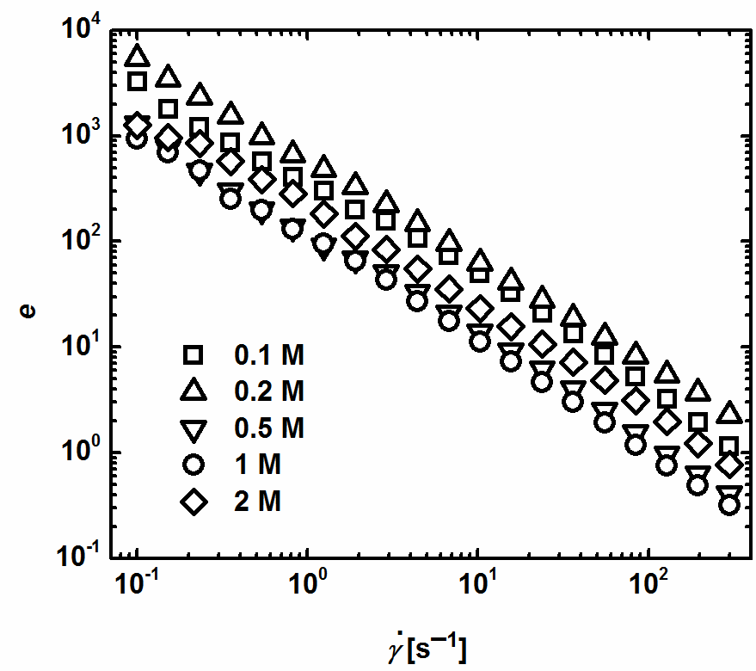
Fig. 9 – The dependence of ER efficiency, e, on the shear rate, , for suspensions based on carbonized aniline oligomers prepared at various concentrations of NH₄OH.
From the application point of view, the rheological behaviour of ER suspensions under dynamic oscillatory loading is of high interest. Therefore, oscillatory tests at single strain from LVR (γ = 10⁻⁴) were carried out. The results are shown only for the suspensions based on carbonized samples, since their ER effect is of higher interest in comparison with their original analogues. In the absence of the electric field (Fig. 10a), the elastic modulus of the suspensions is low, which demonstrates only small portion of elastic behaviour. However, when the electric field of strength 3 kV mm^{–1} is applied, the particles start to join together thanks to electrostatic forces and span the electrodes. This leads to steep increase by several orders of magnitude in the elastic modulus (Fig. 10b) approving the transition to significantly more solid state. Unlike the steady shear tests, the highest storage modulus is achieved for the suspension based on carbonized particles prepared in 0.2 M NH₄OH solution. The storage modulus is significantly higher than that achieved for suspension based on carbonized particles prepared in 0.1 M NH₄OH solution, i.e. those particles with the highest ER activity in steady shear experiments. This can be explained as a consequence of shorter relaxation time of the suspension based on carbonized particles prepared in 0.2 M NH₄OH solution and smaller particles of suspension based on carbonized particles prepared in 0.1 M NH₄OH solution. It seems that, under dynamic oscillation loading, the structures created by smaller particles (sample 0.1 M) do not exhibit as high toughness as the structures created by two-dimensional plates. From comparison of elastic modulus of suspensions based on carbonized particles prepared in 0.1 M and 2 M NH₄OH solution, whose relaxation times are the same (Table 2), it seems that in oscillatory measurements the contribution of larger particles to stronger ER effect is more considerable than in steady-shear mode. This is again a consequence of the carbonized PANI on their surface. Thus, it can be assumed that in the dynamic loading the increase in storage modulus upon an application of electric field is rather dependent on the relaxation time and the dimensions of the particles than on the dielectric relaxation strength. Similar behaviour was observed in the previous study [26].
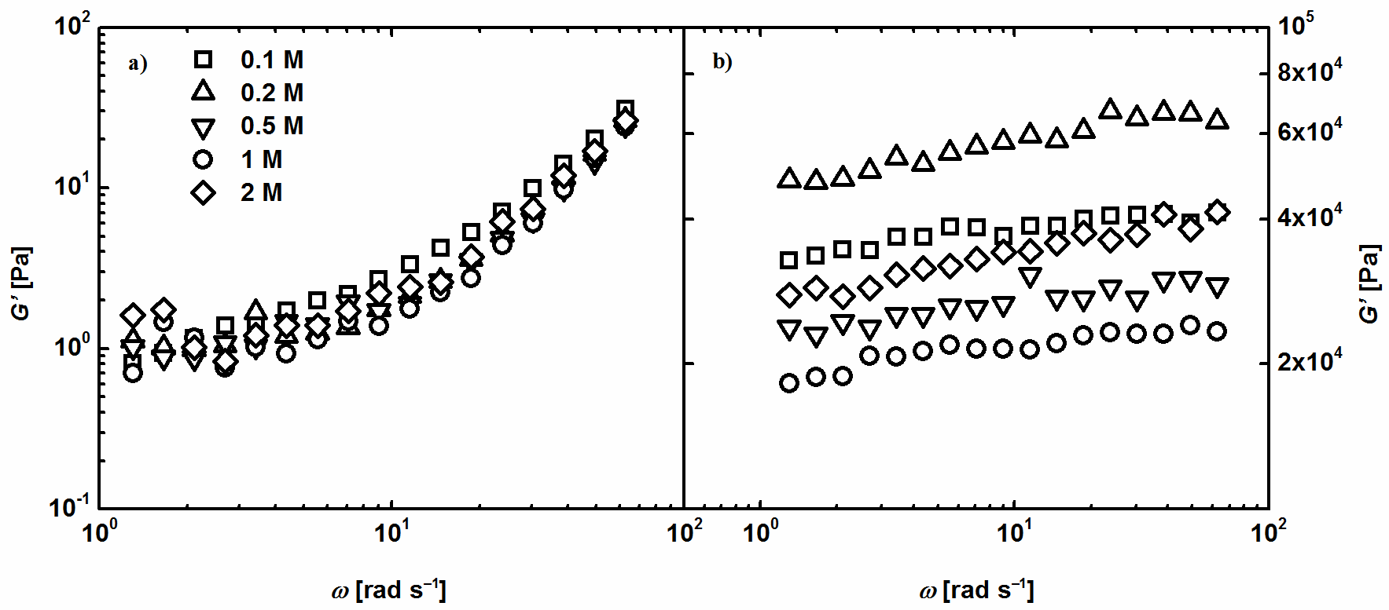
Fig. 10 – The dependence of the elastic modulus, G′, on the angular frequency, ω, (a) in the absence of electric field, and (b) in the presence of electric field of strength 3 kV mm^{–1}for the prepared ER suspensions based on carbonized oligomers.
This can be also seen in Fig. 11, which depicts the ER efficiency for suspensions based on carbonized particles in an oscillation mode, e_{O}:
e_{O} = (G′_{E}–G′₀)/G′₀ (3)
where G′_{E} stands for elastic modulus in the presence of electric field of strength 3 kV mm^{–1}, and G′₀ stands for elastic modulus in the absence of electric field. The efficiency is again the highest for the suspension based on carbonized particles prepared in 0.2 M NH₄OH solution. Although the ER efficiency of the suspension based on carbonized particles prepared in 0.2 M NH₄OH solution was the second highest in steady shear experiments; under dynamic oscillatory loading it is similar as for the suspensions based on two-dimensional carbonized particles prepared in 0.5 M, 1 M and 2 M NH₄OH solution, which possess significantly higher dimensions than carbonized particles prepared in 0.1 M NH₄OH solution. (The role of PANI layers on the first particles may be of more importance than their dimensions, or the smaller dimension is a consequence of the PANI on the surface). In other words, the increase in the storage modulus upon the application of external electric field is not so high in the case of smaller particles as in the system composed of significantly bigger particles, in this case of two-dimensional plates.
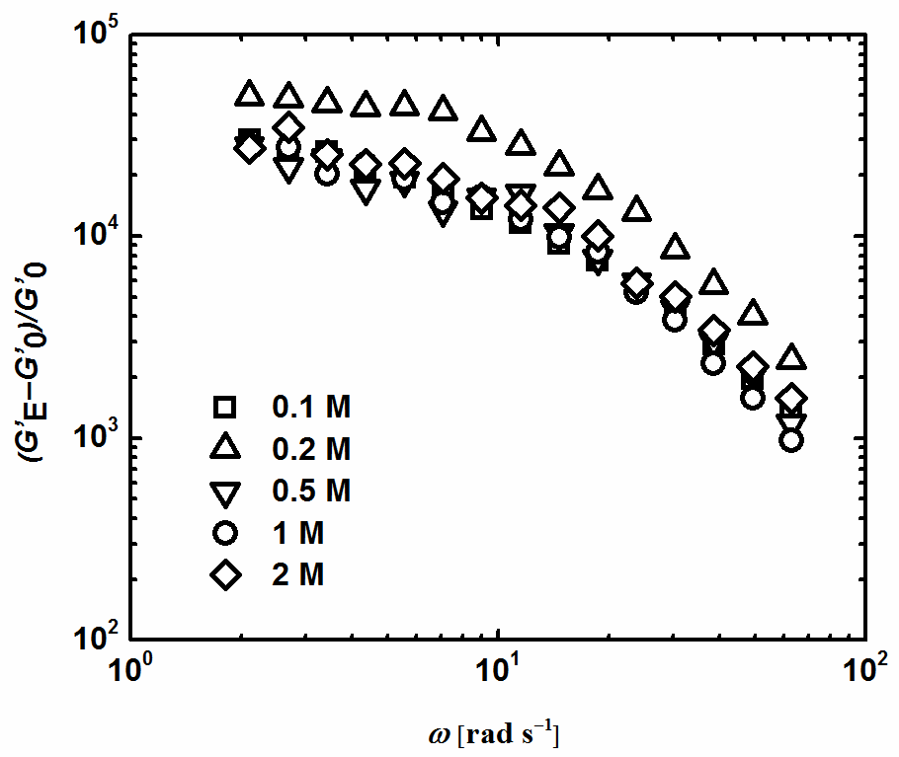
Fig. 11 – The dependence of ER efficiency calculated from elastic modulus in the presence of electric field of strength 3 kV mm^{–1}, G′_{E}, and elastic modulus in the absence of electric field, G′₀, on the angular frequency, ω, for suspensions based on carbonized aniline oligomers.
  - Dielectric properties
The ER effect is closely linked to dielectric properties of ER suspensions, since it is assumed that the interfacial polarization of the ER suspension plays one of the dominant roles in their ER performance. The interfacial polarization occurs in the frequency region 10²–10⁵ Hz. Therefore, the relaxation time should lie within this frequency range and the dielectric relaxation strength should be large in this region for high ER effect. Preferably, the relaxation time should be closer to the upper limit of this region. The complex study of dielectric behaviour of aniline-based oligomers prepared in the presence of methanesulfonic acid has been introduced by Mrlik et al. [44].
Figures 12 and 13 show the dependence of real and imaginary part of the complex permittivity on the frequency for suspensions based on original and carbonized particles, respectively.
In rheological measurements, the suspension based on particles prepared in 0.1 M NH₄OH could be measured only in electric field up to 0.5 kV mm⁻¹. The dielectric data obtained for this suspension declare too high electric conductivity of the particles, since the result shows clear electrode polarization, which occurs in highly conducting suspensions. The peak in range of higher frequencies (Fig. 13b) corresponds then to its relaxation process. Fig. 12a also shows that suspensions based on original particles do not exhibit clear relaxation in the desired frequency region which corresponds well with ER measurements and low intensity of ER effect. The suspension based on particles prepared in 0.2 M NH₄OH solution exhibited the highest ER effect among the original samples. However, it also does not show clear relaxation within the desired frequency. These problems are connected with the conducting PANI present on the surface of these particles. The wide peak of the suspension based on particles prepared in 0.2 M NH₄OH reflects the broad spectrum of the particles with different relaxation times; and in the low frequencies the measured data are influenced by electrode polarization. This suspension exhibits the ER effect; however in comparison with carbonized samples, its effect is nearly two times lower. The suspensions based on particles prepared in 0.5 M, 1 M and 2 M NH₄OH solution show absolutely no relaxation in the measured region. These particles were synthesized in the presence of higher concentration of NH₄OH, which did not allow the formation of the conducting PANI form. In other words, these particles have the lowest conductivity, and, thus the response of the suspensions based on these materials to the electric field is not of interest. On the other hand, the suspensions based on carbonized samples prepared in 0.1 and 0.2 M NH₄OH show clear interfacial polarization, which results in symmetric narrow peaks. The spectra for the suspensions based on carbonized samples prepared in higher amount of NH₄OH exhibit relaxation shifted to the lower frequencies out of the region where the interfacial polarization occurs.
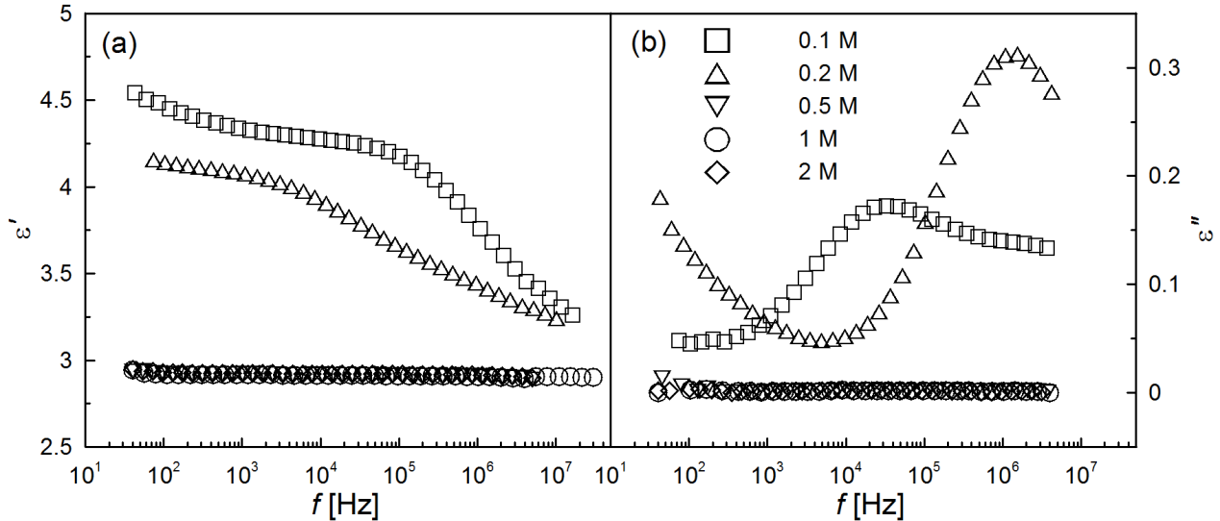
Fig. 12 – Dielectric spectra of (a) relative permittivity and (b) dielectric loss factor for the ER suspensions based on aniline oligomers prepared at various concentrations of NH₄OH.
The suspensions based on carbonized particles exhibit significantly higher ER effects in comparison with their non-carbonized analogues. Their dielectric spectra also better fulfil demands for high performance of ER suspensions. As can be seen from Fig. 13b, the suspension based on carbonized particles prepared in 0.2 M NH₄OH solution particles exhibits faster relaxation process, i.e. the relaxation time is lower, than that of the suspension based on carbonized particles prepared in 0.1 M NH₄OH solution. This is connected with the transformation of the conducting PANI to a non-conducting PANI base [33, 34]. Thus, although the suspension based on carbonized particles prepared in 0.1 M NH₄OH solution shows significantly higher dielectric relaxation strength, it seems that in this case the relaxation time plays more important role in determination of high ER effect than dielectric relaxation strength. The dielectric relaxation strengths for the suspensions based on carbonized particles prepared in 0.5 M, 1 M and 2 M NH₄OH solution do not significantly differ (Fig. 13a). However, the significantly higher ER effect of the suspension based on carbonized particles prepared in 2 M NH₄OH solution is again the consequence of its shorter relaxation time in comparison with the suspensions based on carbonized particles prepared in 0.5 M and 1 M NH₄OH solution (Table 2, Fig. 13b).
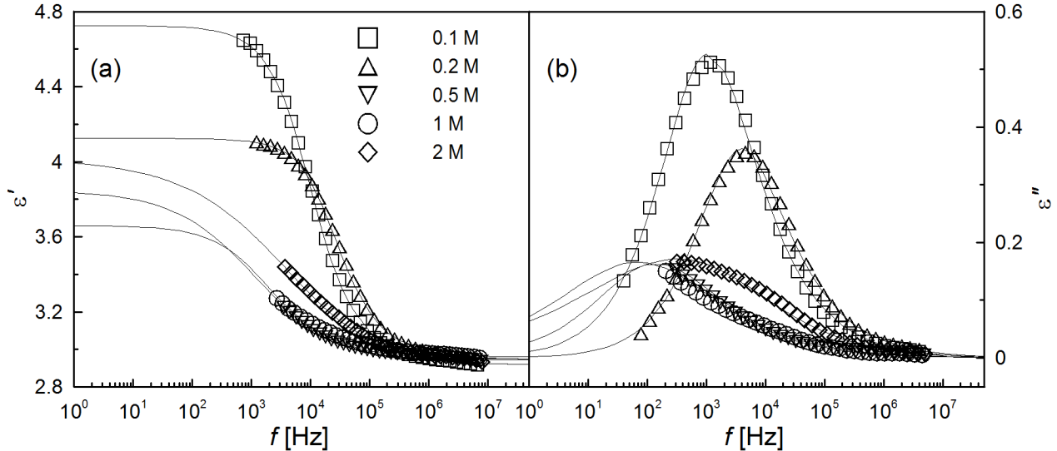
Fig. 13 – Dielectric spectra of (a) relative permittivity and (b) dielectric loss factor for ER suspensions based on carbonized aniline oligomers prepared at various concentrations of NH₄OH.

Table 2 – Dielectric parameters of ER suspensions based on carbonized aniline oligomers obtained from Havriliak-Negami model
Parameter | Sample suspension
Parameter | 0.1 M | 0.2 M | 0.5 M | 1 M | 2 M
ε′₀ | 4.72 | 4.12 | 3.66 | 3.85 | 4.01
ε′∞ | 2.92 | 2.94 | 2.94 | 2.96 | 2.94
∆ε′ | 1.80 | 1.18 | 0.72 | 0.89 | 1.07
t_{rel} [s] | 1.9×10^{–4} | 5.6×10^{–5} | 1.8×10^{–3} | 1.8×10^{–3} | 1.2×10^{–4}
a | 0.71 | 0.77 | 0.60 | 0.44 | 0.35
b | 0.82 | 0.76 | 0.73 | 1.13 | 1.67
- Conclusions
The carbonization of aniline oligomers prepared by oxidation of aniline under alkaline conditions at various concentrations of ammonia leads to new materials suitable for ER suspensions with enhanced ER efficiency. After the carbonization, the morphology transformation of aniline oligomers from microspheres to two-dimensional plates can be observed. The carbonization significantly contributes to the extremely high ER efficiency of their ER suspensions. The suspensions based on the prepared carbonized aniline oligomers exhibit higher viscosity under the external electric field than the suspensions based on their original analogues. The dielectric spectroscopy provides precise correlation between dielectric properties of suspensions and their rheological performance in the presence of external electric field. Although the prepared suspensions exhibit similar dielectric relaxation strength, the shorter relaxation time of the electrorheological suspensions contributes considerably to the high electrorheological effect. The highest ER efficiency and effect are observed for the suspension based on carbonized particles prepared in 0.2 M NH₄OH, and their 10 wt% silicone oil suspension exhibited a yield stress around 200 Pa. In the case of dynamic oscillatory loading, the presence of two-dimensional plates significantly contributes to enhanced ER efficiency of the suspensions in comparison with the suspension consisted of small particles. Thus, in dynamic oscillatory loading the ER efficiency seems to be more dependent on the size of particles and relaxation time than on the dielectric relaxation strength.
Acknowledgements
The authors thank the Internal Grant Agency of Tomas Bata University (IGA/FT/2014/017) and the Czech Science Foundation (P205/12/0911, 13-08944S) for the financial support. This research was also carried out with support of the Operational Program Research and Development for Innovations co-funded by the European Regional Development Fund (ERDF) and national budget of the Czech Republic, within the framework of the Centre of Polymer Systems project (CZ.1.05/2.1.00/03.0111).
References
[1] J.H. Sung, M.S. Cho, H.J. Choi, M.S. Jhon, Electrorheology of semiconducting polymers, J. Ind. Eng. Chem. 10 (2004) 1217-1229.
[2] J.S. Oh, Y.M. Han, S.R. Lee, S.B. Choi, A 4-DOF haptic master using ER fluid for minimally invasive surgery system application, Smart Materials and Structures 22 (2013) 15.
[3] Y.D. Liu, B.M. Lee, T.S. Park, J.E. Kim, H.J. Choi, S.W. Booh, Optically transparent electrorheological fluid with urea-modified silica nanoparticles and its haptic display application, J. Colloid Interface Sci. 404 (2013) 56-61.
[4] M. Sedlacik, M. Mrlik, Z. Kozakova, V. Pavlinek, I. Kuritka, Synthesis and electrorheology of rod-like titanium oxide particles prepared via microwave-assisted molten-salt method, Colloid Polym. Sci. 291 (2013) 1105-1111.
[5] H.J. Choi, T.W. Kim, M.S. Cho, S.G. Kim, M.S. Jhon, Electrorheological characterization of polyaniline dispersions, Eur. Polym. J. 33 (1997) 699-703.
[6] H.J. Choi, M.S. Jhon, Electrorheology of polymers and nanocomposites, Soft Matter 5 (2009) 1562-1567.
[7] M. Mrlik, V. Pavlinek, P. Saha, O. Quadrat, Electrorheological properties of suspensions of polypyrrole-coated titanate nanorods, Appl. Rheol. 21 (2011) 7.
[8] Y.D. Liu, H.J. Choi, Electrorheological response of polyaniline and its hybrids, Chem. Pap. 67 (2013) 849-859.
[9] O. Quadrat, J. Stejskal, Polyaniline in electrorheology, J. Ind. Eng. Chem. 12 (2006) 352-361.
[10] D.H. Kim, Y.D. Kim, Electrorheological properties of polypyrrole and its composite ER fluids, J. Ind. Eng. Chem. 13 (2007) 879-894.
[11] H.J. Choi, M.S. Cho, K. To, Electrorheological and dielectric characteristics of semiconductive polyaniline-silicone oil suspensions, Physica A 254 (1998) 272-279.
[12] A. Lengalova, V. Pavlinek, P. Saha, J. Stejskal, T. Kitano, O. Quadrat, The effect of dielectric properties on the electrorheology of suspensions of silica particles coated with polyaniline, Physica a-Statistical Mechanics and Its Applications 321 (2003) 411-424.
[13] M. Stenicka, V. Pavlinek, P. Saha, N.V. Blinova, J. Stejskal, O. Quadrat, The role of particle conductivity in electrorheology of suspensions of variously protonated polyaniline, Journal of Physics: Conference Series 149 (2009) 012027.
[14] M. Stenicka, V. Pavlinek, P. Saha, N.V. Blinova, J. Stejskal, O. Quadrat, Electrorheology of suspensions of variously protonated polyaniline particles under steady and oscillatory shear, Appl. Rheol. 20 (2010).
[15] B.M. Lee, J.E. Kim, F.F. Fang, H.J. Choi, J.F. Feller, Rectangular-shaped polyaniline tubes covered with nanorods and their electrorheology, Macromol. Chem. Phys. 212 (2011) 2300-2307.
[16] M. Stenicka, V. Pavlinek, P. Saha, N.V. Blinova, J. Stejskal, O. Quadrat, Effect of hydrophilicity of polyaniline particles on their electrorheology: Steady flow and dynamic behaviour, J. Colloid Interface Sci. 346 (2010) 236-240.
[17] M. Stenicka, V. Pavlinek, P. Saha, N.V. Blinova, J. Stejskal, O. Quadrat, Structure changes of electrorheological fluids based on polyaniline particles with various hydrophilicities and time dependence of shear stress and conductivity during flow, Colloid Polym. Sci. 289 (2011) 409-414.
[18] J.B. Yin, X. Xia, X.P. Zhao, Conductivity, polarization and electrorheological activity of polyaniline nanotubes during thermo-oxidative treatment, Polym. Degrad. Stabil. 97 (2012) 2356-2363.
[19] B. Gercek, M. Yavuz, H. Yilmaz, B. Sari, H.I. Unal, Comparison of electrorheological properties of some polyaniline derivatives, Colloid Surf. A-Physicochem. Eng. Asp. 299 (2007) 124-132.
[20] M. Mrlik, M. Sedlacik, V. Pavlinek, P. Bober, M. Trchová, J. Stejskal, P. Saha, Electrorheology of aniline oligomers, Colloid Polym. Sci. 291 (2013) 2079-2086.
[21] J. Stejskal, P. Bober, M. Trchová, J. Horský, J. Pilař, Z. Walterová, The oxidation of aniline with p-benzoquinone and its impact on the preparation of the conducting polymer, polyaniline, Journal of Physics: Conference Series 192 (2014) 66-73.
[22] J. Stejskal, I. Sapurina, M. Trchová, Polyaniline nanostructures and the role of aniline oligomers in their formation, Prog. Polym. Sci. 35 (2010) 1420-1481.
[23] J. Stejskal, I. Sapurina, M. Trchová, E.N. Konyushenko, Oxidation of aniline: Polyaniline granules, nanotubes, and oligoaniline microspheres, Macromolecules 41 (2008) 3530-3536.
[24] J. Stejskal, M. Trchová, Aniline oligomers versus polyaniline, Polym. Int. 61 (2012) 240-251.
[25] G. Ciric-Marjanovic, I. Pasti, N. Gavrilov, A. Janosevic, S. Mentus, Carbonised polyaniline and polypyrrole: towards advanced nitrogen-containing carbon materials, Chem. Pap. 67 (2013) 781-813.
[26] T. Plachy, M. Sedlacik, V. Pavlinek, Z. Morávková, M. Hajná, J. Stejskal, An effect of carbonization on the electrorheology of poly(p-phenylenediamine), Carbon 63 (2013) 187-195.
[27] Y.P. Qiao, X. Zhao, Electrorheological effect of carbonaceous materials with hierarchical porous structures, Colloid Surf. A-Physicochem. Eng. Asp. 340 (2009) 33-39.
[28] M. Sedlacik, V. Pavlinek, M. Mrlik, Z. Morávková, M. Hajná, M. Trchová, J. Stejskal, Electrorheology of polyaniline, carbonized polyaniline, and their core-shell composites, Mater. Lett. 101 (2013) 90-92.
[29] J.B. Yin, X.A. Xia, L.Q. Xiang, X. Zhao, Temperature effect of electrorheological fluids based on polyaniline derived carbonaceous nanotubes, Smart Materials and Structures 20 (2011) 015002.
[30] J.B. Yin, X.A. Xia, L.Q. Xiang, X.P. Zhao, Conductivity and polarization of carbonaceous nanotubes derived from polyaniline nanotubes and their electrorheology when dispersed in silicone oil, Carbon 48 (2010) 2958-2967.
[31] Z. Morávková, M. Trchová, E. Tomšík, A. Zhigunov, J. Stejskal, Transformation of oligoaniline microspheres to platelike nitrogen-containing carbon, J. Phys. Chem. C 117 (2013) 2289-2299.
[32] J.B. Yin, Y.J. Shui, R.T. Chang, X.P. Zhao, Graphene-supported carbonaceous dielectric sheets and their electrorheology, Carbon 50 (2012) 5247-5255.
[33] Z. Rozlívková, M. Trchová, M. Exnerová, J. Stejskal, The carbonization of granular polyaniline to produce nitrogen-containing carbon, Synth. Met. 161 (2011) 1122-1129.
[34] M. Trchová, P. Matějka, J. Brodinová, A. Kalendová, J. Prokeš, J. Stejskal, Structural and conductivity changes during the pyrolysis of polyaniline base, Polym. Degrad. Stabil. 91 (2006) 114-121.
[35] S. Havriliak, S. Negami, A complex plane analysis of alpha-dispersions in some polymer systems, Journal of Polymer Science Part C-Polymer Symposium (1966) 99-&.
[36] M. Trchová, J. Stejskal, Polyaniline: The infrared spectroscopy of conducting polymer nanotubes (IUPAC Technical Report), Pure Appl. Chem. 83 (2011) 1803-1817.
[37] A. Jorio, R. Saito, G. Dresselhaus, M.S. Dresselhaus, Raman Spectroscopy in Graphene Related Systems, Wiley-VCH Verlag GmbH & Co. KGaA, 2011.
[38] M. Trchová, Z. Morávková, M. Bláha, J. Stejskal, Raman spectroscopy of polyaniline and oligoaniline thin films, Electrochimica Acta 122 (2014) 28-38.
[39] M. Trchová, E.N. Konyushenko, J. Stejskal, J. Kovářová, G. Ciric-Marjanovic, The conversion of polyaniline nanotubes to nitrogen-containing carbon nanotubes and their comparison with multi-walled carbon nanotubes, Polym. Degrad. Stabil. 94 (2009) 929-938.
[40] M. Sedlacik, R. Moucka, Z. Kozakova, N.E. Kazantseva, V. Pavlinek, I. Kuritka, O. Kaman, P. Peer, Correlation of structural and magnetic properties of Fe3O4 nanoparticles with their calorimetric and magnetorheological performance, J. Magn. Magn. Mater. 326 (2013) 7-13.
[41] R. Shen, X.Z. Wang, Y. Lu, D. Wang, G. Sun, Z.X. Cao, K.Q. Lu, Polar-molecule-dominated electrorheological fluids featuring high yield stresses, Adv. Mater. 21 (2009) 4631-4635.
[42] F.F. Fang, Y.D. Liu, I.S. Lee, H.J. Choi, Well controlled core/shell type polymeric microspheres coated with conducting polyaniline: fabrication and electrorheology, RSC Adv. 1 (2011) 1026-1032.
[43] Y.D. Liu, H.J. Choi, Electrorheological fluids: smart soft matter and characteristics, Soft Matter 8 (2012) 11961-11978.
[44] M. Mrlík, R. Moučka, M. Ilčíková, P. Bober, N. Kazantseva, Z. Špitálsky, M. Trchová, J. Stejskal, Charge transport and dielectric relaxation processes in aniline-based oligomers, Synth. Met. 192 (2014) 37-42.

Figure captions
Fig. 1 – A possible structure of aniline oligomers.
Fig. 2 – pH profiles during the oxidation of 0.2 M aniline with 0.2 M ammonium peroxydisulfate in 0.1, 0.5, and 1.0 M NH₄OH.
Fig. 3 – UV-Vis spectra of the powders obtained by the oxidation of aniline in water and in 0.2, 0.5, and 1.0 M NH₄OH, and dissolved in N-methylpyrrolidone.
Fig. 4 – Infrared spectra of the powders obtained by the oxidation of 0.2 M aniline with 0.2 M ammonium peroxydisulfate in 0.1, 0.2, 0.5, and 1 M NH₄OH and in water.
Fig. 5 – SEM images of original samples prepared in (a) 0.1 M, (b) 0.2 M, and (c) 2.0 M NH₄OH and (d–f) their carbonized analogues after treatment at 650 °C.
Fig. 6 – Raman spectra of the powders obtained by the oxidation of 0.2 M aniline with 0.2 M ammonium peroxydisulfate in (a) 0.2 M and (b) 1 M NH₄OH and their carbonized analogues.
Fig. 7 – The dependence of shear viscosity, η₀, on the shear rate,, in the absence of the electric field for suspensions based on (a) original and (b) carbonized aniline oligomers prepared at various concentrations of NH₄OH.
Fig. 8 – The dependence of shear stress, τ, on the shear rate, , for suspensions based on (a) original and (b) carbonized aniline oligomers prepared in various concentrations of NH₄OH at electric field strength 3 kV mm^{–1}.
Fig. 9 – The dependence of ER efficiency, e, on the shear rate, , for suspensions based on carbonized aniline oligomers prepared at various concentrations of NH₄OH.
Fig. 10 – The dependence of the elastic modulus, G′, on the angular frequency, ω, (a) in the absence of electric field, and (b) in the presence of electric field of strength 3 kV mm^{–1}for the prepared ER suspensions based on carbonized oligomers.
Fig. 11 – The dependence of ER efficiency calculated from elastic modulus in the presence of electric field of strength 3 kV mm^{–1}, G′_{E}, and elastic modulus in the absence of electric field, G′₀, on the angular frequency, ω, for suspensions based on carbonized aniline oligomers.
Fig. 12 – Dielectric spectra of (a) relative permittivity and (b) dielectric loss factor for the ER suspensions based on aniline oligomers prepared at various concentrations of NH₄OH.
Fig. 13 – Dielectric spectra of (a) relative permittivity and (b) dielectric loss factor for ER suspensions based on carbonized aniline oligomers prepared at various concentrations of NH₄OH.

Table captions
Table 1 – The conductivity of original particles
Table 2 – Dielectric parameters of ER suspensions based on carbonized aniline oligomers obtained from Havriliak-Negami model

Corresponding author. Tel/Fax: +42 57 603 1444. E-mail address: msedlacik@ft.utb.cz (M. Sedlacik)

