review
Recent Advances in Cellulose Depolymerization: Mechanistic Insights, Catalytic Innovations, and Scalable Pathways for Biomass Valorization
Marián Lehocký ^{1,}*
¹ Centre of Polymer Systems, Tomas Bata University in Zlín, Trida Tomase Bati 5678, 760 01 Zlín, Czech Republic
* Correspondence: lehocky@utb.cz
Abstract
Cellulose is the most abundant renewable polymer on Earth and a key feedstock for future low-carbon biorefineries. However, its industrial utilization is fundamentally limited by strong structural recalcitrance arising from crystalline domain organization, hierarchical fibrillar architecture, and extensive hydrogen-bonding networks that restrict catalytic accessibility and glycosidic bond cleavage. As a result, efficient cellulose depolymerization remains a central challenge in biomass conversion. This review critically evaluates recent advances in cellulose depolymerization across chemical, enzymatic, thermochemical, mechanochemical, oxidative, and hybrid catalytic systems. Emphasis is placed on mechanistic principles governing bond activation, including hydrolytic, radical-mediated, and energy-assisted pathways, and on how catalyst design, solvent systems, and substrate morphology influence conversion efficiency and selectivity. We further compare key performance metrics relevant to industrial deployment, including product yield, carbon efficiency, energy demand, catalyst stability, solvent recyclability, and lifecycle environmental impact. Mineral-acid processes enable rapid conversion but suffer from corrosion, degradation by-products, and waste handling issues, whereas enzymatic systems offer high selectivity but are limited by slow kinetics and feedstock sensitivity. Finally, we highlight downstream valorization routes and conclude that no single technology satisfies all industrial requirements. Future progress will depend on integrated, circular process designs combining advanced catalysis, process intensification, and digital optimization strategies.

Keywords: Cellulose depolymerization; Biomass valorization; Lignocellulosic biorefinery; Circular bioeconomy; Glucose production; Cellulose valorization; Cellulose decomposition

1. Introduction

The decarbonization of the chemical and energy industries has generated an international effort to identify sustainable sources of renewable carbon, suitable for large-scale replacement of petroleum-based intermediate compounds. Lignocellulosic biomass is considered one of the best alternatives to fossil carbon, as it is inexpensive, geographically dispersed, does not compete with food production, and aligns with a circular bioeconomy model. One advantage of lignocellulosic biomass over fossil carbon is that it can enter the short-term biogenic carbon cycle when managed sustainably; thus, providing a route to reducing net GHG emissions associated with the use of these biomass products when combined with efficient conversion methods [1]. Of the three major components of lignocellulosic biomass (cellulose, hemicellulose, and lignin), cellulose is unique in terms of its relatively high concentration within plant cell walls, uniform structure, and ability to be converted directly into sugars, fuels, chemicals, and materials. Cellulose is produced annually at a rate greater than 100 billion tons and is therefore the largest single source of renewable, reduced-carbon material available for the development of new industrial applications, followed by chitosan and starch [2,3]. Cellulose consists of long chains of glucose molecules linked together via beta 1-4 bonds arranged in a hierarchical structure (as seen in Figure 1) consisting of crystalline and amorphous regions. Despite its relatively simple structure, cellulose has been shown to be resistant to enzymatic digestion and chemical treatment, primarily due to strong intramolecular and intermolecular hydrogen bonding, close packing of adjacent chains, the formation of aggregates called microfibrils, and associations with hemicelluloses and lignins. These interactions generate a highly recalcitrant material that has evolved to protect itself against biological and chemical attacks. Therefore, the primary barrier to converting cellulose into valuable products is not a lack of carbon availability, but rather a lack of carbon accessibility [4,5].

As such, the controlled depolymerization of cellulose is an essential first step in the operation of modern biorefineries. The breakdown of glycosidic linkages during depolymerization produces soluble oligosaccharides and monomeric sugars, which may then be converted, through catalytic or biological means, into a variety of products, including ethanol, organic acids, furans, polyols, precursors for sustainable aviation fuels, biodegradable polymers, and high-value-added specialty chemicals. Because the efficiency of the initial depolymerization reaction significantly impacts the selectivity of subsequent reactions, separation requirements, reactor throughput and ultimately, overall process costs; the performance of many biomass conversion schemes will depend upon the outcome of this critical first-step [6].

Figure 1. Intramolecular and intermolecular hydrogen bonding network [7]

Despite significant advances made in recent years, however, there remains no commercially viable method for efficiently depolymerizing cellulose using either environmental or economic criteria. Mineral acid hydrolysis is capable of rapidly breaking down glycosidic linkages but generally suffers from corrosion issues associated with equipment used in these processes, degradation of sugars formed during hydrolysis, neutralization of acidic species resulting from hydrolysis, and generation of wastewater. Conversely, enzymatic hydrolysis provides excellent selectivity under mild aqueous conditions but limitations exist related to slow heterogeneous kinetics associated with enzymes immobilized onto solids, expense associated with the purchase of sufficient quantities of enzymes required for commercial-scale processing, inhibitory effects caused by certain products on enzyme activity and nonproductive binding of enzymes to lignin-containing substrates [8]. Rapid conversion rates are possible using thermochemical methods but generally require significant amounts of thermal energy input prior to subsequent chemical or biochemical upgrades. In recent years other methods have been explored including the use of ionic liquids and/or deep eutectic solvents as media for cellulose dissolution; mechanical activation to increase surface area of substrate; electrocatalysis to reduce energy inputs; and cascading combinations of multiple technologies. While each technology has its advantages; considerable uncertainty exists regarding recoverability of solvents or catalysts utilized in these technologies; operational stability and scalability for large volumes of biomass; and life-cycle sustainability [9].

A major barrier to evaluating the effectiveness of new methods for cellulose depolymerization is that most research reports their effectiveness using a limited set of narrowly defined data points. Glucose yield, reaction severity, and catalyst loadings are examples of such measures. Most studies report results under vastly different conditions (solid content, analytically determined parameters, system boundaries) than those in other studies. As such, what appear to be highly effective results from laboratory experiments are not necessarily relevant for use in industrial processes where there are many additional factors, such as: the ability to continuously circulate solvents; the need to handle solids; issues with fouling; efficiencies in recycling used solvents; the amount of water needed during processing; and maintaining continuity in processing operations [10–12]. The gap between optimizing a method in the laboratory and successfully implementing it in an industrial setting has slowed comparisons of technologies and hindered their commercial deployment.

There are many reviews that address the individual components of biomass pretreatment, enzymatic saccharification, solvent systems, and/or downstream upgrading individually. However, very few reviews have attempted to provide an integrated analysis of molecular recalcitrance, bond-cleavage mechanisms, catalytic platform designs, process intensification, and sustainability assessments in one place, focusing specifically on cellulose degradation. Because future advancements in these areas are unlikely to come from incremental changes to catalyst activity or yields alone, it is increasingly important that competing technologies meet all requirements for selectivity, throughput, recyclability, robustness, safety, and cost-effectiveness.

Therefore, this review aims to provide a thorough evaluation of current cellulose depolymerization technologies and strategies, including chemical, enzymatic, thermochemical, mechanochemical, oxidative, and hybrid approaches. First, the structural properties of cellulose that give rise to its recalcitrant nature and affect its reactivity are discussed. Second, the fundamental principles behind hydrolytic, oxidative and energy assisted bond cleavage are presented. Third, several of the most promising technological platforms are evaluated and compared based on key characteristics that include product yield, selectivity, energy consumption per unit product, catalyst lifetime, recoverability of solvents used in processing, environmental impact, and scalability. Fourth, possible valorization options for cellulose derived intermediate products are reviewed as part of an integrated biorefinery strategy. Fifth, some of the recent advances in artificial intelligence-based process optimization; modular reactor design; circular solvent systems; and standardized benchmarking protocols are discussed.

As will be argued here, there is no single depolymerization route that meets all the requirements for large-scale commercialization today. Therefore, successful development of new depolymerization technologies will require decoupling structure deconstruction from selective conversion, combining catalytic and biological functionalities into one technology, and developing closed loop process architectures that optimize both material efficiency and economic viability while minimizing environmental impacts. Cellulose depolymerization therefore can best be thought of as not simply a hydrolysis problem but rather as a system engineering challenge that lies at the heart of creating a sustainable renewable carbon economy.

2. Cellulose Structure and Reactivity
The simplicity of the beta-1,4-linked D-glucose monomers in cellulose contrasts sharply with the complexity of how these molecules are organized at the molecular level. Individual cellulose chains (polymers) are aligned into long, closely packed arrays, forming microfibrils [13]. These microfibrils are held together through networks of hydrogen bonding both within the molecule and between adjacent molecules. Hydrogen bonding, along with van der Waals interactions, produces areas of high crystallinity interspersed with lower-crystallinity or amorphous material [14]. Typically, each polymer has thousands of glucose units and varies based on the plant it was isolated from and the history of its purification (Figure 2). In general, the crystalline portion of the cell wall is densely packed and relatively immobile, whereas the amorphous portion is highly flexible and reactive.

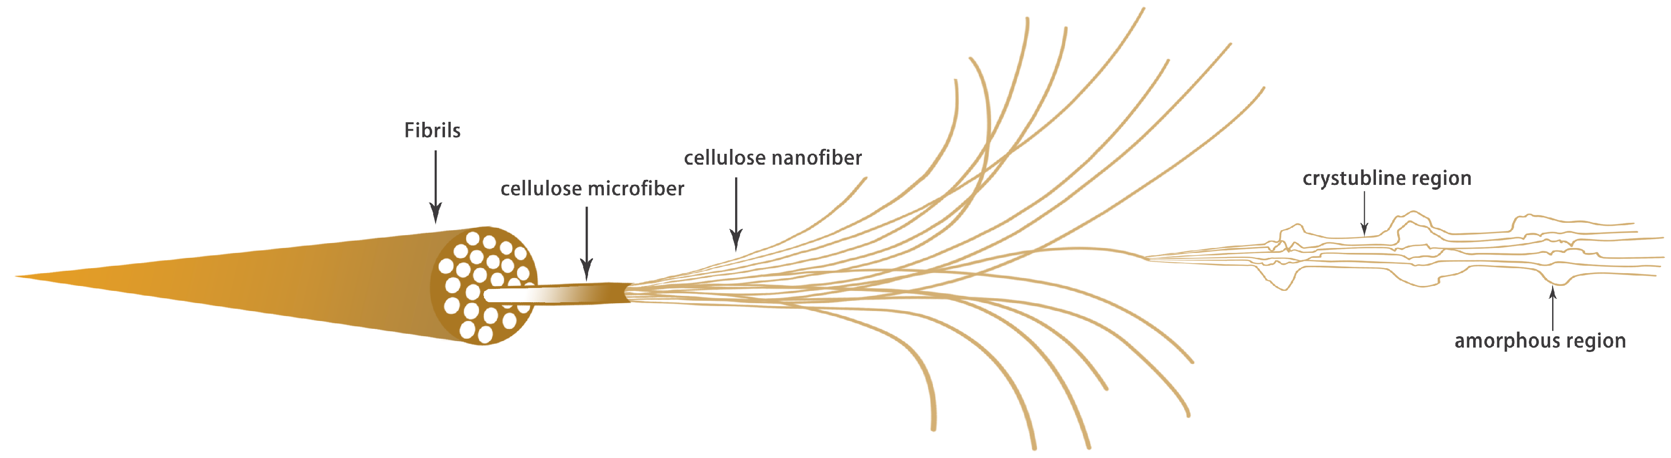
Figure 2. Internal structure of cellulose [15]
The most important variables influencing cellulose reaction include porosity, moisture, associated biopolymers, and accessibility. In Table 1, there is representation of the factors controlling the cellulose reactivity. The tight bonding (hydrogen bonding) within cellulose prevents glycoside bonds from being broken by an incoming attacking nucleophile (an atom that will be bonded to another atom). This results in the inability to dissolve cellulose in virtually all solvents, including most organic solvents, at room temperature. When dissolution can be achieved with specialized solvents, such as ionic liquids or deep eutectic solvents, the activation energy required to break the glycoside bonds remains quite high [16–19]. Water content affects hydrolysis in two ways. Low water levels enhance proton transport during acid-catalyzed hydrolysis. Excessive amounts of water can either cause recrystallization of cellulose or compete for active site(s) on the catalyst [20,21]. In addition, the rate of reactant diffusion into the porous structure of cellulose depends on both porosity and surface area. Therefore, methods for mechanically or chemically disassembling cellulose fibers (and thereby increasing porosity and surface area) generally result in higher hydrolysis rates. A major limitation to enzymatic and acid hydrolysis is interference from lignin and hemicelluloses present in biomass [22,23]. Hemicellulose coats individual cellulose microfibrils, creating a steric hindrance that limits the ability of enzymes or acids to contact the cellulose. Lignin acts not only as a steric hindrance to depolymerization but also has a high degree of cross-linkage and forms covalent complexes with both proteins and catalysts. These complexes effectively remove active enzyme/catalyst molecules from reacting with cellulose, thereby preventing unwanted side reactions and other problems. As these interactions between the matrix components occur with virtually no interaction with pure crystalline cellulose, this leads to exaggerated performance in laboratory experiments using pure microcrystalline cellulose [24,25].

Table 1. Factors controlling cellulose reactivity
Factor | Problem Explanation
Crystallinity | Highly ordered crystalline regions resist chemical/enzymatic attack due to tightly packed chains limiting reagent penetration, reducing glycosidic bond availability for hydrolysis.
Degree of polymerization | Longer chains require more bond cleavages for depolymerization, demanding harsher conditions, while chain entanglement hinders reagent diffusion to reactive sites.
Porosity | Low porosity restricts catalyst/enzyme diffusion into the cellulose matrix, creating mass transfer limitations that dominate overall reaction kinetics.
Lignin interference | Lignin physically shields cellulose and non-productively binds catalysts or enzymes, while lignin-derived compounds may inhibit catalytic activity.
Hemicellulose coating | Hemicelluloses coat cellulose microfibrils, sterically hindering access and requiring disruption before reactive agents can engage substrates.
Moisture content | Insufficient water limits cellulose swelling and reactant mobility; excess water dilutes reactants. Optimal moisture balances accessibility with concentration.
Catalyst accessibility | Reactive sites remain unutilized if catalysts cannot overcome steric, electrostatic, or diffusional barriers; catalyst-pore compatibility is essential.

Cellulose degradation, from both kinetic and thermodynamic perspectives, is a difficult, high-energy process that requires substantial energy to destabilize the cellulose crystal structure and break the glycosidic bonds [26]. Hydrolyzing the beta-1,4 linkages in water is thermodynamically favorable; however, the rate of hydrolysis is very slow due to diffusion limitations and the small number of available reactive sites. All kinetic studies have shown biphase kinetics. The first phase is fast and involves the depolymerization of amorphous regions. In the second phase, there is a great slowing down (deceleration) of the rate of depolymerization, as the crystalline domains become the main source of cellulose [27,28]. Product inhibition also plays a significant role in this slowing down. Product inhibition occurs when oligomers or sugars accumulate and bind to catalytically active sites on the enzyme surface. Alternatively, oligomers can influence local pH or ionic strength near active sites. The basicity of its glycosidic oxygen enhances the thermal stability of cellulose [29,30]. Therefore, either a very acidic environment or one with a unique ability to donate protons to the glycosidic oxygen is needed for effective catalysis. However, if these extreme conditions persist for long enough, they can lead to thermodynamic runaway. Thermodynamic runaway occurs when all liberated sugars quickly dehydrate, fragment, or condense to form other thermodynamically stable species (such as levulinic acid, formic acid, or humins), rather than glucose [31,32]. In following Figure 3. is described the hydrolysis-dehydration reaction of cellulose to glucose and 5-HMF.

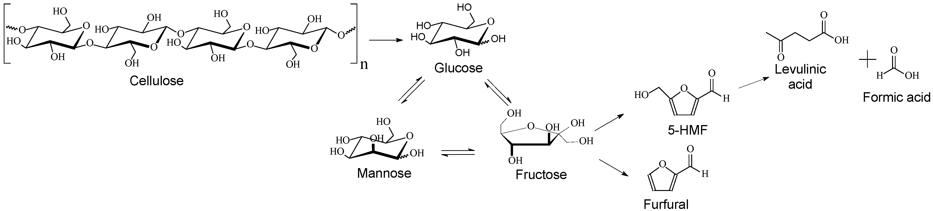
Figure 3. The hydrolysis-dehydration reaction of cellulose to glucose and 5-HMF [33]
The molecular and chemical characteristics of cellulose define the development of solvents and catalysts used to degrade cellulose efficiently. Therefore, an optimal solvent system must provide sufficient solubilizing power, specifically cleave the glycosidic bonds within cellulose, and avoid excessive solvation energy required to break down cellulose into soluble components [31,34]. Additionally, all catalyst systems (homogeneous and heterogeneous) require detailed optimization of their acid-base properties, pore architecture, and surface hydrophilicity to meet the constraints of accessing cellulose. For example, solid acid catalysis may utilize mesoporous surfaces to facilitate access of large cellulose macromolecules, whereas enzyme-based catalytic systems depend on matching surface architectures and synergistically arranged active sites [35]. Further, the interactions among reaction variables, such as the relative polarities of the solvents used, the acidities of the catalysts employed, and reaction temperatures, also need to be optimized to achieve maximum depolymerization selectivity while minimizing unwanted polymerization reactions. Understanding these structure-reactivity interactions will therefore be critical to developing future-generation depolymerization technologies that operate under relatively mild conditions, can effectively process raw biomass contaminated with other species, and achieve very high product selectivity [36,37]. Finally, the ultimate goal in cellulose utilization is to develop technologies that selectively disrupt the ordered H-bonded network that constitutes the crystalline state of cellulose without inducing rapid degradation of the glucose oligomers formed during this disruption, a relationship that remains at the forefront of new developments in green chemistry and biorefinery design.

3. Mechanisms of Cellulose Depolymerization
The depolymerization of cellulose occurs via unique mechanisms (Figure 4), depending on factors such as solvent-catalyst interactions, the amount of energy used during depolymerization, and the environment in which depolymerization occurs.
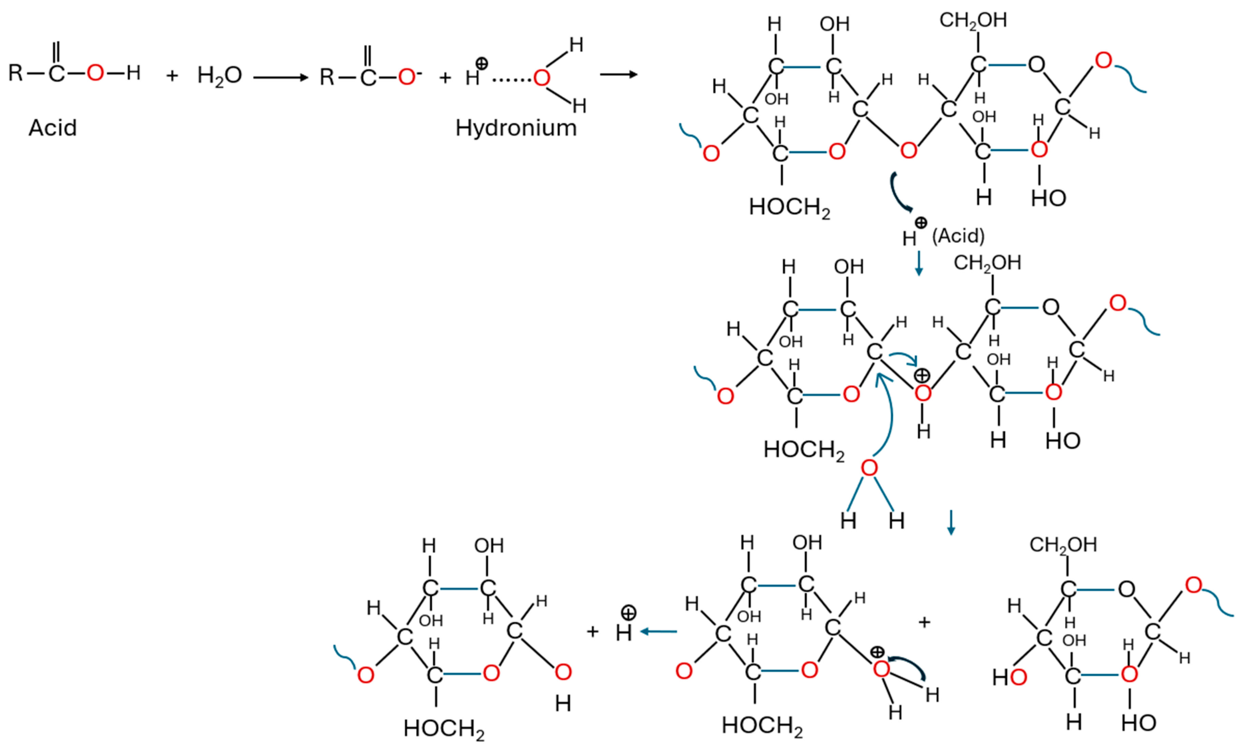
Figure 4. Mechanism of acid hydrolysis of glycosidic bonds in cellulose [38]
Depolymerization through hydrolysis has been studied for many years, with hydrolysis occurring as follows: (i) A proton is placed at the glycosidic oxygen, creating a carbonium ion; (ii) Water acts as a nucleophile to create an acetaldehyde. Mineral acids have the highest concentrations of protons. Therefore, they can quickly protonate glycosidic linkages, forming a carbocation intermediate that ultimately yields either glucose or oligomers. The mechanism of this reaction is similar to that of an SN1 reaction [39–41]. The initial step of the reaction will be determined by how fast the carbocation intermediate forms. Although this method works well, it does lead to excessive hydrolysis. Once glucose or other oligomers are formed from cellulose, if they remain in contact with acidic environments long enough, they may dehydrate or fragment to produce smaller fragments. Comparison of acid hydrolysis methods and the parameters are mentioned in following table 2.
Table 2. Comparison of acid hydrolysis methods
Parameter | Dilute acid (less than 5%) [42,43] | Concentrated acid (30-70%) [44,45]
Temperature | High (160 – 240 °C) | Low (25 – 100 °C)
Glucose yield | Moderate (approx. 50 – 65%) | High (up to 90%)
Sugar degradation | Significant (formation HMF, furfural) | Minimal (with proper control)
Main disadvantage | High pressure and temperature required | Equipment corrosion and recovery needed

In addition, alkaline conditions are also suitable for cellulose depolymerization [46].
In contrast, enzymatic hydrolysis uses cellulase enzymes, which employ acid-base catalysis within their structured binding sites. The four types of cellulase enzymes include endoglucanases, exoglucanases (cellobiohydroxylases), beta-glucosidases and lytic polysaccharide monooxygenases. Lytic polysaccharide monooxygenases (LPMOs) are oxidative enzymes that significantly boost the efficiency of traditional hydrolases [47–49]. Cellobiohydrolases work processively, removing glucose molecules one at a time from both ends of the cellulose chain. Beta-glucosidases break down cellobiose into glucose [50]. In following Table 3 are listed the main parameters of key enzymes in the cellulase complex.
Table 3. Parameters of key enzymes in the cellulase complex
Enzyme (EC Code) | Key Function (Mechanism) | Optimal pH | Optimal Temp. | Primary Product
Endoglucanases (3.2.1.4) [51] | Random cleavage within amorphous chains | 4.5 – 5.5 | 45 – 55 °C | Short-chain polymers
Exoglucanases (3.2.1.91) [52] | Cleaving units from chain ends | 4.0 – 5.0 | 50 – 60 °C | Cellobiose (disaccharide)
beta-glucosidases (3.2.1.21) [53] | Hydrolysis of cellobiose into monomers | 4.8 – 5.2 | 45 – 65 °C | Glucose
LPMO (1.14.99.54) [54] | Oxidative disruption of crystalline structure | 5.0 – 6.0 | 40 – 50 °C | Oxidized chain ends

The synergy of these processes provides excellent specificity and enables operation at low temperature and pressure. However, there are limitations associated with enzymatic hydrolysis, including enzyme sorption/desorption kinetics and product inhibition, and limited diffusional access into crystalline structures [23].
Oxidative depolymerization presents an alternative route to the conventional hydrolytic process, in which the glycosidic bond is broken using an electron transfer mechanism (or radical) to break the glycosidic bond; therefore, TEMPO-mediated oxidation (Figure 5.) is a selective process that only breaks down the primary hydroxyl group at the C6 position on the cellulose chain, and thus creates swollen and thus more easily attacked cellulose chains for subsequent hydrolysis.

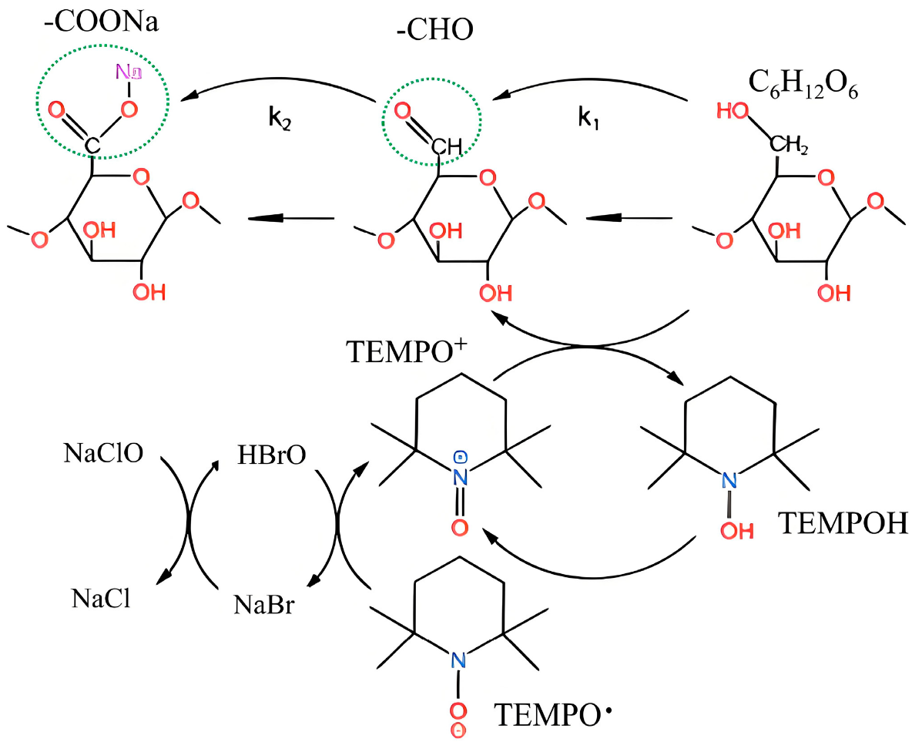
Figure 5. Mechanism of selective oxidation of cellulose by the TEMPO system [55]
Although this method does not directly cleave the beta-1,4 linkage, it does reduce the degree of crystallinity and degree of polymerization, thereby facilitating further depolymerization. Metal-catalyzed oxidative cleavage of glycosidic bonds with H₂O₂ or molecular oxygen generates hydroxyl radicals that randomly attack glycosidic bonds, yielding a broad range of oxidatively modified fragments [56]. The metal-catalyzed oxidative cleavage of glycosidic bonds is highly dependent on reaction conditions (e.g., temperature, pH) to determine whether controlled cleavage will occur or random oxidative degradation will occur. Electrochemical and photonic catalytic processes provide an attractive means to mediate oxidative cleavage reactions and minimize the use of chemical oxidants [57].
Thermal and mechanochemical methods of degrading cellulose involve non-chemical (energetic) input rather than chemical treatment. Hydrothermal processes are methods of physically weakening hydrogen-bonded intermolecular interactions within cellulose structures by using hot water. In addition, during the process, auto-generated acids are formed from dissolved biomaterial components, which can lead to self-catalyzed hydrolysis [58,59]. Pyrolytic fast pyrolysis occurs at substantially higher temperatures than hydrothermal processing (in a low-oxygen environment), resulting in rapid thermal cleavage. As a result, fast pyrolysis produces levoglucosan and anhydro-oligosaccharides via transglycosylation mechanisms [20,60]. Mechanical depolymerization of cellulose is primarily achieved through ball-milling techniques (Figure 6).

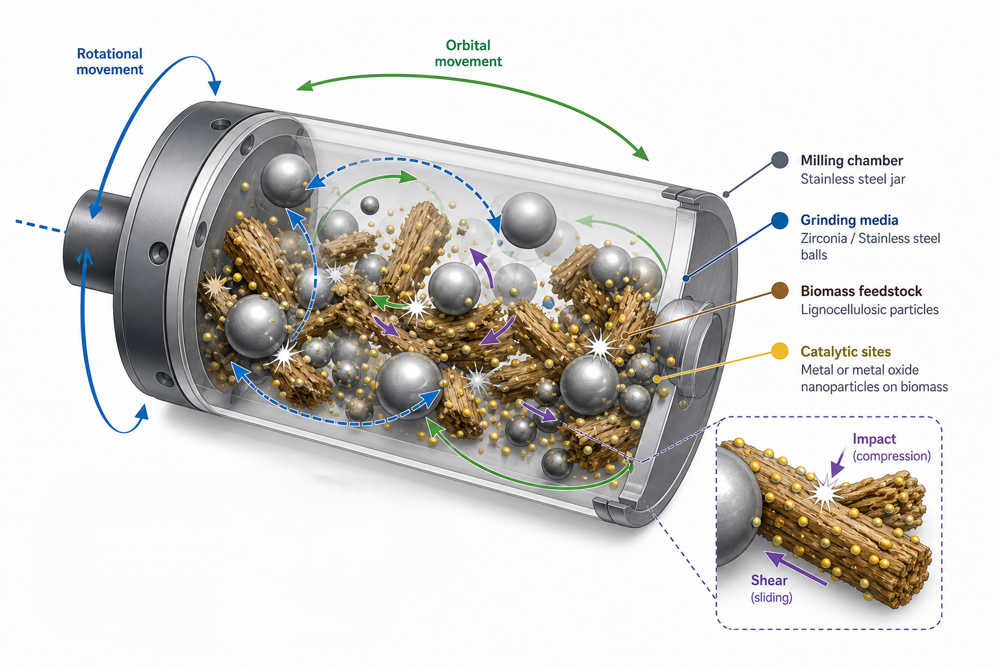
Figure 6. Image of planetary milling for the mechanocatalytic hydrolysis of lignocellulosic biomass.
Ball milling uses shear/impact forces to mechanically break crystalline regions within cellulose, decrease particle size, and create reactive surface defects. However, when used in conjunction with solid acid catalysts, the synergy between mechanical activation (exposing glycosidic bonds) and catalysis enables the high-yield conversion of cellulose to soluble sugars [61-63]. Reaction kinetic rates among all three pathways depend significantly on substrate crystallinity, acidity of catalysts, solubility (polarity) of the solvent(s), and the residence time of reactants in the reactor system. The relative rate of primary bond cleavage versus secondary degradation determines product selectivity [64,65]. Therefore, optimal operating conditions require strict control over proton activity, radical flux, and/or thermal energy. Mechanistically, it has been demonstrated that understanding structural/activity relationships is key. Catalysts must possess sufficient acidity to enable activation of glycosidic bonds while possessing insufficient acidity to promote degradation of produced sugars. Reaction schemes for illustrative depolymerization pathways have consistently shown that depolymerization efficiency is directly related to access to glycosidic linkages, the stability of oxocarbenium ions (intermediates), and the ability to rapidly remove the produced sugars from the catalytically active site, thereby preventing retro-reaction. Understanding these mechanistic parameters will provide the basis for rationally designing effective catalysts and optimizing viable processes for the future value-added use of cellulose [29].

4. Classification of Depolymerization Strategies
Ionic liquid-based depolymerization is a new method for depolymerizing cellulose that uses the disruption of hydrogen bonding between cellulose molecules by an ionic liquid (IL) to dissolve cellulose. The dissolved cellulose is then treated with acid or a metal catalyst to hydrolyze it. Choline chloride-urea mixtures are among the best ILs for this application due to their ability to dissolve large amounts of cellulose; however, the water content of the mixture and the amount of catalyst added need to be carefully optimized to minimize humin formation [31]. A second approach to breaking down cellulose into smaller fragments involves oxidative cleavage. This can be achieved by reacting cellulose with either oxygen, hydrogen peroxide, or electrochemically. Oxidation has several advantages over acid catalysis, since no strong acids are required [66]. However, there are also disadvantages to using oxidation to break down cellulose. For example, if too much oxygen is introduced into the reaction mixture, the resulting degradation leads to random cleavage of glycosidic bonds and subsequent fragmentation of polymer chains [67]. It should be noted that each of the above chemical methods for degrading cellulose suffers from limitations related to environmental concerns and economic feasibility. For example, the use of ionic liquids results in viscous solutions that are difficult to handle during processing and are expensive to synthesize. In addition, there are questions about whether ionic liquids are biodegradable [68,69]. Similarly, while solid acids can be readily regenerated after treatment with organic materials, they suffer from similar problems in removing adsorbed sugars or humin deposits. Further, many commercial applications of solid acids do not incorporate closed-loop solvent recovery processes, which would allow them to meet green chemistry standards [70,71]. The comparison of most often used solvents and catalysts for cellulose depolymerization are mentioned in following table 4.
Table 4. Solvents and catalysts used in cellulose depolymerization
Solvent/catalyst | Type | Role | Advantages | Challenges
Ionic liquids | Solvent | Dissolve cellulose | High dissolution | Expensive
Deep eutectic solvents | Solvent | Disrupt H-bond network | Green | Water sensitivity
Solid acids | Catalyst | Glycosidic cleavage | Reusable | Deactivation
Cellulases | Enzyme | Hydrolysis | Selective | Cost

Enzyme-catalyzed depolymerization of cellulose uses biological catalysts to achieve unparalleled selectivity under mild conditions using water as a solvent. Cellulase enzymes work synergetically, where endoglucanases initiate breakage in the disordered region of cellulose chains; Cellobiohydrolases continue by releasing a cellobiose unit from the termini of the chain, and beta-glucosidase completes hydrolysis to glucose [72]. Typical reaction conditions are temperatures between 40 and 50 degrees centigrade and pH values between 4 and 5, reducing energy consumption and environmental corrosion. Advances have been made in engineering cellulase enzymes for improved thermostability, reduced product inhibition, and enhanced tolerance to lignin and hemicellulose derivatives [73]. Strategies for immobilizing cellulase enzymes onto mesoporous silica nanocrystals, magnetic particles, or a polymer matrix have enabled catalyst recycling and continuous operation in packed-bed reactors. Despite these advances, enzyme-catalyzed hydrolysis is limited by slow kinetics, the high cost of production of cellulase enzymes, and extreme sensitivity to feedstock impurities [35,74]. Non-pressurized binding of enzymes to lignin dramatically decreases catalytic efficiency while accumulation of cellobiose and glucose reduces beta-glucosidase activity through competitive and allosteric mechanisms. The requirement for extensive pretreatment to reduce crystallinity and remove lignin adds additional complexity and capital expense to this process [20]. Therefore, the enzyme-catalyzed route provides very high selectivity and excellent environmental benefits, but poor throughput and economic competitiveness at an industrial scale without significant process intensification or reductions in manufacturing costs for enzyme production [75].
Physicochemical and thermochemical techniques use various forms of thermal energy (heat), mechanical force, and/or electromagnetic waves to break down cellulose into smaller units and to cleave chemical bonds. The primary physicochemical technique used to treat cellulose is hydrothermal treatment. This type of treatment uses elevated temperature and pressure to dissociate ions in water, resulting in an "auto-catalyst" that enables the hydrolysis of cellulose without the addition of exogenous acid. Using elevated temperatures and pressures enables an autocatalytic process [76]. Supercritical water treatment can be considered the next level up, as it operates under much more extreme conditions than those required for hydrothermal treatment. It achieves very rapid depolymerization under these conditions; however, supercritical water treatment requires specialized equipment (e.g., high-pressure reactors) and significant cooling to rapidly halt further reactions once they occur [77]. Planetary ball mills have been extensively utilized for mechanochemical treatment of biomass, including cellulose. Planetary ball milling applies extremely high shear and impact stresses to reduce crystallinity and increase the surface area of cellulose particles. As well, the planetary ball mill generates reactive free radicals on the surfaces of the treated cellulose particles. Therefore, when planetary ball milling is coupled with either a solid acid catalyst or small amounts of liquid additives, significant increases in sugar yield are observed, along with reduced time required to heat-treat the biomass [78,79]. The comparison of cellulose depolymerization methods is presented in Table 5, where the advantages and limitations of each method are also noted.
Table 5. Comparison of most used cellulose depolymerization methods
Method | Catalyst | Temperature | Main products | Advantages | Limitations
Acid hydrolysis [80] | Mineral acids | 120-250 °C | Glucose | Fast | Sugar degradation
Enzymatic [81] | Cellulases | 40-50 °C | Glucose | High selectivity | Slow kinetics
Oxidative [82] | TEMPO/metal | 50-150 °C | Oxidized oligomers | Mild | Low selectivity
Hydrothermal [83] | Water | 200-400 °C | Sugars | No catalyst | Energy intensive
Mechanochemical [84] | Ball milling | 20-100 °C | Oligomers | No solvents | Scaling issues

Microwave and ultrasonic-assisted depolymerization treatments provide a means to both create local areas of increased temperature (dielectric heating) that enhance mass transport and to create localized turbulence via sonic vibrations (acoustic cavitation). Both microwave and ultrasonic-assisted treatments accelerate the hydrolysis of cellulose, producing soluble oligomers and monomers [85,86]. Plasma treatments are another method used to assist in the breaking down of cellulose [87]. Plasma treatments generate reactive species, such as oxygen radicals and other oxidizing agents, that help degrade cellulose into soluble components [88–90].
Integrated and emerging technologies that combine multiple mechanisms to improve the performance of individual techniques include hybrid (or one-pot) systems. Mild chemical pretreatment can be used in chemo-enzymatic cascade processes to reduce the crystallinity of biomass and/or remove lignin before enzymatic hydrolysis at low temperatures for maximum yield. Acid catalysis depolymerizes biomass in tandem with isomerization or hydrogenation, enabling a single-step process in which glucose can be converted to sorbitol, mannitol, or organic acids [36,91,92]. Renewable electricity or light can power selective bond cleavage in electrocatalytic and photocatalytic depolymerization reactions, respectively. Energy inputs required for thermal degradation are minimized by using renewable energy. Reaction paths also become more predictable because they can be controlled precisely using electrical or light energy. In addition, AI/Machine Learning can be used to identify optimal catalyst formulations; predict reaction kinetic properties; and develop optimal solvents to accelerate the development of highly effective depolymerization media. Selective conversion rates are enhanced, energy requirements are reduced, and environmental sustainability is improved through lower solvent use and reduced waste generation compared with single-technique approaches [34]. However, these hybrid approaches also pose new technical challenges in process control, catalyst compatibility, and long-term operability. Successful application of hybrid technologies requires optimized integration of reaction conditions, coordination of sequential catalytic steps, and efficient separation protocols to minimize cross-inhibitory effects [93]. Despite the technical challenges associated with the application of hybrid technologies, they offer the best prospects for economical and environmentally benign cellulose valorization in future generations of biorefineries.

5. Performance Metrics and Comparative Analysis
Evaluating the performance of cellulose depolymerization strategies using a common evaluation method will provide a standardized means for comparing all cellulose depolymerization research based on real-world application feasibility. Although sugar yield, selectivity, and reaction severity remain widely used as general benchmarks for evaluating cellulose depolymerization research, these indicators are subject to varying interpretations due to differences in analytical methods and raw material specifications. Therefore, glucose yield alone does not accurately assess the effectiveness of many cellulose depolymerization methods, since they may be designed to produce cello-oligosaccharides or other intermediate products from cellulose conversion into platform chemicals [40,94]. Additionally, cello-oligosaccharide yields are often affected by competing reactions that produce unwanted products, including hydroxymethyl furfural, levulinic acid, and Humins; not only do these undesired products decrease the economic value of the product streams, but they also make downstream processing more difficult. While reaction severity, which is most commonly defined in terms of temperature, time, and catalyst concentration, has been used to evaluate process intensities across various cellulose depolymerization methods, this variable does not account for the effects of solvents, catalyst recycling, and/or heat integration on overall system efficiency [95,96]. In addition to reaction severity and catalyst lifetime, solvent recyclability is becoming increasingly important as an additional criterion for evaluating the performance of cellulose depolymerization methods. This is particularly true for both homogeneous and heterogeneous cellulose depolymerization systems, where fouling, leaching, and changes in viscosity during operation directly affect continuous operation [97]. Several highly effective laboratory-scale catalysts have demonstrated significant losses in activity over just three to five recycle operations due to pore blockages, poisoning of active sites, or structural collapse caused by hydrothermal conditions. Finally, while high recovery efficiencies for solvents used in cellulose depolymerization methods, i.e., ionic liquids and deep eutectic mixtures, can require relatively large amounts of energy for distillation or extraction, these high energy requirements can offset some of the positive environmental implications associated with mild reaction conditions [98].

Table 6. Life Cycle Assessment (LCA) comparison of cellulose depolymerization methods
Method | Energy Demand | Catalyst/Solvent Impact | GHG Emissions (relative) | Waste Generation | Water Use | Catalyst/Solvent Recyclability | Key Environmental Hotspots | Overall LCA Assessment
Dilute Acid Hydrolysis | High (due to high T/P: 160-240 °C) | Mineral acids (corrosive, hazardous) | High | High (acid wastewater, degradation products like HMF, humins) | Moderate-high | Low (acid neutralization required) | Acid production, corrosion-resistant equipment, wastewater treatment | Poor-Moderate (efficient but environmentally intensive)
Concentrated Acid Hydrolysis | Moderate (lower temperature) | Large acid volumes; recovery required | High | Moderate-High (acid losses, toxic residues) | High | Moderate (energy intensive acid recovery) | Acid recovery energy demand, equipment corrosion | Moderate (high yield but high environmental burden)
Enzymatic Hydrolysis | Low (40-60 °C) | Biocatalysts (cellulases) | Low-Moderate | Low (minimal toxic by-products) | High (aqueous systems) | Moderate (enzyme immobilization possible) | Enzyme production, pretreatment energy, slow kinetics | Good-Very Good (green but limited by upstream impacts)
Oxidative Depolymerization (eg. TEMPO, metal catalysts) | Moderate | Oxidants (H₂O₂, O₂) metal catalysts | Moderate | Moderate (oxidized fragments, possible metal residues) | Moderate | Moderate | Oxidant production, catalyst leaching, selectivity issues | Moderate (balanced but selectivity-dependent)
Ionic Liquid Based Systems | Moderate | IL (expensive, synthesis intensive) | Moderate-High | Low-Moderate (if recycled) | Low-Moderate | High (closed-loop possible) | IL synthesis, viscosity-related processing energy | Moderate-Good (excellent if solvent recycling is efficient)
Deep Eutectic Solvents (DES) | Low-Moderate | Generally biodegradable components | Low-Moderate | Low | Moderate | Moderate-High | Water sensitivity, solvent recovery efficiency | Good (promising green alternative)
Hydrothermal Processing | Very High (200-400 °C, high pressure) | Water (no added catalyst) | High | Moderate (organic acids, degraded sugars) | High | High (no catalyst needed) | Thermal energy input, pressure requirements | Moderate-Poor (simple but energy intensive)
Supercritical Water Treatment | Extremely High | Water under extreme conditions | Very High | Moderate | High | High | Extreme energy input, specialized infrastructure | Poor (limited sustainability despite efficiency)
Mechanochemical (Ball Milling) | Moderate (mechanical energy) | Mineral solvent use | Low-Moderate | Low | Low | High | Electricity demand, scale-up limitations | Good (low solvent footprint, scalable challenges)
Microwave/Ultrasonic Assisted | Moderate | Depends on coupling chemistry | Moderate | Low-Moderate | Moderate | Moderate | Electricity source, equipment efficiency | Moderate-Good
Hybrid (Chemo – Enzymatic, Catalytic Cascades) | Optimized (moderate overall) | Mixed systems (enzymes-catalysts-solvents) | Low-Moderate | Low-Moderate | Moderate | High (if integrated) | Process integration complexity, catalyst compatibility | Very Good (Best Potential)

Assessing industrial scalability requires understanding energy consumption, mass balances, and environmental footprints. The thermochemical method requires significant thermal energy and, therefore, requires a robust heat recovery network to achieve a positive net energy balance. Low-temperature enzymatic processes require substantial energy for upstream pretreatment and downstream enzyme production. In all life cycle assessments (Table 6), it is evident that most of the environmental impact comes from producing solvents, manufacturing catalysts, and treating wastewater, usually far outweighing the reduction in carbon use from using biomass. Economic analysis shows that for bio-oil to compete economically with petroleum, the sugar yield must exceed 80% and the catalytic turnover number (the number of times each catalyst molecule can process) must exceed 1000. Unfortunately, there is little evidence of both being achieved simultaneously. There is a trade-off between a process's performance and its sustainability. A mineral acid system may perform very quickly (be highly active); however, it produces toxic wastes [99]. On the other hand, a green solvent system minimizes its environmental impact but is expensive to build and runs slowly. Below, in Figure 7. is the radar chart comparing life cycle sustainability metrics of major cellulose depolymerization methods. Higher scores indicate more favorable environmental performance. Hybrid and enzymatic systems show the most balanced sustainability profiles, while thermochemical routes remain energy-intensive.
Figure 7. Radar chart comparing life cycle sustainability metrics of major cellulose depolymerization methods.
The distance between performing a process at lab scale versus piloting the same process is also great. Most of this is because engineers working at the bench do not consider issues such as heat transfer limitations, poor mixing, or operating continuously at larger scales when developing their ideas. Thus, standardized benchmarking protocols are urgently needed to allow comparison of different study results, including defining the system boundaries (feedstock characterization, product quantification, catalyst regeneration procedures, etc.) and which elements should be included in mass/energy balances. Without establishing common ground for comparing study results, performance data will remain fragmented, making technology transfer difficult and industry adoption nearly impossible.

6. Downstream Valorization Pathways
The products from cellulose breakdown also provide a wide range of feedstock options for a variety of conversions to produce fuels, chemicals, and higher-value materials (Figure 8). The major monomer produced (glucose) serves as a focal point for the various biochemical cascades in a biorefinery system. Hydrogenation of glucose creates sugar alcohols (such as sorbitol and mannitol), which are very important to the pharmaceutical and food industries. Through dehydration reactions of glucose, hydroxymethyl furfural is produced, a highly reactive platform molecule. It can then undergo hydrogenation reactions to produce 2,5-dimethylfuran or oxidation reactions to form 2,5-furadicarboxylic acid, a renewable version of terephthalic acid used in the production of polyesters [100,101]. After isomerizing glucose to fructose through dehydration reactions, levulinic acid is formed. Levulinic acid can be converted into gamma valerolactone, alkyl levulinates, and biodegradable solvents. A retro-aldol condensation reaction pathway will break down glucose into lower-molecular-weight carbonyl compounds, which can be upgraded to ethylene glycol, propylene glycol, or lactic acid. These reaction paths illustrate the chemical flexibility of cellulose after it has been broken down, enabling the production of "drop-in" replacements for petrochemical-derived products while maintaining carbon neutrality [102,103]. The biofuel industry uses the same platform molecules derived from these depolymerized cellulose products through fermentation and/or catalytic upgrading. Ethanol, currently the largest commercial-scale process for glucose from biomass fermentation, continues to be improved through advances in metabolic engineering to enable direct conversion to biobutanol, isobutanol, and other advanced jet fuel precursors [104]. Catalytically hydrodeoxygenating the depolymerization byproducts will create renewable diesel and sustainable aviation fuel components with high energy density, compatible with current infrastructure. To integrate the fuel synthesis pathways with the depolymerization systems, there must be a precise match between the product streams and the catalytic requirements. This may require intermediate purification steps or even direct tandem processing to limit energy penalties [105].

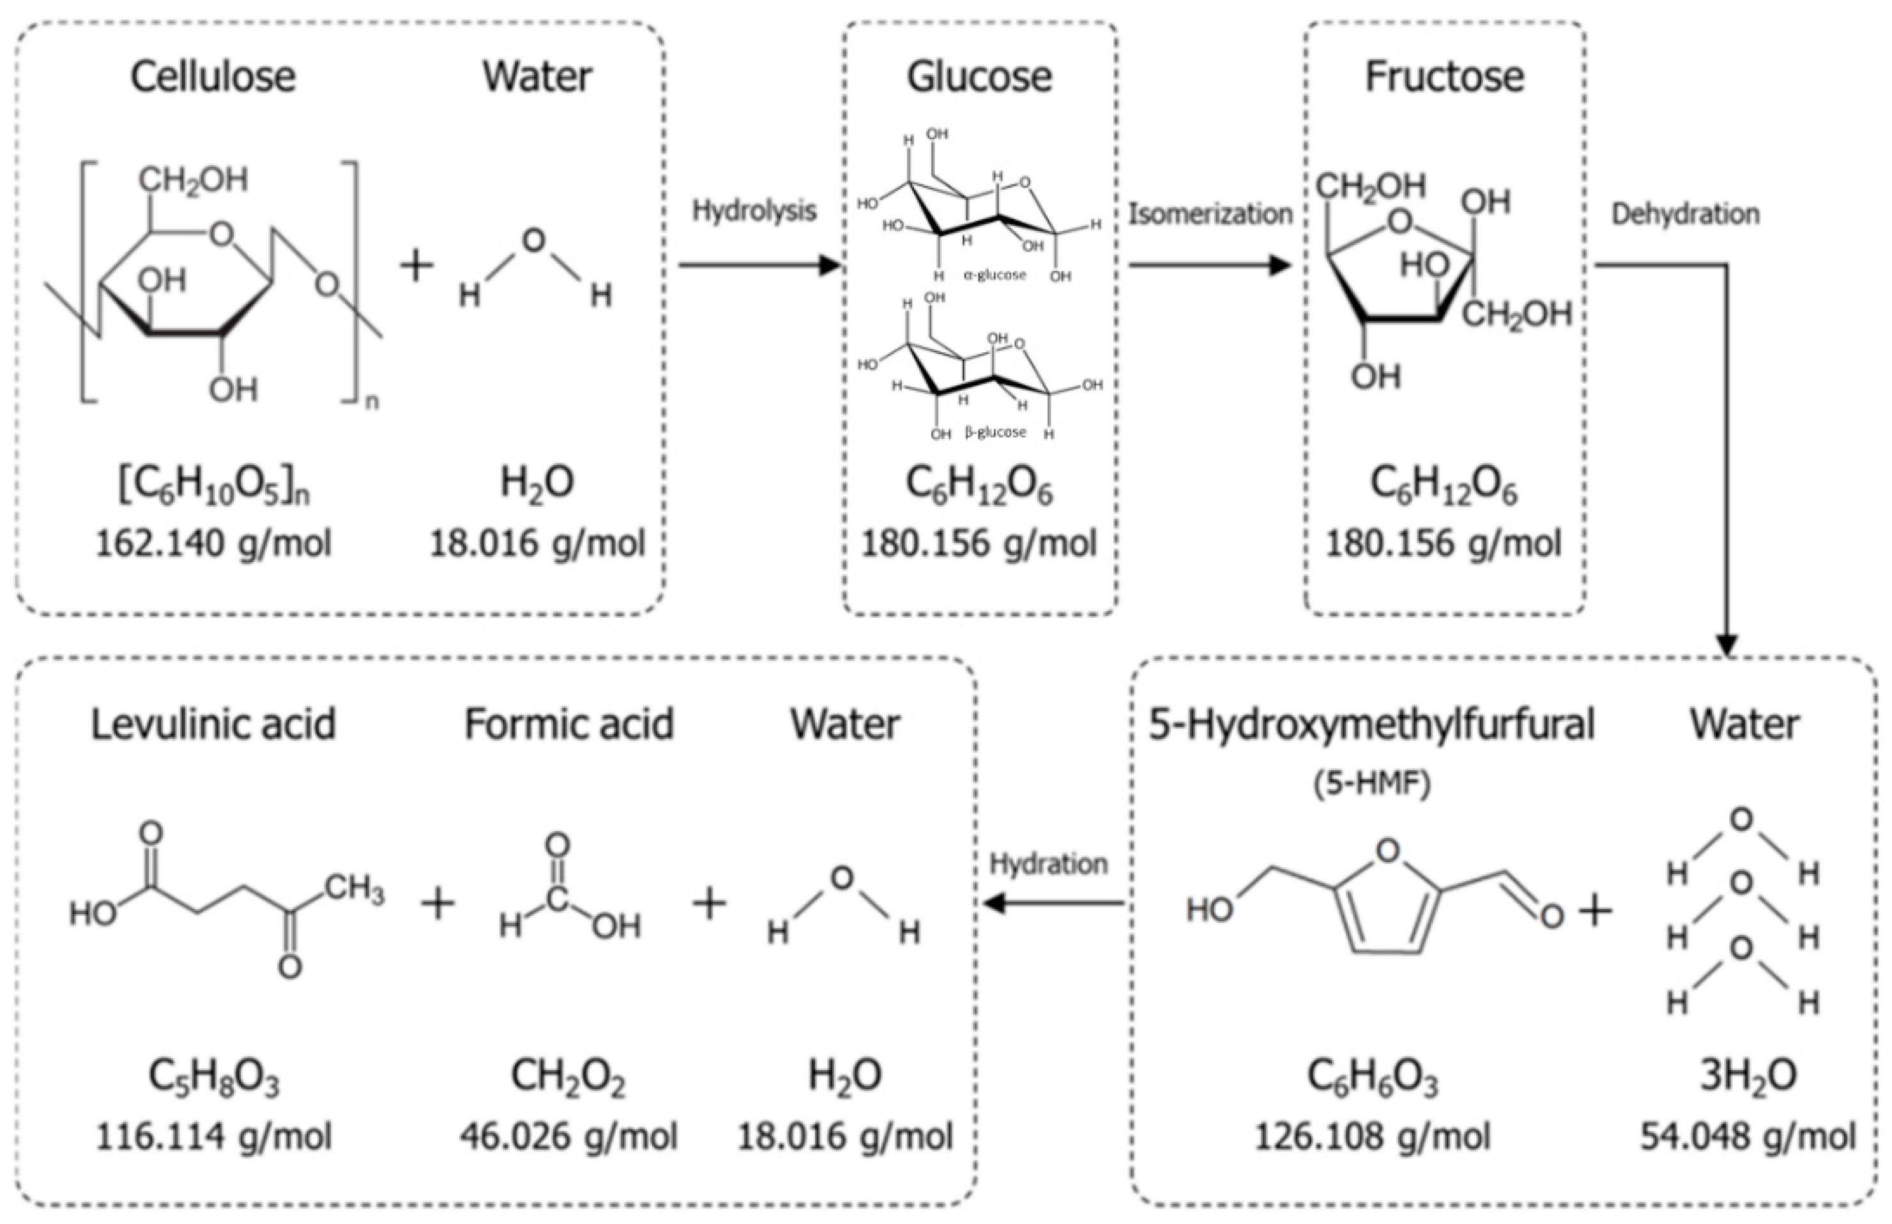
Figure 8. Typical conversion pathways of cellulosic biomass into value-added organic acids [106]
Beyond their use as a fuel source or chemical feedstock, cellulose-based intermediates have been used to synthesize a range of functional materials. The controlled partial degradation of cellulose produces cellulose nano-crystals and nano-fibrils [14]. Cellulose nanocrystals and nanofibrils are highly mechanically strong and optically transparent, and they also exhibit good biocompatibility. Therefore, these materials can be used to reinforce polymer matrices, provide biocompatible layers for biomedical devices, and coatings for barrier films [107]. When subjected to heat treatment in the presence of an alkaline solution at elevated temperatures, cello-oligosaccharides are converted into carbon dots. The carbon dots produced via this method exhibit adjustable fluorescent properties, are low-toxicity, and have demonstrated high quantum yields. As such, carbon dots derived from cello-oligosaccharide precursors are being developed for bioimaging, sensor technologies, and optoelectronic applications [108]. Networks and hydrogels formed from various types of derivatized celluloses that have undergone some degree of depolymerization can be designed to exhibit customized levels of porosity, swelling, and mechanical strength. As such, networks and hydrogels formed from derivatized cellulose products are increasingly used in tissue engineering, drug delivery, and the manufacture of sustainable packaging solutions [109]. The development of one-pot and cascade-type reaction systems has greatly enhanced the downstream processing options available to those seeking to utilize thermally degradable cellulose-based products. One-pot reaction systems integrate all of the necessary reactions into a single reactor vessel. Cascade reaction systems contain multiple reactor vessels but perform multiple steps in each vessel. Both one-pot and cascade reaction systems have reduced or eliminated the need to isolate intermediate products after each step. They have also reduced the volume of solvents required per unit mass of substrate processed and improved the overall atom economy of the resulting products [110]. Bifunctional catalysts possessing both acid and metal active sites have been employed to convert cellulose directly into sorbitol or mannitol. Multistep catalytic bed reactors have enabled sequential dehydration/hydrogenation processes to produce high-value furanic compounds [103]. Modular biorefinery designs employ these cascade approaches by combining thermochemical depolymerization with biological upgrading. Chemically derived sugars that result from thermochemical depolymerization are then fermented by genetically engineered microorganisms to produce complex molecules that are difficult to synthesize chemically. This hybrid approach efficiently utilizes resources, reduces waste streams, and provides biorefinery operators with greater economic resiliency by offering a diverse portfolio of products that can be dynamically adjusted to meet changing market conditions [111,112].

7. Challenges and Limitations
Despite tremendous progress in recent years in research on cellulose depolymerization, several persistent technical and economic hurdles remain to be overcome for commercial-scale operation. The recalcitrant nature of crystalline cellulose represents the single greatest barrier to its successful conversion. This barrier stems from two factors inherent within the structure of crystalline cellulose: (1) it has an extremely dense hydrogen bonding network, and (2) it exists as long chains of polymer. As a result, crystalline cellulose resists all attempts at chemical or physical breakdown under relatively mild conditions. Consequently, incomplete depolymerization typically yields complex, heterogeneous product streams comprising unreacted cellulose, partially depolymerized oligomeric fragments, and degradation products formed during the reaction. Additionally, the complexity of generating these product streams makes subsequent purification operations difficult to execute [113]. Furthermore, the heterogeneity of the feedstock materials used in all industrial processes provides another layer of complexity to this problem. Real-world biomass feedstocks vary widely in crystallinity, lignin content, mineral ash composition, and moisture content. In particular, the presence of lignin and hemicelluloses creates significant challenges for the efficient conversion of cellulose into fermentable sugars or chemicals. For example, the lignin component can physically shield the cellulose fibril surfaces and thereby prevent enzyme access, can adsorb onto the surface of the catalytically active sites on metal catalysts and thus inhibit their ability to function as catalysts, and can act as a free radical scavenger that will interfere with those enzymatic and/or catalytic oxidation reactions that would otherwise generate reactive oxygen species necessary for breaking down the carbohydrate polymers [114,115]. In addition, when carbohydrates present in the biomass feedstock undergo hydrolysis during processing, they produce a variety of organic acids, including acetic acid, formic acid, levulinic acid, etc., and aldehydes, including furfural, as well as other soluble compounds. When produced in sufficient quantities, these soluble compounds can lower the pH in the bioreactor to a level at which microorganisms cannot survive. Also, some metal-based catalysts can become poisoned by the accumulation of these soluble organics. Since many researchers currently use purified microcrystalline cellulose to evaluate their proposed methods for converting cellulose to biofuels, these matrix effects are commonly overlooked in laboratory studies and therefore often result in exaggerated estimates of performance that do not accurately reflect what one may expect when attempting to scale up their technology for use with raw biomass feedstocks [116].
The three major drawbacks to catalytic conversion, enzymatic treatment, and solvent extraction include catalyst deactivation, enzyme inhibition, and the toxic effects of some solvents. Solid acid catalysts can also pose several problems, including clogging pores due to humin deposits, loss of activity through leaching of active metal species under hydrothermal conditions, and structural breakdown during the regenerative cycle. All enzymes exhibit inhibitory effects from products, bind nonproductively to lignin, and denature thermally; this means they need to be constantly replaced, which is costly for operations. Although many ionic liquids and deep eutectic solvents dissolve well, they all have issues related to cytotoxicity, lack of biodegradability, and high manufacturing costs, which raise both environmental and financial concerns [34]. Costs associated with the separation and purification of effluent typically dominate process economics because most water-based solutions are very diluted and require significant energy to concentrate. Further complicating matters are the reproducibility and standardization challenges in these studies, due to inconsistencies in feed characterization, reporting of reaction conditions, analytical techniques used, and yield calculation, making it difficult to make reliable comparisons across studies. Most articles do not report methodologies for loading catalysts, recovering solvents, or quantifying product distributions, so it remains unclear whether the described processes are technically feasible [117]. Finally, the lack of a standard testing protocol prevents the comparison of technologies using widely recognized benchmarks, thereby slowing the commercialization of new technologies.
Scale-up and process intensification present both significant engineering and economic challenges. Continuous laboratory-scale reactors cannot be relied upon to duplicate, or even approximate, the heat transfer problems, poor mixing efficiencies, and residence time distributions of continuous large-scale production systems. As a result, exothermic reactions may lead to thermal runaway, while endothermic reactions are limited by low heating rates, which significantly reduce their conversion efficiency. The high cost associated with capital expenditures for specialized reactors, corrosion-resistant materials, and advanced separation equipment represents another barrier to the use of intensified process technologies. However, there are also a number of ways to address this issue through the implementation of new process intensification technologies (e.g., microwave heating, continuous-flow reactors, membrane technology), provided that sufficient pilot-plant testing and lifecycle evaluation have been conducted.

8. Future Perspectives and Research Directions
The next 10 years of cellulose depolymerization research will be characterized by the development of new generations of environmentally friendly "green" solvents and recoverable catalytic systems that are active yet have minimal environmental impact. The design of solvents for this future will need to consider three main factors: biodegradability (the ability of a solvent to degrade into harmless components), low toxicity (i.e., harmful effects on humans or animals), and easy solvent recovery. In addition to these factors, there is an increasing interest in developing "switchable" ionic liquids, "bio-eutectic" solutions developed from plant-derived products, and water-in-salt electrolyte solutions. All of these solutions can dissolve cellulose efficiently without compromising subsequent processing steps. The area of catalyst development will begin to focus on hierarchical porous solids, single-atom catalysts, and enzymatic mimetic solid structures, which incorporate the selective aspects of biological systems with the durability of heterogeneous catalysts. A hybrid approach to cellulosic depolymerization processes will become the norm as many researchers continue to develop integrated systems using AI and Machine Learning algorithms to determine the optimal catalyst-solvent combination, maximize reaction rates, and dynamically adjust process operating conditions in response to variations in feedstocks. The most important key challenges and proposed solutions are summarized in the following Table 7.
Table 7. Summary of key challenges and future directions
Challenge | Cause | Proposed Solutions
Feedstock variability | Biomass composition | Pretreatment standardization
Catalyst deactivation | Humins | Regeneration strategies
Product inhibition | Glucose accumulation | Continuous reactor
Lack of benchmarking | No standardized metrics | Universal testing protocols

Circular design strategies will revolutionize biorefinery design, with an emphasis on waste-free production, closed-loop solvents & catalysts, and complete biomass fractionation. Value from waste is the basis for new paradigms, which will include both the valorization of lignin and hemicellulose, as well as the depolymerization of cellulose; this means that every part of the biomass will be used to ensure the economics of the biomass are environmentally sustainable. Market adoption through policy frameworks and certifications will depend on standardized methodologies (e.g., life-cycle assessments), carbon accounting, and environmental benchmarks that capture the full value of bio-chemicals. Private-sector capital for pilot/demonstration plants, and government incentives (carbon pricing, green procurement), will provide the necessary bridge to convert academically developed technologies into industrially deployable ones [118,119].

9. Conclusions
Cellulose depolymerization is a crossroads of molecular complexity, chemical innovation, and industrial necessity; it is a fundamental process in transforming biomass into sustainable products. This review outlines the breadth of the challenge posed by cellulose's structural recalcitrance; despite being the most abundant renewable carbon source available today, cellulose's unique crystalline hydrogen bonding structure, high molecular weight, and tight associations with both lignin and hemicellulose contribute to significant kinetic and thermodynamic barriers to facile, selective bond cleavage when subjected to mild conditions. The need to overcome these barriers has led to an extensive array of cellulose depolymerization strategies, each with its own advantages and disadvantages, and appropriate applications. While acid catalysis enables fast reaction kinetics, it suffers from low sugar yield and produces corrosive waste. On the other hand, enzymatic systems provide superior selectivity and are environmentally friendly; however, they suffer from low throughput rates, high costs, and sensitivity to impurities in the feedstock. Additionally, thermochemical and mechanochemical processes offer flexible processing options coupled with fast processing times; however, they consume large amounts of energy and require complex downstream separation of products. In contrast, emerging hybrid/cascade-based systems have the greatest promise for large-scale industrial implementation due to their ability to integrate multiple synergistic mechanisms into simplified single-pot configurations that simultaneously optimize yields, minimize energy losses, and reduce the amount of solvent required.
A comparative evaluation indicates that at this time, no single method meets all the necessary criteria for potential commercial applications. To maximize both sugar yield and specificity, as well as catalyst durability, solvent recycling, energy consumption, and environmental sustainability, these factors must also be optimized. The use of solid acid catalysts in mechanocatalytic depolymerizations has been identified as a particularly viable option for producing high yields (>90%) of water-soluble sugars at relatively low temperatures, with minimal generation of degradative products. In addition, integrated chemo-enzymatic and tandem catalysis methods improve overall system performance by leveraging the selective properties of biological catalysts and the activating properties of chemical catalysts. Nevertheless, the successful transition from the laboratory to an industrially relevant scale is impeded by inconsistencies in reporting standards across laboratories, limited consideration of the actual effects of the biomass matrix, and a limited focus on developing a closed-loop system for recycling solvents and catalysts. All techno-economic and life-cycle analyses indicate that reaction yields alone do not determine the economic feasibility of processes; rather, it is the costs associated with separations, catalyst turnover, and waste disposal/management. Therefore, until standard benchmarking protocols are developed and established, and pilot-scale validations are conducted, there will continue to be a lack of consistency in evaluating or comparing technologies, thereby hindering progress toward transferring technology to commerce.
Systemic shortcomings in current research approaches and commercial applications need to be addressed as a priority by both academia and industry. Therefore, researchers need to move away from optimizing individual yields and instead optimize entire processes, including efficient catalyst recycling, effective solvent recovery, and control of product distribution across long-term operational cycles. The issue of feedstock variability (i.e., differences among various types of biomass) needs to be incorporated into all aspects of experimental design and shifted from purified substrate models to raw or minimally processed biomass, similar to what is typically used in the commercial production of biofuels. To further develop artificial intelligence and machine learning systems for identifying catalysts, predicting pathways, and dynamically controlling processes, there also needs to be increased collaboration among chemists, engineers, and data scientists. Companies interested in commercializing the use of biomass-derived chemicals need to provide funding to develop modular, commercially scaled biorefineries that can demonstrate the integration of depolymerization with downstream conversion/separation/waste valorization. These will provide the data needed to improve techno-economic modeling and life-cycle assessment. Finally, policy-makers/certification agencies need to create universally accepted criteria that will incentivize companies to engage in closed-loop production, low-toxicity solvents, and full utilization of biomass.
The potential for long-term success in sustainable biomass utilization is extremely high because of the need to convert petroleum-based chemical manufacturing systems to lower-carbon alternatives, as well as to transition toward a new circular-economy model. Cellulose depolymerization will be an essential component of transitioning from fossil fuel-based systems to renewable energy-based systems, as it provides the initial building blocks for many products made possible through the conversion of biomass (i.e., fuels, degradable plastics and bioplastics, specialty chemicals). To achieve this transition will require sustained collaboration among scientists and engineers with complementary expertise; rigorous process development and scale-up; and a steadfast commitment to the tenets of green chemistry. Ultimately, there are three key challenges that need to be addressed for cellulose depolymerization to become viable on a commercial scale: overcoming recalcitrance by developing new catalyst designs; reducing matrix effects by using integrated fractionation; and achieving economically viable processes through closed-loop processing. Once these challenges have been met by the scientific community and subsequently by industry, all the elements necessary to fully realize the value of lignocellulosic biomass will be in place. Therefore, the future of cellulose depolymerization does not lie in single technical innovations, but rather in integrating molecular science, process engineering, and circular design systematically, thereby enabling large-scale deployment of low-carbon biorefineries capable of converting today's agricultural and forestry wastes into the sustainable materials of tomorrow.

Author Contributions: M.L.: Conceptualization, resources, literature review, data interpretation, manuscript drafting, and final revision of the manuscript.
Funding: This research was funded by the Ministry of Education, Youth and Sports of the Czech Republic, grant number RP/CPS/2024-28/005 and OP JAC (POCEK), number CZ.02.01.01/00/23_021/0009004.
Institutional Review Board Statement: Not applicable.
Data Availability Statement: No new results and datasets were generated or analyzed during the current study.
Acknowledgments: Suggestions from Grammarly were partially considered to correct the English language.
Conflicts of Interest The author declares no conflicts of interest.

Abbreviations
The following abbreviations are used in this manuscript:
GHG emissions Greenhouse Gas emissions
AI artificial intelligence
EMIC 1-ethyl-3-methylimidazolium chloride
SN1 unimolecular nucleophilic substitution
HMF hydroxymethylfurfural
TS transition state
ET electron transfer
IM intermediate
LPMOs lytic polysaccharide monooxygenases
EC Code enzyme commission number
TEMPO 2,2,6,6-tetramethylpiperidin-1-oxyl
IL ionic liquid

References
- Abdulkareem-Alsultan, G.; Asikin-Mijan, N.; Obeas, L.K.; Isalam, A.; Mansir, N.; Nassar, M.F.; Razali, S.Z.; Yunus, R.; Taufiq‐Yap, Y.H. Biofuel and Biorefinery Technologies. In IntechOpen eBooks ; IntechOpen, 2022.
- Lehocký, M. Environmental Applications of Chitosan Derivatives and Chitosan Composites. Polymers 2025 , 17 , 2583, doi:10.3390/polym17192583.
- He, Z.; Chen, K.; Liu, Z.; Li, B.; Yuan, Y. Valorizing Renewable Cellulose from Lignocellulosic Biomass toward Functional Products. Journal of Cleaner Production 2023 , 414 , 137708, doi:10.1016/j.jclepro.2023.137708.
- Ning, P.; Yang, G.; Hu, L.; Sun, J.; Shi, L.; Zhou, Y.; Wang, Z.; Yang, J. Recent Advances in the Valorization of Plant Biomass. Biotechnology for Biofuels 2021, 14 .
- Yuan, Z.; Dai, W.; Zhang, S.; Wang, F.; Jian, J.; Zeng, J.; Zhou, H. Heterogeneous Strategies For Selective Conversion of Lignocellulosic Polysaccharides. Research Square (Research Square) 2021 , doi:10.21203/rs.3.rs-881938/v1.
- Fukuoka, A.; Kobayashi, H. Valorization of Cellulose and Chitin into Valuable Chemicals by Heterogeneous Catalysis. Journal of the Japan Petroleum Institute 2023 , 66 , 48, doi:10.1627/jpi.66.48.
- Tayeb, A.H.; Amini, E.; Ghasemi, S.; Tajvidi, M. Cellulose Nanomaterials—Binding Properties and Applications: A Review. Molecules 2018, 23, 2684. https://doi.org/10.3390/molecules23102684
- Sumarno, S.; Trisanti, P.N.; Airlangga, B.; Mayangsari, N.E.; Haryono, A. The Degradation of Cellulose in Ionic Mixture Solutions under the High Pressure of Carbon Dioxide. RSC Advances 2021 , 11 , 3484, doi:10.1039/d0ra07154d.
- Yabushita, M.; Fukuoka, A. Selective Separation of Biomass-Derived Sugars and Aromatics with Aromatic Domains of Metal-Organic Frameworks and Surface-Modified Silica. Journal of the Japan Petroleum Institute 2020 , 63 , 163, doi:10.1627/jpi.63.163.
- Li, W.; Wu, S. Investigating the Depolymerization Behavior of Structurally Modified Kraft Lignin in Deep Eutectic Solvents. BioResources 2024 , 20 , 219, doi:10.15376/biores.20.1.219-234.
- Molder, T.D.J. te; Kersten, S.R.A.; Lange, J.; Ruiz, M.P. Cellulosic Glycols: An Integrated Process Concept for Lignocellulose Pretreatment and Hydrogenolysis. Biofuels Bioproducts and Biorefining 2021 , 15 , 1725, doi:10.1002/bbb.2269.
- Wang, X.; Xu, W.; Zhang, D.; Li, X.; Shi, J. Structural Characteristics–Reactivity Relationships for Catalytic Depolymerization of Lignin into Aromatic Compounds: A Review. International Journal of Molecular Sciences 2023 , 24 , 8330, doi:10.3390/ijms24098330.
- Nyamayaro, K.; Hatzikiriakos, S.G.; Mehrkhodavandi, P. Utilizing Cellulose-Based Conducting Hydrogels in Iontronics. RSC Sustainability 2023 , 1 , 1369, doi:10.1039/d3su00139c.
- Kaur, R.; Kaur, P. CHEMICAL VALORIZATION OF CELLULOSE FROM LIGNOCELLULOSIC BIOMASS: A STEP TOWARDS SUSTAINABLE DEVELOPMENT. Cellulose Chemistry and Technology 2021 , 55 , 207, doi:10.35812/cellulosechemtechnol.2021.55.21.
- Yi, T.; Zhao, H.; Mo, Q.; Pan, D.; Liu, Y.; Huang, L.; Xu, H.; Hu, B.; Song, H. From Cellulose to Cellulose Nanofibrils—A Comprehensive Review of the Preparation and Modification of Cellulose Nanofibrils. Materials 2020, 13, 5062. https://doi.org/10.3390/ma13225062
- Walters, M.G.; Mando, A.D.; Reichert, W.M.; West, C.W.; West, K.N.; Rabideau, B.D. The Role of Urea in the Solubility of Cellulose in Aqueous Quaternary Ammonium Hydroxide. RSC Advances 2020 , 10 , 5919, doi:10.1039/c9ra07989k.
- Morais, E.S.; Lopes, A.M. da C.; Freire, M.G.; Freire, C.S.R.; Coutinho, J.A.P.; Silvestre, A.J.D. Use of Ionic Liquids and Deep Eutectic Solvents in Polysaccharides Dissolution and Extraction Processes towards Sustainable Biomass Valorization. Molecules 2020 , 25 , 3652, doi:10.3390/molecules25163652.
- Taokaew, S.; Kriangkrai, W. Recent Progress in Processing Cellulose Using Ionic Liquids as Solvents. Polysaccharides 2022 , 3 , 671, doi:10.3390/polysaccharides3040039.
- Bahadur, I.; Phadagi, R. Ionic Liquids as Environmental Benign Solvents for Cellulose Chemistry: A Review. IntechOpen eBooks 2020.
- Brown, J.L.; Lindstrom, J.K.; Ghosh, A.; Rollag, S.A.; Brown, R.C. Production of Sugars from Lignocellulosic Biomass via Biochemical and Thermochemical Routes. Frontiers in Energy Research 2024 , 12 , doi:10.3389/fenrg.2024.1347373.
- Yavorov, N.; Valchev, I.; Radeva, G.; Todorova, D. Kinetic Investigation of Dilute Acid Hydrolysis of Hardwood Pulp for Microcrystalline Cellulose Production. Carbohydrate Research 2020 , 488 , 107910, doi:10.1016/j.carres.2020.107910.
- Ethaib, S.; Omar, R.; Kamal, S.M.M.; Biak, D.R.A.; Zubaidi, S.L. Toward Sustainable Processes of Pretreatment Technologies of Lignocellulosic Biomass for Enzymatic Production of Biofuels and Chemicals: A Review. BioResources 2020, 15 , 10063.
- Santos, D. de A.; Siqueira, J.G.W.; Silva, M.G.L. da; Donato, M.V.L.C.; Silva, G. da; Pratto, B.; Albuquerque, A.; Dutra, E.D.; Sonego, J.L.S. Enzymatic Hydrolysis of Lignocellulosic Biomass: Structural Features, Process Aspects, Kinetics, and Computational Tools. Biomass 2026 , 6 , 13, doi:10.3390/biomass6010013.
- Long, H.; Mo, J.; Yang, F.; Xiao, J.; Zhang, S.; Xao, D.; Guan, L.; Zheng, W.; Gu, J.; Zhou, W.; et al. Novel Nanocellulose - Microcrystalline Cellulose Complex with Hierarchical Structure Reinforcing Polylactic Acid as 3D Printing Materials. Research Square (Research Square) 2022 , doi:10.21203/rs.3.rs-2262218/v1.
- Miljković, V.; Nikolić, L.; Miljković, M. MICROCRYSTALLINE CELLULOSE: A BIOPOLYMER WITH DIVERSIFORM APPLICATIONS. Cellulose Chemistry and Technology 2024 , 58 , 683, doi:10.35812/cellulosechemtechnol.2024.58.62.
- Zhuang, H.; Lee, P.; Wu, Z.; Jing, H.; Guan, J.; Tang, X.; Tan, G.-Y.A.; Leu, S. Genomic Driven Factors Enhance Biocatalyst-Related Cellulolysis Potential in Anaerobic Digestion. Bioresource Technology 2021, 333 , 125148.
- Leboucher, J.; Bazin, P.; Goux, D.; Siblani, H.E.; Travert, A.; Barbulée, A.; Bréard, J.; Duchemin, B. High-Yield Cellulose Hydrolysis by HCl Vapor: Co-Crystallization, Deuterium Accessibility and High-Temperature Thermal Stability. Cellulose 2020 , 27 , 3085, doi:10.1007/s10570-020-03002-2.
- Paajanen, A.; Rinta‐Paavola, A.; Vaari, J. High-Temperature Decomposition of Amorphous and Crystalline Cellulose: Reactive Molecular Simulations. Cellulose 2021 , 28 , 8987, doi:10.1007/s10570-021-04084-2.
- Yang, G.; Luo, X.; Shuai, L. Bioinspired Cellulase-Mimetic Solid Acid Catalysts for Cellulose Hydrolysis. Frontiers in Bioengineering and Biotechnology 2021, 9 .
- Nemmaru, B.; Douglass, J.; Yarbrough, J.M.; DeChellis, A.; Shankar, S.; Thokkadam, A.; Wang, A.; Chundawat, S.P.S. Supercharged Cellulases Show Superior Thermal Stability and Enhanced Activity towards Pretreated Biomass and Cellulose. Frontiers in Energy Research 2024 , 12 , doi:10.3389/fenrg.2024.1372916.
- Kim, H.U.; Kim, J.W.; Seo, S.; Jae, J. Hydrolysis of Regenerated Cellulose from Ionic Liquids and Deep Eutectic Solvent over Sulfonated Carbon Catalysts. RSC Advances 2023 , 13 , 8153, doi:10.1039/d2ra08224a.
- Ghatta, A.A.; Hallett, J.P. Bioderived Furanic Compounds as Replacements for BTX in Chemical Intermediate Applications. RSC Sustainability 2023 , 1 , 698, doi:10.1039/d3su00038a.
- Medvedeva, T.B.; Ogorodnikova, O.L.; Yakovleva, I.S.; Isupova, L.A.; Taran, O.P.; Gromov, N.V.; Parmon, V.N. Impact of Design on the Activity of ZrO₂ Catalysts in Cellulose Hydrolysis-Dehydration to Glucose and 5-Hydroxymethylfurfural. Catalysts 2021, 11, 1359. https://doi.org/10.3390/catal11111359.
- Liu, Y.; Deak, N.; Wang, Z.; Yu, H.; Hameleers, L.; Jurak, E.; Deuss, P.J.; Barta, K. Tunable and Functional Deep Eutectic Solvents for Lignocellulose Valorization. Nature Communications 2021 , 12 , 5424, doi:10.1038/s41467-021-25117-1.
- Sulman, A.M.; Matveeva, V.G.; Bronstein, L.M. Cellulase Immobilization on Nanostructured Supports for Biomass Waste Processing. Nanomaterials 2022 , 12 , 3796, doi:10.3390/nano12213796.
- Wang, S.; Cheng, A.; Liu, F.; Zhang, J.; Xia, T.; Zeng, X.; Fan, W.; Zhang, Y. Catalytic Conversion Network for Lignocellulosic Biomass Valorization: A Panoramic View. Industrial Chemistry and Materials 2023 , 1 , 188, doi:10.1039/d2im00054g.
- Arias, P.L.; Cecilia, J.A.; Gandarias, I.; Iglesias, J.; Granados, M.L.; Mariscal, R.; Morales, G.; Moreno‐Tost, R.; Maireles‐Torres, P. Oxidation of Lignocellulosic Platform Molecules to Value-Added Chemicals Using Heterogeneous Catalytic Technologies. Catalysis Science & Technology 2020 , 10 , 2721, doi:10.1039/d0cy00240b.
- Adekunle, A.A.; Oparanti, S.O.; Fofana, I.; Picher, P.; Rodriguez-Celis, E.M.; Arroyo-Fernandez, O.H.; Meghnefi, F. Degradation Mechanisms of Cellulose-Based Transformer Insulation: The Role of Dissolved Gases and Macromolecular Characterisation. Macromol 2025, 5, 20. https://doi.org/10.3390/macromol5020020
- Qiao, Y.-Z.; Wang, X.; Dai, H. Experimental and Kinetic Study of the Conversion of Waste Starch into Glycolic Acid over Phosphomolybdic Acid. RSC Advances 2021 , 11 , 30961, doi:10.1039/d1ra05890h.
- Chen, P.; Shrotri, A.; Fukuoka, A. Synthesis of Cello-Oligosaccharides by Depolymerization of Cellulose: A Review. Applied Catalysis A General 2021 , 621 , 118177, doi:10.1016/j.apcata.2021.118177.
- Spitzer, L.; Lecommandoux, S.; Cramail, H.; Jérôme, F. Sequential Acid-Catalyzed Alkyl Glycosylation and Oligomerization of Unprotected Carbohydrates. Green Chemistry 2021 , 23 , 1361, doi:10.1039/d0gc04198j.
- Zhang, B.; Wu, L.; Wang, Y.; Li, J.; Zhan, B.; Bao, J. Re-Examination of Dilute Acid Hydrolysis of Lignocellulose for Production of Cellulosic Ethanol after de-Bottlenecking the Inhibitor Barrier. Journal of Biotechnology 2022 , 353 , 36, doi:10.1016/j.jbiotec.2022.05.006.
- Pasquier, J. du; Paës, G.; Perré, P. Principal Factors Affecting the Yield of Dilute Acid Pretreatment of Lignocellulosic Biomass: A Critical Review. Bioresource Technology 2022 , 369 , 128439, doi:10.1016/j.biortech.2022.128439.
- Lv, Y.; Zhang, Y.; Xu, Y. Understanding and Technological Approach of Acid Hydrolysis Processing for Lignocellulose Biorefinery: Panorama and Perspectives. Biomass and Bioenergy 2024 , 183 , 107133, doi:10.1016/j.biombioe.2024.107133.
- Zhou, S.; Zhang, M.; Zhu, L.; Zhao, X.; Chen, J.; Chen, W.; Chang, C. Hydrolysis of Lignocellulose to Succinic Acid: A Review of Treatment Methods and Succinic Acid Applications. Biotechnology for Biofuels and Bioproducts 2023 , 16 , 1, doi:10.1186/s13068-022-02244-5.
- Shao, C.; Shi, K.; Hua, Q.; Zhang, L.; Dai, Y.; You, W.; Liu, Y.; Li, C.; Zhang, C. Mechanism for the Depolymerization of Cellulose under Alkaline Conditions. Journal of Molecular Modeling 2018 , 24 , 124, doi:10.1007/s00894-018-3654-3.
- Ipsen, J.Ø.; Hallas-Møller, M.; Brander, S.; Leggio, L.L.; Johansen, K.S. Lytic Polysaccharide Monooxygenases and Other Histidine-Brace Copper Proteins: Structure, Oxygen Activation and Biotechnological Applications. Biochemical Society Transactions 2021, 49 , 531.
- Huang, J.; Xue, Y.; Han, J.; Liu, J.; Gan, L.; Long, M. Recombinant Expression of Lytic Polysaccharide Monooxygenase and Its Functional Characterization. BioResources 2020 , 15 , 7143, doi:10.15376/biores.15.3.7143-7158.
- Mathieu, Y.; Raji, O.; Bellemare, A.; Falco, M.D.; Nguyen, T.T.M.; Viborg, A.H.; Tsang, A.; Master, E.R.; Brumer, H. Functional Characterization of Fungal Lytic Polysaccharide Monooxygenases for Cellulose Surface Oxidation. Biotechnology for Biofuels and Bioproducts 2023 , 16 , doi:10.1186/s13068-023-02383-3.
- Barbosa, F.C.; Silvello, M.A. de C.; Goldbeck, R. Cellulase and Oxidative Enzymes: New Approaches, Challenges and Perspectives on Cellulose Degradation for Bioethanol Production. Biotechnology Letters 2020 , 42 , 875, doi:10.1007/s10529-020-02875-4.
- Li, Y.; Song, W.; Han, X.; Wang, Y.; Rao, S.; Zhang, Q.; Zhou, J.; Li, J.; Liu, S.; Du, G. Recent Progress in Key Lignocellulosic Enzymes: Enzyme Discovery, Molecular Modifications, Production, and Enzymatic Biomass Saccharification. Bioresource Technology 2022 , 363 , 127986, doi:10.1016/j.biortech.2022.127986.
- Ranjan, R.; Rai, R.; Bhatt, S.B.; Dhar, P. Technological Road Map of Cellulase: A Comprehensive Outlook to Structural, Computational, and Industrial Applications. Biochemical Engineering Journal 2023 , 198 , 109020, doi:10.1016/j.bej.2023.109020.
- Datta, R. Enzymatic Degradation of Cellulose in Soil: A Review. Heliyon 2024 , 10 , doi:10.1016/j.heliyon.2024.e24022.
- Tang, C.; Cavka, A.; Bui, M.; Jönsson, L.J. Comparison of Simultaneous Saccharification and Fermentation with LPMO-Supported Hybrid Hydrolysis and Fermentation. Frontiers in Bioengineering and Biotechnology 2024 , 12 , 1419723, doi:10.3389/fbioe.2024.1419723.
- Kong, L.; Du, P.; Pei, L.; Sun, D. The Role of TEMPO/NaBr/NaClO in Hemp Fiber Oxidation: Deciphering the Mechanism and Reaction Kinetics. Polymers 2025 , 17 , 2629, doi:10.3390/polym17192629.
- Chen, X.; Sun‐Waterhouse, D.; Yao, W.; Li, X.; Zhao, M.; You, L. Free Radical-Mediated Degradation of Polysaccharides: Mechanism of Free Radical Formation and Degradation, Influence Factors and Product Properties. Food Chemistry 2021 , 365 , 130524, doi:10.1016/j.foodchem.2021.130524.
- Abdelhameed, S.A.M.; Azambuja, F. de; Vasović, T.; Veličković, T.Ć.; Parac‐Vogt, T.N. All-Inorganic Ligand Featuring an Enzyme-Like Recognition Enables Rapid and Regioselective Protein Cleavage Under Oxidative Conditions. Research Square (Research Square) 2022 , doi:10.21203/rs.3.rs-1603896/v1.
- Wojtasz-Mucha, J.; Hasani, M.; Theliander, H. Dissolution of Wood Components during Hot Water Extraction of Birch. Wood Science and Technology 2021 , 55 , 811, doi:10.1007/s00226-021-01283-9.
- Chandraratne, M.R.; Daful, A.G. Hydrothermal Conversion of Lignocellulosic Biomass to Hydrochar: Production, Characterization, and Applications. IntechOpen, 2023.
- Bartolli M.; Giorcelli M. Recent Perspectives in Pyrolysis Research ; IntechOpen, 2022;
- Kobayashi, H.; Fukuoka, A. Mechanochemical Hydrolysis of Polysaccharide Biomass: Scope and Mechanistic Insights. ChemPlusChem 2024 , 89 , doi:10.1002/cplu.202300554.
- Sierra-Cantor, J.F.; Vigier, K.D.O.; Labat, G.; Perez, D. da S.; Jérôme, F. Mechanocatalytic Depolymerization of Hemicellulose to Low Molecular Weight Oligosaccharides over an Aquivion Ionomer. RSC Sustainability 2023 , 1 , 446, doi:10.1039/d3su00028a.
- Meyer, G.M.; Lumpp, D.; Stulik, A.-K.; Hoffmann, D.; Rose, M. Systematic Investigation of the Mechanocatalytic Partial Depolymerization of Cellulose towards Oligomeric Glycans. RSC Mechanochemistry 2024 , 1 , 130, doi:10.1039/d3mr00005b.
- González-Rosario, A.M.; Oyola-Rivera, O.; Cardona-Martı́nez, N. Production of Levoglucosan and Levoglucosenone from Cellulose Using Brønsted Acid Catalysts in Polar Aprotic Solvents. Waste and Biomass Valorization 2024 , doi:10.1007/s12649-024-02708-9.
- Sahayaraj, D.V.; Lusi, A.; Kohler, A.J.; Bateni, H.; Radhakrishnan, H.; Saraeian, A.; Shanks, B.H.; Bai, X.; Tessonnier, J. An Effective Strategy to Produce Highly Amenable Cellulose and Enhance Lignin Upgrading to Aromatic and Olefinic Hydrocarbons. Energy & Environmental Science 2022 , 16 , 97, doi:10.1039/d2ee02304k.
- Zhang, J.; Qi, Y.; Shen, Y.F.; Li, H. Research Progress on Chemical Modification and Application of Cellulose: A Review. Materials Science 2021, 28 , 60.
- Zhang, L.; Fu, J.; Gao, W.; Li, Y.; Fan, X. Revealing the Structural Variation and Degradation Mechanism of Cellulose during Ozone Oxidation Treatment. Industrial Crops and Products 2024 , 219 , 119101, doi:10.1016/j.indcrop.2024.119101.
- Flieger, J.; Flieger, M. Ionic Liquids Toxicity—Benefits and Threats. International Journal of Molecular Sciences 2020 , 21 , 6267, doi:10.3390/ijms21176267.
- Jesus, S.S. de; Filho, R.M. Are Ionic Liquids Eco-Friendly? Renewable and Sustainable Energy Reviews 2022 , 157 , 112039, doi:10.1016/j.rser.2021.112039.
- Yang, J.; Niu, X.; Wu, H.; Zhang, H.; Ao, Z.; Zhang, S. Valorization of Humin as a Glucose Derivative to Fabricate a Porous Carbon Catalyst for Esterification and Hydroxyalkylation/Alkylation. Waste Management 2020 , 103 , 407, doi:10.1016/j.wasman.2020.01.004.
- Liguori, F.; Moreno‐Marrodán, C.; Barbaro, P. Biomass-Derived Chemical Substitutes for Bisphenol A: Recent Advancements in Catalytic Synthesis. Chemical Society Reviews 2020, 49 , 6329.
- Østby, H.; Hansen, L.D.; Horn, S.J.; Eijsink, V.G.H.; Várnai, A. Enzymatic Processing of Lignocellulosic Biomass: Principles, Recent Advances and Perspectives. Journal of Industrial Microbiology & Biotechnology 2020 , 47 , 623, doi:10.1007/s10295-020-02301-8.
- Dadwal, A.; Sharma, S.; Satyanarayana, T. Progress in Ameliorating Beneficial Characteristics of Microbial Cellulases by Genetic Engineering Approaches for Cellulose Saccharification. Frontiers in Microbiology 2020 , 11 , 1387, doi:10.3389/fmicb.2020.01387.
- Osman, A.I.; Elgarahy, A.M.; Eltaweil, A.S.; El-Monaem, E.M.A.; El-Aqapa, H.G.; Park, Y.; Hwang, Y.; Ayati, A.; Farghali, M.; Ihara, I.; et al. Biofuel Production, Hydrogen Production and Water Remediation by Photocatalysis, Biocatalysis and Electrocatalysis. Environmental Chemistry Letters 2023 , 21 , 1315, doi:10.1007/s10311-023-01581-7.
- Woodley, J.M. Advances in Biological Conversion Technologies: New Opportunities for Reaction Engineering. Reaction Chemistry & Engineering 2020 , 5 , 632, doi:10.1039/c9re00422j.
- Fujimoto, S.; Aoyagi, M.; Kihara, H.; Yoshida, M. Unprecedented Glucose Production Using Auto-Catalytic Hydrothermal Hydrolysis of Lignocellulosic Biomass with No Catalyst Addition. Biomass and Bioenergy 2023 , 181 , 107028, doi:10.1016/j.biombioe.2023.107028.
- Benmakhlouf, N.; Outili, N.; García-Jarana, B.; Sánchez‐Oneto, J.; Portela, J.R.; Jeguirim, M.; Meniai, A.H. Applications of Supercritical Water in Waste Treatment and Valorization: A Review. Energies 2023 , 16 , 2081, doi:10.3390/en16042081.
- Liu, H.; Meng, H.; Cong, H.; Shen, X.; Chen, X.; Xing, H.; Dai, J. Alcoholysis Kinetics and Mechanism Studies of Ethyl Levulinate Production from Ball Milled Corn Stover. RSC Advances 2022 , 12 , 34145, doi:10.1039/d2ra05644e.
- Shukla, A.; Kumar, D.; Girdhar, M.; Kumar, A.; Goyal, A.; Malik, T.; Mohan, A. Strategies of Pretreatment of Feedstocks for Optimized Bioethanol Production: Distinct and Integrated Approaches. Biotechnology for Biofuels and Bioproducts 2023, 16 .
- Zeng, M.; Pan, X. Insights into Solid Acid Catalysts for Efficient Cellulose Hydrolysis to Glucose: Progress, Challenges, and Future Opportunities. Catalysis Reviews 2020 , 64 , 445, doi:10.1080/01614940.2020.1819936.
- Houfani, A.A.; Anders, N.; Spieß, A.C.; Baldrián, P.; Benallaoua, S. Insights from Enzymatic Degradation of Cellulose and Hemicellulose to Fermentable Sugars– a Review. Biomass and Bioenergy 2020 , 134 , 105481, doi:10.1016/j.biombioe.2020.105481.
- Tang, Z.; Lin, X.; Yu, M.; Mondal, A.K.; Wu, H. Recent Advances in TEMPO-Oxidized Cellulose Nanofibers: Oxidation Mechanism, Characterization, Properties and Applications. International Journal of Biological Macromolecules 2023 , 259 , 129081, doi:10.1016/j.ijbiomac.2023.129081.
- Wang, X.; Wang, P.; Su, Y.; Wang, Q.; Ling, Z.; Yong, Q. Supramolecular Deconstruction of Bamboo Holocellulose via Hydrothermal Treatment for Highly Efficient Enzymatic Conversion at Low Enzyme Dosage. International Journal of Molecular Sciences 2022 , 23 , 11829, doi:10.3390/ijms231911829.
- Hou, D.; Li, M.; Yan, C.; Zhou, L.; Liu, Z.; Yang, W.; Yang, M. Mechanochemical Preparation of Thermoplastic Cellulose Oleate by Ball Milling. Green Chemistry 2021 , 23 , 2069, doi:10.1039/d0gc03853a.
- Haouache, S.; Karam, A.; Chave, T.; Clarhaut, J.; Amaniampong, P.N.; Fernández, J.M.G.; Vigier, K.D.O.; Capron, I.; Jérôme, F. Selective Radical Depolymerization of Cellulose to Glucose Induced by High Frequency Ultrasound. Chemical Science 2020 , 11 , 2664, doi:10.1039/d0sc00020e.
- Cai, B.; Mazahreh, J.; Ma, Q.; Wang, F.; Hu, X. Ultrasound-Assisted Fabrication of Biopolymer Materials: A Review. International Journal of Biological Macromolecules 2022 , 209 , 1613, doi:10.1016/j.ijbiomac.2022.04.055.
- Primc, G.; Mozetič, M. Plasma Treatment of Cellulose as the First Step in the Synthesis of Second-Generation Biofuel. Polymers 2025 , 17 , 782, doi:10.3390/polym17060782.
- Primc, G.; Mozetič, M. Plasma Treatment of Nanocellulose to Improve the Surface Properties. Polymers 2024 , 16 , 2516, doi:10.3390/polym16172516.
- Ogrizek, L.; Lamovšek, J.; Primc, G.; Leskovšek, M.; Vesel, A.; Mozetič, M.; Gorjanc, M. Improved Adhesion of Bacterial Cellulose on Plasma-Treated Cotton Fabric for Development of All-Cellulose Biocomposites. Molecules 2024 , 29 , 5009, doi:10.3390/molecules29215009.
- Primc, G.; Vesel, A.; Zaplotnik, R.; Gorjanc, M.; Gselman, P.; Lehocký, M.; Mozetič, M. Recent Progress in Cellulose Hydrophobization by Gaseous Plasma Treatments. Polymers 2024 , 16 , 789, doi:10.3390/polym16060789.
- Świątek, K.; Gaag, S.; Klier, A.; Kruse, A.; Sauer, J.; Steinbach, D. Acid Hydrolysis of Lignocellulosic Biomass: Sugars and Furfurals Formation. Catalysts 2020 , 10 , 437, doi:10.3390/catal10040437.
- Bonnin, I.; Méreau, R.; Tassaing, T.; Vigier, K.D.O. Selective One-Pot Synthesis of Sorbitans (1,4-Sorbitan and 3,6-Sorbitan) from Glucose via Catalytic Hydrogenation and CO2-Mediated Dehydration. ACS Sustainable Chemistry & Engineering 2024 , 12 , 7276, doi:10.1021/acssuschemeng.3c08156.
- Lancien, A.; Wojcieszak, R.; Cuvelier, E.; Duban, M.; Dhulster, P.; Paul, S.; Dumeignil, F.; Froidevaux, R.; Heuson, E. Hybrid Conversion of5‐Hydroxymethylfurfural to5‐Aminomethyl‐2‐furancarboxylic Acid: Toward New Bio‐sourced Polymers. ChemCatChem 2020 , 13 , 247, doi:10.1002/cctc.202001446.
- Liao, Y.; Beeck, B.O. de; Thielemans, K.; Ennaert, T.; Snelders, J.; Dusselier, M.; Courtin, C.M.; Sels, B.F. The Role of Pretreatment in the Catalytic Valorization of Cellulose. Molecular Catalysis 2020 , 487 , 110883, doi:10.1016/j.mcat.2020.110883.
- Lu, X. Reductive Catalytic Depolymerization of Industrial Lignin and Hemicellulose : Process Development and Intensification. HAL (Le Centre pour la Communication Scientifique Directe) 2021 .
- Li, P.; Xie, W.; Farid, M.F.; Ren, T.; Chong, C.T.; He, Z.; Liao, Y.; Cui, Y.D.; Wang, C. Rapid Reductive Catalytic Fractionation for Holistic Valorization of Lignocellulose through Precise Acid Tuning and Temporal Window Identification. RSC Advances 2025 , 15 , 43853, doi:10.1039/d5ra06710c.
- Luo, X.; Wu, H.; Li, C.; Li, Z.; Li, H.; Zhang, H.; Li, Y.; Su, Y.; Yang, S. Heteropoly Acid-Based Catalysts for Hydrolytic Depolymerization of Cellulosic Biomass. Frontiers in Chemistry 2020, 8 .
- Jancikova, V.; Jablonský, M. Fractionation of Biomass Using Green Solvents. Biointerface Research in Applied Chemistry 2022 , 13 , 261, doi:10.33263/briac133.261.
- Upadhyay, M.K. Biocatalysts vs. Metal Catalysts: A Meta-Analysis of Green Chemistry Efficiency, Sustainability, and Industrial Applications. International Journal of Chemical Studies 2025 , 13 , 16, doi:10.22271/chemi.2025.v13.i5a.12583.
- Strien, N. van; Rautiainen, S.; Asikainen, M.; Thomas, D.A.; Linnekoski, J.; Niemelä, K.; Harlin, A. A Unique Pathway to Platform Chemicals: Aldaric Acids as Stable Intermediates for the Synthesis of Furandicarboxylic Acid Esters. Green Chemistry 2020 , 22 , 8271, doi:10.1039/d0gc02293d.
- Birikh, K.R.; Michine, A.; Heikkilä, M.; Ihalainen, P. Enzymes – Key Elements of the Future Biorefineries. In IntechOpen eBooks ; IntechOpen, 2021.
- Mthembu, L.D.; Gupta, R.; Deenadayalu, N. Conversion of Cellulose into Value-Added Products. In IntechOpen eBooks ; IntechOpen, 2021.
- Xin, H.; Hu, X.; Cai, C.; Wang, H.; Zhu, C.; Li, S.; Xiu, Z.; Zhang, X.; Liu, Q.; Ma, L. Catalytic Production of Oxygenated and Hydrocarbon Chemicals From Cellulose Hydrogenolysis in Aqueous Phase. Frontiers in Chemistry 2020, 8 .
- Sherkhanov, S.; Korman, T.P.; Chan, S.; Faham, S.; Liu, H.; Sawaya, M.R.; Hsu, W.-T.; Vikram, E.P.; Cheng, T.; Bowie, J.U. Isobutanol Production Freed from Biological Limits Using Synthetic Biochemistry. Nature Communications 2020 , 11 , 4292, doi:10.1038/s41467-020-18124-1.
- Abu‐Omar, M.M.; Ford, P.C. The Lignin Challenge in Catalytic Conversion of Biomass Solids to Chemicals and Fuels. RSC Sustainability 2023 , 1 , 1686, doi:10.1039/d3su00117b.
- Victor, A.; Sharma, P.; Pulidindi, I.N.; Gedanken, A. Levulinic Acid Is a Key Strategic Chemical from Biomass. Catalysts 2022, 12, 909. https://doi.org/10.3390/catal12080909.
- Salama, A.; Hesemann, P. Recent Trends in Elaboration, Processing, and Derivatization of Cellulosic Materials Using Ionic Liquids. ACS Sustainable Chemistry & Engineering 2020 , 8 , 17893, doi:10.1021/acssuschemeng.0c06913.
- Berdimurodov, E.; Elangovan, N.; Kumar, A.; Thakur, A.; Sobirova, F.; Polvonov, K.; Tojieva, S.; Makhkamov, M.; Hosseini–Bandegharaei, A.; Sapaev, I.B. Recent Advancements in Application of Carbohydrate-Derived Carbon Quantum Dots in Analytical Chemistry: A Comprehensive Update. Bioresources and Bioprocessing 2025 , 12 , 121, doi:10.1186/s40643-025-00953-x.
- Singh, A.K.; Itkor, P.; Lee, Y.S. State-of-the-Art Insights and Potential Applications of Cellulose-Based Hydrogels in Food Packaging: Advances towards Sustainable Trends. Gels 2023 , 9 , 433, doi:10.3390/gels9060433.
- Tsogoeva, S.B. Catalytic Multi-Step Domino and One-Pot Reactions. Beilstein Journal of Organic Chemistry 2024 , 20 , 254, doi:10.3762/bjoc.20.25.
- Seo, K.; Wei, S.; Rückert, C.; Gerlinger, P.D.; Erb, T.J.; Kalinowski, J.; Wittmann, C. From Waste to Health-Supporting Molecules: Biosynthesis of Natural Products from Lignin-, Plastic- and Seaweed-Based Monomers Using Metabolically Engineered Streptomyces Lividans. Microbial Cell Factories 2023 , 22 , doi:10.1186/s12934-023-02266-0.
- Decker, S.R.; Brunecky, R.; Yarbrough, J.M.; Subramanian, V. Perspectives on Biorefineries in Microbial Production of Fuels and Chemicals. Frontiers in Industrial Microbiology 2023 , 1 , doi:10.3389/finmi.2023.1202269.
- Nilza, N.; Salam, M.D. Recent Advances in Generation of Bioproducts from Lignin: A Comprehensive Review. Discover Sustainability 2025, 6 .
- Ofoedu, C.E.; You, L.; Osuji, C.M.; Iwouno, J.; Kabuo, N.O.; Ojukwu, M.; Agunwah, I.M.; Chacha, J.S.; Muobike, O.; Agunbiade, A.O.; et al. Hydrogen Peroxide Effects on Natural-Sourced Polysacchrides: Free Radical Formation/Production, Degradation Process, and Reaction Mechanism—A Critical Synopsis. Foods 2021 , 10 , 699, doi:10.3390/foods10040699.
- Isogai, A. TEMPO-Catalyzed Oxidation of Polysaccharides. Polymer Journal 2021 , 54 , 387, doi:10.1038/s41428-021-00580-1.
- Davis, R.; Bartling, A.; Tao, L. Biochemical Conversion of Lignocellulosic Biomass to Hydrocarbon Fuels and Products: 2020 State of Technology and Future Research ; 2021;
- Mantei, F.; Ali, R.; Baensch, C.; Voelker, S.; Haltenort, P.; Burger, J.; Dietrich, R.; Aßen, N. von der; Schaadt, A.; Sauer, J.; et al. Techno-Economic Assessment and Carbon Footprint of Processes for the Large-Scale Production of Oxymethylene Dimethyl Ethers from Carbon Dioxide and Hydrogen. Sustainable Energy & Fuels 2021 , 6 , 528, doi:10.1039/d1se01270c.
- Blay-Roger, R.; Saif, M.; Bobadilla, L.F.; Reina, T.R.; Nawaz, M.A.; Odriozola, J.A. Embracing the Sustainable Horizons through Bioenergy Innovations: A Path to a Sustainable Energy Future. Frontiers in Chemistry 2024, 12 .
- Cresko, J.; Rightor, E.; Carpenter, A.; Peretti, K.; Elliott, N.; Nimbalkar, S.; Morrow, W.R.; Hasanbeigi, A.; Hedman, B.; Supekar, S.D.; et al. U.S. Department of Energy’s Industrial Decarbonization Roadmap ; 2022;
Disclaimer/Publisher’s Note: The statements, opinions and data contained in all publications are solely those of the individual author(s) and contributor(s) and not of MDPI and/or the editor(s). MDPI and/or the editor(s) disclaim responsibility for any injury to people or property resulting from any ideas, methods, instructions or products referred to in the content.

