One-Pot Preparation of Conducting Melamine/Polypyrrole/Magnetite Ferrosponge

Jaroslav Stejskal,^{1,*} Irina Sapurina,^{2,3} Jarmila Vilčáková,² Marek Jurča,² Miroslava Trchová,⁴ Zdeňka Kolská,⁵ Jan Prokeš,⁶ Ivo Křivka⁶

¹Institute of Macromolecular Chemistry, Academy of Sciences of the Czech Republic, 162 06 Prague 6, Czech Republic
²Centre of Polymer Systems, Tomas Bata University in Zlin, 760 01 Zlin, Czech Republic
³Institute of Macromolecular Compounds, Russian Academy of Sciences, St. Petersburg 199004, Russian Federation
⁴University of Chemistry and Technology Prague, 166 28 Prague 6, Czech Republic;
⁵J.E. Purkyně University, Faculty of Science, 400 96 Ústí nad Labem, Czech Republic;
⁶Charles University, Faculty of Mathematics and Physics, 180 00 Prague 8, Czech Republic;

*Corresponding Author:
Jaroslav Stejskal – Institute of Macromolecular Chemistry, Academy of Sciences of the Czech Republic, 162 06 Prague 6, Czech Republic; E-mail: stejskal@imc.cas.cz

ORCID:
Jaroslav Stejskal: 0000-0001-9350-9647
Irina Sapurina: /0000-0001-7579-7577
Jarmila Vilčáková: 0000-0002-1216-2862
Miroslava Trchová: 0000-0001-6105-7578
Zdeňka Kolská: 0000-0003-0239-9046
Jan Prokeš: 0000-0002-8635-7056
Ivo Křivka: 0000-0002-2808-8898

ABSTRACT
Polypyrrole was deposited in situ on the macroporous open-cell melamine sponge by the oxidation of pyrrole with iron(III) chloride. The oxidant was used in excess, and the reaction mixture after the polymerization thus contained both iron(II) and iron(III) chlorides. These subsequently provided magnetite after treatment with ammonia solution. The conducting melamine/polypyrrole produced in the first step thus afforded melamine/polypyrrole/magnetite ferrosponge in the second. The composite sponge was characterized with respect to molecular structure by FTIR spectroscopy. The dependence of conductivity on the sponge compression is provided and magnetic properties have also been determined. The performance of sponge in electromagnetic radiation shielding in GHz region is demonstrated. While conducting polypyrrole afforded the radiation reflection, magnetite added the absorption component.

Keywords: Ferrosponge; Melamine sponge; Polypyrrole; Magnetite; Fe₃O₄; Electromagnetic radiation shielding

1. INTRODUCTION
Magnetic hydrogels and sponges that incorporate magnetic particles have become of interest especially in biomedical applications.¹ Such composite materials can be used as drug carriers with tunable release by external magnetic field. The system is composed of (1) carrier sponge that provides the macroporous mechanical support, and (2) a magnetic component, typically represented by iron oxides, that affords the attractive response to the external magnetic field. Such macroporous materials are referred to as ferrosponges¹ and they can contain various paramagnetic or superparamagnetic components and they are not limited to ferromagnetic ones as the ferrosponge name may suggest.
In the next step, however, another component, for example, a conducting polymer providing electrical, electrochemical, responsive or other value-added properties can be introduced. The present study is aimed at the preparation of conducting ferrosponge that uses open-pore macroporous melamine sponge as a template for the deposition of conducting polypyrrole followed by incorporation of magnetite nanoparticles.
The range of potential applications of composites that combine the conducting and magnetic component extends far beyond biomedicine and suitable materials forms are sought. Here, the discussion is limited to a conducting polymer, polypyrrole, and inorganic magnetic component, magnetite. Polypyrrole/magnetite composite has often been used for the water-pollution treatment by the removal of organic dyes, where polypyrrole took over the role of an adsorbent and magnetite afforded its separation from the medium by magnetic field.² Both the adsorptions of anionic^{3–8} and cationic dyes^{7,9–11} have been reported. They have also been tested as photocatalysts for the dye decomposition^{12–14} or for the separation of heavy-metal ions^{15–17} or other pollutants.¹⁸ The composite was applied in photothermal therapy because of its absorption of near-infrared radiation,¹⁹ in microwave absorption.^{20,21} electromagnetic radiation shielding,^{22–24} magnetorheology²⁵ or in the design of new materials for supercapacitor electrodes.^{26–28} The list demonstrates that other than electrical properties of conducting polymers often come to the forefront.²⁹
The routine preparation of a composite has proceeded as a rule in two steps:¹⁹ (1) In the standard approach, magnetite was prepared at first. The coprecipitation method using the mixture of iron(II) and iron(III) chlorides in ammonia solution is the most common.^{7,21,24,30,31} Magnetite may be generated in particulate form or as a colloid stabilized by surfactants or water-soluble polymers that afford the control of particle size and colloidal stability of magnetite nanoparticles. (2) In the second step, the oxidation of pyrrole with iron(III) chloride,^{19,21} ammonium peroxydisulfate^{7,22} or by electropolymerization³² to polypyrrole took place in magnetite presence. The process resulted in a magnetite core–polypyrrole shell structures, often denoted as Fe₃O₄@PPy.^{15,20,32}
Both steps can be also reversed. (1) When pyrrole was oxidized to polypyrrole with excess iron(III) chloride, only a part of oxidant converted to iron(II) chloride.^{19,33} (2) As the system contained both the iron(II) and iron(III) ions, the magnetite was produced after the addition of ammonia in the second step. Polypyrrole decorated with magnetite particles is a result. Because polypyrrole produced in the first reaction need not be separated before the addition of ammonia, such synthesis is referred to as "one-pot".
Polypyrrole/magnetite composites have typically been prepared as intractable powders. For the individual applications, a material form is important, i.e. a carrier substrate that provides the mechanical support is required for the deposition of conducting and magnetic component. The preparation of a macroporous conducting ferrosponge is discussed in the present study and melamine sponge is offered as a suitable template. The synthetic strategy, when polypyrrole is generated in situ on the sponge at first followed by the deposition of magnetite nanoparticles in same reaction mixture is demonstrated.

2. RESULTS AND DISCUSSION

2.1. Preparation
One of the most important conducting and electroactive polymers, polypyrrole is prepared by the oxidation of pyrrole, iron(III) chloride being an oxidant of a choice (Figure 1).

Figure 1. When oxidized with iron(III) chloride, pyrrole converts to polypyrrole. Iron(II) chloride is a by-product.

Magnetite, Fe₃O₄, is prepared usually by the chemical co-precipitation method based on the treatment of the mixture of iron(III) and iron(II) chlorides with ammonium hydroxide as a precipitant^{19,30}:
2 FeCl₃ + FeCl₂ + 8 NH₄OH → Fe₃O₄ + 4 H₂O + 8 NH₄Cl (1)
The obvious strategy how to produce the conducting and magnetic polypyrrole/magnetite composite is to use stoichiometric excess of iron(III) chloride in the preparation of polypyrrole followed by the conversion of resulting mixture of iron oxides to magnetite by treatment with ammonia. This makes the composite preparation extremely simple.
It has to be stressed that conducting polypyrrole salt converts to a less conducting polypyrrole base by the treatment with ammonia³⁴ (Figure 2).
Figure 2. Polypyrrole hydrochloride converts to polypyrrole base under alkaline conditions.

When the composite preparation is carried out in the presence of a melamine sponge, the sponge becomes coated with polypyrrole at first (Figure 3) and with magnetite after the subsequent treatment with ammonia. The content of polypyrrole in the composite with melamine was 21.1 wt% as determined from the mass increase after polymer deposition. After the generation of magnetite inside polypyrrole-coated sponge, the content of inorganic part represented by iron oxides, 14.1 wt%, was determined as an ash. The content of polypyrrole in this ternary composite was thus reduced to 18.1 wt%.

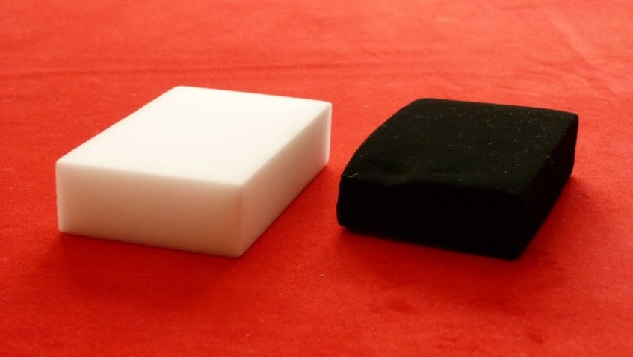
Figure 3. Original (left; 105×62×25 mm³) and polypyrrole-coated melamine sponge (right).

2.2. Morphology
The coating of melamine sponge with a black polypyrrole (Figure 3) is well visible by the electron microscopy (Figure 4). Macroporous structure of the sponge is preserved and polypyrrole is deposited on melamine as a thin polymer film with some adhering polypyrrole nanoparticles. There are also some free polypyrrole nanoparticles in the pores that are not observed by microscopy but seen as a "smoke" emanating from sponge during its cutting to smaller pieces. In the next step, magnetite deposits as clusters of nanoparticles onto polypyrrole coating. The open-pore structure is maintained and the macropores are not blocked by magnetite.
Corresponding polymer or composite powders were produced also in the aqueous medium surrounding the immersed sponges and their morphology is provided in Supporting Information. It is reasonable to expect that their characteristics are about the same as those of components generated inside the sponge. Polypyrrole has a typical morphology of fused globules, which become coated with magnetite after subsequent treatment by ammonia (Figure S1). The magnetite prepared under the similar conditions in the absence of pyrrole had a needle-like morphology with the length ca 100–200 nm and cross-section ca 30–50 nm (Figure S2).
Iron has not been detected in polypyrrole alone by EDAX (Figure S3a), i.e., all iron chlorides were removed by washing after the synthesis. The presence of chlorine reflects the protonation of polypyrrole with hydrochloric acid (Figure 1). On the other hand, 51.5 wt% Fe is found in the composite with magnetite (Figure S3b). The result proved the presence of iron but it is distorted by the high content of carbon due to a carbon paste used in the sample fixation for microscopy. On the other hand, nearly all chlorine atoms disappeared as a result of deprotonation in ammonia solution (Figure 2). EDAX is basically a method of surface characterization, and the high content of iron atoms confirms the coating polypyrrole/melamine with magnetite. Integral content of magnetite, 14.1 wt%, was quantitatively determined as an ash.

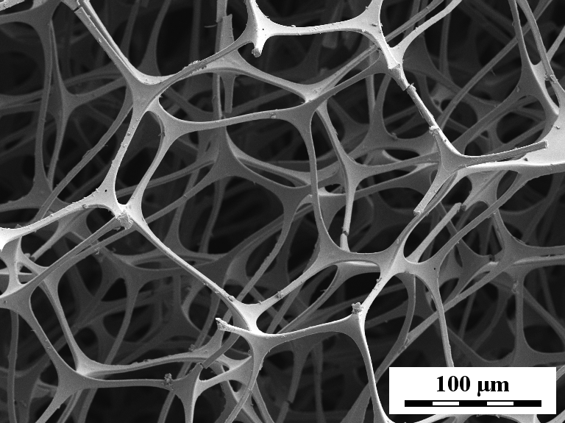 | 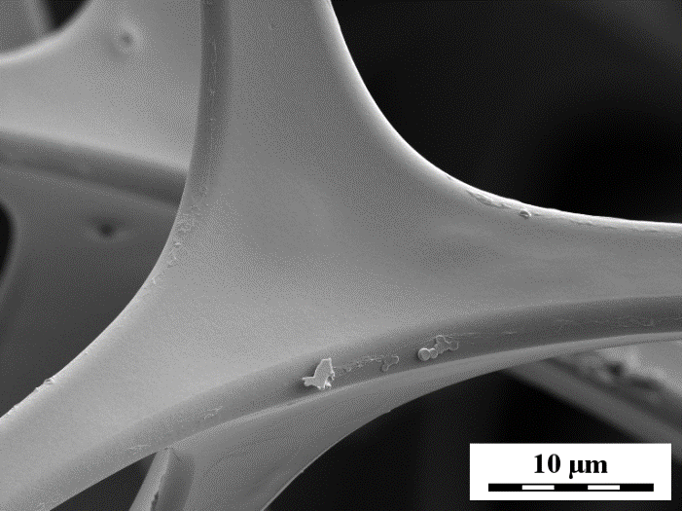
Melamine sponge
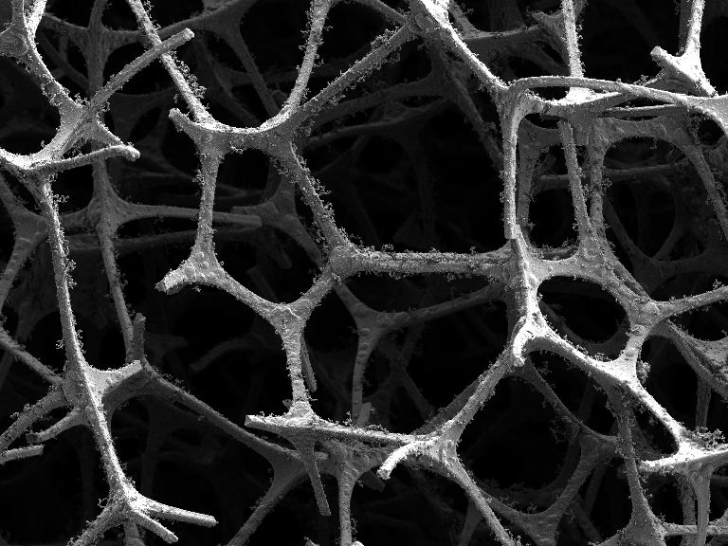 | 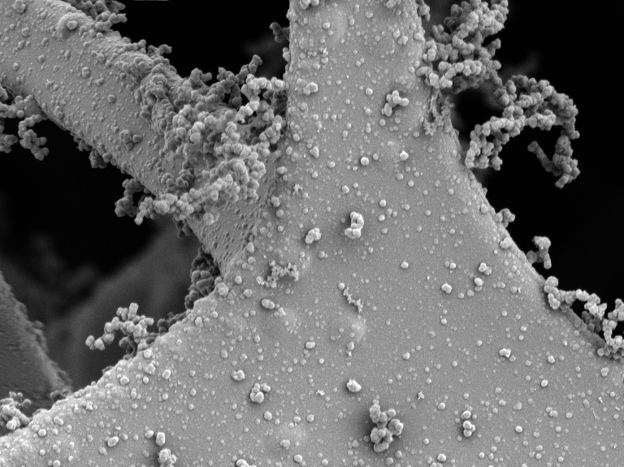
Melamine/polypyrrole
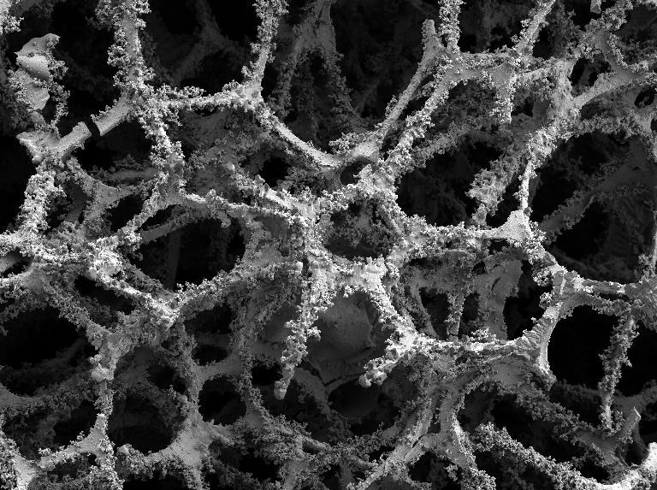 | 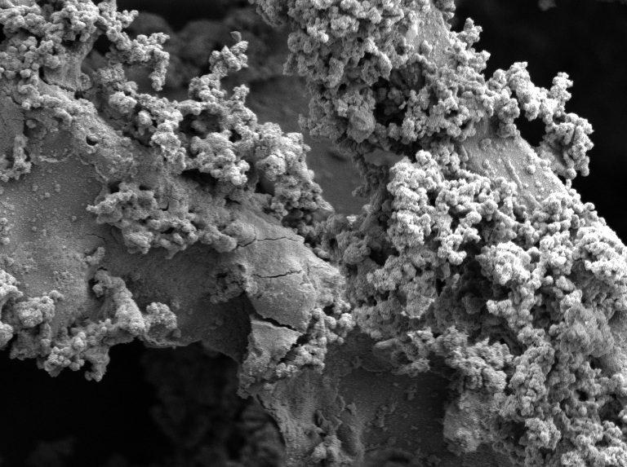
Melamine/polypyrrole/magnetite
Figure 4. Melamine sponge: original, polypyrrole-coated, and after additional deposition of magnetite. Lower magnification (left) and higher one (right).

2.3. FTIR Spectra
Spectra of sponges. The ATR FTIR spectrum of the composite melamine/polypyrrole/magnetite sponge (M/PPy/Fe₃O₄) is close to the spectrum of standard polypyrrole (PPy std) (Figure 5), which exhibits the main bands with maxima at 1536 cm^{–1} (C–C stretching vibrations in the pyrrole ring), 1448 cm^{–1} (C–N stretching vibrations in the ring), 1287 cm^{–1} (C–H or C–N in-plane deformation modes), 1160 cm^{–1} (breathing vibrations of the pyrrole rings), at about 1030 cm^{–1} (C–H and N–H in-plane deformation vibrations), 966 and 847 cm^{–1} (C−H out-of-plane deformation vibrations of the ring).³⁵ The overlapping with the peaks observed in the spectrum of magnetite (Fe₃O₄) situated at 1420, 1018 and 847 cm^{–1} is perceptible. A sharp peak at 807 cm⁻¹ belongs to the melamine sponge (M). The decreased absorption above 1600 cm^{–1} signifies a partial deprotonation of polypyrrole in the melamine/polypyrrole/magnetite sponge in response to ammonia treatment (Figure 3) during the magnetite deposition (Stejskal et al. 2016). In the spectrum of the melamine/polypyrrole sponge (M/PPy), the main bands of polypyrrole situated at 1536 and 1160 cm^{–1} in the spectrum of standard polypyrrole are slightly shifted to 1515 and 1138 cm^{–1} and two new sharp peaks are detected at 1638 and 1606 cm^{–1}.
Spectra of powders. ATR FTIR spectrum of polypyrrole/magnetite (Fe₃O₄+(PPy)) powder produced along with melamine/polypyrrole/magnetite sponge (M/PPy/Fe₃O₄) contains the main bands of polypyrrole (Figure 5) in which the bands shifted to 1536 and 1434 cm^{–1} in comparison to the bands of standard polypyrrole. The presence of magnetite manifests itself by the baseline which imitates the shape of the spectrum of neat magnetite (Fe₃O₄). The broad band with local maximum at 1620 cm^{–1} may correspond to the band of magnetite or to the overoxidation of the polypyrrole powder, because iron(III) in magnetite may act as an oxidant. The last explanation is supported by the observation of this band also in the spectrum of polypyrrole powder produced during synthesis of the composite melamine/polypyrrole sponge (M/PPy) outside the sponges (PPy) which is expected to be overoxidized.
Figure 5. ATR FTIR spectra the neat melamine sponge (M) melamine/polypyrrole sponge (M/PPy) and melamine/polypyrrole/magnetite sponge (M/PPy/Fe₃O₄). The spectra of polypyrrole (PPy) and polypyrrole/magnetite (Fe₃O₄ (+PPy)) powders produced outside the sponges are included and compared with the spectrum of standard polypyrrole (PPy std) and magnetite (Fe₃O₄). Powdered samples are depicted in blue and sponges in green.

2.4. Surface Properties
The specific surface area and porosity play important role for the applications exploiting surface functions. While the surface area of original melamine sponge is few tens of m²g⁻¹, after coating with polypyrrole and of the same sponge after deposition of magnetite the surface area increases by one order of magnitude (Table 1). The pore volume increases slightly after polypyrrole coating but more after the magnetite deposition. This is a result of adhering polypyrrole and magnetite nanoparticles (Figure 4). The corresponding adsorption/desorption isotherms are available in Supporting Information (Figure S4).
The determination of surface area was carried out at temperature of liquid nitrogen. It is interesting to note that the surface area of original sponge increased from 39 m²g⁻¹ to 156 m²g⁻¹, and even to 218 m²g⁻¹ after repeated freezing, and with no increase after additional freezing cycles. Similar, but less pronounced behavior was visible for melamine coated with polypyrrole and only marginal increase after deposition of magnetite. This is explained by the gradual delamination of melamine microstructure.

Table 1. Specific surface area, S, and pore volume, V
Sponge | S (m²g⁻¹) | V (cm³g⁻¹)
Melamine | 39.2 ± 0.5 | 0.071 ± 0.001
Melamine/PPy | 118.9 ± 0.8 | 0.081 ± 0.002
Melamine /PPy/magnetite | 121.8 ± 8.7 | 0.102 ± 0.011

2.5. Conductivity
The conductivity is a key parameter of materials based on conducting polymers. It is a material property, which is independent of sample size or shape, in the contrast to other electrical characteristics, such as resistance. Melamine sponge is non-conducting from the practical point of view. After the deposition of polypyrrole it acquired the conductivity 6.3×10⁻³ S cm⁻¹, which further increased after the compression to maximum value 0.38 S cm⁻¹ (Figure 6). This is close to the conductivity of neat globular polypyrrole, which is ≈1 S cm⁻¹.^{36–38} Conducting polypyrrole is deposited of the individual threads of the sponge (Figure 4) and the conducting pathways are thus connective. During the continuing compression, the number of pathways within the infinitesimal cross-section increases and conductivity does so accordingly (Figure 6).
After the deposition of magnetite, the conductivity decreased only moderately to 2.9×10⁻³ S cm⁻¹ for the sponge in the absence of pressure and increased to 0.131 S cm⁻¹ after compression. The original decrease is due to a partial deprotonation of polypyrrole under alkaline conditions (Figure 3) used for the generation of magnetite (Figure 2), which is associated with the decrease in conductivity.³⁴ This is partly compensated by the fact that magnetite is mildly conducting, with the conductivity of the order of 10⁻³ S cm⁻¹.³⁰
Figure 6. Conductivity as a function of compression, i.e. the reduction of the relative height of cylindrical sample d/d₀, for melamine sponge coated with polypyrrole (M/PPy) and this sponge after deposition of magnetite (M/PPy/magnetite). The starting height was d₀ ≈ 8 mm.

2.6. Compressibility
Melamine sponge is a macroporous material that is easily deformed by applied pressure. The setup for the conductivity determination allows also to follow the compression of the sample in dependence on applied pressure (Figure 7). The dependences are close to linear in double-logarithmic presentation. The steeper they are, the easier the sponge deforms. The slopes of the dependences do not significantly change after the coating with polypyrrole and deposition of magnetite. This means that the mechanical properties of the melamine sponge have not been affected by the deposition of components, which includes the treatment of sponges both under acidic and alkaline conditions. The moderate shift of the dependences to higher pressures illustrates some mechanical reinforcement of sponges, especially with magnetite, which acts as a filler.
Figure 7. The dependence of the relative height of cylindrical sample, d/d₀, on pressure for original melamine sponge (M), the sponge coated with polypyrrole (M/PPy), and finally the sponge after deposition of magnetite (M/PPy/magnetite). d₀ ≈ 8 mm.

2.7. Magnetic Properties
The composite melamine/polypyrrole/magnetite sponge is attracted to a permanent magnet (Figure 8) and can therefore be regarded as a ferrosponge.¹ Original melamine sponge alone or the sponge coated with polypyrrole do not display any marked magnetic properties, except for those caused by the traces of iron compounds in the latter case (Figure 9). Melamine/polypyrrole has the saturation magnetization M_{s} = 0.29 emu g⁻¹ (Figure 9), remanent magnetization M_{r} = 1.78×10⁻³ emu g⁻¹, and coercivity H_{c} = 2.67 Oe. Melamine/polypyrrole/magnetite sponge had saturation magnetization of M_{s} = 12.3 emu g⁻¹ which is significantly higher and remanent magnetization M_{r}=0.076 emu g⁻¹ with coercivity H_{c} = 2.40 Oe. The presence of magnetite endows the sponge with superparamagnetic properties as demonstrated by notable saturation magnetization a marginal remanent magnetization. On the other hand, the sponges do not exhibit ferromagnetic behavior as follows from low coercivity.
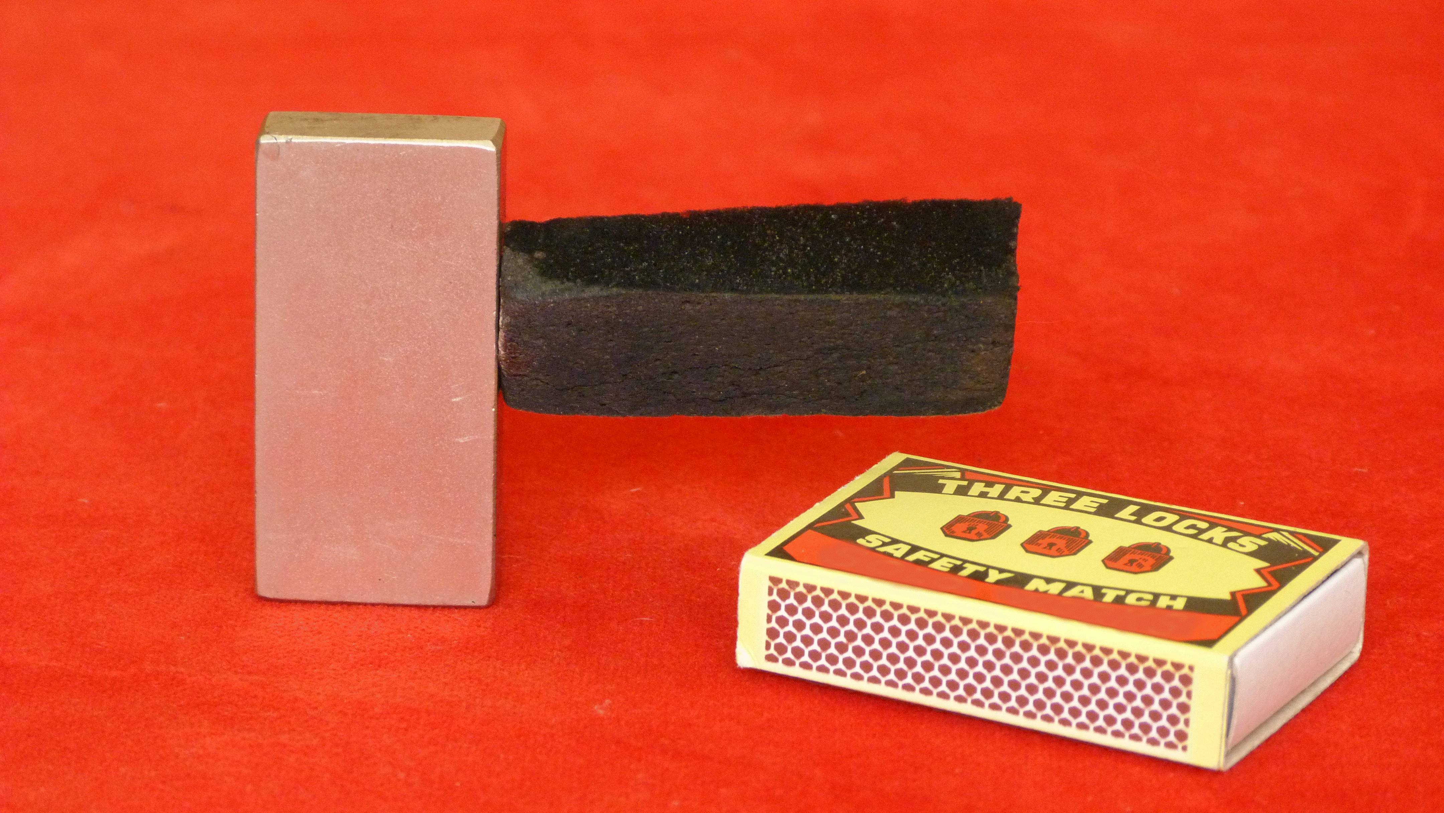
Figure 8. Black melamine/polypyrrole/magnetite sponge is attracted to the permanent magnet. A matchbox is shown for the size comparison.
Figure 9. Magnetic hysteresis curves of the melamine sponge coated with polypyrrole (M/PPy) and the sponge after deposition of magnetite (M/PPy/magnetite). Original melamine sponge (M) does not display any magnetic properties.

2.8. Electromagnetic Radiation Shielding
The sponges filled with conducting polypyrrole of moderate conductivity and modified with magnetite could be potentially utilized as shielding materials for electromagnetic radiation in GHz frequency range. The total shielding effectiveness SE_{T} for shielding materials is given as:^{39,40}
${SE}_{T}\left(dB\right)={SE}_{A}\left(dB\right)+ {SE}_{R}\left(dB\right)+ {SE}_{M}\left(dB\right)$ (2)
where SE_{A}, SE_{R}, and SE_{M} are the partial shielding efficiencies related to absorption, reflection, and multiple reflections, respectively. The term related to multiple reflections and scattering SE_{M} can be usually neglected:
${SE}_{T}\left(dB\right)={SE}_{T}\left(dB\right)+ {SE}_{R}\left(dB\right)$ (3)
The total efficiency SE_{T} is evaluated by using scattering parameters determined from a vector network analyzer, S₁₁ a forward reflection coefficient and S₂₁ a reverse transmission coefficient (Figure 10). They provide the quantitative assessment of the applicability of the individual materials in electromagnetic radiation and refer to a specific thickness, here 20 mm. The transmittance T and the reflectance R are related as:
$T={{|S}_{12}|}^{2}={{|S}_{21}|}^{2}$ (4)
$R={{|S}_{11}|}^{2}={{|S}_{22}|}^{2}$ (5)
and the absorbance is A = (1−R–T). The efficiencies SE_{A} and SE_{R} are linked to the transmittance T and reflectance R, SE_{A}(dB) = 10 log[T/(1−R)] and SE_{R}(dB) = 10 log(1−R).
The experimental data describing the sponges are little dependent on the radiation frequency (Figure 10). On a relative basis, they can be presented as the analysis of the individual contributions to the shielding, which are, consequently, qualitatively similar for the individual frequencies (Figure 11).

Figure 10. Frequency dependence of (a) forward reflection coefficient S₁₁ and (b) reverse transmission coefficient S₂₁.

Concerning the original melamine sponge, there is practically no radiation absorption and reflection (Figure 11). Polypyrrole coating introduces a marked increase in reflection, as might be expected from the conducting material, and fraction of transmitted radiation decreases accordingly. Magnetite is generated under alkaline condition where polypyrrole salt converts to polypyrrole base, and the conductivity is reduced but not lost³⁴ and the reflectance decreases accordingly. The presence of magnetite in the composite sponge clearly adds to the absorption. The combination of the conducting and magnetic component is thus beneficial for the shielding efficiency, and the transmission substantially decreases.
Figure 11. Absorbance A, transmittance T, and reflectance R of melamine sponge (M), the sponge coated with polypyrrole (M/PPy) and after deposition of magnetite (M/PPy/magnetite) at 5.85, 7.0, and 8.2 GHz.

3. CONCLUSIONS
The macroporous open-cell melamine sponge was used as substrate for the in-situ coating with conducting polymer, polypyrrole. The oxidant of pyrrole, iron(III) chloride, was used in stoichiometric excess, and its residual part was converted in the same reaction mixture to magnetite after addition of ammonium hydroxide. A resulting melamine/polypyrrole/magnetite ferrosponge displays paramagnetic behavior. When tested in electromagnetic radiation shielding, the conducting polypyrrole increased the reflection of electromagnetic radiation in GHz region, while magnetite contributed to radiation absorption.

4. EXPERIMENTAL SECTION

4.1. Preparation
The macroporous open-cell melamine sponge (105×62×25 mm³) produced by BASF AG (Germany) technology, distributed under the trade-mark Basotect, and advertised as "a miraculous sponge" or "a magic eraser sponge", was purchased from Drogerie ZDE (Czech Republic).
The melamine sponge was immersed in a freshly prepared aqueous mixture of 0.05 M pyrrole and 0.25 M iron(III) chloride hexahydrate pre-cooled to 5°C to slow down the reaction rate. The oxidation of pyrrole was thus carried out at oxidant/monomer mole ratio 5, i.e. with excess of oxidant compared with current preparations of polypyrrole using stoichiometric oxidant/monomer mole ratio 2.5. In practice, 1 L of reaction mixture thus contained 3.35 g of pyrrole and 67.6 g of iron(III) chloride hexahydrate. The sponge immersed in the reaction mixture was briefly gently squeezed to replace air in the pores with reactants solution and the polymerization of pyrrole was let to proceed for 30 min. The polypyrrole-coated melamine sponge was then removed, repeatedly washed in excess of 0.2 M hydrochloric acid until no coloration of acid solution was observed, followed by similar washing with ethanol. The composite melamine/polypyrrole sponge was left to dry in open air.
Another piece of polypyrrole-coated sponge still swollen with the solution of residual reaction mixture containing iron(II) and iron(III) chlorides was transferred to excess 1 M ammonia solution and left for 1 h to allow for the formation of magnetite nanoparticles. The composite melamine/polypyrrole/magnetite sponge was rinsed with water, immersed in ethanol in order to remove soluble low-molecular-weight residues and any free magnetite, and dried as above. Polypyrrole and polypyrrole/magnetite powders produced in both syntheses outside the sponges were separated and treated in the same manner.

4.2. Characterization
Morphology was observed with a scanning ultra-high-resolution electron microscope MAIA3 Tescan. FTIR spectra were recorded using a Nicolet 6700 (Thermo-Nicolet, USA) spectrometer equipped with a reflective ATR extension GladiATR (PIKE Technologies, USA) with diamond crystal in the 4000–400 cm^{–1} wavenumber region with a deuterated L-alanine doped triglycine sulfate detector at 4 cm^{–1} resolution with 64 scans and Happ-Genzel apodization. Specific surface area and pore volume were determined from nitrogen adsorption and desorption isotherms with a NOVA3200 (Quantachrome Instruments) using NovaWin software. Samples were degassed for 24 h at 100°C. Brunauer-Emmett-Teller (BET) analysis has been applied for the total surface area determination and Barrett-Joyner-Halenda (BJH) model for pores volume.
The sponges have been characterized also by van der Pauw method when compressed in a lab-made cylindrical glass cell with inner diameter of 10 mm between an insulating support and a glass piston carrying four platinum/rhodium electrodes on the perimeter of its base. The set-up used the current source Keithley 220, a Keithley 2010 multimeter and a Keithley 705 scanner with a Keithley 7052 matrix card. The pressure was controlled with L6E3 load cell (Zemic Europe BV, The Netherlands). Magnetic characteristics of prepared nanocomposites were investigated by vibrating sample magnetometer (VSM, Model 7407, USA). Electromagnetic radiation shielding parameters of sponges were studied with the PNA-L Network Analyzer Agilent N5230A (Agilent Technologies, Santa Clara, CA, USA) in the frequency range 5.85–8.2 GHz.

Supporting Information
Scanning electron microscopy of accompanying powders; Transmission electron microscopy of magnetite nanoparticles; EDAX of powders; Adsorption/desorption isotherm of sponges

Notes
The authors declare no competing interests.

ACKNOWLEDGMENTS
The authors thank the Czech Science Foundation (19-04859S) and the Technology Agency of the Czech Republic (TH71020006) for the financial support. Thanks are also due to Ms. J. Hromádková for electron microscopy and EDAX.

REFERENCES

(1) Ganguly, S.; Margel, S. Review: Remotely Controlled Magneto-Regulation of Therapeutics from Magnetoelastic Gel Matrices. Biotechnol. Adv. 2020, 44, 107611.
(2) Stejskal, J. Interaction of Conducting Polymers, Polyaniline and Polypyrrole, with Organic Dyes: Polymer Morphology Control, Dye Adsorption and Photocatalytic Decomposition. Chem. Pap. 2020, 74, 1–54.
(3) Gholivand, M. B.; Yamini, Y.; Dayeni, M.; Seidi, S. Adsorptive Removal of Alizarin Red-S and Alizarin Yellow GG from Aqueous Solutions using Polypyrrole-Coated Magnetic Nanoparticles. J. Environ. Chem. Eng. 2015, 3, 529–540.
(4) Shanehsaz, M.; Seidi, S. Ghorbani, Y.; Shoja, S. M. R. Polypyrrole-Coated Magnetic Nanoparticles as an Efficient Adsorbent for RB19 Synthetic Textile Dye: Removal and Kinetic Study. Spectrochim. Acta A 2015, 149, 481–486.
(5) Diaz-Flores, P. E.; Guzmán-Álvarez, C. J.; Ovando-Medina, V. M.; Martínez-Gutiérrez, H.; González-Ortega, O. Synthesis of α-Cellulose/Magnetite/Polypyrrole Composite for the Removal of Reactive Black 5 Dye from Aqueous Solutions. Desalination Water Treat. 2019, 155, 350–363.
(6) Feng, J. T.; Sun, N.; Wu, D. Y.; Yang, H. H.; Xu, H. Preparation of Fe₃O₄/TiO₂/Polypyrrole Ternary Magnetic Composite and using as Adsorbent for the Removal of Acid Red G. J. Polym. Environ. 2017, 25, 781–791.
(7) Mashkoor, F.; Nazar, A. Facile Synthesis of Polypyrrole Decorated Chitosan-Based Magadsorbent: Characterization, Performance, and Applications in Removing Cationic and Anionic Dyes from Aqueous Medium. Int. J. Biol. Macromol. 2020, 161, 88–100.
(8) Zhang, M. M.; Yu, Z. H.; Yu, H. C. Adsorption of Eosin Y, Methyl Orange and Brilliant Green from Aqueous Solution using Ferroferric Oxide/Polypyrrole Magnetic Composite. Polym. Bull. 2020, 77, 1049–1066.
(9) Bai, L. Z.; Li, Z. P.; Zhang, Y.; Wang, T.; Lu, R. H.; Zhou, W. F.; Gao, H. X.; Zhang, S. B. Synthesis of Water-Dispersible Graphene-Modified Magnetic Polypyrrole Nanocomposite and its Ability to Efficiently Adsorb Methylene Blue from Aqueous Solution. Chem. Eng. J. 2015, 279, 757–766.
(10) Chen, J.; Feng, J. T.; Yan, W. Influence of Metal Oxides on the Adsorption Characteristics of PPy/Metal Oxides for Methylene Blue. J. Colloid Interface Sci. 2016, 475, 26–35.
(11) Yao, T. J.; Jia, W. J.; Tong, X.; Feng, Y.; Qi, Y.; Zhan, X.; Wu, J. One-Step Preparation on Nanobeads-Based Polypyrrole Hydrogel by a Reactive Template Method and their Applications in Adsorption and Catalysis. J. Colloid Interface Sci. 2018, 525, 214–221.
(12) Wei, S. T.; Hu, X. L.; Liu, H. L.; Wang, Q.; He, C. Y. Rapid Degradation of Congo Red by Molecularly Imprinted Polypyrrole Coated Magnetic TiO₂ Nanoparticles in Dark and at Ambient Conditions. J. Hazardous Mater. 2015, 294, 168–176.
(13) Amer, W. A.; Al-Saida, B.; Ayad, M. M. Rational Design of a Polypyrrole-Based Competent Bifunctional Magnetic Nanocatalyst. RSC Adv. 2019, 9, 18245–18255.
(14) Pethsangave, D. A.; Khose, R. V.; Wadekar, P. H.; Kulal, D. K.; Some, S. One-Pot Synthetic Approach for Magnetically Separable Graphene Nanocomposite for Dye Degradation. ChemistrySelect 2020, 5, 1516–1525.
(15) Mehdinia, A.; Niroumand, R.; Jabbari, A. Removal of Lead and Copper Ions from Environmental Water Samples by Nanorattle Magnetic Polypyrrole. Int. J. Environ. Sci. Technol. 2019, 17, 2721–2730.
(16) Lin, Z. F.; Pan, Z. W.; Zhao, Y. H.; Qian, L.; Shen, J. T.; Xia, K.; Guo, Y. F.; Qu, Z. Removal of Hg²⁺ with Polypyrrole Functionalized Fe₃O₄/Kaolin: Synthesis, Performance and Optimization with Response Surface Methodology. Nanomaterials 2020, 10, 1370.
(17) Liu, Z. W.; Gao, Z. M.; Xu, L. C.; Hu, P. P. Polypyrrole Modified Magnetic Reduced Graphene Oxide Composites: Synthesis, Characterization and Application for Selective Lead Adsorption. RSC Adv. 2020, 10, 17524–17533.
(18) Goswami, B.; Mahanta, D. Polyaniline-Fe₃O₄ and Polypyrrole Fe₃O₄ Magnetic Nanocomposites for Removal of 2,4-Dichlorophenoxyacetic Acid from Aqueous Medium. J. Environ. Chem. Eng. 2020, 8, 103919.
(19) Getiren, B.; Çıplak, Z.; Gökalp, C.; Yıldız, N. NIR-Responsive Fe₃O₄@PPy Nanocomposite for Efficient Potential Use in Photothermal Therapy. J. Appl. Polym. Sci. 2020, 137, 49343.
(20) Li, J. H.; Ji, H. M.; Xu, Y. F.; Zhang, J. J.; Yan, Y. Three-Dimensional Graphene Supported Fe₃O₄ Coated by Polypyrrole toward Enhanced Stability and Microwave Absorbing Properties. J. Mater. Res. Technol. 2020, 9, 762–772.
(21) Liu, F. B.; Li, C. P.; Jiang, X. H.; Waterhouse, G. I. N.; Xing, C. J.; Zhang, Z. M.; Yu, L. M. Novel Three-Dimensional TiO₂-Fe₃O₄@Polypyrrole Composites with Tunable Microwave Absorption in the 2–40 GHz Frequency Range. J. Mater. Sci. 2020, 55, 15493–15509.
(22) Shukla, V. Role of Spin Disorder in Magnetic and EMI Shielding Properties of Fe₃O₄/C/PPy Core/Shell Composites. J. Mater. Sci. 2019, 55, 2826–2835.
(23) Zhang, L.; Wan, X. N.; Duan, W. J.; Qiu, H.; Hou, J. Q.; Wang, X. R.; Li, H.; Du, X. Y. One-pot Synthesis of Doped-Polypyrrole/Fe₃O₄ Nanosphere Composites and their Microwave Absorption Performance. J. Nanosci. Nanotechnol. 2019, 19, 7664–7672.
(24) Chen, X. L.; Shi, T.; Wu, G. L.; Lu, Y. Design of Molybdenum Disulfide@Polypyrrole Composite Decorated with Fe₃O₄ and Superior Electromagnetic Wave Absorption Performance. J. Colloid Interface Sci. 2020, 572, 227–235.
(25) Dong, Y. Z.; Choi, K.; Kwon, S. H.; Nam, J. D.; Choi, H. J. Nanoparticles Functionalized by Conducting Polymers and their Electrorheological and Magnetorheological Applications. Polymers 2020, 12, 204.
(26) Ma, Y.; Hou, C. P.; Zhang, H. P.; Zhang, Q.Y.; Liu, H.; Wu, S. D.; Guo, Z. H. Three-Dimensional Core–Shell Fe₃O₄/Polyaniline Coaxial Heterogeneous Nanonets: Preparation and High-Performance Supercapacitor Electrodes. Electrochim. Acta 2019, 315, 114–123.
(27) Mariappan, C. R.; Gajraj, V.; Gade, S.; Kumar, A.; Dsoke, S.; Indris, S.; Ehrenberg, H.; Prakash, G. V.; Jose, R. Synthesis and Electrochemical Properties of rGO/Polypyrrole/Ferrites Nanocomposites Obtained via a Hydrothermal Route for Hybrid Aqueous Supercapacitors. J. Electroanal. Chem. 2019, 845, 72–83.
(28) Chu, R. X.; Tan, D. G.; Zhang, J.; Chen, Y. L.; Jiang, H.; Lin, J.; Li, L.; Zhang, Y.; Guo, H. Long-Term Cycling of Core–Shell Fe₃O₄–Polypyrrole Composite Electrodes via Diffusive and Capacitive Lithiation. J. Alloy Compd. 2020, 835, 155192.
(29) Stejskal, J. Conducting Polymers are not just Conducting. Polym. Int. 2020, 69, 662–664.
(30) Petcharoen, K.; Sirivat, A. Synthesis and Characterization of Magnetite Nanoparticles via the Chemical Co-Precipitation Method. Mater. Sci. Eng. B 2012, 177, 421–427.
(31) Gurusiddesh, M.; Madhu, B. J.; Shankaramurthy, G. J.; Shruthi, B. Structural, Dielectric and Magnetic Studies on Polyaniline-Decorated Ni_{0.5}Cu_{0.5}Fe₂O₄ Nanoferrites for Electromagnetic Interference Shielding Applications. Appl. Phys. A-Mater. Sci. Process. 2020, 126, 85.
(32) Tang, S.; Lian, Q.; Liang, J. Y.; Chen, S. R.; Liu, C.; Zhao, J. X.; Cheng, Q.; Cao, Y. C.; Liu, J. Y. Facile Synthesis of Fe₃O₄@PPy Core–Shell Magnetic Nanoparticles and their Enhanced Dispersity and Acid Stability. Mater. Design 2017, 121, 47–50.
(33) Yang, Z. Y.; Sheng, Q. L.; Zhang, S.; Zhang, X. H.; Zheng, J. B. One-Pot Synthesis of Fe₃O₄/Polypyrrole/Graphene Oxide Nanocomposites for Electrochemical Sensing of Hydrazine. Microchim. Acta 2020, 184, 2219–2226.
(34) Stejskal, J.; Trchová, M.; Bober, P.; Morávková, Z.; Kopecký, D.; Vrňata, M.; Prokeš, J.; Varga, M.; Watzlová, E. Polypyrrole Salts and Bases: Superior Conductivity of Nanotubes and their Stability towards the Loss of Conductivity by Deprotonation. RSC Adv. 2016, 6, 88382–88391.
(35) Stejskal, J.; Trchová, M. Conducting Polymer Nanotubes: a Review. Chem. Pap. 2018, 72, 1563–1595.
(36) Qiu, G. H.; Wang, Q.; Nie, M. Polypyrrole-Fe₃O₄ Magnetic Nanocomposite Prepared by Ultrasonic Irradiation. Macromol. Mater. Eng. 2006, 291, 68–74.
(37) Milakin, K. A.; Acharya, U.; Trchová, M.; Zasońska, B. A.; Stejskal, J. Polypyrrole/Gelatin Cryogel as a Precursor for a Macroporous Conducting Polymer. React. Funct. Polym. 2020, 157, 104751.
(38) Stejskal, J.; Prokeš, J. Conductivity and Morphology of Polyaniline and Polypyrrole Prepared in the Presence of Organic Dyes. Synth. Met. 2020, 264, 116373.
(39) Varsheny, S.; Dhawan, S. K. Designing of Materials for EMI Shielding Applications. In: Microwave Materials and Applications, Sebastian, M. T.; Ubic, R.; Jantunen, H., Eds; Vol. 2, Chap. 13, Wiley, UK, 2017.
(40) Kumar, R.; Sharma, A.; Pandey, A.; Chaudhary, A.; Dwivedi, N.; Shafeeq, M.; Mondal, D. P.; Srivastava, A. K. Lightweight Carbon-Red Mud Hybrid Foam Toward Fire-Resistant and Efficient Shield against Electromagnetic Interference. Sci. Rep. 2020, 10, 9913.

Table of Contents Graphic:

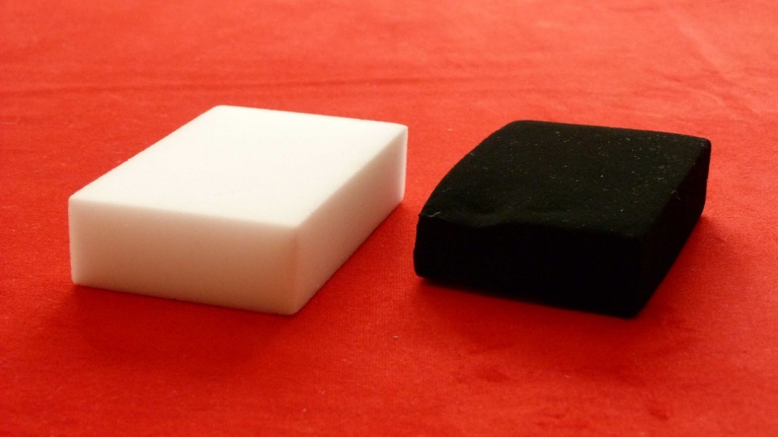
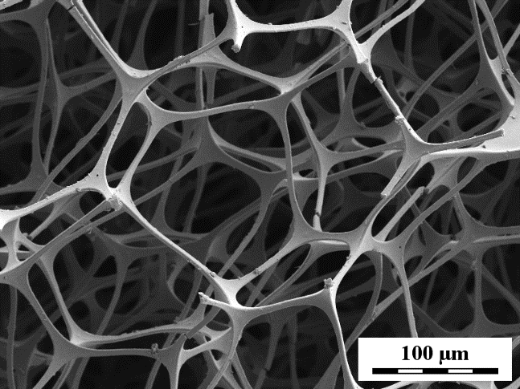
Melamine
+ polypyrrole + Fe₃O₄

