Fabrication of a binder-free lithium manganese oxide cathode for secondary Li - Ion batteries

C. Bubulinca ^{1*}, I. Sapurina ¹, N. E. Kazantseva ¹, J. Vilčáková ¹, Q. Cheng ^{1, 2}, P. Sáha ¹

1 Centre of Polymer Systems, Tomas Bata University in Zlin, tř. T. Bati 5678, Zlin, 760 01, Czech Republic
2 Key Laboratory for Ultrafine Materials of Ministry of Education, School of Material Science and Engineering, East China University of Science and Technology, Shanghai, China 200237, China.
Address correspondence to E-mail: bubulinca@utb.cz

Abstract
The binder-free technology is used to produce flexible self-standing cathodes for secondary Li-ion batteries containing commercial materials: lithium manganese oxide (LMO) and multiwall carbon nanotubes (CNT). The fragmentation of commercial LMO by short time ball-milling with low energy intensities, allows one to reduce the particle size from tens of microns to the micron and submicron level, while maintaining its spinel crystal structure. The electrode exhibits high electrical conductivity (46 S⋅m⁻¹) due to homogeneous distribution of LMO particles in the matrix of CNT. Electrochemical assessment of the electrode revealed good cyclic stability and a high reversibility of 93% after 120 galvanostatic charge/discharge cycles at 0.6C, with an initial specific discharge capacity of about 110 mAh⋅g⁻¹ and 80 mAh⋅g⁻¹ at high current rate of 2C.

Key words: flexible binder-free LiMn₂O₄ cathode, secondary Li-ion battery, dry ball milling, aqueous electrolyte

Introduction
The most problematic element in modern Li-ion batteries is the cathode [1]. For this reason, new cathode materials are being actively developed and the technologies of cathode fabrication are being improved [2-4]. The first cathode in commercial Li-ion batterries was LiCoO₂ [5], and which is still widely used today [6, 7]. The new generation of cathode materials includes LMO with the chemical formula LiMn₂O₄ [8-11]. This material has a capacity density comparable to that of the traditional LiCoO₂ cathode [12], but it has advantages in terms of price and safety [6]; i.e., LMO is nontoxic [12], and, moreover, manganese is very abundant in nature [6, 13]. In addition, the heat release on a LMO cathode is ten times lower than that on LiCoO₂, which significantly reduces the risk of inflammation in the case of batteries with organic electrolyte [8]. For this reason, MnO₂ has been intensively studied as an electrode material in rechargeable lithium-ion batteries and asymmetric supercapacitors. Among a multitude of polymorphous forms containing MnO₂, spinel has the optimum pore structure for the intercalation/deintercalation of Li⁺ ions. The spinel framework of MnO₂ provides three-dimensional tunnels for Li⁺ insertion and extraction without significant changes in the unit cell volume. Reversible intercalation/deintercalation of Li⁺ ion changes the composition of Li_{x}Mn_{2-x}O₄ in the range 0.33 ≤ x ≤ 1 and therewith changes the average oxidation state of Mn between 3.0 and 4.0 [14]. Among of polymorphous forms of MnO₂, spinel-type LiMn₂O₄ has highest capacity as a cathode material for Li-ion batteries [15]. The specific capacity is determined not only by lithiation/delithiation on the surface of LMO, but also by the redox processes (Mn ⁴ ⁺ ↔ Mn ³ ⁺ ↔ Mn ² ⁺) in the bulk of the material [9]. The disadvantages of all forms of LMO, including spinel-type oxides, are low electrical conductivity (10⁻⁴−10⁻⁶ S⋅m⁻¹). Therefore, to improve the level of electrical conductivity, it is necessary to combine LiMn₂O₄ with an electrically conductive material, usually with carbon-based materials like mesoporous carbon, activated carbon, CNT, and graphene, which are characterized by high specific surface area and high electrical conductivity [7, 9].
The technology of combining the active energy storage component with carbon must ensure a uniform distribution of the components and good contact between them. A conventional method of electrode fabrication is based on the slurry-coating process. A slurry from the active material, carbon, and binder is deposited on a current collector as a planar layer [16, 17]. Typically, polyvinylidene fluoride and polytetrafluoroethylene are used as a binder [17-21]. The binder sticks carbon and brittle inorganic material and fixes them to the current collector; however, at the same time, the binder partially blocks the transport of ions and electrons, thus reducing the active surface area of the electrode. In addition, such electrodes exhibit low flexibility due to the rigid structure [16].
The new binder-free technology of electrode fabrication is mainly based on in-situ composite preparation, when inorganic active materials are synthesized in the presence of a carbon component, or carbon is deposited on active material precursors [9, 22, 23]. This technology is based on chemical or electrochemical synthesis, which is not suitable for preparation of large amounts of material.
Preparation of flexible and self-standing electrodes for portable electronics needs a flexible component adapted to reversible deformation. The structure of a tangle of CNT can provide outstanding stretchability [24-26]. A matrix of this type filled with well-dispersed particles of inorganic materials forms a so-called “island-bridge” structure [27, 28]. Here, the islands of active and non-conductive inorganic material are combined with bridges of stretchable and conducting CNT.
In this work, a flexible and free-standing cathode for a Li-ion battery is fabricated by a simple binder-free method using commercially available materials such as LiMn₂O₄ and CNT. According to the results obtained, a reduction in the cost of the battery is expected without sacrificing electrochemical performance.

2. Materials and methods
2.1. Materials
Sintered LiMn₂O₄ with spinel-type structure was purchased from MTI Co. Ltd, where it was produced by heat treatment (750ºC in air) of a mixture of lithium salt (e.g. CH₃COOLi×2H₂O) and manganese oxide.
Multiwall carbon nanotubes with length of about 1.5 μm and diameter of about 10 nm were purchased from Nanocyl Company, where they are produced by chemical vapor deposition method.
Triton X-100 - poly(ethylene glycol) p-isooctyl-phenyl ether from Sigma Aldrich was used as a surfactant for preparation of aqueous dispersions.
Polyvynilidene fluoride (PVDF) membranes with a pore size below 200 nm and a total volume of pores greater than 70% were purchased from Millipore Corporation (USA).

2.2. Ball-milling procedure
As received LMO powder was milled in LAB WIZZ 320 MICRO BALL MILL using stainless steel balls of 30 mm diameter. The ball-to-LMO powder mass ratio was 32.6/4 g. The rotation speed was set to 300 rpm, and the milling time was ranged from 20 to 50 minutes (20, 30, 40 and 50 minutes: samples LMO20, LMO30, LMO40 and LMO50, respectively).

2.3. Fabrication of a binder-free self-standing cathode
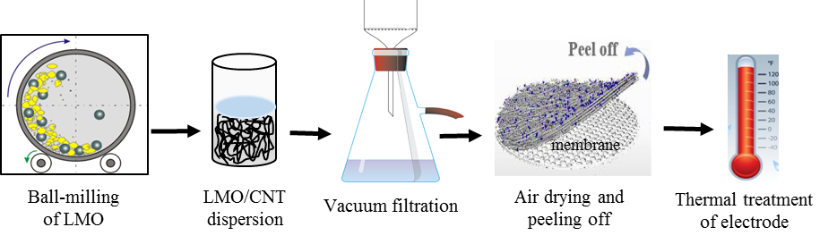
Schematic procedure of the common fabrication process of a binder-free self-standing LMO/CNT electrode is shown in figure 1.

Fig. 1. Fabrication technology of a self-standing binder-free electrode: ball-milling of LMO; ultrasonic dispersion of LMO and CNT in aqueous solution; vacuum filtration of dispersion via PVDF membrane; air drying of precipitate and peeling off from the membrane; thermal treatment of the self-standing electrode at 110 °C for 12h.
At the first step, the size of LMO particles is reduced by ball-milling. Then, LMO (178 mg) and CNT (23 mg) with component ratio of 88/12 wt.% were dispersed in 50 ml of aqueous solution of Triton X-100 (1 wt. %) and ultrasonicated for 30 minutes until a stable blue-violet colloid was formed. The stability of LMO50/CNT dispersions is good, and no sedimentation was observed after several months of storage at ambient conditions (Fig. 2). Vacuum filtration of the colloid and washing of the sediment with water to remove Triton X-100 was carried out on a 2.5 cm diameter PVDF membrane. After air drying, the LMO/CNT layer was peeled off from the membrane, washed with deionized water and dried at 110 °C for 12 h. All stages of a binder-free self-standing cathode material fabrication, except for the heat treatment stage, were carried out at normal pressure and room temperature.
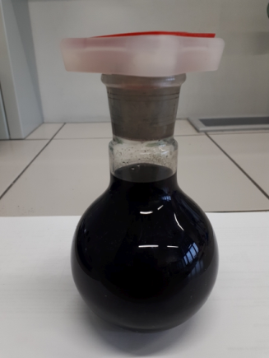

Fig. 2. Digital photo of LMO50/CNT dispersions in aqueous solution with 1% Triton X-100.
2.4. Characterization
The LMO particle size and particle size distribution were determined by the laser diffraction method (Malvern Mastersizer 3000), in which the angular variation in the intensity of light scattered from the particles was measured and the data obtained were used to calculate the particle size on the basis of the Mie light scattering theory. The particle size is reported as a volume equivalent sphere diameter (D_{v}) [29].
The specific surface area of samples was determined by BET analysis on a NOVA instrument (USA). The specific surface area of the samples was calculated by the formula S = А×а_{m}×V_{m}/ m, where А is Avogadro’s constant, а_{m} is the surface area of the sorbate molecule, V_{m} is the nitrogen monolayer volume, and m is the sample mass.
The morpho-structural properties of the materials were studied by a scanning electron microscope (FE-SEM, FEI T12) operating at 120 kV and transmission electron microscopy (TEM/HRTEM, JEOL JEM-2100F).
The crystal structure of the LMO was analyzed with the help of X-ray diffraction techniques (XRD, Advance D8, Bruker) with Cu-Kα radiation, 0.1540560 nm wavelength and current of about 1 µA.
Raman spectroscopy was conducted to determine the structural changes in LMO after fragmentation. To this end, a Nicolet DXR (Thermo Scientific) dispersive Raman microscope with a He-Ne laser (514 nm) was used in the range of 200 − 800 cm⁻¹.
The DC conductivity was measured by a four-point Van der Pauw method on electrode samples (with a diameter of 15 mm and a thickness of about 100 µm) after peeling off from a polymeric membrane. A Keithley2410 programmable high-voltage source-meter and a Keithley 6517B electrometer/high resistance meter with a Keithley 7002 switch were employed. The measurements were carried out at ambient temperature with a current of about 10⁻⁶ A.
Assessment of electrochemical performance at room temperature was performed by using Autolab PGSTAT-128N potentiostat.

2.5. Electrochemical assessment
The electrochemical behavior of a binder-free self-standing electrode was studied using cyclic voltammetry (CV) at a scan rate of 2 mV⋅s⁻¹ and 0.1mV⋅s⁻¹, galvanostatic charge-discharge using various current rates in range of 0.5-2C, and electrochemical impedance spectroscopy (EIS). The current rate was calculated according to LiMn₂O₄ theoretical capacity (1C = 148 mAh⋅g⁻¹). Electrochemical window potential was between 0.4 and 1.2 V.
Electrochemical measurements were performed in a three-electrode system with an Ag/AgCl reference electrode and a platinum counter electrode in 1M Li₂SO₄.
The specific capacity was calculated with regard to the total mass of the self-standing electrode.
- Results and Discussion
3.1. Fragmentation of LMO particles by ball-milling
The reducing the particle size at the first step of cathode preparation (Fig. 1) leads to a extensive surface area and shortens the diffusion length for Li⁺ ions intercalating from/into the host structure of LMO. In addition, particles of submicron size have lower mechanical stress during intercalation of Li-ions. Therefore, using nanoparticles as active material in the cathode increases the charge-discharge rate and the cycling stability. However, intensive ball milling can lead to negative effects. It is reported that long-time ball milling (for more than 6 hours) and high rotation speed result in the destruction of the LMO spinel crystal structure; i.e., they give rise to defects and residual stress in the lattice that can affect the electrochemical stability of the material [30]. For this reason, we used short-time ball-milling (less than 1 hour) during which the particle size of LMO was controlled by SEM, HRTEM and its crystal structure were controlled by XRD and Raman spectroscopy.

  - Morpho-structural properties of LMO particles
Figure 3 shows the evolution of the particle size distribution during the ball-milling process, which leads to an increase in the specific surface area.
A commercial LMO product is a powder with a wide but unimodal particle size distribution, where half of particles are 15-20 μm in size (fraction D_{v}(50)), 10% of particles are larger than 60 μm (fraction D_{v}(10)), and the amount of particles with a size of 2−3 μm is less than 10 % (fraction D_{v}(90)). During milling time, the amount of small particles continuously increases, the distribution becoming multimodal and broader. Thus, after 50 minute, the particle size in all fractions decreases down to 2−3 μm in fraction D_{v}(50), to submicron size in fraction D_{v}(90) and to about 18 μm in fraction D_{v}(10). The fragmentation of particles occurs mainly due to the destruction of large particles and leads to a significant increase in the specific surface area of LMO. According to the BET analysis, the specific surface area of original LMO powder is 0.5 m²⋅g^{-1,} whereas for LMO50, it is 8 m²⋅g⁻¹, which is 16 times higher.

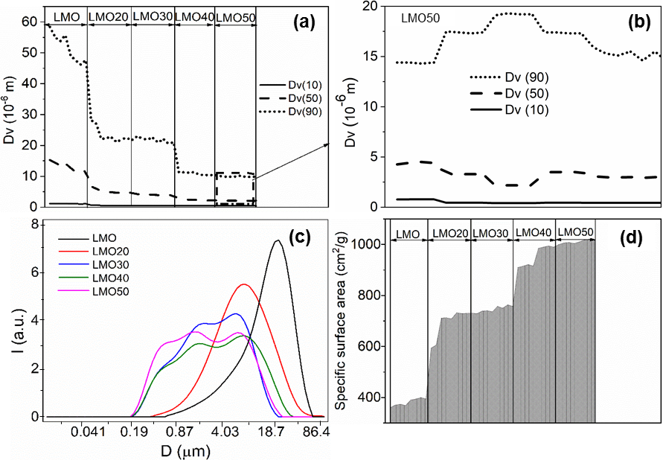
Fig. 3. LMO particles size distribution in individual fractions according the laser diffraction method: (a) before ball-milling, the middle size (D_{v} 50), large size (D_{v} 10) and small size (D_{v} 90); (b) zooming of the LMO50 sample; (c) particle size distribution of LMO before and after ball milling. Specific surface area of particles in different samples (d).
The results of the of particle size distribution are confirmed by the results of scanning electron microscopy (Fig. 4), which show that the particle size of LMO significantly decreases after ball-milling from tens of microns to hundreds and tens of nanometers.
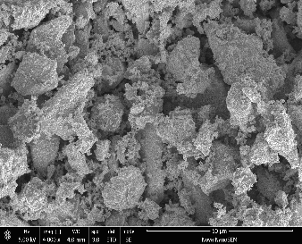
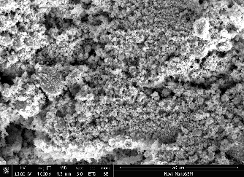
50 µm

1 µm
50µm
1 µm
(a)
(b)
(c)
(d)

Fig. 4. SEM images of pristine LMO before (a) and after ball-milling: LMO30 (b), LMO50 (c, d).
Despite the fact that the particle size as a result of grinding decreases significantly, all particles retain the spinel structure that is evidenced by the results of XRD and Raman spectra of pristine LMO and as-prepared LMO samples after ball milling (Fig. 5).

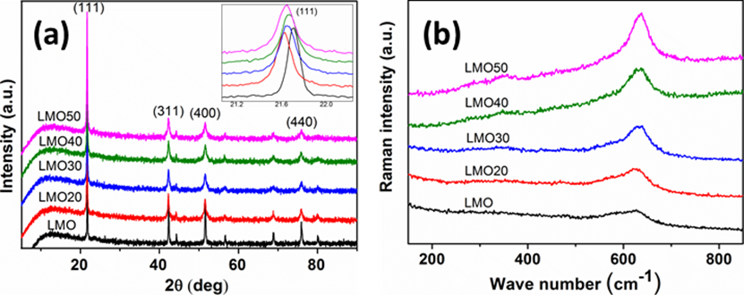
Fig. 5. XRD (a) and Raman (b) spectra of LMO before and after ball milling.
All peaks in the XRD spectra are well indexed to the spinel structure: the patterns are assigned to a cubic symmetry with Fd3m space group, and the lattice constant a is equal to 8.03 Å [14]. The positions of the patterns of as-prepared and pristine LMO samples are similar, but the reduction in the intensity and the broadening of the diffraction peaks provide evidence for a decrease in the particle size. To emphasis the effect of ball milling on the crystal structure, we locally magnified the (111) peaks. The position of the (111) diffraction peaks are not appreciably changed. However, the intensity of the (111) peaks decrease, and the peaks becomes broader with increasing milling time. The shift of the (111) diffraction peaks to lower 2θ degree angles and the diffraction peaks broadening are associated with a decrease in the crystallite size during the milling procedure. Thus, for larger crystallites (LMO pristine), the diffraction peaks are produced at the precise location of the Bragg angle due to coherent scattering within the structure. For smaller particles, the broadening of the diffraction peaks and a small deviation from the Bragg angle are observed. However, the shift of (111) diffraction peaks to lower 2θ is small (< 0.02 θ) and is within experimental error.
The Raman spectra also confirm the retention of the spinel structure of pristine LMO after ball-milling (Fig. 5b). The spectra of all the samples exhibit two peaks: the main peak at 650 cm⁻¹, which is attributed to the motion of oxygen atoms inside the octahedral MnO₆ unit [31-33], and a low-intensity peak at 380 cm⁻¹, which is related to the Li–O motion in the tetrahedral unit with symmetry F_{2g} ^{{3}} [34]. The intensity of the peaks increases with an increase with the milling time, which shows the enhancement of the surface area of particles.
Figure 6 shows HRTEM images and SAED diffraction patterns of LMO50 particles with various sizes: a 10-micron particle with clearly marked edges (Fig. 6a) and a particle with a size of tens of nanometers (Fig. 6b). The crystallographic structure of all particles belongs to cubic symmetry with the space group Fd3m, which corresponds to spinel type LiMn₂O₄ (Fig. 6c).

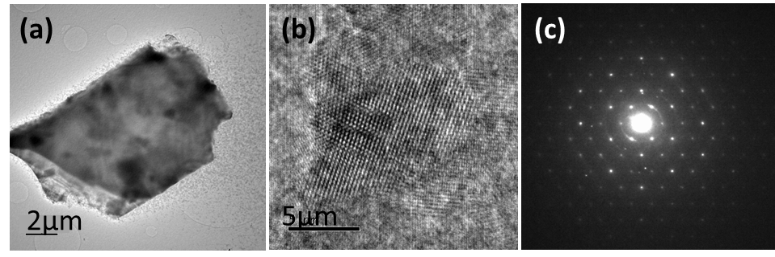
Fig. 6. HRTEM images (a, b) and SAED (c) of LMO50 with different particle size.
Therefore, the investigation of the morpho-structural properties of as-prepared samples in comparison with LMO pristine, confirms that short-time ball milling at low energy intensities does not change its initial spinel-type crystalline structure. It is known that low energy does not introduce macrostrain and defects into a crystal lattice, so that the fragmentation occurs mainly from already existing defects through the cleavage breakage process [35]. In the case of LMO, the destruction occurs mainly perpendicular to the (111) plane [30]. This feature can lead to an increase in the electrode stability against dissolution of Mn⁺², since dissolution occurs mainly on the (111) plane of LMO [36]. Thus, the short-time ball milling of spinel-type LMO is an expedient procedure: it allows one to obtain micron- and submicron-size particles with a sixteen times increased specific surface area of the active material without destroying the spinel structure and to reduce the amount of previously existing defects in the material.
  - Fabrication of a self-standing electrode
Another task that was solved by the fragmentation of LMO is the preparation of a homogeneous LMO50/CNT based dispersion. The smaller the particle size, the less their sedimentation, and the higher the homogeneity of the electrode material. However, the agglomeration and sedimentation of LMO and CNT occur even for small particles. To overcome this problem, we used a low molecular weight surfactant (Triton X-100). Triton X-100 is chosen since it is successfully used as a dispersant for nano-carbon black in organic (N-metyl pyrrolidone) solvent [37] and for dispergation of CNT in distilled water [38]. Moreover, Triton X-100 shows a positive effect on dispersion of carbon with another type of cathode material, LiFePO₄, in aqueous solution [39]. It is established that the optimal concentration of Triton X-100 for CNT dispersion in water is 1.3 wt. % [38]. We prepared stable dispersions of CNT and LMO50/CNT (with component contents of 88 wt. % and 12 wt. %, respectively) in 1 wt. % of aqueous solution of Triton X-100. The SEM images of the morphology obtained are presented in Figure 7.
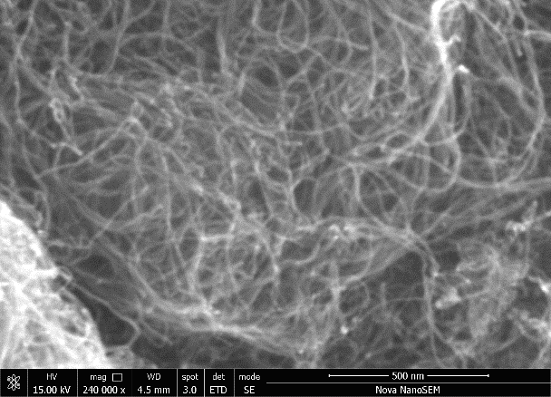
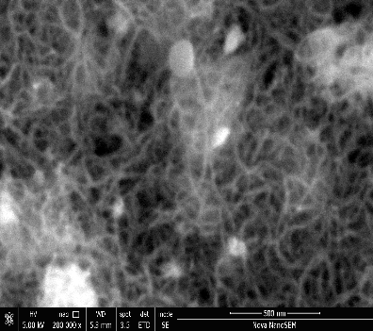
500 nm
500 nm
LMO50
(a)
(b)
Fig. 7. SEM images of dried samples of CNT (a) and LMO50/CNT (b) after dispersion in aqueous solution with surfactant 1% Triton X-100.
We can see that LMO50 particles of different size (100 nm − 1 μm) are uniformly distributed in the CNT network.
We used the vacuum filtration method to obtain a thin film of a self-standing flexible electrode. To this end, we filtrated the LMO50/CNT dispersion through a PVDF membrane with a pore size of 200 nm. Therefore, only low-molecular weight components could pass through the filter. Additional intensive washing with deionized water allowed us to remove Triton X-100 residues, while a uniform LMO50/CNT layer with a thickness of about 150 μm remained on the filter. After brief drying at ambient conditions, the LMO50/CNT layer was peeled off from the PVDF membrane and treated at 110 °C during 12h. The heat treatment fixed the electrode structure, thus preventing delamination and dissolution of the material. As a result, the electrode remained stable in aqueous electrolyte solutions; namely, there were no swelling and no mass loss.
Figure 8 shows a digital photo of a self-standing LMO50/CNT flexible electrode and SEM images of its surface at different magnification.

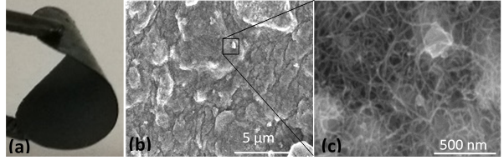

Fig. 8. Digital photo of a self-standing flexible LMO50/CNT electrode (a), SEM image of the electrode surface and bridge island matrix (b, c).
The electrode consists of tightly packed micron-size fragments of sediment (Fig. 8b). Increasing the magnification of the SEM image, we can observe the "island-bridge" structure of the electrode obtained: CNT forms a network with uniformly distributed submicron-size LMO50 particles. In the "island-bridge" structure of the LMO50/CNT electrode, the islands of LMO are connected by bridges of stretchable and conducting CNT. Even a small mass fraction of CNT (12 % wt.) leads to an increase in the electrical conductivity of the electrode up to 46 S⋅m⁻¹. This is more than six orders of magnitude greater than the electrical conductivity of pristine LMO and corresponds to the level of electrical conductivity necessary for the electrode of a power source [40].
  - Electrochemical performance of the LMO/CNT electrode material
The electrochemical study of a self-standing flexible LMO50/CNT electrode obtained using binder-free technology was carried out in the presence of a neutral aqueous electrolyte that is used in aqueous Li-ion batteries. The aqueous Li-ion batteries are non-toxic, non-flammable and much cheaper than organic electrolyte batteries due to the simplification of the manufacturing technology and cheaper components. However, they exhibit lower energy density compared to organic Li-ion batteries [41-43] due to the reduced potential window. A typical capacity of cathodes with aqueous electrolyte does not exceed 100 mAh⋅g⁻¹ [1, 43].
The LMO50/CNT electrode tests were carried out in a three-electrode cell with a neutral aqueous electrolyte (1.0 M Li₂SO₄). The reference electrode was Ag/AgCl, while platinum served as counter electrode, and the self-standing flexible film of LMO50/CNT was used as a working electrode. Potential scanning was limited to 1.20 V, to avoid the water decomposition (1.23 V). The results obtained are shown in Fig. 9.
Figure 9a shows cyclic volt-amperogram (CV) for the first 50 cycles at a high scanning rate of 2 mV⋅s⁻¹. Excepting first cycle, CV curve shows one wide peak on both cathodic (0.95 V) and anodic (0.9 V) sides, due to the high potential rate. However, with decrease of scanning rate to 0.1 mV⋅s⁻¹, two reduction/oxidation peaks appear on both cathodic (0.82 V and 0.95 V) and anodic (0.75 and 0.9 V) sides of CV curves (Fig. 9b) which is correlated with the redox-type reactions along with ion-exchange-type of Li⁺ extraction/insertion. This indicates that commercial LMO used exhibits redox-type spinel structure which contains some Mn³⁺ along with Mn⁴⁺ sites. It is established [14, 44] that Mn³⁺ can be reversibly oxidized to Mn⁴⁺ following two-step reaction forming two peaks in CVs:
Li_{0.5}Mn₂O₄ ↔0.5Li⁺+2 λ-MnO₂+0.5e⁻
LiMn₂O₄ ↔ 0.5Li⁺+Li_{0.5}Mn₂O₄+0.5e⁻
The formation of the λ-MnO₂ structure is the result of this redox process. The content of Mn³⁺ is small, that is way the contribution of the redox process is also small.

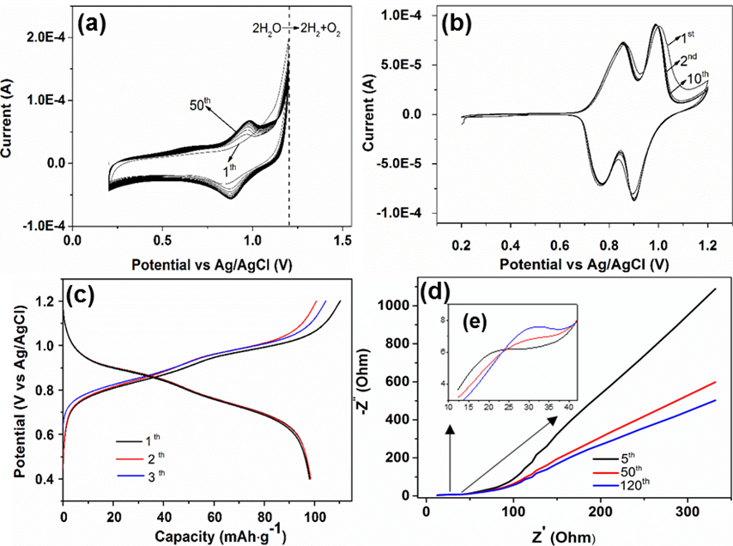
Fig. 9. Cyclic voltammetry of LMO50/CNT at a scan rate of 2 mV⋅ s⁻¹ (a) and 0.1 mV⋅ s⁻¹ (b) for the first 50 cycles, Galvanostatic charge-discharge curve at 0.6C (c), electrochemical impedance spectra (EIS) of LMO50/CNT over the frequency range of 0.01 Hz – 5⋅10⁴ Hz after 5, 50 and 120 cycles (d), and zoom of EIS for semicircle region (e).

The sharpness of the peaks on CV curves indicates the good kinetic for ion transfer during the cycling process, thus revealing the intensification of Faradaic reactions. Changes in the CV curve shape are observed for the first cycle when an activation process appears. Then the shape remains unchanged, indicating the high stability of the electrode material. It can be noticed that next CV curves follow the same shape, except the first and the second ones, which suggests that the material exhibits a reversible reduction/oxidation reaction.
As can be seen from Fig. 9c, there are two semiplateaus on first three charge/discharge curves at 0.6C associated with the reduction/oxidation process of lithium insertion/extraction.
The Nyquist plots of LMO50/CNT electrode after 5, 50 and 120 cycles are shown in Fig. 9d. All curves contain a semicircle in the high-frequency range (Fig. 9e) and a quasi-linear part in the low-frequency range. The presence of a semicircle is due to the resistance of the electrode to charge transport. The diameter of the semicircle remains unchanged during 120 cycles, which indicates a good stability of the LMO50/CNT structure. The quasi-linear part at low frequency is the Warburg contribution of Li-ion diffusion through the bulk of the electrode material. The decrease in the angle of the quasi-linear Warburg part with cycling indicates an improvement in Li-ion diffusion and an increase in the charge transport rate in the LMO50/CNT electrode.
The specific discharge capacity was measured galvanostatic at different current rates: 0.16 mA (0.6C), 0.2 mA (0.8C), 0.3 mA (1C) and 0.6 mA (2C). To prove the stability and high ionic reversibility of the fabricated cathode, we repeated 3 series of charge/discharge cycles at different current rates: 0.6C, 0.8C, 1C, and 2C. The results are shown on Fig. 10.
Accordingly, a specific discharge capacity of about 110 mAh⋅g⁻¹ was obtained at 0.6C and 77 mAh⋅g⁻¹ for 2C. At the same time, the variation of Coulombic efficiency is rather low during lithiation/delithiation, which demonstrates electrochemical stability of the cathode material structure (Fig.10a). These results show good discharge capacity of the cathode material obtained in comparison with other aqueous Li-ion battery systems based on LMO as the active material (Table 1) [45-49]. The advantage of LMO50/CNT electrode is the use of a simple binder free technology and a commercial LiMn₂O₄ product. Practically, this will reduce the cost of the battery, while maintaining its electrochemical performance.
To prove cycling stability of LMO50/CNT electrode, discharge capacity for 120 cycles and corresponding Coulombic efficiency were analyzed (Fig.10b). As follows from this figure, LMO50/CNT cathode material shows good electrochemical performance, with a specific discharge capacity of 110.8 mAh ⋅g⁻¹ after the first cycle and 104.1 mAh ⋅g⁻¹ after 120 cycles, thus retaining a capacity of about 93%. The decrease of discharge capacity during first cycles can be explained by evolution of activation process of ionic charge transfer. The coulombic efficiency is situated at high level, near 100%, that show the stability of the insertion/extraction of Li-ion during charging/discharging process. Therefore, the process of lithiation/delithiation occurs without a significant change in the structure of the LMO50/CNT cathode. Indeed, it can be seen from the SEM micrographs that before and after 120 charge/discharge cycles, the structure of LMO50/CNT cathode remains unchanged and shows a homogenous distribution of LMO in the CNT network matrix (Fig. 10 c, d).
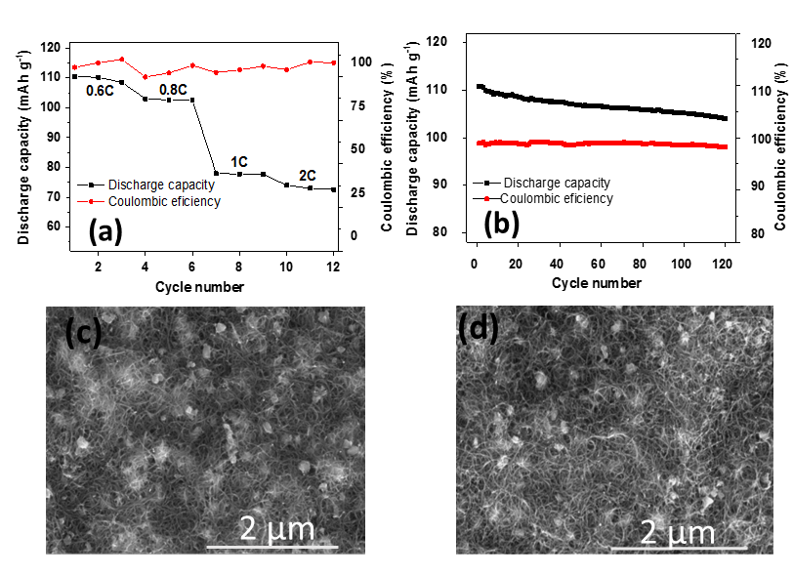
Fig. 10. Comparison of rate capability (0.6C, 0.8C, 1C and 2C) of self-standing binder-free LMO50/CNT (a), cycling performances at 0.6C for a series of 120 cycles (b), SEM micrographs of LMO50/CNT electrode before cycling (c) and after 120 cycles (d) with a current rate of 0.6C.

- Conclusions

We simplified the technology for preparing a self-standing flexible cathode for rechargeable Li-ion batteries. The active material of the cathode is based on commercially available spinel-type LiMn₂O₄ and multiwall CNT which enhanced electrical conductivity of cathode. We have shown that the preliminary fragmentation of LMO by short-time ball-milling with low energy intensity significantly reduces the particle size without destroying its spinel structure. The fragmentation of particles to micron and submicron size ensures significant increase in the specific surface area, their uniform distribution in the CNT matrix, and a stable aqueous dispersion. This facilitates the fabrication of a flexible self-standing electrode and improves its stability and capacitive characteristics. Indeed, electrochemical tests of the cathode material in neutral aqueous electrolyte (1.0 M Li₂SO₄) revealed its stable structure resulting in a specific discharge capacity of about 110.8 mAh ⋅g⁻¹ after the first cycle and 104.1 mAh ⋅g⁻¹ after 120 cycles.

References
[1] Q. Li, J. Chen, L. Fan, X. Kong, Y. Lu, Progress in electrolytes for rechargeable Li-based batteries and beyond, Green Energy & Environ. 1 (2016) 18-42. https://doi.org/10.1016/j.gee.2016.04.006
[2] W. Tang, L. Liu, Y. Zhu, H. Sun, Y. Wu, K. Zhu, Aqueous rechargeable lithium batteries as an energy storage system of superfast charging, Energ. Environ. Sci. 5 (2012) 2093-2104. https://doi.org/10.1039/c2ee21294c.
[3] Q. Qu, L. Fu, X. Zhan, D. Samuelis, J. Maier, L. Li, S. Tian, Z. Li, Y. Wu, Porous LiMn₂O₄ as cathode material with high power and excellent cycling for aqueous rechargeable lithium batteries, Energ. Environ. Sci. 4 (2011) 3985-3990. https://doi.org/10.1039/c0ee00673d.
[4] W. Tang, Y. Zhu, Y. Hou, L. Liu, Y. Wu, K.P. Loh, H. Zhang, K. Zhu, An aqueous rechargeable lithium battery of excellent rate capability based on a nanocomposite of MoO₃ coated with PPy and LiMn₂O₄, Energ. Environ. Sci. 6 (2013) 6909-6913. https://doi.org/10.1039/c2ee21294c.
[5] K. Mizushima, P.C. Jones, P.J. Wiseman, J.B. Goodenough. Li_{x}CoO₂ (0<x≤1): A new cathode material for batteries of high energy density. Mater. Res. Bull. 15 (1980) 783-789.
[6] A. Mauger, C.M. Julien, Critical review on lithium-ion batteries: are they safe? Sustainable? Ionics, 23 (2017) 1933-1947. https://doi.org/10.1007/s11581-017-2177-8.
[7] R. Fang, K. Chen, L. Yin, Z. Sun, F. Li, H. M. Chen, The regulating role of carbon nanotubes and graphen in lithium-ion and lithium-sulfur batteries, Adv. Mater. 31 (2019) 1800863. https://doi.org/10.1002/adma.201800863.
[8] N.S. Choi, Z. Chen, S.A. Freunberger, X. Ji, Y.K. Sun, K. Amine, G. Yushin, L.F. Nazar, J. Cho, P.G. Bruce, Challenges facing lithium batteries and electrical double-layer capacitors, Angew. Chem. Int. Ed., 51 (2012) 9994-10024. https://doi.org/10.1002/anie.201201429.
[9] C. M. Julien and A. Mauger, Nanostructured MnO₂ as electrode materials for energy storage, Nanomaterials, 7 (2017) 1-42. https://doi.org/10.3390/nano7110396.
[10] X.D. Luo, Y.Z. Yin, M. Yuan, W. Zeng, G. Lin, B. Huang, Y.W. Li, S.H. Xiao, High performance composites of spinel LiMn₂O₄/3DG for lithium ion batteries, RSC Adv., 8 (2018) 877-884. https://doi.org/10.1039/c7ra12613a.
[11] X. Gao, Y. Sha, Q. Lin, R. Cai, M.O. Tade, Z. Shao, J. Power Sources, Combustion-derived nanocrystalline LiMn₂O₄ as a promising cathode material for lithium-ion batteries, 275 (2015) 38-44. http://dx.doi.org/10.1016/j.jpowsour.2014.10.099.
[12] Ch. Julien, A. Mauger, A. Vijh, K. Zaghib, Lithium Batteries, 1st ed., Springer, Switzerland, 2016.
[13] H. Manjunatha, G.S. Suresh, T.V. Venkatesha, Electrode materials for aqueous rechargeable
lithium batteries, J. Solid State Electrochem. 15 (2011) 431-445. https://doi.org/10.1007/s10008-010-1117-6.
[14] Q. Feng, H. Kanoh, K. Ooi, Manganese oxide porous crystals, J. Mater. Chem. 9 (1999) 319-333. https://doi.org/10.1039/A805369C.
[15] O. Ghodbane, J.L. Pascal, F. Favier, Microstructural Effects on Charge-storage properties in MnO2-based electrochemical supercapacitors, ACS Appl. Mater. Interfaces, 1 (2009) 1130-1139. https://doi.org/10.1021/am900094e.
[16] L. Wen, F. Li, H.M. Cheng, Carbon nanotubes and graphene for flexible electrochemical energy storage: from materials to Devices, Adv. Mater. 28 (2016) 4306-4337. https://doi.org/10.1002/adma.201504225.
[17] M. Buga, A. Rizoiu, C. Bubulinca, S. Badea, M. Balan, A. Ciocan, A. Chitu, Study of LiFePO4 electrode morphology for Li-ion battery performance, Revista de Chimie, 69 (2018) 549-552.
[18] L. Qiu, Z. Shao, D. Wang, W. Wang, F. Wang, J. Wang, Enhanced electrochemical properties of LiFePO₄ (LFP) cathode using the carboxymethyl cellulose lithium (CMC-Li) as novel binder in lithium-ion battery, Carbohydr. Polym. 111 (2014) 588-591. http://dx.doi.org/10.1016/j.carbpol.2014.05.027
[19] H. Zhong, A. He, J. Lu, M. Sun, J. He, L. Zhang, Carboxymethyl chitosan/conducting polymer as water-soluble composite binder for LiFePO4 cathode in lithium ion batteries, J. Power Sources, 336 (2016) 107-114. http://dx.doi.org/10.1016/j.jpowsour.2016.10.041.
[20] M. Mancini, F. Nobili, R. Tossici, R. Marassi, Study of the electrochemical behavior at low temperatures of green anodes for Lithium ion batteries prepared with anatase TiO2 and water soluble sodium carboxymethyl cellulose binder, Electrochimica Acta, 85 (2012) 566-571. http://dx.doi.org/10.1016/j.electacta.2012.08.115
[21] T. Tanabe, Y. Liu, K. Miyamoto, Y. Irii, F. Maki, T. Gunji, S. Kaneko, S. Ugawa, H. Lee, T. Ohsaka, F. Matsumoto, Synthesis of water-resistant thin TiO_{x} layer-coated high-voltage and high-capacity LiNi_{a}Co_{b}Al_{1-a-b}O₂ (a > 0.85) cathode and its cathode performance to apply a water-based hybrid polymer binder to Li-Ion batteries, Electrochimica Acta, 258 (2017) 1348-1355. https://doi.org/10.1016/j.electacta.2017.11.193
[22] X. Jia, Y. Kan, X. Zhu, G. Ning, Y. Lu, F. Wei, Building flexible Li4Ti5O12/CNT lithium-ion battery anodes with superiorrate performance and ultralong cycling stability, Nano Energ. 10 (2014) 344-352. http://dx.doi.org/10.1016/j.nanoen.2014.10.012.
[23] W. Huang, J. Li, Y. Xu, Nucleation/growth mechanisms and morphological evolution of porous MnO₂ coating deposited on graphite for supercapacitor, Materials, 10 (2017) 1-18. https://doi.org/10.3390/ma10101205.
[24] H. Chen, S. Zeng, M. Chen, Y. Zhang, Q. Li, Fabrication and functionalization of carbon nanotube films for high-performance flexible supercapacitors, Carbon, 92 (2015) 271-296. http://dx.doi.org/10.1016/j.carbon.2015.04.010
[25] Y. Cheng, Z. Chen, M. Zhu, Y. Lu, Polyacrylic acid assisted assembly of oxide particles and carbon nanotubes for high-performance flexible battery anodes, Adv. Energ. Mater. (2014) 1401207. https://doi.org/10.1002/aenm.201401207.
[26] H. Fei, N. Saha, N. Kazantseva, R. Moučka, Q. Cheng, P. Saha, A highly flexible supercapacitor based on MnO2/RGO nanosheets and bacterial cellulose-filled gel electrolyte, Materials, 10 (2017) 1251-1263. http://dx.doi.org/10.3390/ma10111251.
[27] X. Jia, Z. Chen, A. Suwarnasarn, L. Rice, X. Wang, H. Sohn, Q. Zhang, B.M. Wu, F. Wei, Y. Lu, High-performance flexible lithium-ion electrodes based on robust network architecture, Energ. Environ. Sci. 5, (2012) 6845-6849. http://dx.doi.org/10.1039/c2ee03110h.
[28] S. Luo, K. Wang, J. Wang, K. Jiang, Q. Li, S. Fan, Binder-free LiCoO₂/carbon nanotube cathodes for high-performance lithium ion batteries, Adv. Mater. 24 (2012) 2294-2298. https://doi.org/10.1002/adma.201104720.
[29] M. Frías, M.I. Sánchez de Rojas, M.P. Luxán, N.García, Determination of specific surface area by the laser diffraction technique. Comparison with the blaine permeability method, Cem. Concr. Res. 21 (1991) 709-717. http://dx.doi.org/10.1016/0008-8846(91)90165-E.
[30] C. Wei, J. Shen, J. Zhang, H. Zhang, Ch. Zhu, Effects of ball milling on the crystal face of spinel LiMn₂O₄, RSC Adv. 4 (2014) 44525-44528. http://dx.doi.org/10.1039/c4ra03875d.
[31] C. Julien, M. Massot, S. Rangan, M. Lemal, D. Guyomard, Study of structural defects in γ-MnO₂ by Raman spectroscopy J. Raman Spectrosc. 33 (2002) 223-228. https://doi.org/10.1002/jrs.838.
[32] B. Ammundsen, G.R. Burns, M.S. Islam, H. Kanoh, J. Roziere, Lattice dynamics and vibrational spectra of lithium manganese oxides: a computer simulation and spectroscopic study, J. Phys. Chem. B, 103 (1999) 5175-5180. https://doi.org/10.1021/jp984398l.
[33] M.M. Sinha, H.C. Gupta, Study of zone-center phonons in lithium manganese oxide, Phys. B, 316-317 (2002) 166-169. https://doi.org/10.1016/S0921-4526(02)00449-0.
[34] C.V. Ramana, M. Massot, C.M. Julien, XPS and Raman spectroscopic characterization of LiMn₂O₄ spinels, Surf. Interface Anal. 37 (2005) 412-416. https://doi.org/10.1002/sia.2022.
[35] E. G. Kelly, D.J. Spottiswood, The breakage function; What is it really? Minerals Engineering 3 (1990) 405-414. https://doi.org/10.1016/0892-6875(90)90034-9.
[36] A.N. Grundy, B. Hallstedt, L.J. Gauckler, Assessment of the Mn-O System, J. Pha. Equilib. 24 (2003) 21-39. https://doi.org/10.1007/s11669-003-0004-6.
[37] Z. Zhang, Ch. Qu, T. Zheng, Y. Lai, J. Li, Effect of Triton X-100 as dispersant on carbon black for LiFePO₄ cathode, Int. J. Electrochem. Sci. 8 (2013) 6722-6733.
[38] P. Randhawa, J.S. Park, S. Sharma, P. Kumar, M.S. Shin, S.S. Sekhon, Effect of surfactant (Triton x-100) concentration on dispersion and functionalization of multiwall carbon nanotubes, J. Nanoelectron. Optoelectron. 7 (2012) 1-8. https://doi.org/10.1166/jno.2012.1303.
[39] W. Porcher, B. Lestriez, S. Jouanneau, D. Guyomard, Optimizing the surfactant for the aqueous processing of LiFePO₄ composite electrodes, J. Power Sources. 195 (2010) 2835-2843. https://doi.org/10.1016/j.jpowsour.2009.11.088.
[40] X. Wang, G. Shi, Flexible graphene devices related to energy conversion and storage, Energ. Environ. Sci. 8 (2015) 790-823. https://doi.org/10.1039/C4EE03685A.
[41] J. Yan, J. Wang, H. Liu, Z. Bakenov, D. Gosselink, P. Chen, Rechargeable hybrid aqueous batteries, J. Power Sources. 216 (2012) 222-226. https://doi.org/10.1016/j.jpowsour.2012.05.06.
[42] Y. Wang, J. Yi, Y. Xia, Recent Progress in Aqueous Lithium-Ion Batteries, Adv. Energ. Mater. 2 (2012) 830-840. https://doi.org/10.1002/aenm.201200065.
[43] N. Alias, A.A. Mohamad, Advances of aqueous rechargeable lithium-ion battery: A review, J. Power Sources, 274 (2015) 237-251. http://dx.doi.org/10.1016/j.jpowsour.2014.10.009.
[44] H. Kanoh, Q. Feng, Y. Miyai, K. Ooi, Kinetic properties of a Pt/Lambda-MnO₂ electrode for the electroinsertion of lithium ions in an aqueous phase J. Electrochem. Soc. 142 (1995) 702-707. http://dx.doi.org/10.1149/1.2048520
[45] M. Kheirmand, A. Ghasemi, LiMn₂O₄ nanoparticles as cathode in aqueous Lithium-ion battery, Sur. Eng. and Appl. Electrochem. 52 (2016) 480-486. http://dx.doi.org/10.3103/S1068375516050069.
[46] M. Tang, A.Yuan, H. Zhao, J. Xu, High-performance LiMn₂O₄ with enwrapped segmented carbon nanotubes as cathode material for energy storage, J Power Sources, 235 (2013) 5-13. http://dx.doi.org/10.1016/j.jpowsour.2013.01.182.
[47] X. Zhu, X. Wu, T.N.L. Doan, Y. Tian, H. Zhao, P. Chen, Binder-free flexible LiMn2O4/carbon nanotube network as high power cathode for rechargeable hybrid aqueous battery J. Power Sources. 326 (2016) 498-504. http://dx.doi.org/10.1016/j.jpowsour.2016.07.029.
[48] Y. Wang, L. Chen, Y. Wang, Y. Xia, Cycling stability of spinel LiMn₂O₄ with different particle sizes in aqueous electrolyte, Electrochem. Acta. 173 (2015) 178-183. http://dx.doi.org/10.1016/j.electacta.2015.05.051.
[49] Z. Li, L. Wang, K. Li, D. Xue, LiMn₂O₄ rods as cathode materials with high rate capability and good cycling performance in aqueous electrolyte, J Alloys Compd. 580 (2013) 592-597. http://dx.doi.org/10.1016/j.jallcom.2013.07.116.

Acknowledgments: This work was supported by the Ministry of Education, Youth, and Sports of the Czech Republic (project no. LTACH17015), NPU Program I (LO1504) and Operational Program Research and Development for Innovations co-funded by the European Regional Development Fund (ERDF) and national budget of the Czech Republic, within the framework of the CPS – strengthening research capacity (reg. number: CZ.1.05/2.1.00/19.0409), as well as by National Key R&D Program of China (2016YFE0131200).

Table 1. Comparison of fabrication methods and electrochemical performance of spinel-type LiMn₂O₄ cathode materials for rechargeable aqueous Lithium-ion battery.

Cathode  composition | Method  of  LiMn₂O₄  preparation | LiMn₂O₄  average particle  size | Bin-  der | Electro-lyte | Specific capacity | Charge/  discharge  cycle  performance | Ref.  no.
LiMn₂O₄/  25 wt % of vulcan and  graphite with an equal ratio | Sol-gel synthesis | 125 nm | 5 wt. %  PVDF | 5 M LiNO₃ | 130 mAh⋅g⁻¹  at the current density of 500 mA⋅g⁻¹ | Not mentioned | [45]
LiMn₂O₄/  MWCNT | Hydro-thermal synthesis  followed with thermal treatment | 20 nm | 5 wt. %  PTFE | 5 M LiNO₃ | 136 mAh⋅g⁻¹  at the current density of 500 mA⋅ g⁻¹ | Capacity retention  59.8 %  after 2000 cycles at  2000 mA⋅g⁻¹ | [46]
LiMn₂O₄/  CNT/ acetylene black | Commercial product | 150 nm | Binder free | 2 M Li₂SO₄ mixed with  1 M ZnSO₄ | 116 mAh⋅g⁻¹  at current density of  500 mA⋅ g⁻¹ | Capacity retention  62%  after 300 cycles at  500 mA⋅g⁻¹ | [47]
LiMn₂O₄/  80 wt % acetylene black | Sol-gel synthesis followed with thermal treatment | 100-200 nm | 10 wt.%  PTFE | 1 M Li₂SO₄ | 100 mAh⋅g⁻¹  at current density of  148 mA⋅ g⁻¹ | Capacity retention  93 % after 50 cycles at  148 mA⋅g⁻¹ | [48]
LiMn₂O₄/  80 wt % acetylene black | Sol-gel synthesis followed with thermal treatment | 2-4 µm | 10 wt.%  PTFE | 1 M Li₂SO₄ | 110 mAh⋅g⁻¹  at current density of  148 mA⋅g⁻¹ | Capacity retention  78 % after 50 cycles  at 148 mA⋅g⁻¹ | [48]
LiMn₂O₄/  carbon black | Hydro-thermal synthesis  followed with thermal treatment | Particles with rods shape:  D=350 nm  L=2.5 µm | 10 wt.%  PTFE | 1 M Li₂SO₄ | 93 mAh⋅g⁻¹  at current density of  500 mA⋅g⁻¹ | Capacity retention  95 % after 200 cycles  at 200 mA⋅g⁻¹ | [49]
LMO50/CNT | Ball-milled commercial product | 2-6 µm | Binder free | 1 M Li₂SO₄ | 110 mAh⋅g⁻¹ at current density of  100 mA⋅ g⁻¹ | Capacity retention  93 % after 120 cycles  at 100 mA⋅g⁻¹ | our re-sults

