INSIGHTS AND PRACTICES FROM BRANDING IN DESTINATION MANAGEMENT
Monika Hýblová
Abstract
The article is focused on the topic of a destination branding. It explains the basic concepts and specifics in the Czech Republic, then there follow the findings from a previously conducted foreign scientific work through critical literature review and examples of successful branding from foreign countries. Branding in practice is shown with two different successful approaches.
The concept of branding in destination management is a relatively new idea, that is gradually tested in practice in each destination. The importance of marketing and branding has increased with transport development, but still 10 main destinations are visited by 70 % of the visitors. The tourism is a major source of income in many countries in the world.
The tourism formed nearly 3 % of GDP and employed 225 000 persons in the Czech Republic in 2014. The total internal tourism consumption in the Czech Republic amounted to 238 bln. CZK in 2014. The incoming tourism generated almost 61 % of the consumption (144 bln. CZK). The average daily expenditure of foreign visitors amounted to 4,880 CZK, while the Czech tourists spent only 1230 CZK. This statistics shows, how the tourism is important. The Czech Republic is not a typical touring country, but its benefits from tourism are considerable and the importance of tourism in other countries is even increased with higher tourist popularity.
Keywords: branding, destination management, tourism
- INTRODUCTION
The components of branding are used in companies these days as a part of company marketing. The use of branding in tourism is not very common, it can be found only rarely in the field of destination management. The methods of branding can still be used successfully in tourism management it could even become a competitive advantage.
The concept of tourism is very old – the people were travelling since the beginning of their existence. Ancient tribes were wandering for many reasons, the main ones were food, water, territory and many others. After satisfying their basic needs for survival, the people began to be more interested in the culture. At that time the new kind of tourism appeared – the same one we know in present. Now we have the possibilities to travel around the world in a few hours and discover every part of the world. With this fast progress, the marketing started to be very important in this growing economic sector.
Destination characteristics in the Czech Republic, is focused on the division of the territory into individual parts, with the possibility of creating a destination of a region, area or city. This division is based on a natural and cultural condition and tradition of the destination. The destination management can use the same principles, that are used by companies and business sector, only with some necessary adjustments for this specific conditions.
Marketing is very important tool for communication with customers, to address them and keep in touch with them. An advertising presentation is a main tool for gaining new customers for a lot of companies. Every destination or area can also use these marketing presentations as their products are individual. It is a specific sector of economy, because it does not offer a particular product or service, but it offers the whole destination and its services.
This article is focused on a knowledge of branding in destination management, clarification of terms and a description of first use of branding in destination management. A literature review is formulated with emphasis on using branding in practice of destination management.
- THEORETICAL BACKGROUND
  - Branding
The term "brand" has a very long history and its origin is anglo-saxon, with original meaning – to burn. First brands were owned by farmers and it was a symbol of quality of their farm animals and for differentiation from other farmer's animals. Another advantage was, that these animals could not be stolen, everybody could recognize them. The brand was burned on animal's skin, so this meaning is a metaphor for branding, how we understand it today. Brands are burned into mind of customers. (Cliffton, Simmons, 2003)
Branding is a way, that could change the customer's opinion, it can become part of their life. Brands are not used only in business sector for each product, but also in non-profit organizations, political parties or zoos, they all have their own brand. (Keller, 2007, Kotler, 2007)
A brand is not only a logo, it contains expectations of customers, their emotions. It is necessary to build the brand, give it a value and invest money in it. Nowadays, a successful company brand is seen as an asset - a property of the company. (Aaker, 2003)
  - Branding and marketing
Brand awareness is an important part of brand building and at the same time it is the goal of significant investments in marketing. This awareness can have two types - passive and active. An active awareness is a situation, where the target group of the brand can actively think about it when choosing what to buy from a category of products. In contrast to this, passive awareness is typical for commercial communication when the target group just identifies the brand. (Healey, 2010, Přibyl, 2005)
A branding should precede and underlie any marketing effort. It represents the expression of the essential truth or value of an organization, product, or service. It is a communication of characteristics, values, or attributes, which show what the brand is and what it is not. The strongest brands use their understanding of the difference between branding and marketing to build marketing campaigns that work hand in hand with their brand positioning strategy. A brand is in your mind associated with a product, service, or organization. The brand is what determines if you will be a loyal customer or not. The marketing persuades people to buy a specific product, but the brand determines whether the product will have a longterm success. (Brand Marketing, 2012, The Difference Between Marketing and Branding, 2011, Whats the difference between marketing and branding, 2017)
  - Destination
A destination is specified, according to the World Tourism Organization, as a place with attractions, facilities associated with them and the tourism services, that the guest chooses for his visit and that the providers bring to the market. (Destination Management)
In general, a destination is a spot that is an aim for the tourists. There are plenty of tourist services, which are provided in response to local attractions. (Palatková, 2006a)
A destination is a regional unit of supply, that is internationally competitive and strategically managed on the international market. Destinations are trying to meet expectations of their clients and offer appropriate products. (Palatková, 2011)
  - Destination management
Destination management is a form of management of certain areas and its task is to increase the effectiveness of activities related to tourism and its sustainable development. Its goal is to coordinate all stakeholders in the promotion of their interests, in developing of strategic plans or implementing marketing activities. Together, they want to create and manage a destination that is competitive in the market. Among the interest groups we primarily include service providers, local residents, environmentalists, non-profit organizations, investors, entrepreneurs and public authorities. (Ryglová, Burian, Vajčnerová, 2011, Holešinská 2010)
We can define a destination management also as techniques, tools and measures that can be used for planning, organization, communication and decision-making in the area. The aim of destination management is a set of sustainable and competitive tourism products, that share its main characteristics as a logo, quality, reservation system or pricing policy among all partners. (Zelenka, Pásková, 2012)
  - Marketing of tourism destination
This term means the process of harmonizing resources of the destination with the market situation. The main part of it is the destination analysis, planning, organization, management and strategy control of the area. All this activity leads to strengthening of its competitive position. From this perspective branding in tourism does not adhere to the underlying assumption of traditional product and service brand management that the whole process of creation and management of the brand is controlled by and within an individual organization. The destination brand is a powerful tool with the ability to create emotional appeal and a brand image is considered crucial to the marketing success of a tourism destination. (Jakubíková, 2012, Janečková, Vaštíková, 1999)
For the effectiveness of destination marketing is necessary to take into account also the time and place limitations of product realization and purchase, high share of emotions and the importance of personal recommendations. Good image and communication skills of all partners are also essential. It is necessary to support a communication between supply and demand, as well as among the various stakeholders. (Palatková, 2006b)
A Destination Brand is a name, symbol, logo, word mark or other graphic that both identifies and differentiates the destination; furthermore, it conveys the promise of a memorable travel experience that is uniquely associated with the destination; it also serves to consolidate and reinforce the recollection of pleasurable memories of the destination experience. (Blain, 2005)
The definition is composed from two parts, with first part pointing to identification and differentiation of a brand. The second part is very important, the main part is experience. (Blain, 2005)

A branding in destination management is the brainchild of the past 20 years. The first academic conference on this topic took place in 1996. At the end of the 20th century began to appear the scientific articles addressing this issue. The first book on the subject was published in 2002 postulating a bright future for the branding of destinations. (Pike, 2005)
  - Destination management in the Czech Republic
Czech Republic is, according to the organization CzechTourism, divided into 40 destinations, as can be seen on image 2, instead of tourism regions on image 1. They are all very different in manner of area and attractions. (CzechTourism)
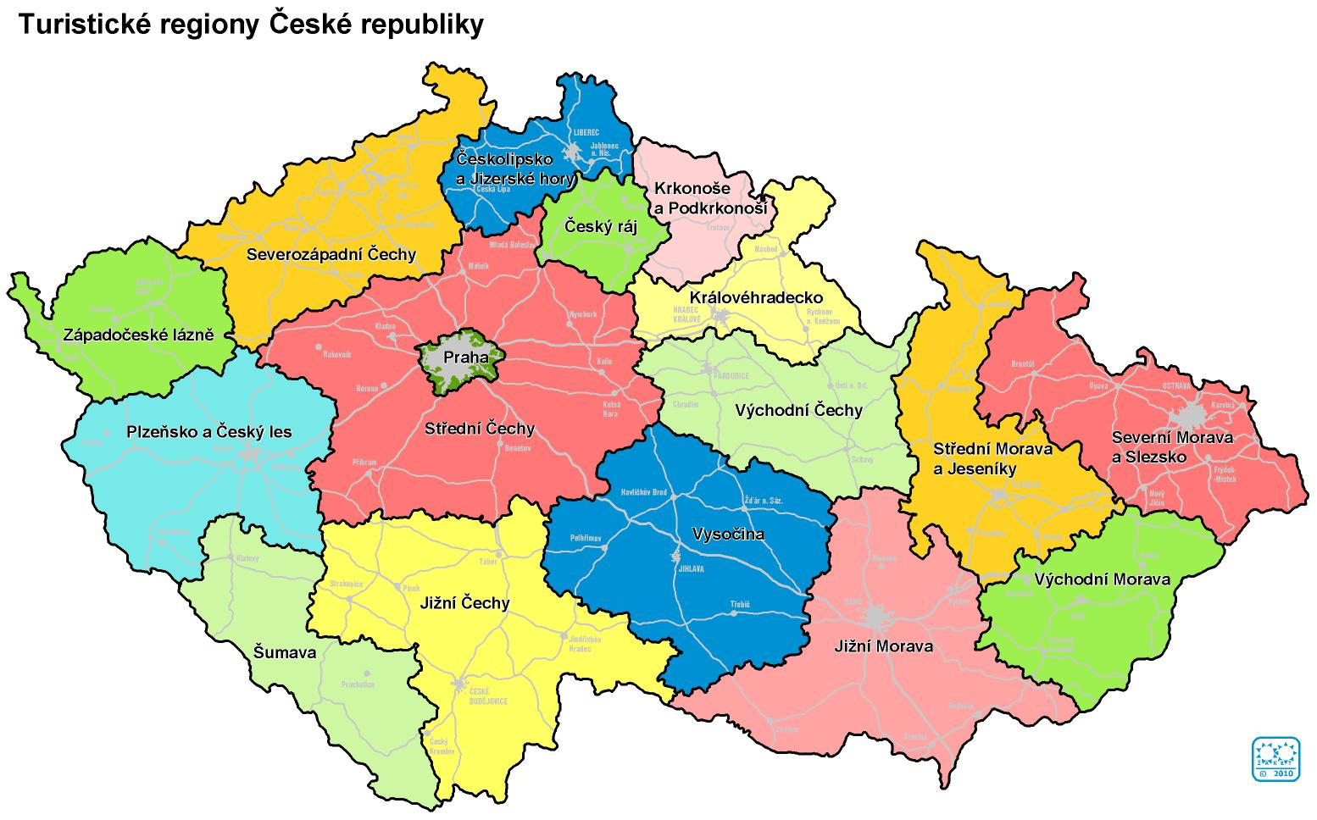
Image 1 Touristic regions in the Czech Republic (CzechTourism)
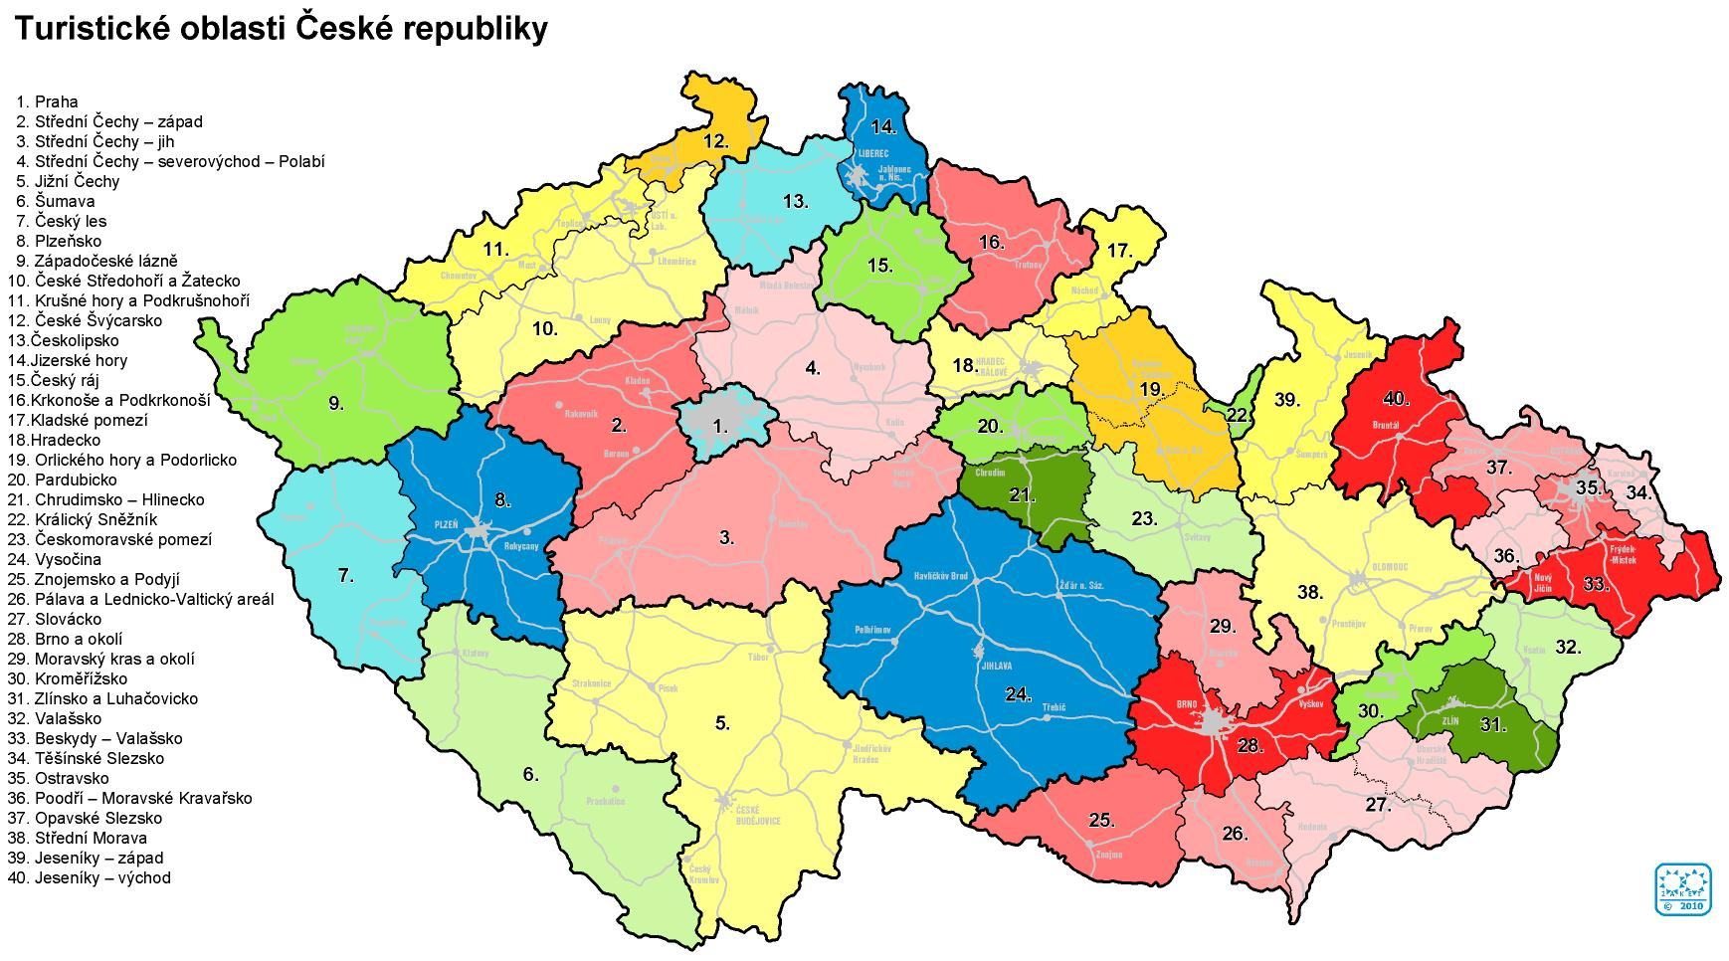
Image 2 Touristic destinations (CzechTourism)

Destination management leading company is focused on the development and proactive sales of major products, it coordinates and manages the creation of tourism products, as well as pricing policies and active destination sale. It is very often supported or created by major service providers in the area. The main task of destination management is to merge legally independent providers of tourism services such as hotels, guest houses, businesses, infrastructure facilities and other service providers into unions, which can perform many tasks. The public authorities can play strong or even dominant role in these societies at the local and regional level. These authorities have several basic tasks: planning, supply, marketing and representation of interests. (CzechTourism)
It is estimated that nearly 80 % of the territory of the Czech Republic is suitable for recreational purposes. The country has a large number of historical, cultural and technical monuments. There is very dense network of well-marked hiking trails and paths in the Czech Republic. There is also developing a new offer of tourism products - eg. urban tourism, congress, cycling, cultural tourism, agro-tourism, or even Czech traditional spa tourism. (CzechTourism)
A lack of organization and management concept is one of the main barriers to the tourism development in the country. There are implemented only simple cooperation activities focused primarily on promotional activities. The problem is the underestimation of the importance of this sector for the development of the Czech Republic. There is not supported a large multiplier effect of tourism, and despite the importance of tourism to the national economy, it is getting only low political support. Furthermore, there is lack of private subjects involving in tourism management. Only public-law entities are involved in concept making processes, the business sector gets involved only marginally. The importance of tourism is not much appreciated even in regions. The problem is in very low efficiency of cooperation of micro-regions and voluntary associations of municipalities, already existing micro-regions lack the concept and sufficient funding for tourism management. The concept of creating micro-regions and DSO is also missing. These micro-regions and DSO originated rather spontaneously to obtain grant funding. There is also lack of strong interest and lobbying groups of businessmen in tourism, whose task would be to promote the interests of its business members. The number of experts is also insufficient as well as the legislative and taxation system. (CzechTourism)
Low cooperation is not only within the business sector of tourism but also between public and private spheres. As a key development issue in this sector is considered an immaturity of interest and professional groups with great influence on the tourism destinations management. (CzechTourism)
- APPLYING BRANDING IN DESTINATION MANAGEMENT
The first use of branding in destination management was in 1998 in North America. Branding became a powerful tool and a reputable component of marketing. First examples were Brand Oregon, Branding of Canada, Brand of Texas, Missouri, New Orleans or Hawaii. (Ekinci, 2003)
At first, the branding in destination management was intended as a support of marketing efforts. Many of the destination management organizations just created a logo for their better presentation. This could be the reason, why some destination managers understand branding only as a logo or a catchword. Effective branding in practice is a process with three-stages. This process outlines image 3. (Ekinci, 2003, Clifton 2003)
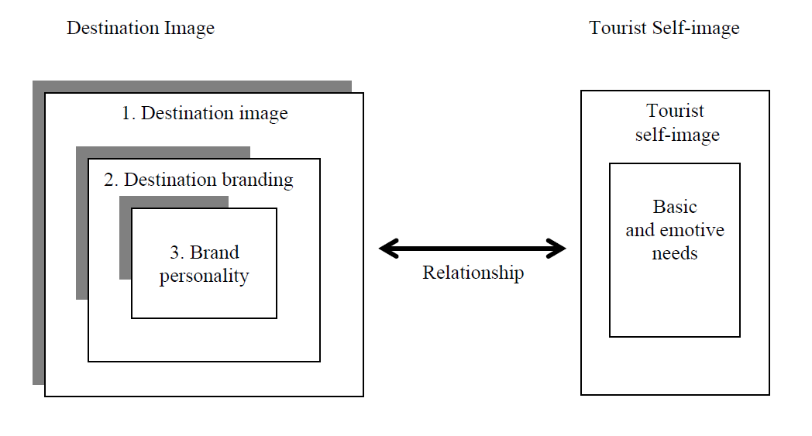
Image 3 Destination image and destination branding (Yuksel Ekinci)
Surveys and interviews are used to determine, how the current branding of destination looks in practice. This research has some downsides - the results show, that organizations, that did not reply, do not have any logo, so they decided not to answer. About 30 % of organizations, that did not reply, had this kind of attitude. (Ekinci, 2003)
Logos are still the main part of branding in destination management. Organizations use their logo on printed materials in 98 % of cases, on goods in 73 % of cases and they display the logo also in videos with 68% share. Logos are usually presented in media, which help to build consistent and distinctive image of the organization. (Ekinci, 2003, Healey, 2010)
The main reason, why tourism destinations have a logo, is to support the image of its area. Other reason is to provide a label that describes the destination and differentiates it from other places. Some DMOs have not involved any local organizations of tourism services (in 35 %) or visitors (in 40 %) in the logo design process to any extent. A lesser percentage of DMOs have substantially involved local tourism businesses (in 29%) or visitors (in 26%) in creating a logo design. Logos are in 87 % of cases a work of external consultants, because they can improve the logo design process due to their expertise. Only 32 % of destination organizations, which asked external consultants for help, involved tourism businesses or visitors in the logo design process. A shocking information also was a fact, that nearly 40 % of organizations did not test their new logo at all before publishing it, just one quarter of them tested it extensively. (Ekinci, 2003, Pike, 2005)
It was also found out, that the process of destination branding begins, when the evaluation of a destination image includes a strong emotional attachment. A tourist destination may have a name, but not necessarily a brand name. Branding often presents emotions, that are typical for the destination. It means, that a brand emphasises the human side of the brand image. In practical terms, a brand personality uses human personality traits to describe a destination image. For example, Paris or Venice are typical romantic cities, on the other hand Las Vegas is a symbol for gambling, naughtiness and fun. It was found out, that it is beneficial to connect a place with human's emotions, it is helpful for the brand. The result of a successful marketing is, that a brand differentiates itself from other ones, like a human being is different from other people. (Ekinci, 2003, Pike, 2003, Glińska, 2013)
A successful example of brand building is the case of the ‘100% pure New Zealand’ brand, where the destination was positioned as an appealing niche player in today’s global tourism industry. (Morgan, 2003)
The process of destination branding can be divided into three parts as shows image 4. At first, the destination benefits have to be found, then the names and association are determined. The third part is an aesthetic one. This part provides a satisfaction of customer's aesthetic needs. That can bring a great benefit, but it is very difficult to obtain it. (Ritchie, 1998)
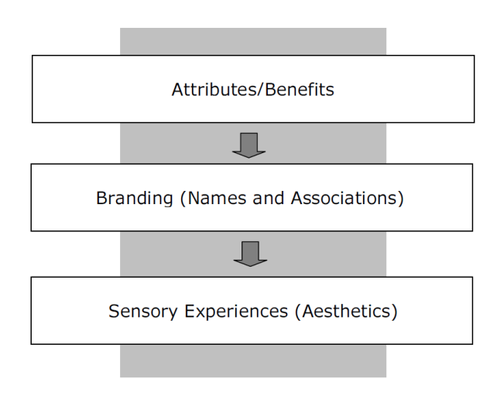
Image 4 Evolving focus of marketing approaches (Ritchie)

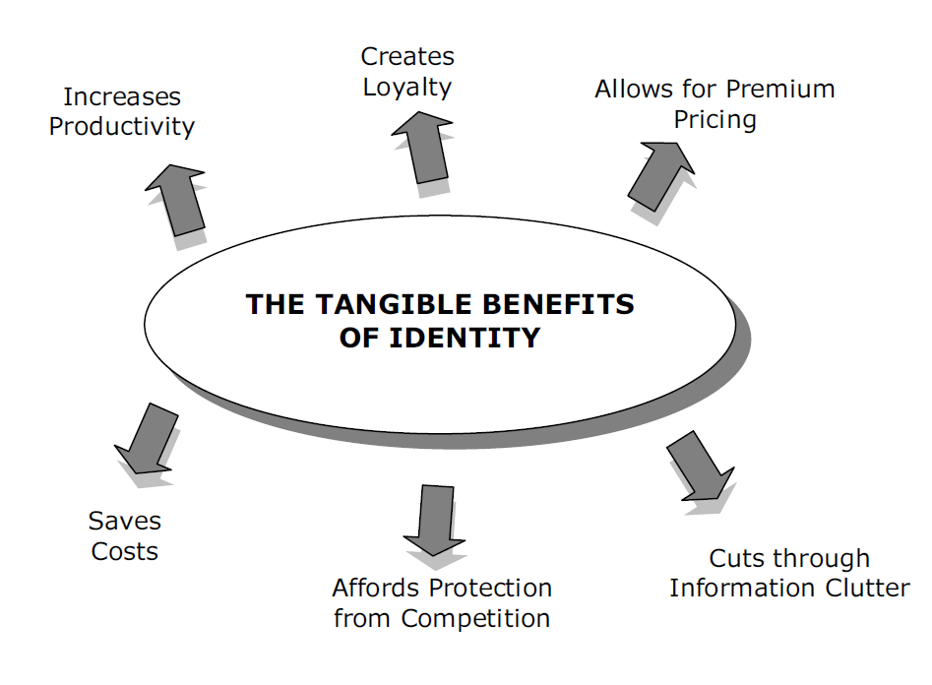
Image 5 Tangible benefits (Ritchie)
- DIFFICULTIES OF BRANDING IN DESTINATION MANAGEMENT
The praxis also shows some other specifics of branding of destination management. It is very difficult to transfer and use some branding in different destinations. Borrowing or adaptation of a brand causes problems and therefore a caution is necessary when trying to set a branding in this manner. The main difference between a traditional production and a destination management is that the product in destination management is usually sold by a group of companies, which have common interests and characteristics. A destination is very diverse and complex product, which is delivered by many different companies. That means, a brand of a destination is a collective phenomenon. That is one big problem, because destination management organizations have to find a collective agreement. It is problematic to find an ideal image. The process can cause an ambiguity and inefficiency. In this discussion the residents have more idealistic ideas than the companies. Brand has to capture the essence of the pleasure dimension, not only the functional dimension. It is affected by symbols and logos. It is hard to make an agreement for many products and services. Because of this a family of brands is used sometimes. (Ritchie, 1998, Cliton, 2003, Chan, 2016)
A family of brands can also cause some problems, for example a disparity among the brands, when one brand is considered the main brand. This situation happens in Orlando, Florida where the Disney Corporation is dominant and its concept is prominent in all aspects of the destination. (Ritchie, 1998)
Difficulty of branding in destination management is also related to time. The final product consists of many small parts and services that can change over time. Sometime there is a time difference between a moment when a client buys the service and a moment when he consumes the service - for example a hotel services are usually booked in advance. A cycle of branding is observable in different seasons of the year. It is different to visit a place in summer or in winter. A political or a social situation can also change over time. (Ritchie, 1998, Cox, 2014)
- MEASURES OF EFFECTIVENESS
Based on a previous research, destination managers and other participants want to see, if their brand of destination provides higher turnover. The research describes five primary roles of a destination brand. These are identification, differentiation, anticipation, expectation and reassurance. These roles are layered on themselves. That means, that every ply covers the previous one. The identification represents a degree of recognition or association. The differentiation is a distinction among destinations, products or services. The anticipation includes a desire to visit the destination. The expectation describes the nature and importance of benefits, which a visitor expects and the reassurance is the feeling of a visitor, that everything will go well during his visit in the destination. (Ritchie, 1998, Marzano, 2009)
Then the visitor has a post-experiente, a recollection. The recollection has two layers - a consolidation and a reinforcement. A consolidation represents the ability of a brand to unite all parts of memories of the destination and the reinforcement is a conversion of memories into experience. These layers make a holistic memory of the experience. The effectiveness of a brand is therefore dependent on how thoroughly it performs each of those roles. (Ritchie, 1998)
The research and praxis show also some less important roles of branding. A brand works like a coordinating symbol for a broad range of community development and promotion efforts. It could help to enhance the status of tourism within a community. A brand can also earn money from selling promotional items with a brand or a destination name. A brand also helps to reduce the number of thefts of materials or equipment that belong to the destination. (Ritchie, 1998)
- EXAMPLE OF BRANDING IN DIFFERENT PARTS OF THE WORLD
The first examples were Brand Oregon, Branding of Canada, Brand of Texas, Missouri, New Orleans or Hawaii. The first global branding campaign took place in New Zealand in 1999. The branding in New Zealand is a very successful example, this destination managed to defeat such a big destination like Australia. New Zealand is divided into five macro regions, 12 regional councils, 26 regional tourism organisations and numerous district tourism organisations. That is the reason, why it is important to have unanimous agreement from local authorities. This big achievement was reached with slogan "100% Pure New Zealand" and just with minimal costs, minuscule 0.01 per cent of worldwide advertising presence. The slogan was then modified into a few other mottos, every time with the part "100%". New Zealand gained a portion of popularity because of the movies based on J.R.R. Tolkiens book "The Lord of the Rings", whose fantasy world of Middle-earth was filmed in New Zealands nature. (Morgan, 2003)
We can find another example of successful use of branding in Catalonia. This region is very popular, nearly 11 % of its GDP comes from tourism and almost 17 % of the working population is employed in the service sector. Their branding strategy is different from the one used in New Zealand. Catalonia has an umbrella brand for the whole destination and some sub brands for smaller parts of this destination. One of the reason to have more brands is the fact, that each part can have its own visions and objectives. There are four brands in the Barcelona province and one individual brand for Barcelona city. The provinces of Tarragona and Girona have two brands each, while Lleida has three brands. The Pirineus also has a special logo, where one half of the logo shows a picture of the main Catalonia brand. In fact, the few tourist destinations, that have defined their brand, describe it with its basic characteristics and attributes. (Datzira-Masip, 2014)

- TABLE OF RESEARCHES OF DESTINATION MANAGEMENT

Table 1 Research in destination management
Author | Research topic | Research | Result
CHAN, Chung-Shing a Lawal M. MARAFA | Difference of the green resource  brand between local residents and visitors | Questionnaire, interview | Residents generally rated the “green potential” elements more highly then visitors, results  represent a lack of recognition of green resource elements and their potential to be  transformed into an important brand element for Hong Kong
MORGAN, N. J., A. PRITCHARD a R. PIGGOTT | Destination branding and the role of the  stakeholders | explore the  context and creation of the New Zealand brand | New Zealand tourism stepped from the shadows of Australia with a new branding
DATZIRA-MASIP, Jordi a Alessio POLUZZI | Brand in local or top level | Analysis of tourism information | one side is  government at the top level could define a methodology to apply  to all the destinations of the territory, other side brand should be developed at local level, because in order to be effective,  brand strategy must be shared by those who are intending to  implement it
GLIŃSKA, Ewa a Magdalena FLOREK | The differences  between the set of city attributes used in the process of building the  desired image of the city | Questionnaire (the respondents are  municipal office managers), factor analysis | The representatives of the municipal self-governments declare that they  base branding strategies on the attributes of cities, marketing policy implemented by the municipal self-governments clearly separates the  municipal sphere of the city
- CONCLUSION
The travelling itself is a very old theme, but branding in destination management is quite a new topic. A branding was used for the first time in the United States. There is an effort to find out a measurement of branding effectivity and prove the influence of branding for a destination. The main problem of destination branding is the inapplicability of the same theme in different locations around the world. A brand has to show a specification of a particular destination, present its history, traditions, events, services and everything, what the visitor can see, when he decides to visit the place.
A branding in destination management could be a competitive advantage. Researches show that 10 main world tourism destinations attract 70 % of travellers. That is one of the reasons, why public and private sectors should cooperate. An article represents two totally different ways of branding. The first one is represented by an example of New Zealand. New Zealand branding was founded on a slogan "100% Pure New Zealand". This slogan has some auxiliary slogans, but they are all based on the "100 %" theme. The branding in New Zealand was successful, but they did not measure its effectiveness. The movies "The Lord of the Rings" had also a considerable influence on the popularity of New Zealand, because they were highly popular and they showed an unspoilt beauty of New Zealand's landscape. An another way of branding was used in Catalonia. The main brand was complemented by a sub brand for each smaller destination. This could help to show a specific feature of every destination. This style is better for the presentation of each destination independently, but like a unit Catalonia looks a little bit disorganized. It is typical for Spain, which is united state with a very complicated division. This is the reason for a different presentation, every participant has a different opinion and wants to enforce its own interests. Catalonia is with this kind of branding fairly successful as it is a very popular tourism destination, it is the second most visited area in Spain last year, behind the Canary Islands on first place. The tourism generates more than 10 % of a gross domestic product of Spain and it is the second largest economic sector after the automotive industry.

References:
Aaker, D. A. (2003).Brand building: budování značky: vytvoření silné značky a její úspěšné zavedení na trh. Brno: Computer Press, Business books (Computer Press). ISBN 80-7226-885-6
Blain, C. (2005). Destination Branding: Insights and Practices from Destination Management Organizations. Journal of Travel Research [online]., 43(4), 328-338 [cit. 2017-01-10]. DOI: 10.1177/0047287505274646. ISSN 0047-2875.
Brand Marketing. (©2012) Marketing schools [online]. USA: Marketing-schools, [cit. 2017-02-20]. Dostupné z: http://www.marketing-schools.org/types-of-marketing/brand-marketing.html
Chan, Chung-Shing $\&$ Lawal, M. Ma. The green branding of Hong Kong: visitors’ and residents’ perceptions. Journal of Place Management and Development [online]. 2016, 9(3), 289-312 [cit. 2017-02-01]. DOI: 10.1108/JPMD-02-2016-0008. ISSN 1753-8335. Dostupné z: http://www.emeraldinsight.com/doi/10.1108/JPMD-02-2016-0008
Clifton, R. $\&$ John S. (2003).. Brands and branding. London: Profile Books, ISBN 18-476-5000-7.
Cox, N. Gyrd-Jones R $\&$ Gardiner. S. Internal brand management of destination brands: Exploring the roles of destination management organisations and operators. Journal of Destination Marketing & Management [online]. 2014, 3(2), 85-95 [cit. 2017-01-18]. DOI: 10.1016/j.jdmm.2014.01.004. ISSN 2212571x.
CzechTourism [online]. Praha, ©2005-2013 [cit. 2016-12-20]. Dostupné z: http://www.czechtourism.cz/
Datzira-Masip, J.i $\&$ Alessio P. (2014) Brand architecture management: The case of four tourist destinations in Catalonia. Journal of Destination Marketing & Management [online]., 3(1), 48-58 [cit. 2017-01-18]. DOI: 10.1016/j.jdmm.2013.12.006. ISSN 2212571x.
Destination Management & Quality Programme. World tourism organization [online]. 2002 [cit. 2017-01-20]. Dostupné z: http://destination.unwto.org/content/conceptual-framework-0 Dostupné z: http://linkinghub.elsevier.com/retrieve/pii/S2212571X13000784
Ekinci, Y. (2003). From destination image to destination branding: An emerging area of research. E-review of Tourism Research, 1.2: 1-4.
Glińska, E. $\&$ Florek, M. (2013),. In searching for town brand distinguishing features – local leaders' inner perspective. International Journal of Academic Research [online]. 5(4), 200-205 [cit. 2017-02-04]. DOI: 10.7813/2075-4124.2013/5-4/B.30. ISSN 20754124. Dostupné z: http://www.ijar.lit.az/pdf/ijar/2013(24B-30).pdf
Healey, M., (2010).. What is branding?. Mies: RotoVision, ISBN 2888931354.
Holešínská, A. (2010) Destinační management jako nástroj regionální politiky cestovního ruchu.. Brno, Masarykova univerzita.
Jakubíková, D. (2012). Marketing v cestovním ruchu: jak uspět v domácí i světové konkurenci.. 2., aktualiz. a rozš. vyd. Praha: Grada, ISBN 978-80-247-4209-0.¨
Janečková, L. $\&$ Vaštíková M. (1999). Marketing měst a obcí. Praha: Grada, Města a obce. ISBN 80-7169-750-8.
Keller, K. L. (2007).Strategické řízení značky. Praha: Grada, Expert (Grada). ISBN 978-80-247-1481-3.
Kotler, P. (2007) Marketing management.. Praha: Grada, ISBN 978-80-247-1359-5.
Marzano, G. $\&$. Scott. N. POWER IN DESTINATION BRANDING. Annals
of Tourism Research [online]. 2009, 36(2), 247-267 [cit. 2017-01-28]. DOI: 10.1016/j.annals.2009.01.004. ISSN 01607383.
Metelková, P. (2005). Destinační management v České republice. Brno,
Morgan, N. J., Pritchard, A., $\&$Piggott, R. Destination branding and the role of the stakeholders: The case of New Zealand. Journal of Vacation Marketing [online]. 2003, 9(3), 285-299 [cit. 2017-01-22]. DOI: 10.1177/135676670300900307. ISSN 1356-7667.
Palatková, M. (2011) Marketingový management destinací: strategický a taktický marketing destinace turismu, systém marketingového řízení destinace a jeho financování, řízení kvality v destinaci a informační systém destinace..Praha: Grada, ISBN 978-80-247-3749-2.
Palatková, M. (2006a). Marketingová strategie destinace cestovního ruchu: jak získat více příjmů z cestovního ruchu.. Praha: Grada, Manažer. ISBN 80-247-1014-5.
Palatková, M. (2006b). Prolínání destinací a destinační partnerství.. Praha,
Pike, Steven. (2005) Tourism destination branding complexit. Journal of Product & Brand Management.,14(4), 258-259.
Pike, S., Gentle, J. Kelly, L.$\&$ Beatson, A. Tracking brand positioning for an emerging destination: 2003 to 2015. Tourism and Hospitality Research [online]. , - [cit. 2017-02-08]. DOI: 10.1177/1467358416646821. ISSN 1467-3584.
Přibyl, M. (2012) Branding - značka a její budování..Znojmo,
Ritchie, J. R. B. $\&$ Ritchie, R. J. B. (1998). THE BRANDING OF TOURISM DESTINATIONS: PAST ACHIEVEMENTS & FUTURE CHALLENGES. Marrakech,
Ryglová, K. Burian, M.$\&$ Vajčnerová, I. Cestovní ruch - podnikatelské principy a příležitosti v praxi. 2011. Praha: Grada Publishing, ISBN 978-80-247-4039-3.
The Difference Between Marketing and Branding. Tronvig Group [online]. NY: TRONVIG GROUP, 2011 [cit. 2017-02-20]. Dostupné z: http://www.tronviggroup.com/the-difference-between-marketing-and-branding/
Whats the difference between marketing and branding. (©2017) Microarts [online]. Greenland: MicroArts Creative Agency, [cit. 2017-02-20]. Dostupné z: https://microarts.com/insights/whats-the-difference-between-marketing-and-branding/
Zelenka, J. $\&$ Pásková M. (2012). Výkladový slovník cestovního ruchu.. Kompletně přeprac. a dopl. 2. vyd. Praha: Linde, ISBN 978-80-7201-880-2.

Contact information
Name: Monika Hýblová
University, Faculty: Univerzita Tomáše Bati ve Zlíně, Fakulta managementu a ekonomiky
Address: Mostní 5139, 760 01 Zlín
Telephone number: 777 332 119
E-mail: mhyblova@fame.utb.cz

