Powder Technology 194 (2009) 1-196

Pressure-affected flow properties of powder injection moulding compounds

Berenika Hausnerova, Tomas Sedlacek, Pavlina Vltavska

Tomas Bata University in Zíin, Faculty of Technology, Polymer Centre, TGM275, 762 72 Zlín, Czech Republic

Abstract
The effect of pressure and temperature on the flow properties of the materials intended for Powder Injection Moulding (PIM) technology was studied using a single-piston capillary rheometer modified by additional backpressure chamber. The influence of pressure and temperature on shear viscosity has been quantified through pressure and temperature sensitivity coefficients derived from Carreau-Yasuda model. The temperature sensitivity of the 50 vol.% compound based on cemented carbide powder is lower than that of pure polymeric binder, and it varies only slightly with pressure. In contrast, the pressure sensitivity of compounds was found to be higher than that of pure polyolefin binder, and it is decreasing function of temperature. In addition, it is shown that temperature sensitivity of binder, which is considerably enhanced by pressure (in contrast to the PIM demands), cannot be determined as being equal to the properties of particular binder components.
© 2009 Elsevier B.V. All rights reserved.

Keywords
Pressure-dependent viscosity, Temperature and pressure coefficients, Modified capillary rheometer, PIM technology

1. Introduction
At present demands on multiphase materials as those intended for PIM technology are stringent. It is obvious that reliable simulations of the PIM process can only be performed when the material parameters are known with sufficient accuracy. A parameter that is still omitted is the influence of the pressure on the flow properties during injection moulding step.
Regardless of many papers devoted to the rheology of PIM feedstocks in the last decade [e.g.1-4], there is no relevant reference in literature concerning the pressure affected viscosity up to date, and even for pure polymers, where the influence of pressure on the flow behaviour is significant, reported results are ambiguous.
The discrepancies in the pressure sensitivity coefficients reported for polymers might be partly explained by the differences in the molecular weight distributions and molecular characteristics as LCB of the particular resins' grades, but the main responsible factors are heterogeneous definitions of pressure sensitivity coefficients, various evaluation techniques and test artefacts connected.
The evaluation methods of pressure sensitivity can be divided into two general groups: direct — experimental, and indirect — analysis and/or correlation to other properties.
The first group concerns double piston rheometers, as introduced by Maxwell and Jung [5], where the fluid is pressurised when confined between two pistons. The principle was explored by Mackley et al. [6], which developed a "multi-pass rheometer" capable to measure both steady state and oscillatory flow properties at the elevated pressures.
A simpler version of direct measurement of pressure-affected viscosity is represented by single piston capillary rheometers modified by secondary chamber located downstream of the capillary as first involved by Driscoll and Bogue [7] on an Instron capillary rheometer in order to measure melt viscosity at pressures up to 130 MPa. Another possibility of the modification of single piston rheometers is implementation of a conical restriction downstream of the capillary.
Indirect evaluation of pressure-dependent viscosity is based mainly on the calculations from Bagley plots [8] intercepting non- linearities in the pressure profiles (capillary and slit rheometry). Regardless of its simplicity, this method brings number of obstacles and limitations as pointed out by Moldenaers et al. [9], Binding et al. [10], Denn [11] and others exploring this technique.
Utracki [12] proposed an alternative indirect technique based on the relationship between viscosity and free volume. His method of deriving pressure-affected viscosity from pvT data with the help of Simha-Somcynsky equation of state [13] was recently expanded by Sedlacek et al. [14] for a series of polymer materials under high pressures and various temperatures, who successfully substituted Utracki's empirical constants set for the individual materials with a unique coefficient correcting reduced compressibility, which was proved to be valid for polymers with various structure (PS, PMMA, PC, LDPE, LLDPE, HDPE, PP).
The comparison of Utracki's method, calculations from Bagley plots and measurement on modified single piston rheometer performed by Goubert et al. [15] has proved the reliability of the last mentioned method. We already presented the introductory paper [16] concerning cemented carbide based compounds employing the direct measurement of the pressure influence on the flow properties using this technique, showing temperature and pressure sensitivity of polymer binder and low to moderate (30 vol.%) concentrated powder compounds. In this paper the 50 vol.% carbide powder compounds as well as the particular binder components are considered.
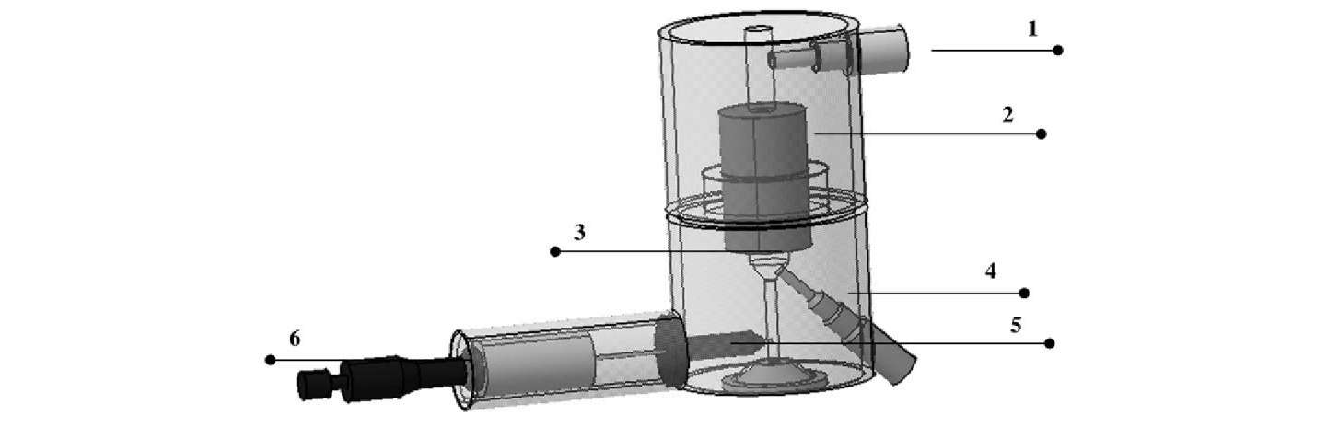
Fig. 1. Schema of modified rheometer: 1 - entrance pressure transducer, 2 - capillary, 3 - pressurizing chamber, 4 - backpressure transducer, 5 - restricting needle valve, 6 - micrometric screw.

2. Description of the evaluation method
A secondary chamber has been implemented to the capillary rheometer Göttfert 2001 with a plane capillary entrance. The pressure acting on the melts tested is enhanced by the horizontal movement of the restricting needle valve located sideward of the chamber. The level of pressurization applied on the material during its flow through the die is set by means of screw thread. The device (Fig. 1) has been designed and developed at the Polymer Centre TBU in Zlín, Czech Republic, and it has been already successfully employed in the series of papers by Sedlacek et al. [17-19].
The pressure values were taken at two points: in the reservoir closely upstream from the entrance to the capillary (entrance pressure), and in the second chamber (backpressure). Experiments were done with two capillaries: long (L/D = 20/1) and orifice (L/D = 0.12/1). Pressure dependent viscosity was measured at different values of backpressure in the shear rate range of 80 to 5000 s⁻¹.
First, the shear stress treated with Bagley correction was calculated
$σ_{C}= \frac{\left({∆P}_{L}- {∆P}_{O}\right)R}{2L}$ (1)
where, ΔP_{L} = P_{1L} — P_{2L} is the pressure drop through the long capillary (subscripts 1 and 2 correspond to measured pressures at the capillary entrance and exit, respectively), ΔP_{O} = P_{1O} — P_{2O} accordingly stands for the entrance pressure drop of the orifice die, R represents capillary radius, and L is capillary length.
Then, the flow indexes n were evaluated properly as slopes of loglog plot of true shear stress versus apparent shear rate through second order polynomial function fit within measured shear rate and mean pressure ranges $P_{M}= \frac{P_{1L}+P_{2L} }{2}$.
The true shear rate was derived from
${\dot{γ}}_{C}= \frac{4\dot{Q}}{πR^{3}}\left(\frac{3n+1}{4n}\right)$ (2)
where $\dot{Q}$ represents volume flow through a capillary,
Accordingly, the true (corrected) shear viscosity was obtained as
$η_{C}= \frac{σ_{C}}{{\dot{γ}}_{C}}$ . (3)
Finally, the Carreau-Yasuda model [20] was employed for fitting of the measured temperature and pressure dependent shear viscosity
$$η(\dot{γ)}= \frac{η_{0}f}{{\left[1+{(K_{1}f\dot{γ)}}^{a}\right]}^{\frac{1-m}{a}}}$$
where η₀ means zero-shear viscosity, $\dot{γ}$ is shear rate, $η(\dot{γ)}$ represents the shear rate-dependent viscosity, K₁, m, and a are empirical constants, and f stands for the exponential relations giving the temperature coefficient of viscosity α (f = e^{-α(T-Tr)}, where T and T_{r} are testing and reference temperatures, respectively), and/or the pressure coefficient of viscosity β (f = e^{(βP)}, where P stands for the gauge pressure). The method used is based on minimizing the summation of the squares of the residuals accomplished through nonlinear regression employing the Marquardt-Levenberg algorithm.

3. Experimental
3.1. Materials and compounding
The powder (cemented carbide) used in the experiments described below was a composite of tungsten carbide, cobalt, and other carbides (Table 1). The metallic component (cobalt), which constitutes only a minor proportion of the carbide mixture, serves as the matrix for the final sintered part. The average density amounts to 13.2 g cm³. The shape of the particles was irregular, with relatively broad particle size distribution. The polymer binder was based on 53 wt.% low density polyethylene Lacqtene 1200 MN 8 (Atochem) and 21 wt.% paraffin in addition to 26 wt.% ethylene-acrylic acid block copolymer Ex 225 (Exxon) serving as a steric stabilisator of the feedstock.
The compounds were prepared in a laboratory kneader (Brabender Plasticorder PL-2000-6, mixer type W 50E) at 150 °C and 80 rpm. The mixing chamber was filled by 70-80% of its volume. Firstly, a small portion (1/5) of the polymer binder was preheated in the mixer. Then, the powder and remaining binder were added by turns during the first minute and the suspension was mixed for about 5 more minutes. The kneader torque was always constant over the last 2-3 min indicating that the dispersion process had been completed.

Table 1
Powder composition.
Component | WC | Co | TaC | TiC | NiC
Content [%] | 77 | 11 | 6.1 | 4.0 | 1.9

4. Results and discussion
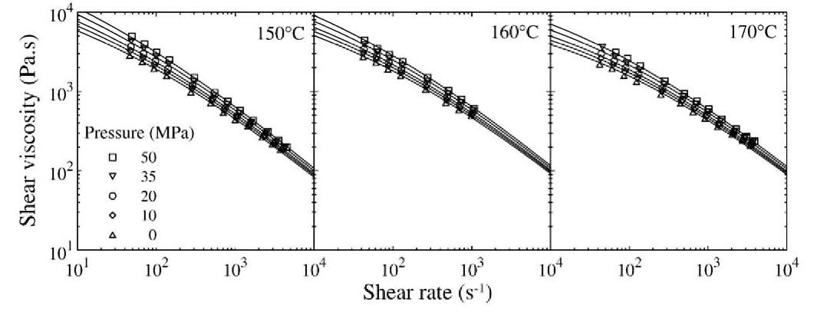
Fig. 2. Pressure-dependent viscosity vs. shear rate curves for 50 vol.% carbide compounds at 150,160 and 170 °C. Solid lines represent data fitting by the Carreau-Yasuda model.
Pressure-dependent viscosities of the 50 vol.% compound of cemented carbide powder and polyolefin based binder for pressures up to 50 MPa with temperature as a variable are depicted in Fig. 2 together with Carreau-Yasuda fitted data represented by solid lines. The powder loading was kept at 50 vol.% (about 14% below maximum for this particular compound) in order to provide the smooth flow without any disturbances since it has been reported the viscosity cause failure from Arrhenius relation for flows accompanied with spurt [22]. As pointed out by German [21], pressure suppresses particles' dilation to allow interparticle motion during the flow resulting in higher viscosity, which can be demonstrated with the Carreau-Yasuda parameters at the various pressure levels as shown in Table 2.
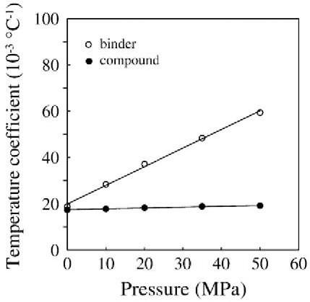
Fig. 3. Temperature sensitivity coefficients as a function of pressure for 50 vol.% carbide compounds (full symbols) and pure binder (open symbols).
From the pressure sensitivity coefficients β obtained for various temperatures (Table 3) it is clear that the sensitivity of the compound to pressure is enhanced in comparison to the pure polymer binder. It can be speculated that the compressibility of structure formed by interacting particles becomes important at such high loading level, while for low to moderate concentrations the pressure sensitivity is governed by polymer binder predominantly, and therefore decreases with powder loading as reported for compounds up to 30 vol.% [16].As already mentioned in the Introduction the data available on pressure affected viscosity of inorganic materials are reported very scarcely. In the series of papers Rutters et al. [23,24] reported both almost negligible viscosity changes upon pressurization for liquid Fe, and large effect of pressure on viscosity of liquid Fe-FeS alloy. In the study of the Earth interior [25] viscosity of sodium aluminosilicate (albite) was found to decrease with increasing pressure in the range of 2.6 to 5.3 GPa.

As can be seen in Fig. 3, temperature sensitivity of the carbide compound does not vary significantly with pressure, in contrast to the pure binder whose α is linear increasing function of pressure. The compound's temperature sensitivity coefficient reveals the value (18.4 ± 0.7) 10⁻³ °C⁻¹ for pressures up to 50 MPa, while α obtained for pure binder increased from 18.8 10⁻³ °C⁻¹ at ambient pressure to 59.4 10⁻³°C⁻¹ at 50 MPa.
Further, regardless of the pressure effect, the viscosity of carbide compound is less temperature sensitive than viscosity of pure polymeric binder. This finding is in agreement with Shenoy's opinion [26] that fillers provide very little free volume change with temperature in relation to binder, and it has been experimentally confirmed e.g. for cemented carbides in polyolefin based binder [22], barium ferrite in polyethylene and elastomeric matrices [27], or glass beads and polyethylene composites [28].
Table 2
Parameters of Carreau-Yasuda model for 50 vol.% carbide compound at temperatures ranging from 150 to 170 °C
Pressure [MPa] | η₀ [Pa s] | m | K₁10⁻³ | a | α [10⁻³ °C⁻¹]
0 | 38,600 | 0.100 | 0.032 | 0.249 | 17.7
10 | 48,900 | 0.138 | 0.071 | 0.271 | 17.8
20 | 62,000 | 0.159 | 0.127 | 0.288 | 18.3
35 | 88,300 | 0.100 | 0.100 | 0.272 | 18.9
50 | 125,800 | 0.100 | 0.147 | 0.271 | 19.2

Table 3
Pressure sensitivity coefficients as a function of temperature of 50 vol.% carbide compounds and their comparison to the data revealed for pure binder in [16].
Temperature [°C] | 140 | 150 | 160 | 170
Pressure coefficient [GPa−1] | Pure binder (Ref. [16])
 | 26.1 | 16.4 | 8.7 | –
 | 50 vol.% compound
 | – | 24.1 | 19.6 | 18.3

In this work we also amplify findings [16] concerning sensitivity of three-component binder, and evaluate α and β of the particular binder components. Figs. 4 and 5 demonstrate pressure and temperature dependent viscosities of LDPE as functions of temperature and pressure, respectively. Both pressure and temperature sensitivity coefficients of
LDPE were found dependent on T and p, respectively. Since LDPE is highly flexible polymer, it is less prone to the reduction of free volume during pressurization, and therefore its sensitivity coefficients are relative low comparing to polymers having bulky side groups.
Pressure and temperature sensitivity coefficients of ethylene based copolymer (EAA) also vary with temperature and pressure (Figs. 6 and 7). The data evaluated for third binder component — paraffin wax was scattered due to its narrow melting region and low viscosity, and therefore it has been excluded from the presentation.

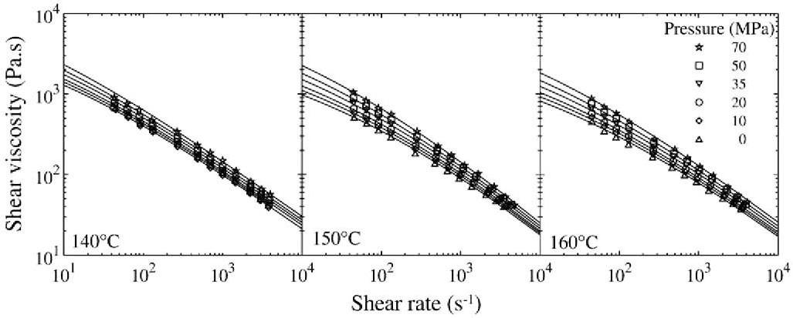
Fig. 4. Pressure-dependent viscosity vs. shear rate curves of LDPE at 140,150 and 160 °C. Solid lines represent data fitting by the Carreau-Yasuda model.
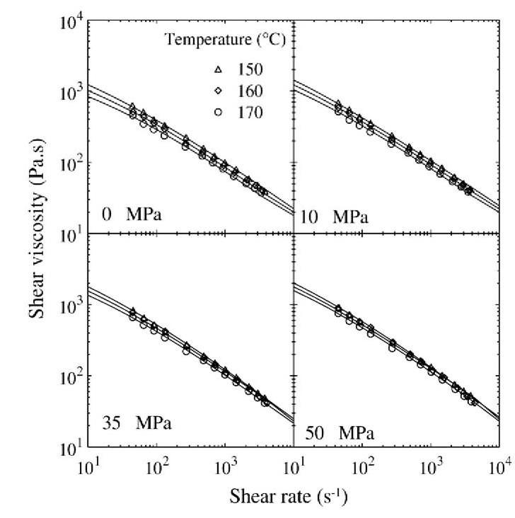
Fig. 5. Temperature-dependent viscosity vs. shear rate curves of LDPE at pressures up to 50 MPa. Solid lines represent data fitting by the Carreau-Yasuda model.
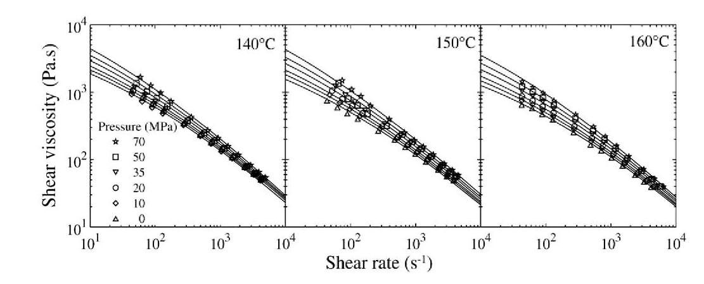
Fig. 6. Pressure-dependent viscosity vs. shear rate curves of EAA at 140,150 and 160 °C. Solid lines represent data fitting by the Carreau-Yasuda model.

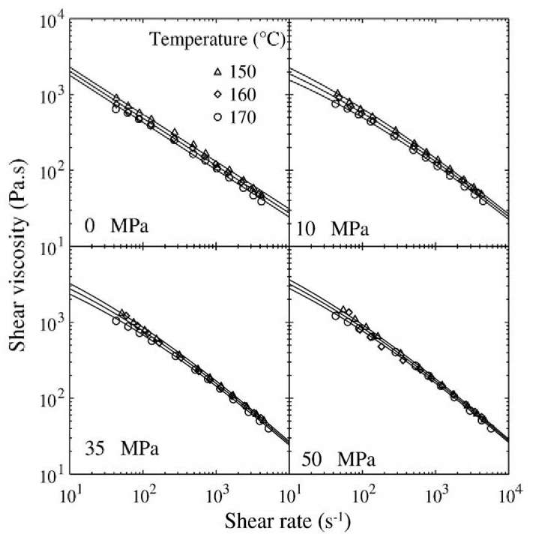
Fig. 7. Temperature-dependent viscosity vs. shear rate curves of EAA at pressures up to 50 MPa. Solid lines represent data fitting by the Carreau-Yasuda model.
Table 2
Parameters of Carreau-Yasuda model for 50 vol.% carbide compound at temperatures ranging from 150 to 170 °C
Parameter | Temperature sensitivity
Pressure [MPa] | Material | η₀ [Pa s] | m | K₁10⁻³ | a | α [10⁻³ °C⁻¹]
0 | LDPE | 7072 | 0.314 | 0.400 | 0.393 | 32.5
 | EAA | 14,231 | 0.376 | 0.184 | 0.690 | 33.0
10 | LDPE | 8331 | 0.352 | 0.791 | 0.482 | 29.3
 | EAA | 18,200 | 0.179 | 0.227 | 0.330 | 33.5
20 | LDPE | 10,206 | 0.284 | 0.431 | 0.382 | 28.0
 | EAA | 23,365 | 0.144 | 0.214 | 0.325 | 32.3
35 | LDPE | 13,726 | 0.261 | 0.463 | 0.361 | 25.2
 | EAA | 33,987 | 0.091 | 0.191 | 0.308 | 30.9
50 | LDPE | 17,604 | 0.237 | 0.434 | 0.343 | 22.6
 | EAA | 49,200 | 0.097 | 0.281 | 0.297 | 26.6
70 | LDPE | 25,462 | 0.171 | 0.281 | 0.295 | 19.8
Temperature [°C] | Pressure sensitivity |  |  |  |  | β [GPa−1]
140 | LDPE | 7041 | 0.295 | 0.339 | 0.400 | 15.9
 | EAA | 14,199 | 0.000 | 0.030 | 0.269 | 23.1
150 | LDPE | 5402 | 0.117 | 0.350 | 0.286 | 20.8
 | EAA | 10,518 | 0.078 | 0.048 | 0.286 | 27.8
160 | LDPE | 4150 | 0.221 | 0.079 | 0.315 | 19.9
 | EAA | 7860 | 0.000 | 0.016 | 0.263 | 26.4

Comparison of α and β obtained for binder system with binder components' values depicted in Table 4 reveals that both temperature and pressure sensitivity of binder must be experimentally evaluated and not derived from the sensitivities of the particular binder components.

5. Conclusion
During the capillary flow the different pressure levels were inserted on melted carbide powder compounds. It has been shown that the pressure sensitivity of 50 vol.% concentrated materials is pronounced comparing to the pure polymeric binder. The mechanism of the behaviour is not clarified yet, although it is supposed to have connection with the compressibility of the powder structures formed during shear, and therefore will vary with powder characteristic.

Acknowledgement
This work has been financially supported by the Grant Agency of the Czech Republic (project 103/08/1307) and Ministry of Education, Youth and Sports of the Czech Republic (project no. MSM 7088352101). B.H. is the laureate of the national section "For Women in Science", being financially supported by L'Oréal during the year 2007.

References
- S. Novak, S.M.H. Olhero, J.M.F. Ferreira, A. Zupancic, Rheol. Acta 43 (2004) 559-566.
- J.M. Contreras, A. Jiménez-Morales, J.M. Torralba, Powder Metall. 51 (2008) 103-106.
- M. Khakbiz, A. Simchi, R Bagheri, Mater. Sci. Eng. A407 (2005) 105-113.
- C. Karatas, A. Kocer, H.I. Unal, S. Saritas, J. Mater. Process. Technol. 152 (2004) 77-83.
- B. Maxwell, A. Jung, Mod. Plast. 35 (1957) 174-182.
- M.R Mackley, R.T.J. Marshal, J.B.A.R. Smeulders, J. Rheol. 39 (1995) 1293-1309.
- P.D. Driscoll, D.C. Bogue, J. Appl. Polym. Sci. 39 (1990) 1755-1768.
- J. Duvdevani, I. Klein, SPE J. 23 (1967) 41-45.
- P. Moldenaers, J. Vermant, J. Mewis, I. Heynderickx, J. Rheol. 40 (1996) 203-219.
- D.M. Binding, M.A. Couch, K. Walters, J. Non-Newton. Fluid Mech. 79 (1998) 137-155.
- M.M. Denn, Polym. Eng. Sci. 21 (1981) 65-68.
- L.A. Utracki, Polym. Eng. Sci. 25 (1985) 655-668.
- R. Simha, T. Somcynsky, Macromolecules 2 (1969) 342-350.
- T. Sedlacek, R Cermak, B. Hausnerova, M. Zatloukal, A. Boldizar, P. Saha, Int. Polym. Process. 20 (2005) 286-295.
- Goubert, J. Vermant, P. Moldenaers, A. Göttfert, B. Ernst, Appl. Rheol. 11 (2001) 26-37.
- Hausnerova, T. Sedlacek, R. Slezak, P. Saha, Rheol. Acta 45 (2006) 290-296.
- T. Sedlacek, M. Zatloukal, P. Filip, P. Saha, A. Boldizar, Polym. Eng. Sci. 44 (2004) 1328-1337.
- T. Sedlacek A. Lengalova, M. Zatloukal, P. Filip, P. Saha, Plast. Rubber Compos. 33 (2004) 299 - 304.
- T. Sedlacek, A. Lengalova, M. Zatloukal, R Cermâk, P. Saha, Int. Polym. Process. 21 (2006) 98-103.
- K. Yasuda, R.C. Armstrong, R.E. Cohen, Rheol. Acta 20 (1981) 163-178.
- R.M. German, Powder Injection Moulding. MPIF, Princeton, New Yersey, 1995.
- T. Honek B. Hausnerova, P. Saha, Appl. Rheol. 12 (2002) 72-80.
- M.D. Rutter, R.A. Secco, H. Liu, T. Uchida, M.L. Rivers, S.R Sutton, Y. Wang, Phys. Rev., B 66 (2002) 1-4.
- M.D. Rutter, R.A. Secco, T. Uchida, H. Liu, Y. Wang, M.L. Rivers, S.R. Sutton, Geophys. Res. Lett. 29 (2001) 58-61.
- Suzuki, E. Ohtani, K. Funakoshi, H. Terasaki, T. Kubo, Phys. Chem. Miner. 29 (2002) 159-165.
- A.V. Shenoy, Rheology of Filled Polymer Systems, Kluwer Academic Publishers, 1999.
- D.R Saini, A.V. Shenoy, V.M. Nadkarni, Polym. Compos. 7 (1986) 193-200.
- J.Z. Liang, R.K.Y. Li, J. Appl. Polym. Sci. 73 (1999) 1451-1456.

Corresponding author. Tel: +420 57 603 1422; fax: +420 57 603 1444. E-mail address: hausnerova@ft.utb.cz (B. Hausnerova). 0032-5910/$ - see front matter © 2009 Elsevier B.V. All rights reserved. doi:10.1016/j.powtec.2009.04.007

